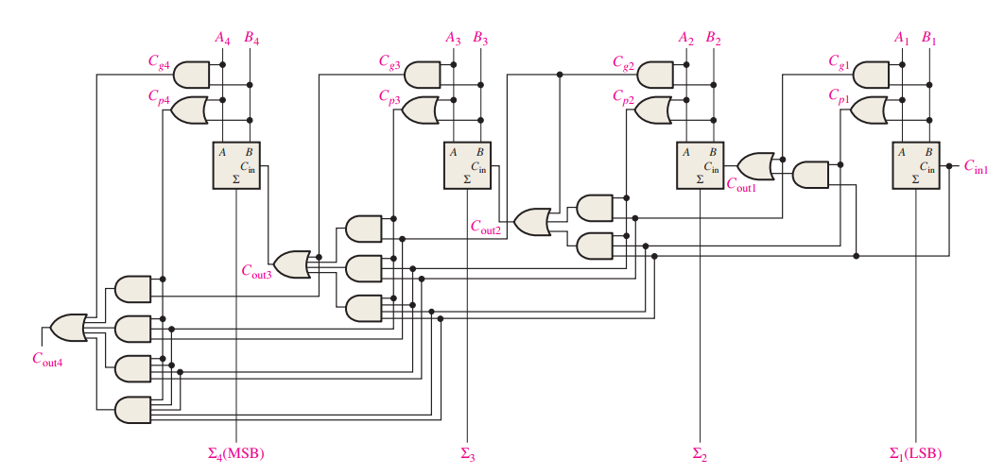

Fig. Logic diagram for a 4-stage look-ahead carry adder.