**GROCERY ORDERING MOBILE APPLICATION**

**PETER SAMUEL**

**SCII/00327/2015**

**OVERVIEW**

**1.Project Background and Description**

The idea of the online grocery shopping application is to enable customers order fresh groceries with a single click. With the use of the online app for grocery shopping, users shall be able to manage their budget in a better manner. The app will ease the process of calculating every item a user adds to their shopping cart hence saving time and tracking their incurring amount on their overall expenses.

**2.Project Scope**

In this app users will be able to search for grocery items that they need, add items to cart, edit and remove items they don’t need. After adding items to cart they will be able to make an order and also make payments for their orders. In addition, the app will also keep history of customers’ orders for future reference. The mobile app will also enable users create and manage their user accounts.

|  |  |  |  |
| --- | --- | --- | --- |
| Level 0 | Level 1 | Level 2 |  |
| Grocery mobile app | Authentication System | Create Account  Login  Logout | User |
| Grocery mobile app | Cart | Add Items  Edit Items  Remove Items | User |
| Grocery mobile app | Order | Create new order  Delete order | User |
| Grocery mobile app | Payment | Pay order | User |
| Grocery mobile app | User profile | Manage user account | User |

**Authentication Flowchart**

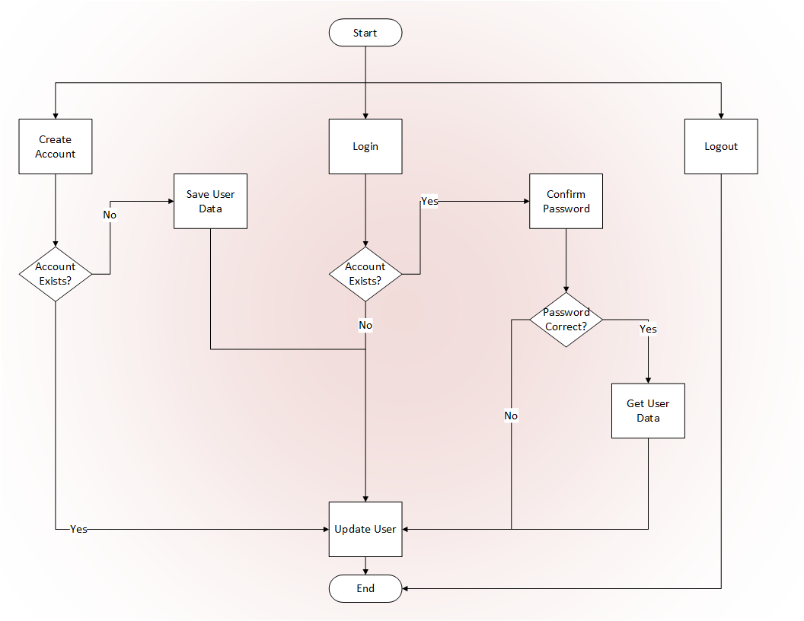

**Cart ERD**

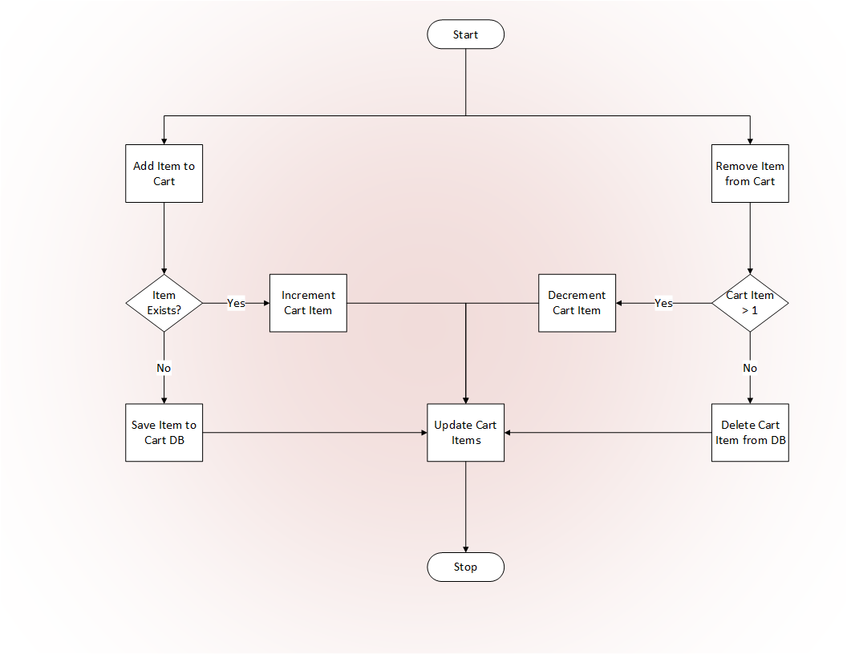

**Order ERD**

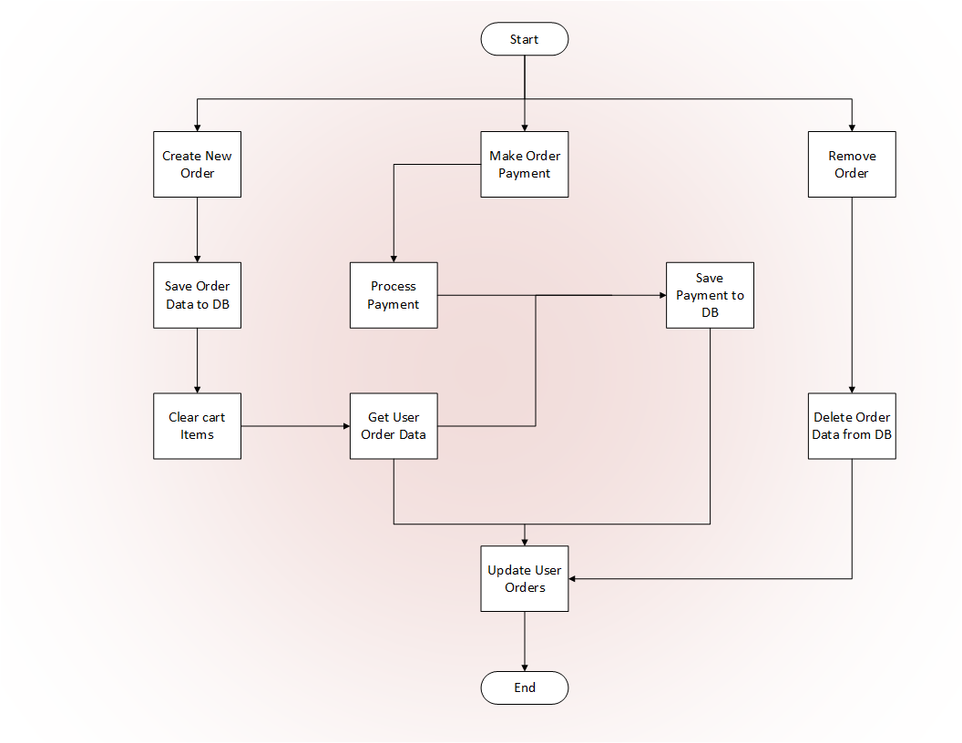

**Authentication UML**

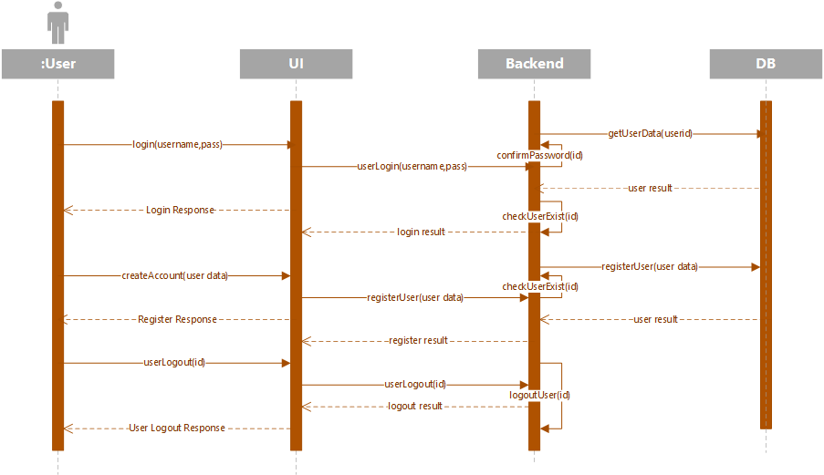

**Cart UML**

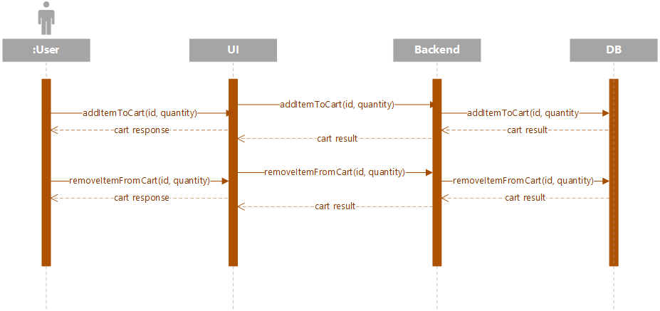

**Order UML**

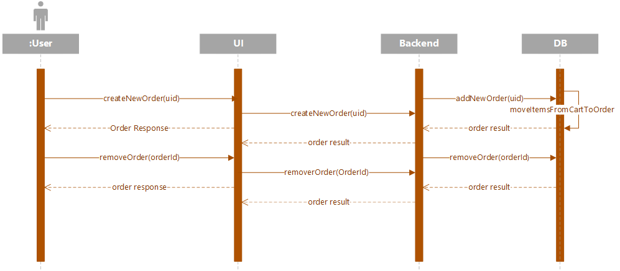

**Payment UML**

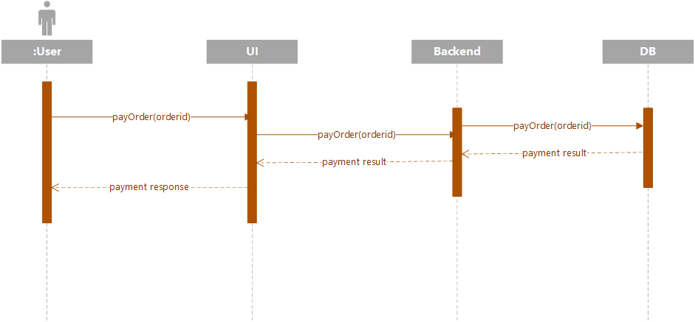

**Manage user account UML**

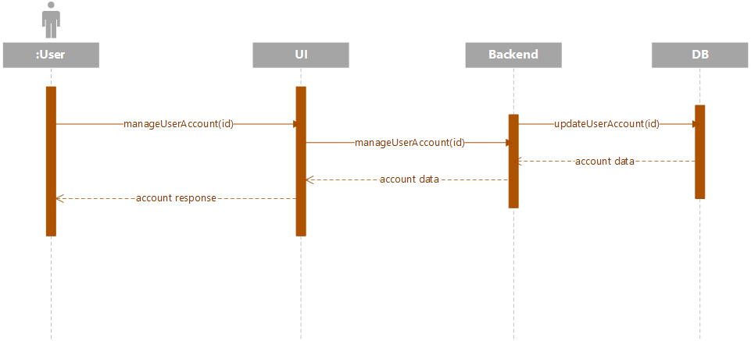

**3.Modules**

* **Authentication Module**
* **Cart Module**
* **Order Module**
* **Payment Module**
* **User Account Module**

**4.Deliverables**

* Create and manage user accounts
* Enable user to select, add, edit and delete items from cart
* Enable user to create an order
* Enable user pay for an order

**5.Affected Parties**

The affected parties of this system are the grocery stores and customers

**6.Affected Systems**

The affected system is the grocery mobile app

**7.Implementation**

**8.Schedule**

|  |  |  |
| --- | --- | --- |
| **Date** | | **Tasks** |
| 1. | 17th – 21st September | Project setup, ui design |
| 2. | 22nd – 28th September | User login, register and account management |
| 3. | 29th – 5th October | List grocery items and backend |
| 4. | 6th – 13th October | Cart module |
| 5. | 14th – 20th October | Order and payment module |
| 6. | 21st – 26th October | Implementation and documentation |
| 7. | 26th – 2nd November | Testing |