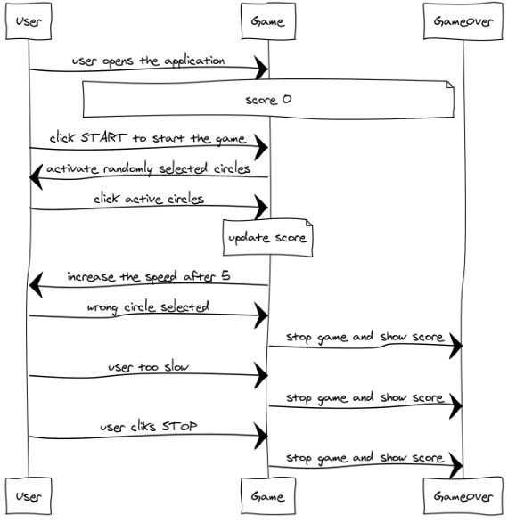

1. User goes to the URL
2. Game loads and sets Score to 0
3. User clicks START
4. Game selects/activates circles randomly
5. User clicks active circle
6. Game keeps updating Score
7. Game increaces speed after 5 succesful clicks
8. If User clicks wrong circle
9. Game ends and updates the score
10. If user is too slow
11. Game ends and updates the score
12. If users clicks STOP
13. Game ends and updates the score