PrimaryKey Foreingn Keys

**branch_id** is PrimaryKey in **Branch-table**, **super_id** refers to another employee **inside the Employee-table**

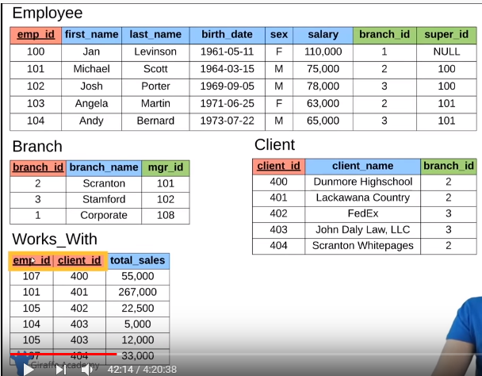

branch_id is a PrimaryKey in Branch-table, mgr_id is a ForeignKey and refers to Employee-table

client_id is a PrimaryKey for Client-table, branch_id is a ForeignKey and refers to Branch-table

emp_id + client_id is a Composite PrimaryKey in Works_With-table and emp_id is a ForeignKey referring to Employee-table and client_id is a ForeignKey referring to Client-table

CREATE TABLE student

DROP TABLE student

ALTER TABLE student ADD gpa DECIMAL(3,2);

ALTER TABLE student DROP COLUMN gpa;

INSERT INTO student(student_id, name) VALUES(3, "Claire");

***

CREATE TABLE student(

student_id INT PRIMARY KEY AUTO_INCREMENT,

name VARCHAR(20),

major VARCHAR(20) DEFAULT "undecided");

INSERT INTO student(name, major) VALUES("Jack", "Biology");

INSERT INTO student(name, major) VALUES("Kate", "Sociology");

INSERT INTO student(name, major) VALUES("Claire", "Chemistry");

INSERT INTO student(name, major) VALUES("Jack", "Biology");

INSERT INTO student(name) VALUES("Mike");

| **student_id** | **name** | **major** |
| --- | --- | --- |
| 1 | Jack | Biology |
| 2 | Kate | Sociology |
| 3 | Claire | Chemistry |
| 4 | Jack | Biology |
| 5 | Mike | undecided |

UPDATE student

SET major=”Bio”

WHERE major=”Biology” OR major=”Chemistry”;

SET major=”Bio”, name=”Tom”

WHERE student_id=2

DELETE FROM student

WHERE student_id=5;

SELECT *

FROM table

WHERE major=”Bio” OR major=”Chemistry”

ORDER BY column, column DESC

LIMIT 3;

**CREATING A COMPANY DATABASE,**

**relational db with few tables and suitable/necessary keys**

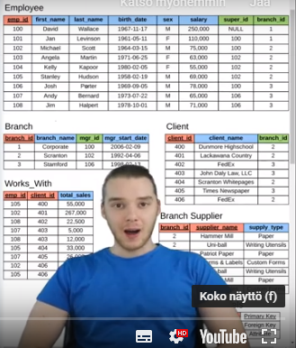

CREATE TABLE employee (

emp_id INT PRIMARY KEY,

first_name VARCHAR(40),

last_name VARCHAR(40),

birth_day DATE,

sex VARCHAR(1),

salary INT,

super_id INT,

branch_id INT

);

CREATE TABLE branch (

branch_id INT PRIMARY KEY,

branch_name VARCHAR(40),

mgr_id INT,

mgr_start_date DATE,

FOREIGN KEY(mgr_id) REFERENCES employee(emp_id) ON DELETE SET NULL

);

ALTER TABLE employee

ADD FOREIGN KEY(branch_id)

REFERENCES branch(branch_id)

ON DELETE SET NULL;

ALTER TABLE employee

ADD FOREIGN KEY(super_id)

REFERENCES employee(emp_id)

ON DELETE SET NULL;

CREATE TABLE client (

client_id INT PRIMARY KEY,

client_name VARCHAR(40),

branch_id INT,

FOREIGN KEY(branch_id) REFERENCES branch(branch_id) ON DELETE SET NULL

);

CREATE TABLE works_with (

emp_id INT,

client_id INT,

total_sales INT,

PRIMARY KEY(emp_id, client_id),

FOREIGN KEY(emp_id) REFERENCES employee(emp_id) ON DELETE CASCADE,

FOREIGN KEY(client_id) REFERENCES client(client_id) ON DELETE CASCADE

);

CREATE TABLE branch_supplier (

branch_id INT,

supplier_name VARCHAR(40),

supply_type VARCHAR(40),

PRIMARY KEY(branch_id, supplier_name),

FOREIGN KEY(branch_id) REFERENCES branch(branch_id) ON DELETE CASCADE

);

-- -----------------------------------------------------------------------------

-- Corporate

INSERT INTO employee VALUES(100, 'David', 'Wallace', '1967-11-17', 'M', 250000, NULL, NULL);

INSERT INTO branch VALUES(1, 'Corporate', 100, '2006-02-09');

UPDATE employee

SET branch_id = 1

WHERE emp_id = 100;

INSERT INTO employee VALUES(101, 'Jan', 'Levinson', '1961-05-11', 'F', 110000, 100, 1);

-- Scranton

INSERT INTO employee VALUES(102, 'Michael', 'Scott', '1964-03-15', 'M', 75000, 100, NULL);

INSERT INTO branch VALUES(2, 'Scranton', 102, '1992-04-06');

UPDATE employee

SET branch_id = 2

WHERE emp_id = 102;

INSERT INTO employee VALUES(103, 'Angela', 'Martin', '1971-06-25', 'F', 63000, 102, 2);

INSERT INTO employee VALUES(104, 'Kelly', 'Kapoor', '1980-02-05', 'F', 55000, 102, 2);

INSERT INTO employee VALUES(105, 'Stanley', 'Hudson', '1958-02-19', 'M', 69000, 102, 2);

-- Stamford

INSERT INTO employee VALUES(106, 'Josh', 'Porter', '1969-09-05', 'M', 78000, 100, NULL);

INSERT INTO branch VALUES(3, 'Stamford', 106, '1998-02-13');

UPDATE employee

SET branch_id = 3

WHERE emp_id = 106;

INSERT INTO employee VALUES(107, 'Andy', 'Bernard', '1973-07-22', 'M', 65000, 106, 3);

INSERT INTO employee VALUES(108, 'Jim', 'Halpert', '1978-10-01', 'M', 71000, 106, 3);

-- BRANCH SUPPLIER

INSERT INTO branch_supplier VALUES(2, 'Hammer Mill', 'Paper');

INSERT INTO branch_supplier VALUES(2, 'Uni-ball', 'Writing Utensils');

INSERT INTO branch_supplier VALUES(3, 'Patriot Paper', 'Paper');

INSERT INTO branch_supplier VALUES(2, 'J.T. Forms & Labels', 'Custom Forms');

INSERT INTO branch_supplier VALUES(3, 'Uni-ball', 'Writing Utensils');

INSERT INTO branch_supplier VALUES(3, 'Hammer Mill', 'Paper');

INSERT INTO branch_supplier VALUES(3, 'Stamford Lables', 'Custom Forms');

-- CLIENT

INSERT INTO client VALUES(400, 'Dunmore Highschool', 2);

INSERT INTO client VALUES(401, 'Lackawana Country', 2);

INSERT INTO client VALUES(402, 'FedEx', 3);

INSERT INTO client VALUES(403, 'John Daly Law, LLC', 3);

INSERT INTO client VALUES(404, 'Scranton Whitepages', 2);

INSERT INTO client VALUES(405, 'Times Newspaper', 3);

INSERT INTO client VALUES(406, 'FedEx', 2);

-- WORKS_WITH

INSERT INTO works_with VALUES(105, 400, 55000);

INSERT INTO works_with VALUES(102, 401, 267000);

INSERT INTO works_with VALUES(108, 402, 22500);

INSERT INTO works_with VALUES(107, 403, 5000);

INSERT INTO works_with VALUES(108, 403, 12000);

INSERT INTO works_with VALUES(105, 404, 33000);

INSERT INTO works_with VALUES(107, 405, 26000);

INSERT INTO works_with VALUES(102, 406, 15000);

INSERT INTO works_with VALUES(105, 406, 130000);



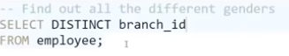

**FUNCTIONS**

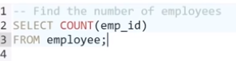9 employees all together, everyone has emp:id

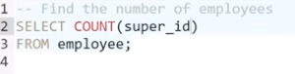8 empl. have supervisors, as for 1 super_id is null



SELECT SUM(salary)

SELECT COUNT(sex), sex FROM employee GROUP BY sex; AGGREGATION

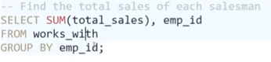

**WILDCARDS**

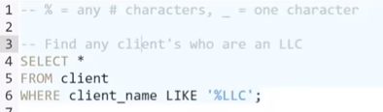

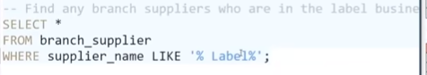

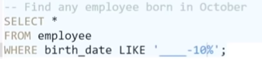4 hyphens for any year and – and 10 and for October

**UNIONS**

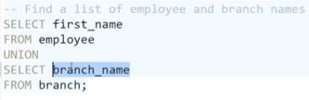gives 1 column list of all firstnames and branch names. UNION must select the same amount of columns from each table + they must have the same data type

SELECT first_name AS "Employee & Branch Names"

FROM employee

UNION

SELECT branch_name AS "Employee & Branch Names"

FROM branch;

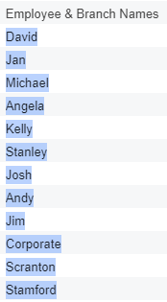

**JOINS**

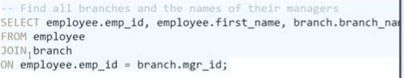 INNER JOIN gives the branches WHERE MGR_ID IS NOT NULL!!! **HOW DO I GET ALL BRANCHES WHETHER they have manager filled in or not**

This is equal to the above:

SELECT a.branch_id AS "BranchID", a.branch_name AS "Branch Name",

b.emp_id AS "Manager's EmplID", b.first_name AS "Manager's Name"

FROM branch a, employee b

WHERE a.mgr_id = b.emp_id;

LEFT JOIN gives ALL the employees

RIGHT JOIN gives ALL branches

FULL OUTER JOIN can’t be used in MySQL but it would give all employees and branches regardless whether the emp_id or mgr_id is NULL

**NESTED QUERIES**

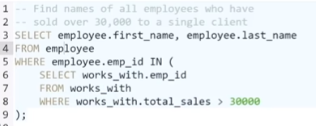

Assume you know Michael’s emp_id and find out the clients that belong to his branch (he has only 1 branch! if he can have several use IN)

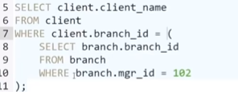

**ON DELETE**

When creating a table referencing to another “main” table think about what happens in this related table when you DELETE a record from the “main” table!

With ON DELETE SET NULL in the related table, the rows/records stay there, only the value referring to the “main” table is deleted meaning SET TO NULL. This IS COOL when the deleted value is only acting as FOREIGN KEY in this related table!

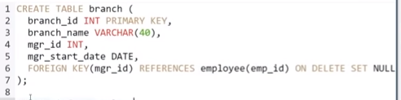

With ON DELETE CASCADE the entire rows/records are deleted from this related table. This NEEDS TO BE because the deleted value is part of the PRIMARY KEY in this related table, primary key can not be set to null!!

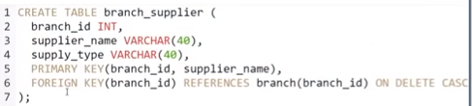

**TRIGGERS**

Can’t be done in POPSQL so we’ll go to a cmd

s1900570@BC-H8FV7S2:/var/www/html$ cd giraffe

s1900570@BC-H8FV7S2:/var/www/html/giraffe$ mysql -u root -p mysql

Enter password:

MariaDB [mysql]> use giraffe

MariaDB [giraffe]> CREATE TABLE trigger_test (

-> message VARCHAR(100)

-> );

Query OK, 0 rows affected (0.039 sec)

MariaDB [giraffe]> DELIMITER $$ *changing the delimiter from ; to $$

MariaDB [giraffe]> CREATE

-> TRIGGER my_trigger BEFORE INSERT

-> ON employee

-> FOR EACH ROW BEGIN

-> INSERT INTO trigger_test VALUES("added new employee");

-> END$$

Query OK, 0 rows affected (0.063 sec)

MariaDB [giraffe]> DELIMITER ; *changing the delimiter back to ;

MariaDB [giraffe]>

Tästä välistä hävis muistiinpanot ☹ en muista mitä kaikkea ☹

**Requirements -> ER Diagram -> Database Schema**

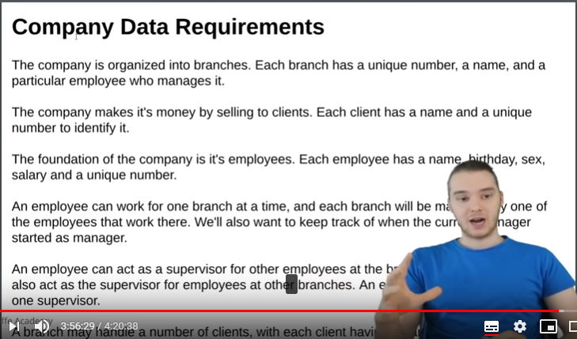

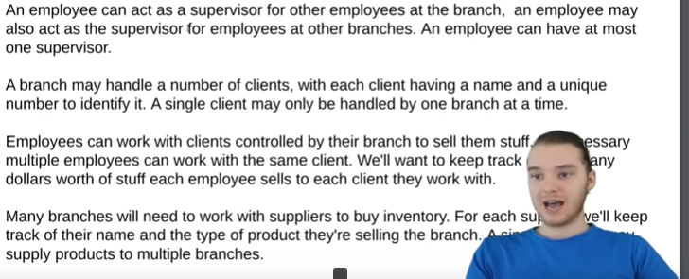

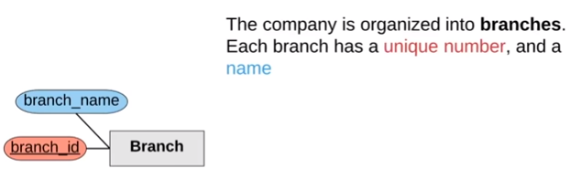

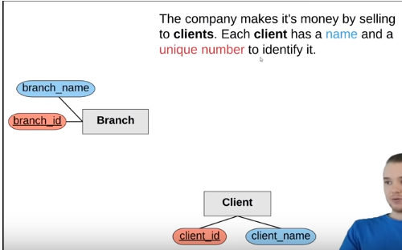

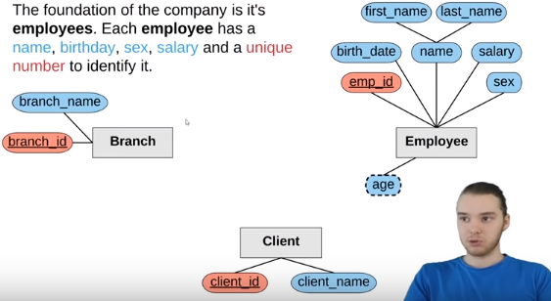

age is a DERIVED value

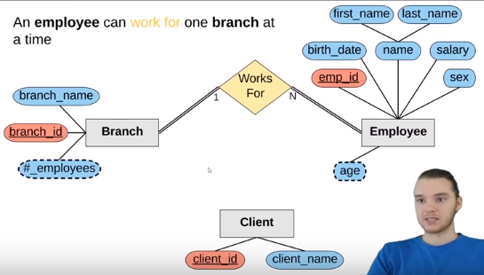

Full participation : every branch must have an employee and every employee must have a branch (double line both ways.Branch can have ANY number of employees (N), employee can work for only 1 branch (1)

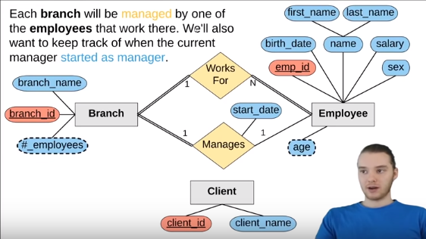

Each branch MUST be managed by an employee (full participation, double line), an employee CAN manage a branch

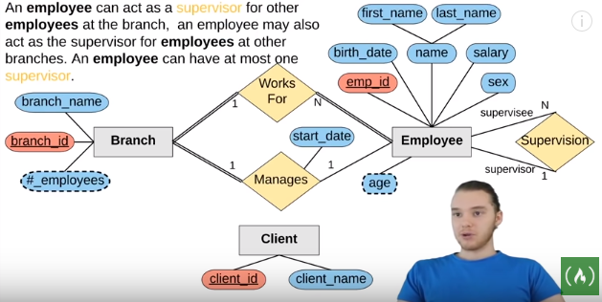

An employee can be a supervisor for another employee, an employee can be a supervisee for another employer, an employee can supervise any number of supervisees, but a supervisee can be supervised only by 1 supervisor

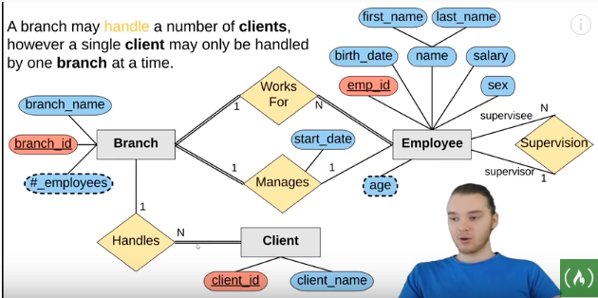

every client must be handled by a branch, every branch does not have to have clients (sisäiset palvelut), and branch can have any number of clients, client can be handled by 1 branch only

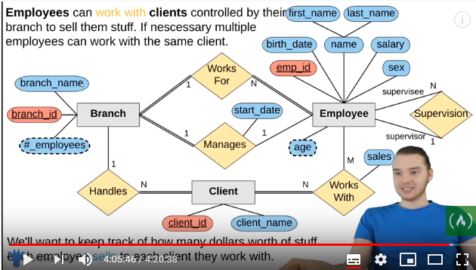

all clients must work with an employee but all employess do not have to work with clients, a client can work with any number of employees and an employee can work with any number of clients

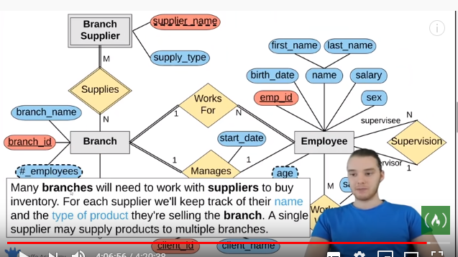

Branch Supplier – weak entity?!

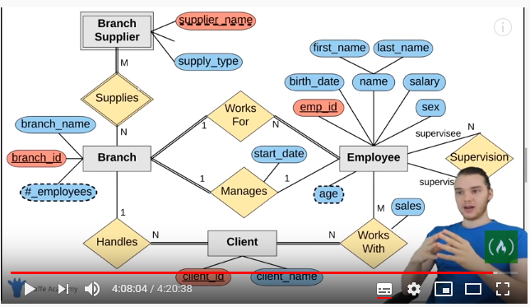

**ER Diagram -> Database Schema**

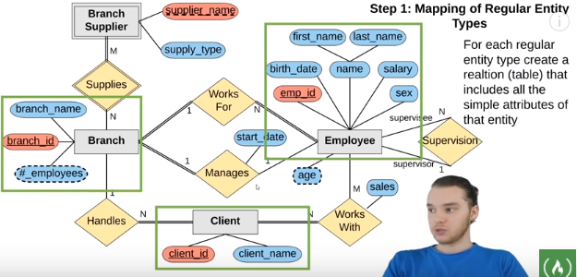

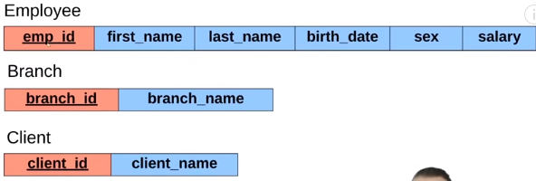

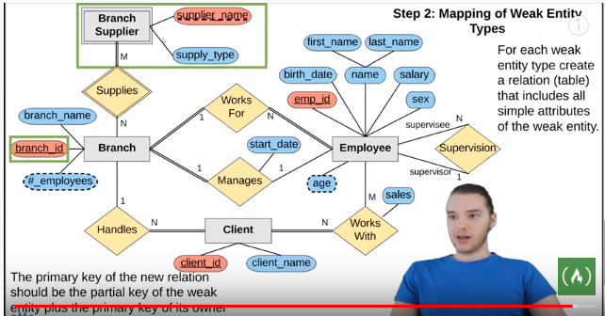

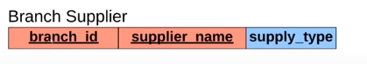

Composite key

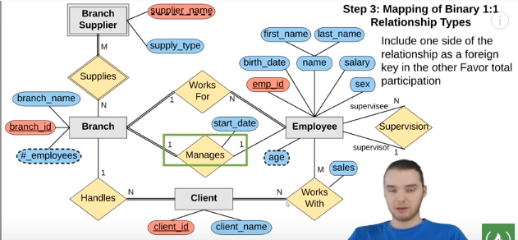

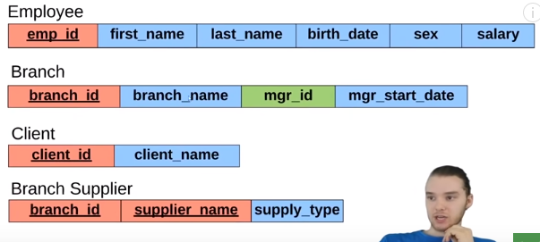

Foreign key : Branch.mgr_id = Employee.emp_id

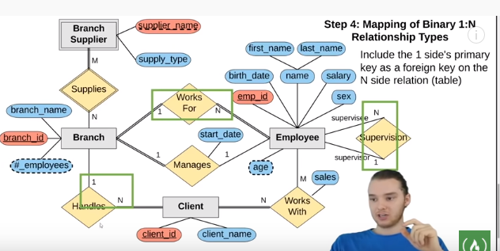

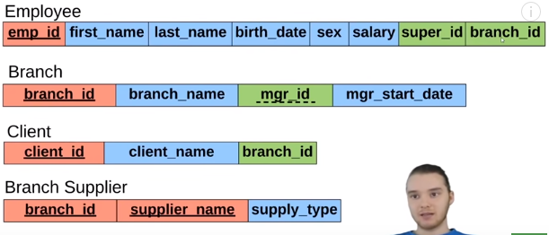

Foreign key is added to the 1 side of the relationship : employee can have only 1 Super and only 1 branch where he works. Client is handled by only 1 branch

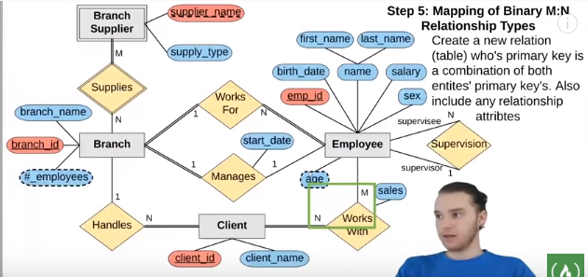

New table : Works On with compsoite key Employee.emp_id + Client.client_id

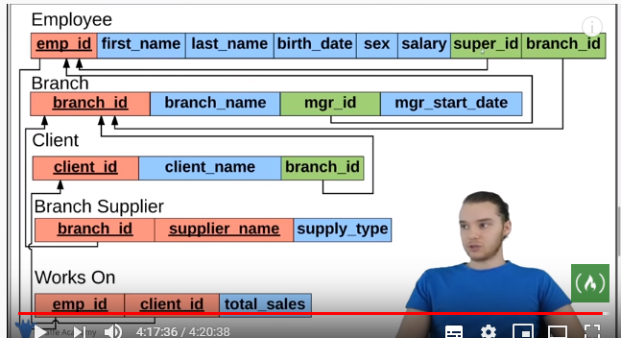

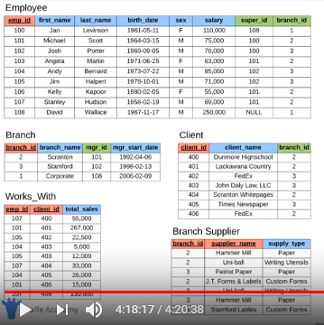

**Code for Creating the Company Database**

CREATE TABLE employee (

emp_id INT PRIMARY KEY,

first_name VARCHAR(40),

last_name VARCHAR(40),

birth_day DATE,

sex VARCHAR(1),

salary INT,

super_id INT,

branch_id INT

);

CREATE TABLE branch (

branch_id INT PRIMARY KEY,

branch_name VARCHAR(40),

mgr_id INT,

mgr_start_date DATE,

FOREIGN KEY(mgr_id) REFERENCES employee(emp_id) ON DELETE SET NULL

);

ALTER TABLE employee

ADD FOREIGN KEY(branch_id)

REFERENCES branch(branch_id)

ON DELETE SET NULL;

ALTER TABLE employee

ADD FOREIGN KEY(super_id)

REFERENCES employee(emp_id)

ON DELETE SET NULL;

CREATE TABLE client (

client_id INT PRIMARY KEY,

client_name VARCHAR(40),

branch_id INT,

FOREIGN KEY(branch_id) REFERENCES branch(branch_id) ON DELETE SET NULL

);

CREATE TABLE works_with (

emp_id INT,

client_id INT,

total_sales INT,

PRIMARY KEY(emp_id, client_id),

FOREIGN KEY(emp_id) REFERENCES employee(emp_id) ON DELETE CASCADE,

FOREIGN KEY(client_id) REFERENCES client(client_id) ON DELETE CASCADE

);

CREATE TABLE branch_supplier (

branch_id INT,

supplier_name VARCHAR(40),

supply_type VARCHAR(40),

PRIMARY KEY(branch_id, supplier_name),

FOREIGN KEY(branch_id) REFERENCES branch(branch_id) ON DELETE CASCADE

);

-- -----------------------------------------------------------------------------

-- Corporate

INSERT INTO employee VALUES(100, 'David', 'Wallace', '1967-11-17', 'M', 250000, NULL, NULL);

INSERT INTO branch VALUES(1, 'Corporate', 100, '2006-02-09');

UPDATE employee

SET branch_id = 1

WHERE emp_id = 100;

INSERT INTO employee VALUES(101, 'Jan', 'Levinson', '1961-05-11', 'F', 110000, 100, 1);

-- Scranton

INSERT INTO employee VALUES(102, 'Michael', 'Scott', '1964-03-15', 'M', 75000, 100, NULL);

INSERT INTO branch VALUES(2, 'Scranton', 102, '1992-04-06');

UPDATE employee

SET branch_id = 2

WHERE emp_id = 102;

INSERT INTO employee VALUES(103, 'Angela', 'Martin', '1971-06-25', 'F', 63000, 102, 2);

INSERT INTO employee VALUES(104, 'Kelly', 'Kapoor', '1980-02-05', 'F', 55000, 102, 2);

INSERT INTO employee VALUES(105, 'Stanley', 'Hudson', '1958-02-19', 'M', 69000, 102, 2);

-- Stamford

INSERT INTO employee VALUES(106, 'Josh', 'Porter', '1969-09-05', 'M', 78000, 100, NULL);

INSERT INTO branch VALUES(3, 'Stamford', 106, '1998-02-13');

UPDATE employee

SET branch_id = 3

WHERE emp_id = 106;

INSERT INTO employee VALUES(107, 'Andy', 'Bernard', '1973-07-22', 'M', 65000, 106, 3);

INSERT INTO employee VALUES(108, 'Jim', 'Halpert', '1978-10-01', 'M', 71000, 106, 3);

-- BRANCH SUPPLIER

INSERT INTO branch_supplier VALUES(2, 'Hammer Mill', 'Paper');

INSERT INTO branch_supplier VALUES(2, 'Uni-ball', 'Writing Utensils');

INSERT INTO branch_supplier VALUES(3, 'Patriot Paper', 'Paper');

INSERT INTO branch_supplier VALUES(2, 'J.T. Forms & Labels', 'Custom Forms');

INSERT INTO branch_supplier VALUES(3, 'Uni-ball', 'Writing Utensils');

INSERT INTO branch_supplier VALUES(3, 'Hammer Mill', 'Paper');

INSERT INTO branch_supplier VALUES(3, 'Stamford Lables', 'Custom Forms');

-- CLIENT

INSERT INTO client VALUES(400, 'Dunmore Highschool', 2);

INSERT INTO client VALUES(401, 'Lackawana Country', 2);

INSERT INTO client VALUES(402, 'FedEx', 3);

INSERT INTO client VALUES(403, 'John Daly Law, LLC', 3);

INSERT INTO client VALUES(404, 'Scranton Whitepages', 2);

INSERT INTO client VALUES(405, 'Times Newspaper', 3);

INSERT INTO client VALUES(406, 'FedEx', 2);

-- WORKS_WITH

INSERT INTO works_with VALUES(105, 400, 55000);

INSERT INTO works_with VALUES(102, 401, 267000);

INSERT INTO works_with VALUES(108, 402, 22500);

INSERT INTO works_with VALUES(107, 403, 5000);

INSERT INTO works_with VALUES(108, 403, 12000);

INSERT INTO works_with VALUES(105, 404, 33000);

INSERT INTO works_with VALUES(107, 405, 26000);

INSERT INTO works_with VALUES(102, 406, 15000);

INSERT INTO works_with VALUES(105, 406, 130000);