**Contents**

**Introduction**

Project Objectives

Project Methods

**Classroom sessions**

Introduction to radio

Introduction to data communications over radio

The Radio Receiver

What is the Raspberry Pi

**Practical Sessions**

Raspberry Pi Preparation

Downloading the operating system

Flashing an SD Card

Configuring the Raspberry Pi

Install third party PSK-31 software

**What to expect on the Centenary Day**

Direction Finding

Build the Radio receiver

Receive data signals from radio amateurs

Write a simple program in Python

**Introduction**

To celebrate 100 years of the national society for radio amateurs, the RSGB are running the Raspberry Pi Learning Project. This project aims to familiarise students with the Raspberry Pi computer and to provide an introduction to the use of radio to communicate digital signals. As part of the project, the students will use an assortment of skills including reading circuit diagrams, soldering and programming.

**Project Objectives**

* To introduce students to the principles of radio communication.
* To introduce students to the use of data communications over radio.
* To introduce students to the Raspberry Pi computer.
* To teach students the skills necessary to be able to load the operating system, configure the computer and load third party software.
* To introduce basic programming using the Python programming language.

**Project Methods**

* Classroom lessons and experiments to help understand radio propagation.
* Prepare a Raspberry Pi for use by loading an operating system onto an SD Card.
* Configure a Raspberry Pi and use it to load a third party amateur radio software package.
* Build a simple radio receiver for receiving amateur radio data signals.
* Write a small program using the Python programming language.

**Introduction to Radio**

Whilst Heinrich Hertz discovered electromagnetic waves in 1887, it was Andrew Muirhead and Sir Oliver Lodge that demonstrated the very first wireless telegraphy communication system in Oxford in 1894.

Following these early successes, it was Guglielmo Marconi in 1897 that recognised the commercial potential of radio. Marconi obtained a patent for the method that allowed telegraphy to be transmitted by radio waves.

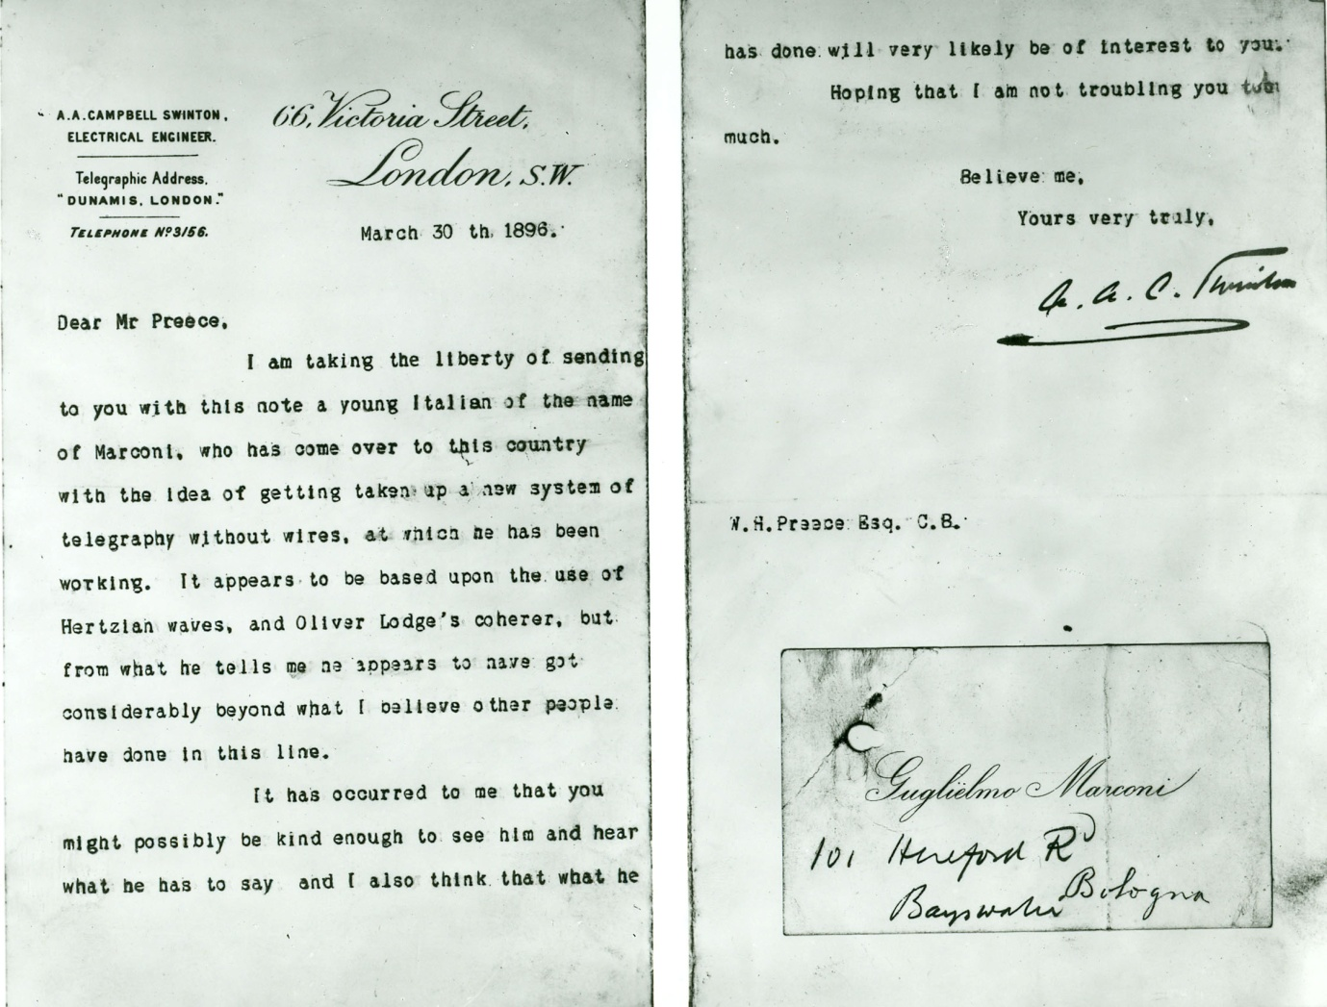

**Marconi’s Letter of Introduction**

Soon after radio had been introduced commercially, the sinking of the Titanic in 1912 proved to the world the value of this new technology. The distress signals sent from the Titanic played a significant role in saving the lives of over 700 survivors from that disaster. As a result, it is now mandatory for all large commercial vessels to carry radio equipment and to monitor emergency radio channels.

In addition to commercial use for shipping, radio was quickly recognised as an excellent entertainment medium and broadcasting stations appeared all over the country. At the same, time crystal sets became popular in the home as they provided a simple way for people to listen to entertainment broadcasts using headphones. Rapid development continued throughout the 20th century and now radio signals are all around us. In addition to being used for our satellite TV and Radio broadcasts, radio delivers our home Internet service our mobile phones and even keeps track of products in the local supermarket! Without radio, much of our current lifestyle would come to an abrupt halt!

**[Crystal set pic]**

**Radio – How does it work?**

Radio signals are electromagnetic waves much the same as light but at a lower frequency that is invisible to our eyes. The very highest frequency radio waves behave in a similar way to light. These waves travel in a straight line and tend bounce off any obstacles they encounter. This characteristic of very high frequency signals is used in modern radar systems where distant objects can be detected by the radio waves that are reflected back from the target. This is very similar to using a torch at night as our eyes detect objects using the light that is reflected back from the torch beam. In the same way that light can be formed into a beam, radio signals can also be concentrated and this can be seen in the design of satellite dishes and TV aerials.

**Radio Propagation**

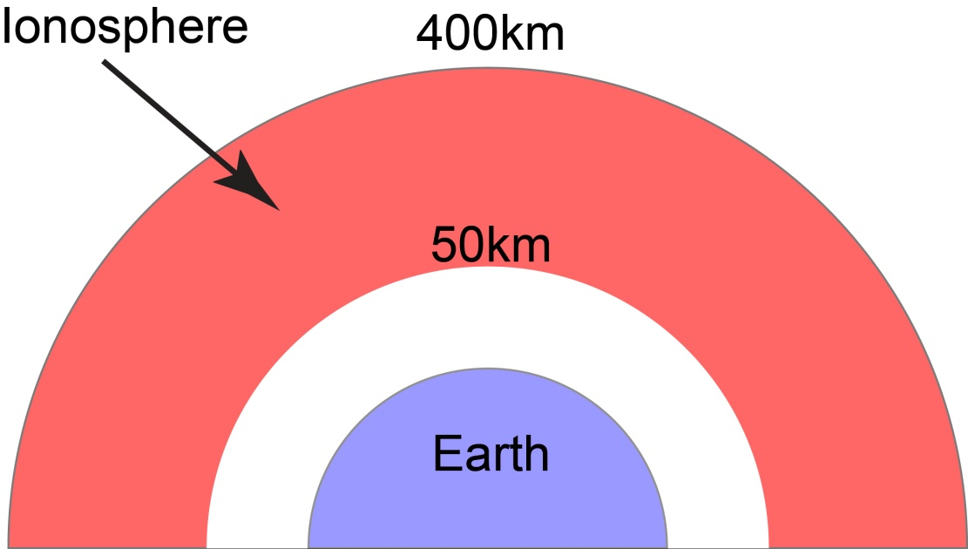All radio signals are affected by the ionised layers in the Earth’s upper atmosphere. These layers exist between about 50km and 400km above the Earth. When the mainly ultra-violet radiation from the Sun hits gas molecules in this part of the atmosphere they become ionised forming a positive ion and a negative electron. This ionisation then has an impact on any electromagnetic radio signals that reach the ionosphere.

Signals at the highest end of the radio frequency spectrum generally pass straight through the ionosphere so it is these frequencies that are employed for communications with satellites. However, at lower frequencies, radio signals can be significantly affected by the ionised layers. There are many different ionised layers above the Earth and the ionisation levels are determined primarily by the Sun’s activity. As a result, the ionisation changes from day to night but is also affected by seasons and any violent activity on the Sun’s surface such as solar flares and sun spots.

Ionisation of the upper atmosphere can cause radio signals of the appropriate frequency to be reflected back down towards Earth where, on reaching the ground, the signal can be reflected back towards the ionosphere. These reflections allow radio signals to be received all around the world. You can easily observe this effect using an ordinary medium wave radio. If you listen during the day you will only be able to receive local broadcasts from the UK. However, if you listen again in the evening, well after the sun has set, you will find that there are many more continental stations. This occurs because the Sun creates a heavily ionised layer in the atmosphere that absorbs medium wave signals. When the sun sets, this ionised layer disperses and radio signals can penetrate to the next layer in the ionosphere which is reflective to medium wave signals. The medium wave signals are therefore bounced back to Earth where they can be received over much greater distances than in daylight. When listening to medium wave signals in the evening you may notice that the signal fades. This is due to the constant changes and turbulence in the reflecting ionospheric layer that can cause the reflected signal to cancel itself out.

**Experiment 1:** To observe the effect the Sun has on the propagation of medium wave signals between 1000kHz and 1300kHz.

**Equipment:** Domestic portable radio covering the medium wave band.

**Method:** Use a medium wave radio during the day and count the number of stations you can hear between 1000kHz and 1300kHz. It would be useful but not essential to note the name of each station. Repeat the experiment in the evening after the Sun has set and it’s dark outside.

**Expected result:** There will be many more signals heard in the evening and the majority of the additional signals will be from the continent.

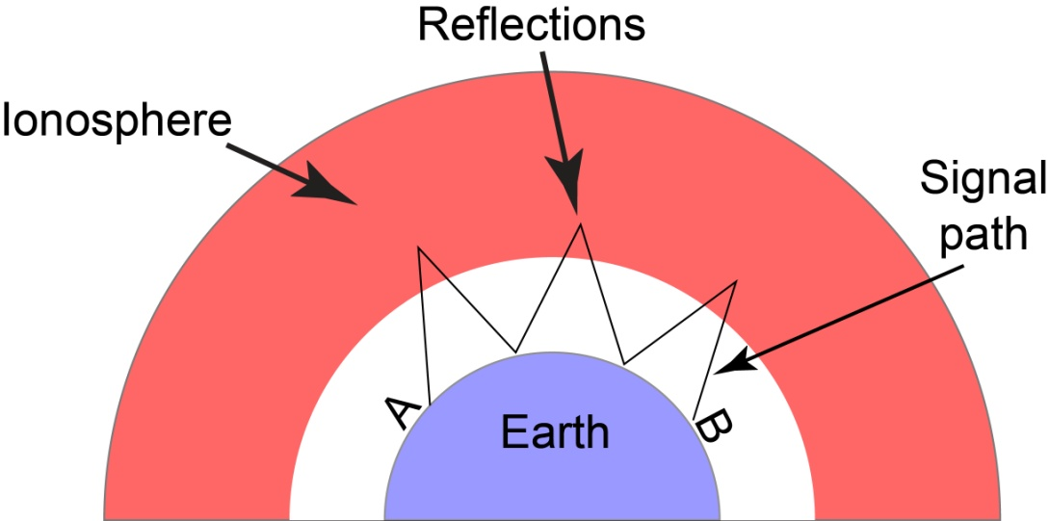At the other end of the radio spectrum, Very Low Frequency (VLF) radio signals have a tendency to cling to the surface of the Earth so will follow the Earth’s curvature to reach destinations well beyond line-of-sight. These frequencies can also penetrate water to a depth of about 40 metres and are used to communicate with submarines.

**HF radio signals often travel great distance by reflecting from the ionosphere**

The radio receiver you will build for this project will use radio signals in the High Frequency (HF) range which extends from 3MHz through to 30MHz. These signals are affected by ionospheric reflection so can be used to communicate over great distances with very low transmitter powers. However, HF propagation is affected by the time of day, season and many other factors that affect the ionised state of the upper atmosphere. As a result, the precise propagation conditions are very hard to forecast.

**Experiment 2:** To simulate the reflection of radio waves in the ionosphere and observe the impact of changing the height of the reflective layer in the ionosphere.

**Equipment:** 1 x squash ball or similar (40mm dia.), 2 planks of wood approximately 100mm wide, 12mm thick and approximately 2m long, 1m length of 50mm diameter plastic waste pipe to guide the ball.

**Method:** Arrange the planks so that they are resting on their narrow edge on a hard floor and held steady by students. The planks need to be parallel to each other and 200mm apart. Arrange the waste pipe so that it is at 45 degrees to the line of the planks and also 45 degress from horizontal. Place the squash ball at the top of the tube and release it so that the ball bounces between the two planks. Mark and measure the distance between each bounce. Repeat the experiment but with the plank separation increased to 400mm and record the bounce length.

**Expected Result:** Providing the angle of entry remains the same, the distance between each bounce will change in proportion to the plank separation. The same is true of radio wave propagation on the HF bands but here the bounce distance is known as the skip distance. As the height of the reflective layer changes, the skip distance will also change so that different receiving stations will hear the signal.

**Radio Signals and Digital Information**

While there are uses for radio waves in their pure form, we need to be able to adapt or alter the radio wave in some way so that they can carry information such as speech and data. The process of altering the pure radio signal or carrier wave as it is more commonly known is called modulation. In the early days of Marconi, the information was added to the radio signal simply by turning it on and off with a switch and using the Morse code sequence of dots and dashes. Although this was very successful, there was a need to be able to communicate human speech and other more complex signals. The first technique employed was amplitude modulation which occurs when the amplitude of carrier is varied in synchronisation with the human voice. Here’s a simple experiment to show how that works.

**Experiment 3:** To demonstrate basic modulation.

**Equipment:** Students!

**Method:** The students should make a steady Ahhhh sound whilst patting their cheeks or patting their hand across their mouth.

**Expected Result:** The Ahhh sound will change as the students pat their cheeks. This occurs because the amplitude of the sound is being changed or modulated by the action of their hands. The students could also experiment with other methods of modulating their voice, including changing the pitch or frequency.

There are three fundamental ways to modulate a radio signal and these are: 1 - change the amplitude (AM), 2 - change the frequency (FM) or 3 - change the phase (PM).

The broadcast stations we listen to for our entertainment use mainly AM on the medium wave and short wave bands but change to FM for high quality VHF broadcasts.

For this project we are going to use phase modulation because this works particularly well for communicating data signals on the frequencies we will be using for this project.

**Digital Signals**

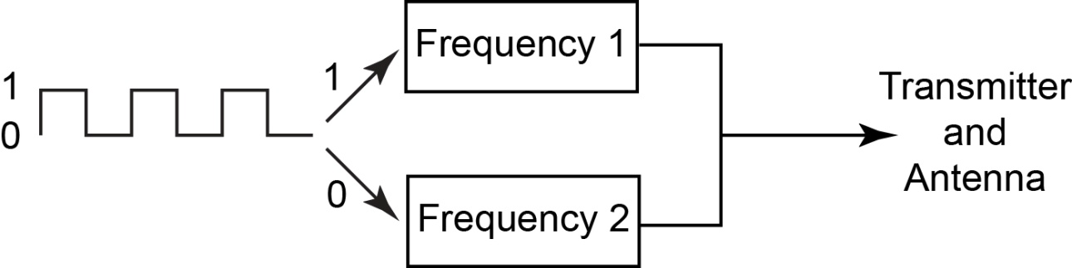Because computers only understand binary numbers, it is the 1s and 0s of the binary numbering system that we need to communicate over radio. We could do that in much the same way as Marconi did with Morse code by turning the transmitter on for a binary 1 and off for a binary 0. However, that is very unreliable because the radio frequencies are full of noise caused by all manner of domestic appliances as well as atmospheric effects. This noise makes it very difficult for the receiver to reliably detect a binary 0, i.e. no signal. A more reliable technique is to use two different states of the transmitter. In early systems, digital radio often used two closely spaced transmitting frequencies. One of these would be used for a binary 0 and the other for a binary 1. In the receiver there would be a detector that would react to the changing frequency and re-create the binary 1s and 0s.

**Illustration showing a simple digital transmitter where binary 1s and 0s use a different frequency**

For our radio project we are going to use phase modulation. Phase modulation occurs when we change the phase of the radio signal or carrier. In our project we will be employing a 180 degree phase shift. This is equivalent to reversing the connection to the aerial. The name of our digital modulation system is PSK-31 where PSK stands for Phase Shift Keying and the 31 represents the speed of the data in binary digits (bits) per second. This may sound very slow when compared with modern Broadband speeds of 10 million bits per second or more but it is plenty fast enough to carry messages that are hand typed on a keyboard.

**Radio Receivers**

If you have ever used a radio, you will know that there are thousands of stations on the air, all of which use different radio frequencies. The first task of the receiver is to include a tuning system so that it can separate the wanted station from all the rest. This can be done in many different ways but the receiver you will build employs crystal resonators for the tuning. Crystal resonators use a small piezoelectric crystal that vibrates when an electrical signal is applied. These crystals can also generate an electrical signal when they are vibrated.

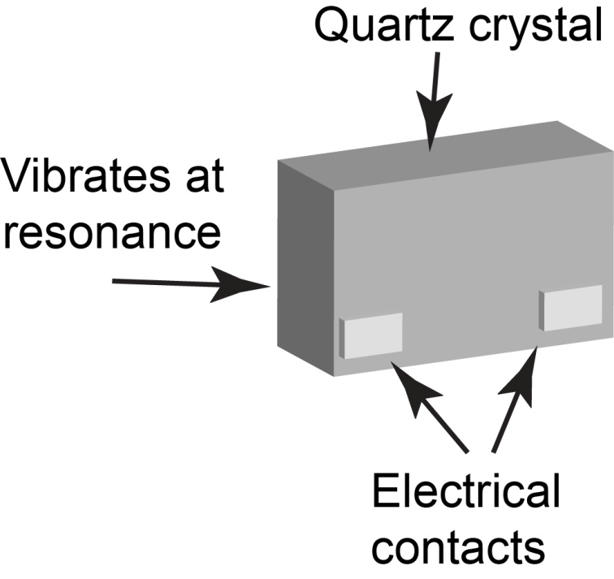

**A crystal resonator as used to tune the radio**

The resonators we are using have two electrical contacts one of which causes the crystal to vibrate whilst the other picks up the electrical signal generated by the vibration. However, these crystals have a very pronounced resonance so the vibration is always very much stronger at the resonant frequency. You can think of resonance rather like a church bell. It is the resonance of the cast iron bell that forces it to chime the same note regardless of how hard you hit it. The same effect happens in our crystal as it is cut to resonate at a specific radio frequency. In our design the incoming radio signals have to pass through two of these crystals. Any incoming signals that are at the same frequency as the crystals will cause them to resonate and so produce the greatest output. As a result, the crystals pass the wanted frequency but reject the rest and we call this combination a crystal filter.

The next requirement of the receiver is to extract the modulation from the signal. There are many different ways to do this but in your receiver we will be using a technique called direct conversion. If you think back to experiment 3 with the Ahhhh sound, we want to get rid of the Ahhh but keep the modulation. To use the correct terms the Ahhh was the carrier and the patting of the cheeks the modulation. In a direct conversion design we generate a separate (un-modulated) carrier at the same frequency as the one we want to demodulate using another crystal. We then connect the incoming signal and our new carrier to a device a called a mixer. The mixer does what it says and mixes the two signals together and produces the sum and the difference between the signals. The sum is no use to us but the difference is the modulation which is exactly what we want. At this point the recovered modulation is too weak to be useful so we connect it to a powerful amplifier.

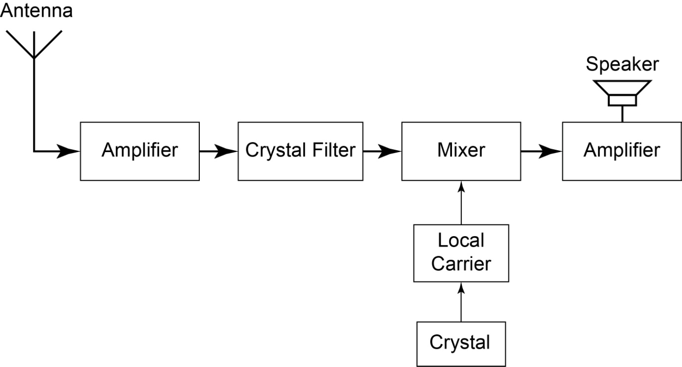

**Block diagram of the receiver**

**What is the Raspberry Pi?**

The Raspberry Pi is a credit-card sized computer that plugs into your TV and a keyboard. It’s a capable little PC which can be used for many of the things that your desktop PC does, like spreadsheets, word-processing and games. It also plays high-definition video. It is designed to be used by kids all over the world to learn programming.

The Raspberry Pi uses the Linux operating system and a cheap SD Card in place of the larger and more expensive hard drives used by PCs and MACs. This makes it very easy to change the operating system or even start again if you get in a muddle.

The first task is to download the operating system from the Internet and burn it onto a SD card. Here’s how to do that:

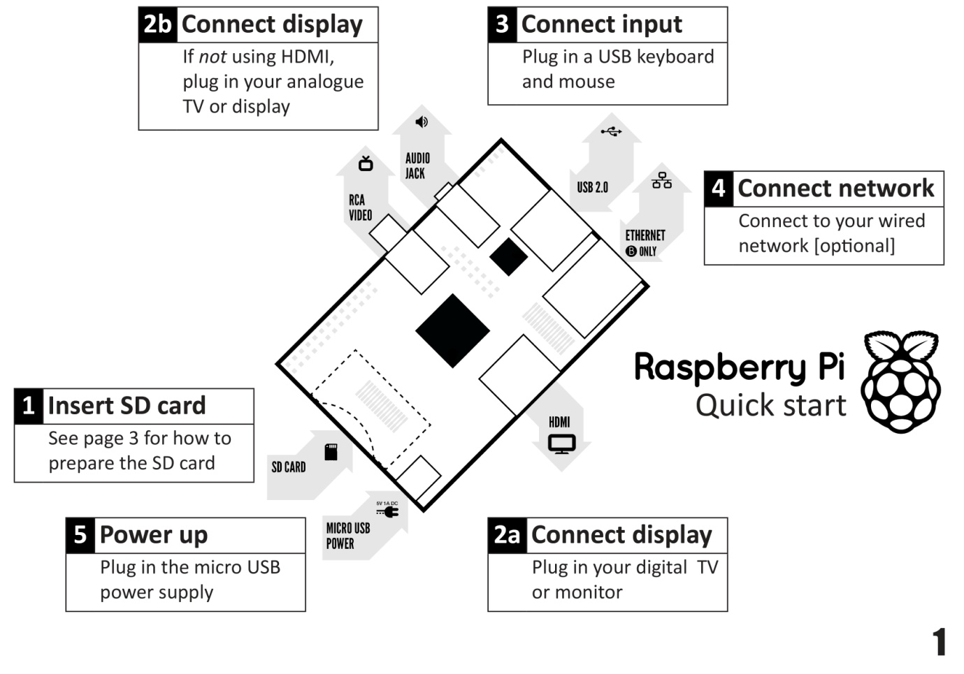**Layout of the Raspberry Pi**

**Task 1: Download Raspberry Pi operating system and install it on an SD Card.**

**Equipment:** PC connected to the Internet, 4GB or larger SD card. SD card reader, Win32 Disk Imager installed on the PC. The imager is available free of charge from:<http://sourceforge.net/projects/win32diskimager/>

**Method:**

1. Open the web browser on the PC and navigate to: <http://www.raspberrypi.org/downloads> and select the Direct download of Rasbian “wheezy”. Save this file to the hard drive and unzip it to a folder of your choice.
2. On the PC run Win32 Disk Imager. Insert the card reader with the SD card plugged in. Navigate to and select the unzipped Raspian “wheezy” image file you downloaded in 1. Click the Write button to transfer the image to the SD Card. The transfer takes about 3 minutes. When complete, you can remove the SD Card and exit Win32 Disk Imager. You now have an SD card that’s ready for use with the Raspberry Pi.
3. To avoid excessive Internet downloads the downloaded “wheezy” file can be used to prepare all the SD cards.

With the SD card loaded, the next step is to connect up the Raspberry Pi and get it working. Here’s how you do that:

**[PC Screenshot showing SD Card setup]**

**Task 2: Starting and configuring the Raspberry Pi.**

**Equipment:** Raspberry Pi model A or B, SD card with operating system as created in Task 1. HDMI monitor or RGB monitor with adapter, USB keyboard, USB mouse, Raspberry Pi Power supply.

**Method:**

1. Insert the programmed SD card into the Raspberry Pi and connect the monitor, keyboard/mouse and finally the power supply.
2. The Raspberry Pi will automatically start and you will see an assortment of text messages appearing on the screen.
3. After a successful boot, you will see the configuration screen as shown in Fig.xxx
4. Use the **arrow** keys on the keyboard to move the cursor to expand_rootfs and press **Enter**. Press **Enter** when you see the next prompt.
5. When you return to the Configuration screen, use the **Tab key** to move the highlight to **<Finish>** and press **Enter**. Select **Yes** and press **Enter** when asked if you would like to reboot now.
6. The reboot will take approximately 30 seconds and when finished you will see the login prompt at the bottom of the screen that will say: **login as:** Type **pi** and press **Enter** you will then be asked for the password. **NB:** you will not be able to see the password as you type. Type **raspberry** and press **Enter**.
7. Type **startx** to start the graphic user interface (GUI).

**[Raspberry Pi configuration Screen pic]**

On completion of tasks 1 and 2 you will have a fully configured Raspberry Pi that you can use to start programming!

**NB:** The following tasks are only necessary if the students have internet access on their Raspberry Pis and intend to install the PSK-31 decoding software.

Tasks 3 and 4 show you how to download and install the PSK-31 decoding package and add an extra USB soundcard.

**Task 3: Preparing and installing amateur radio software FLDIGI**.

1. Following successful logon and prior to typing startx the following tasks need to be undertaken.
2. Type **sudo apt-get update** and answer **yes** to any prompts and press **Enter**.
3. Type **sudo apt-get install fldigi** and press **Enter .** Answer **Yes** to any prompts.
4. Type **sudo raspi-config**.
5. Use the **arrow** key to highlight **overclock** and press **Enter**. Press **Enter** in response to the OK prompt.
6. On the overclock preset screen, use the **arrow** keys to highlight Turbo and then use the **Tab** key to highlight **OK** and press **Enter.**
7. Press **Enter** to accept the SD card corruption warning and press **Enter** again at the next prompt.
8. You should now see the Raspi-config screen again. Use the **Tab** key to highlight **<Finish>** and press **Enter.**
9. Select **Yes** to reboot and press **Enter**.
10. Logon and type startx.
11. That completes the amateur radio software installation.

In addition to the amateur radio software a USB soundcard is required to be able to feed the output of the receiver into the Raspberry Pi. Here are the instructions for connecting the soundcard and checking that it has been installed properly.

**Task 4: Connecting and testing the USB soundcard.**

**Equipment required:** Daffodil US-01 USB soundcard, powered USB hub.

1. With the Raspberry Pi shut down, remove the mouse from the Raspberry Pi USB socket and insert it into one of the USB ports on the powered hub.
2. Insert the Daffodi USB soundcard into a spare port on the hub.
3. Make sure the USB hub is powered up.
4. Start the Raspberry Pi and log in.
5. Before typing startx type **lsusb** and press **Enter.**
6. This will present a list of USB devices on the screen and you should be able to see **C-Media Electronics, Inc. Audio Adapter** in the list.
7. If the card is not shown in the list double-check your connections and restart the Raspberry Pi.