Министерство образования и науки Российской Федерации
САНКТ-ПЕТЕРБУРГСКИЙ НАЦИОНАЛЬНЫЙ ИССЛЕДОВАТЕЛЬСКИЙ УНИВЕРСИТЕТ ИНФОРМАЦИОННЫХ ТЕХНОЛОГИЙ,
МЕХАНИКИ И ОПТИКИ

Факультет информационных технологий и программирования
Кафедра информационных систем
Дисциплина «Инструментальные средства разработки программного обеспечения»

ОТЧЁТ
по лабораторной работе № 1

Студент Георгиев Петър Димитров
группы M3308

Санкт-Петербург 2019 г.

1. Install VS Code



2.Compile code - Python

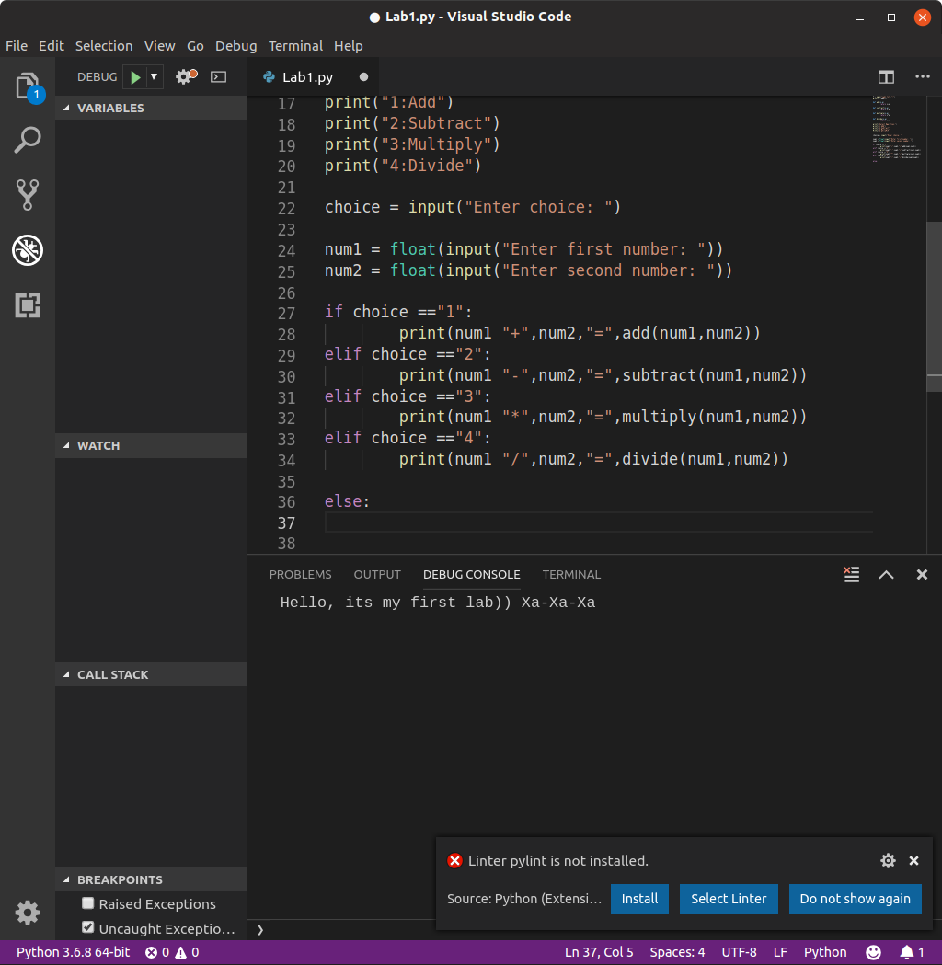
3.Fira Code

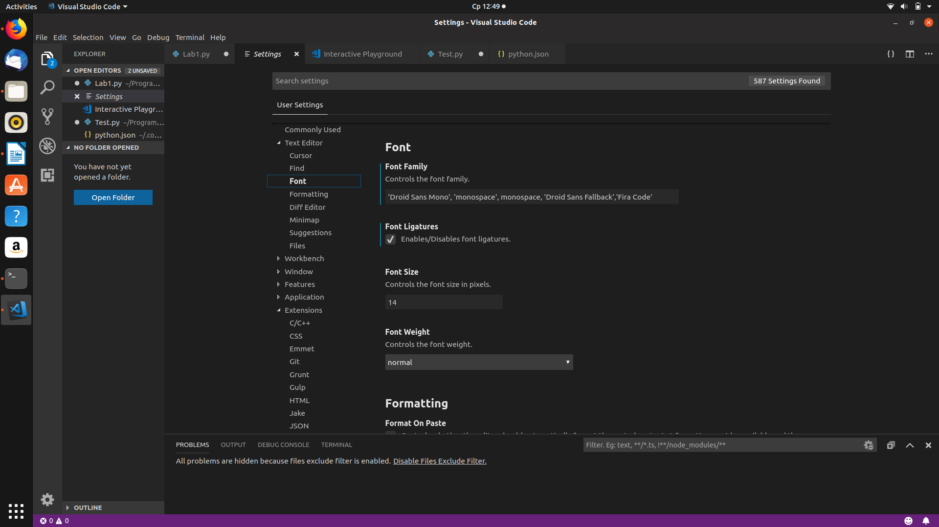

4.Calculator

import math

class Calculator:
def __init__(self, x, y):
self.x = x
self.y = y
def Add():
num1 = int(input("Enter first number:"))
num2 = int(input("Enter second number:"))
return num1 + num2

def Subtract():
num1 = int(input("Enter first number:"))
num2 = int(input("Enter second number:"))
return num1 - num2

def Multiply():
num1 = int(input("Enter first number:"))
num2 = int(input("Enter second number:"))
return num1 * num2

def Divide():
num1 = int(input("Enter first number:"))
num2 = int(input("Enter second number:"))
return num1 / num2

def Modulo():
num1 = int(input("Enter first number:"))
num2 = int(input("Enter second number:"))
return num1 % num2

class Engineering_calculator(Calculator):
def Log():
num1 = int(input("Enter first number:"))
num2 = int(input("Enter second number:"))
return math.log(num1,num2)

def Sqrt():
num1 = int(input("Enter number:"))
return math.sqrt(num1)

def Pow():
num1 = int(input("Enter first number:"))
num2 = int(input("Enter power:"))
return math.pow(num1,num2)

class Programmer_calculator(Calculator):
def LogicalAND():
num1 = int(input("Enter first number:"))
num2 = int(input("Enter second number:"))
return num1 and num2

def LogicalOR():
num1 = int(input("Enter first number:"))
num2 = int(input("Enter second number:"))
return num1 or num2

print("1.Calculator")
print("2.Engineering calculator")
print("3.Proggrammer calculator")
a = int(input("Choose calculator:"))

if a == 1:
print("Select operation:")
print("1:Add")
print("2:Subtract")
print("3:Multiply")
print("4:Divide")
print("5:Modulo")
if a == 2:
print("6:Log")
print("7:Squere")
print("8:Power")
if a == 3:
print("9:Logical AND")
print("10:Logical OR")

choice = int(input("Choose operation:"))
if choice == 1:
print(Calculator.Add())
elif choice == 2:
print(Calculator.Subtract())
elif choice == 3:
print(Calculator.Multiply())
elif choice == 4:
print(Calculator.Divide())
elif choice == 5:
print(Calculator.Modulo())
elif choice == 6:
print(Engineering_calculator.Log())
elif choice == 7:
print(Engineering_calculator.Sqrt())
elif choice == 8:
print(Engineering_calculator.Pow())
elif choice == 9:
print(Programmer_calculator.LogicalAND())
elif choice == 10:
print(Programmer_calculator.LogicalOR())
else:
print("Invalid input")

5.Tests

import unittest
import Lab1

class Test_TestAddSubtract(unittest.TestCase):
def test_add(self):
self.assertTrue(Lab1.Calculator.Add())

def test_subtract(self):
self.assertEqual(Lab1.Calculator.Subtract(),0)

def test_multiply(self):
self.assertTrue(Lab1.Calculator.Multiply())

if __name__ == '__main__':
unittest.main()

6. VS Code CLI

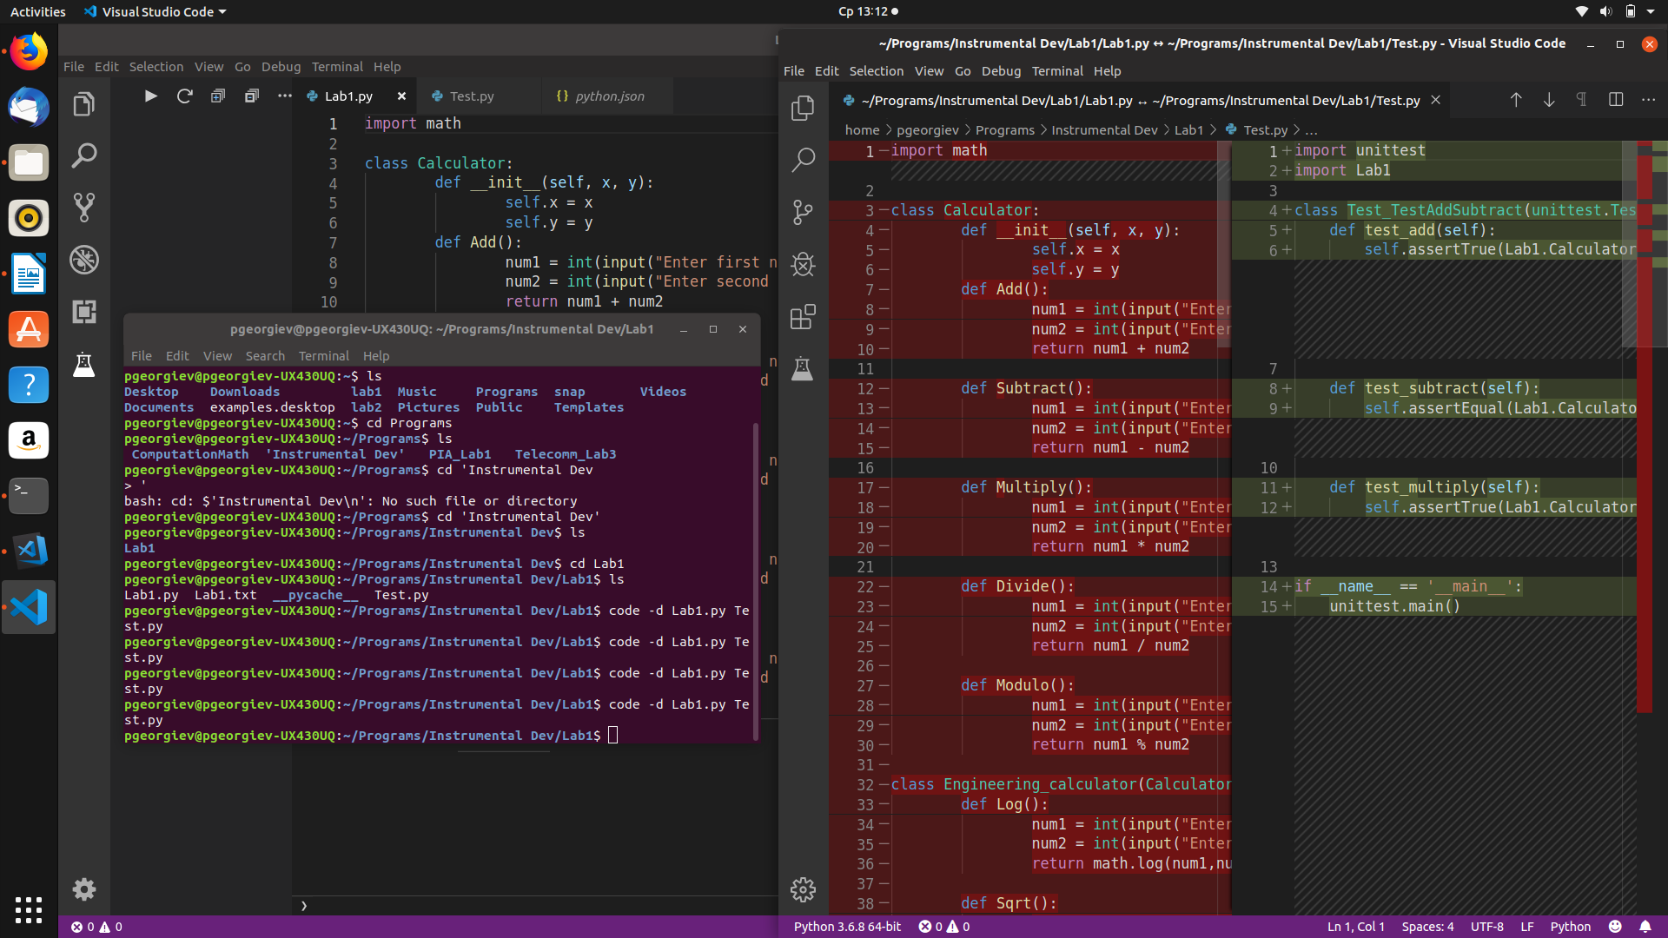
7.Snippets

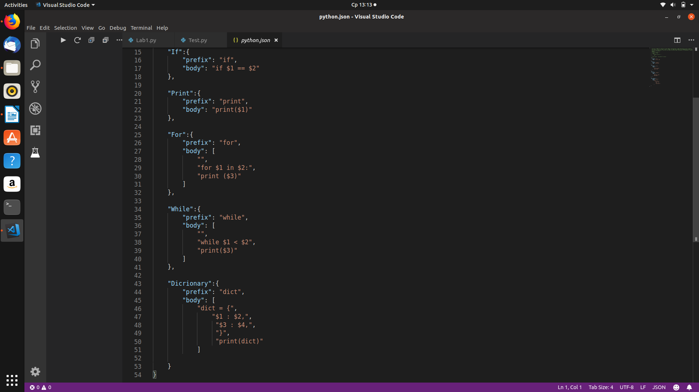

8.Hot keys

* F5 – Start debugging/Continue
* Ctrl + F5 – Start without debugging
* Ctrl + Shift + P – Command Palette
* Ctrl + P – Quickly open files
* Ctrl + Shift + M – Status Bar
* Ctrl + ` - Integrated Terminal
* Ctrl + K Z – Zen Mode
* Ctrl + \ - Side by side editing
* Ctrl + W – Close currently opened folder
* Alt+Up or Alt+Down – Move line up and down

9. autoDocstring Installed

