## Project name: ToDo App

## Team name: Group 3

## Team members [names]:

1. Бояна Максимова
2. Петър Таушанов
3. Силвиян Мартинов

## Link to the repositories [one or more]: <https://github.com/ptaushanov/todos>

## Used technologies:

1. Java
2. Swing
3. MySQL
4. MySQL JDBC driver

## Basic description of the project [purpose of the project]:

A basic app for tracking tasks of individual users.  
Tasks can be created, updated, and deleted.  
Tasks can expire or persist.

## Basic architecture of the project [details about different]:

The connection between the two tables is one to many, one user can have many tasks.  
Table user consists of: id, email, password.  
Table task consists of: id, user_id, subject, content, priority and due_date.

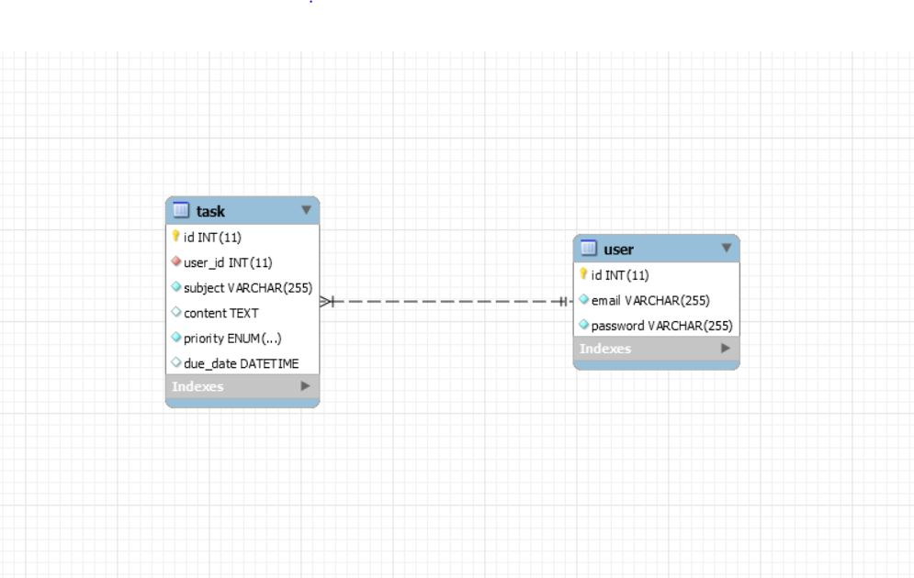

## Link to the database script:

<https://github.com/ptaushanov/todos/blob/development/setup/mysql/setup.sql>  
 + maybe a bash configuration script

## Link to the readme file:

<https://github.com/ptaushanov/todos/blob/development/README.md>

## Features: [describe different functionalities implemented in the project]:

* Login and register form for users
* Main Window after the user has logged in successfully. It has :
  + Panel for displaying all added tasks by the user. Tasks in the panel have:
    - Title
    - Importance (ASAP, Very High, High, Low, Verry Low)
  + Button for refreshing the list of tasks
  + Button for adding new tasks
  + Button for updating the currently selected task
  + Button for deleting the currently selected task
* Form for creating / updating tasks. It has:
  + Title text field
  + Description text area
  + Importance combo box
  + Add due date checkbox
  + Text fields for day, year, month, day, hour, and minute
  + Button for creating / updating the task
* Window for viewing more information about the selected task