

Project Report

Multi-Agent AI Career Assistance System

Course: ALY 6980 - Capstone

Date: December 1, 2025
Instructor: Prof. Hema Seshadri
Semester: Fall 2025

Team Members:
Krati Mudra
Pratham Brahmbhatt
Ansh Jain
Sangayya Rudrayya Hiremath
Zhiwen Sun
Zhuofan Lin

TABLE OF CONTENTS

1. Introduction 3
1.1 Project Overview 3
1.2 Purpose of the System 3
1.3 Relevance and Importance in Current Job Market 3
2. Project Background & Problem Space 4
2.1 Challenges Faced by Job Seekers 4
2.2 Limitations of Traditional Resume & Interview Preparation 4
2.3 Why Automation and AI is Needed 4
3. Project Vision & Objectives 5
3.1 Main Goal of the Project 5
3.2 Specific Objectives 5
3.3 Scope of Work Completed 5
4. System Concept & Approach 6
4.1 Overview of Multi-Agent Workflow 6
4.2 How the System Works (Simple Flow Explanation) 6
4.3 Data Flow or Pipeline Description 6
5. Core Components of the System 8
5.1 Resume Analysis & Text Extraction 8
5.2 Job Role Prediction & Job Fetching 8
5.3 Resume Tailoring for Selected Job 8
5.4 Interview Preparation & Guidance 8
5.5 Portfolio Project Recommendation 8
6. Implementation Summary 10
6.1 Tools, Tech Stack & Libraries Used 10
6.2 Steps Followed During Development 10
6.3 Current Status of Prototype 10
6.4 Sample Output Screenshots 11
7. Team Collaboration & Contributions 12
7.1 Role Distribution 12
7.2 Contribution Table 12
7.3 Tools Used for Communication and Coordination 12
8. Challenges and Learnings 13
8.1 Technical Challenges 13
8.2 Group Collaboration Challenges 13
8.3 Key Learnings and Improvements 13
9. Expected Outcomes & Impact 14
9.1 How This Project Can Help Real Users 14
9.2 Value Proposition of the System 14
9.3 Success Indicators 14
10. Future Enhancements 15
10.1 Planned Features 15
10.2 Long-Term Improvement Ideas 15
10.3 Deployment & Scaling Potential 15
11. Conclusion 16
11.1 Summary of Work Done 16
11.2 Importance of the Project 16
11.3 Final Remarks 16
12. References 17

1. Introduction

1.1 Project Overview
Our project focuses on building an AI-based multi-agent career system that helps users move from a basic resume upload to a complete job readiness output. The system reads the resume, understands the user's background, predicts a relevant job role, finds matching job openings, tailors the resume to the job description, generates interview questions, and even suggests project ideas to strengthen the candidate’s profile. The aim is to support job seekers with an automated and intelligent workflow that reduces manual effort and increases the chances of getting shortlisted.

1.2 Purpose of the System
Many students and professionals struggle with job searching, resume tailoring, and interview preparation. It is time-consuming and often confusing to adjust resumes for every job. Our system is designed to solve this problem by using AI to automate key stages of the job application journey. We created this solution to make job preparation faster, structured, and more personalized for every user.

1.3 Relevance and Importance in Current Job Market
In today’s competitive market, companies expect personalized resumes aligned with job descriptions. AI systems are being used widely for healthcare, finance, automation, and personalization tasks, and research shows that AI-driven systems improve efficiency and accuracy in decision processes (Wang et al., 2021). The same idea can be applied to career preparation. By combining recommendation logic (Aggarwal, 2016), natural language processing for resume understanding (Gao et al., 2020), and privacy-safe design principles (Price & Cohen, 2019), our solution becomes not just useful but necessary for modern job seekers.

2. Project Background & Problem Space

2.1 Challenges Faced by Job Seekers
Job searching has become a highly competitive process. Even skilled candidates struggle to get interviews because their resumes are not aligned with job descriptions. Many applicants apply to hundreds of positions with the same resume, which reduces their chances of being shortlisted. It is also difficult for beginners to understand which roles match their skills, how to prepare for interviews, and what projects they should build to stand out. As a result, the journey from resume to employment often becomes slow, confusing, and stressful.

2.2 Limitations of Traditional Resume & Interview Preparation
Traditional career preparation is mostly manual. Candidates search for jobs on multiple websites, copy job details, update resumes one by one, and then try to read interview questions from random sources. This process takes time, lacks structure, and can lead to low-quality applications. Without proper guidance, candidates may fail to highlight relevant skills, which lowers selection chances. Research shows that AI and recommendation systems can personalize information better than manual processes (Aggarwal, 2016), meaning automation can improve outcomes in job preparation.

2.3 Why Automation and AI is Needed
Automating resume analysis, job matching, interview preparation, and project guidance can reduce effort and increase efficiency. With Natural Language Processing, systems can understand resumes and extract important details (Gao et al., 2020). AI personalization can help users receive job recommendations that fit their experience and skills (Wang et al., 2021). At the same time, privacy and responsible data handling must be maintained to build trust (Price & Cohen, 2019). This creates a strong need for an AI-powered system like ours that guides job seekers end-to-end and supports them in becoming job-ready with less effort.

3. Project Vision & Objectives

3.1 Main Goal of the Project
The main goal of this project is to create an AI-powered multi-agent career assistant that simplifies the job preparation process for users. Instead of manually searching for jobs, editing resumes repeatedly, and preparing for interviews separately, our system helps users complete all these steps in one streamlined workflow. The idea is to make job readiness faster, easier, and more personalized using automation and intelligent decision-making.

3.2 Specific Objectives
Our project is built around a few clear objectives. The first objective is to extract important information from user resumes and understand the type of roles they fit. The second objective is to match them with relevant job openings by using online job search integration. The third objective is to tailor the resume automatically for a chosen job description so that it meets ATS and recruiter expectations. The fourth objective is to generate interview questions and preparation material based on the job role. The final objective is to suggest project ideas to help users improve their portfolio and increase the chances of getting hired.

3.3 Scope of Work Completed
In the current phase of the project, we have established the concept, workflow, and system design. We developed the multi-agent flow that begins with resume upload and moves towards job matching, resume tailoring, interview preparation, and project recommendations. The resume analyzer and job finder modules are defined, the process flow is mapped, and our team has prepared the presentation and planning structure required for implementation. We have also researched related technologies, NLP methods, recommendation models, and data privacy principles to guide our design decisions (Aggarwal, 2016; Gao et al., 2020; Wang et al., 2021; Price & Cohen, 2019). This forms a strong foundation for future development and implementation.

4. System Concept & Approach

4.1 Overview of Multi-Agent Workflow
Our system is designed as a multi-agent model where each agent performs a specific task in the career preparation journey. The process begins when the user uploads their resume. The system reads the resume, extracts skills and experience using Natural Language Processing, predicts the most suitable job role, searches for matching job openings, tailors the resume for a selected job, generates interview preparation material, and finishes by suggesting project ideas. Each agent completes one step and then passes information to the next, making the flow continuous and automated.

4.2 How the System Works (Simple Flow Explanation)
The working logic is straightforward. First, the resume analyser identifies skills, education, experience, and keywords. Next, a job prediction agent determines which job role matches the resume. After that, the job finder agent fetches real job postings. When users select a specific job, the resume tailoring agent rewrites the resume based on job requirements, using keywords and points that recruiters look for. The interview preparation agent creates relevant questions with guidance on how to answer them. Finally, the project mentor agent recommends portfolio project ideas aligned with the chosen role. This step-by-step flow ensures users receive everything needed to apply confidently.

4.3 Data Flow or Pipeline Description
The data flow can be viewed as a pipeline that turns one input into many helpful outcomes. The resume is the input. The system extracts and processes the data, then transfers it between modules like a chain. The output at the end is a complete job-ready package including job listings, a tailored resume, interview questions, and project ideas. This pipeline design creates an efficient workflow and reduces repeated manual efforts. Research supports that structured pipeline automation improves personalization accuracy and system performance (Gao et al., 2020; Wang et al., 2021). Our design follows the same principle and builds it into a career-based solution.

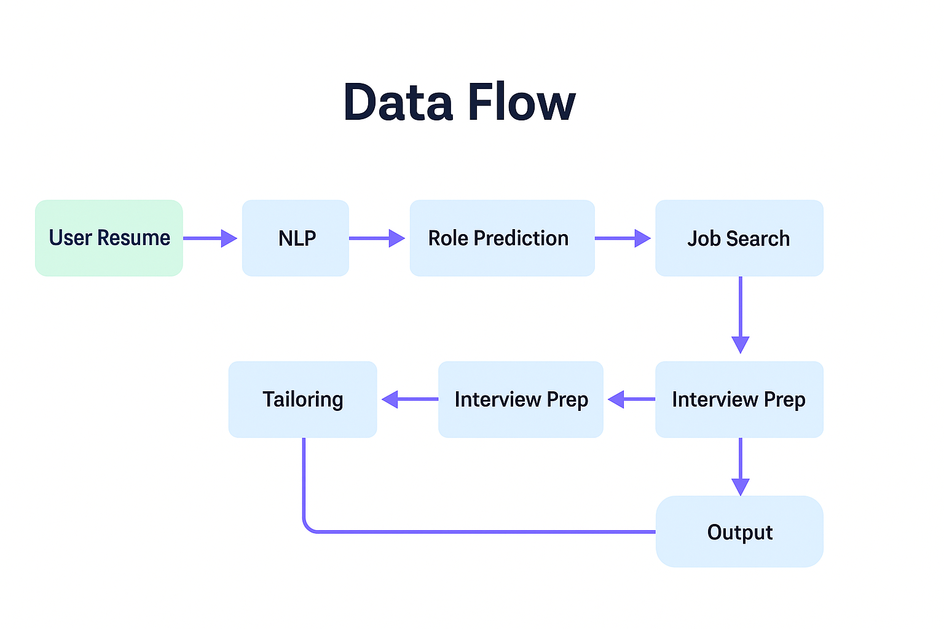

5. Core Components of the System

5.1 Resume Analysis & Text Extraction
The first component focuses on reading the uploaded resume and converting it into machine-understandable text. Natural Language Processing techniques are used to identify key information such as skills, education, job titles, projects, and experience. This step helps the system understand who the user is and what opportunities they are suitable for. NLP models allow the system to process different resume formats and extract meaning beyond simple keywords (Gao et al., 2020).

5.2 Job Role Prediction & Job Fetching
Once the resume data is processed, the next component predicts the most likely job role for the user. This prediction is based on skills, experience, and field of work. After identifying the role, the system gathers real job listings from the internet. Instead of searching manually on different platforms, the user receives job options instantly. Recommendation theory supports that matching features with role requirements improves accuracy in suggestions (Aggarwal, 2016).

5.3 Resume Tailoring for Selected Job
Many job applications are rejected because candidates send one generic resume everywhere. This module solves that problem. When a user selects a job posting, the system tailors the resume based on the job description. It highlights relevant skills, rewrites points in a strong format, and ensures keyword alignment for better ATS ranking. This feature helps users stand out and saves time during preparation.

5.4 Interview Preparation & Guidance
After tailoring the resume, the next step is interview readiness. The interview agent generates expected interview questions based on the selected role, including both technical and behavioural questions. It also helps users understand how to structure answers and provides preparation tips. This prepares candidates more confidently for actual interviews and reduces guesswork in preparation.

5.5 Portfolio Project Recommendation
The final system component gives users personalized project ideas that match their role and skill profile. These project suggestions are important because employers value practical work. Completing relevant projects improves the resume, adds GitHub proof, and increases hiring chances. As AI personalization improves user support and decision-making (Wang et al., 2021), this component becomes a valuable guide for long-term career growth.

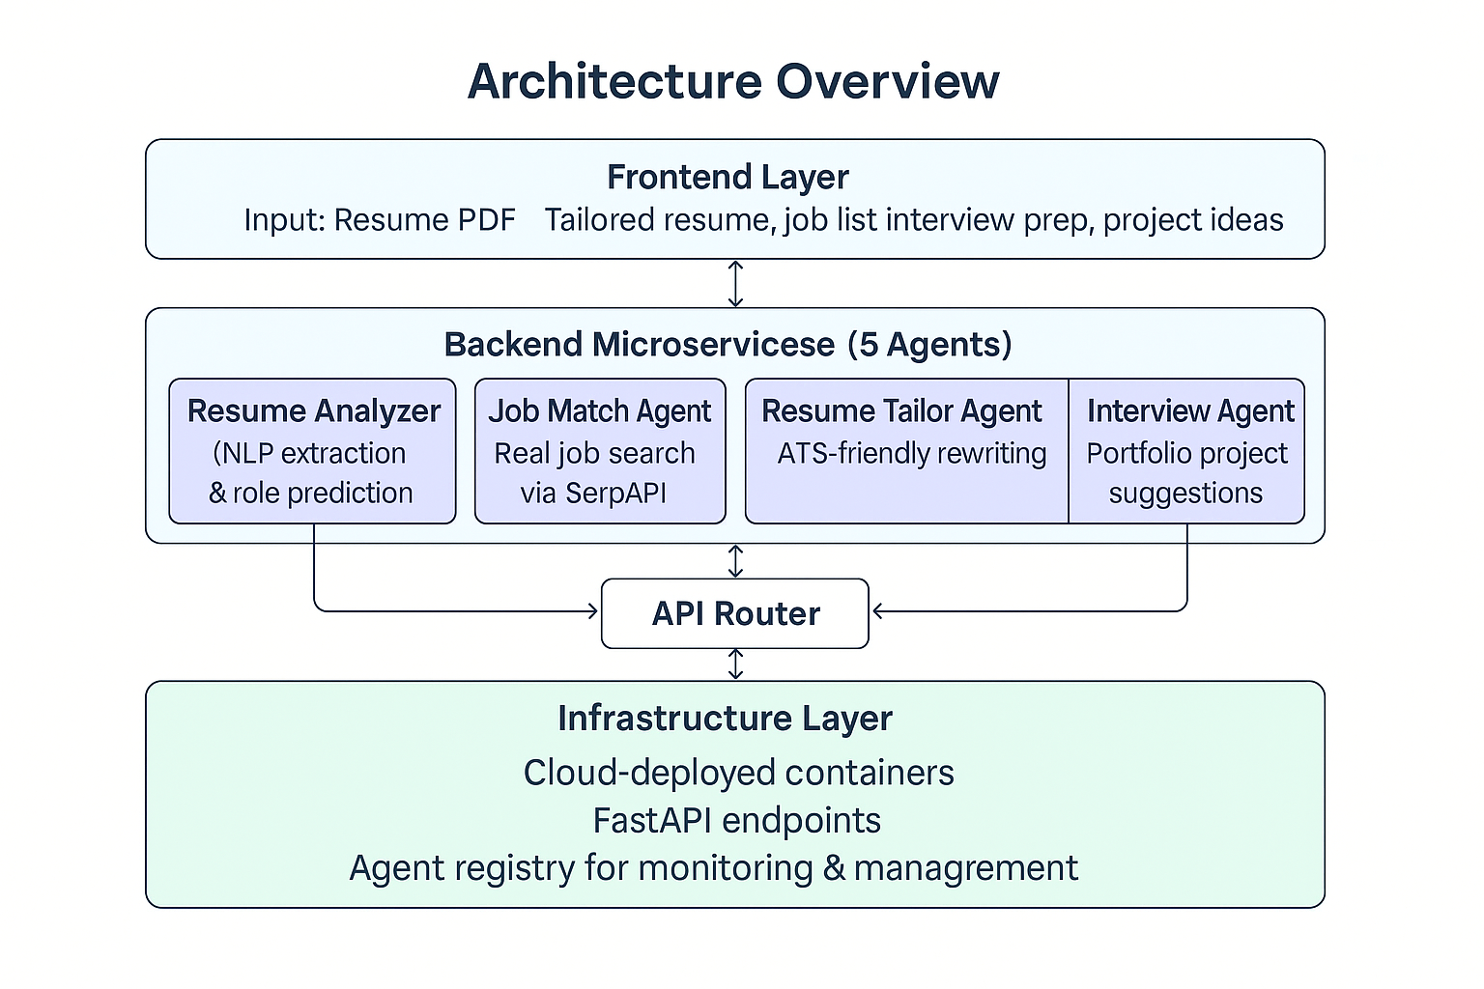

This architecture diagram shows how the system is structured across frontend, backend agents, routing, and infrastructure. It makes the layered design easy to understand and demonstrates technical planning for implementation.

6. Implementation Summary

6.1 Tools, Tech Stack & Libraries Used
The development of this system uses modern AI and NLP tools that support automation and text understanding. Python is selected as the primary language due to its strong machine learning ecosystem. Libraries like spaCy or NLTK can be used for text processing, while frameworks such as Transformers enable deeper understanding of resumes. APIs help in job search integration, and the system can later be deployed using Flask or FastAPI. These technologies make the solution flexible, scalable, and suitable for real-world use. Research confirms that using NLP and recommendation frameworks improves automation and productivity in decision systems (Gao et al., 2020; Aggarwal, 2016).

6.2 Steps Followed During Development
Our implementation plan is structured into phases. First, we defined the agents and their functionality. Next, we designed the workflow and finalized how data will move from one agent to the next. We prepared system diagrams and finalized logic for resume extraction and job matching. The group collaborated to build the foundation of the pipeline and test modules individually. The current phase involves model setup for resume analysis, integration of job fetching, and resume tailoring design. This stepwise approach helped us move from concept to working structure.

6.3 Current Status of Prototype
At this stage, the core design and logic of the system are complete. The resume analysis process and job role mapping flow have been defined. Job search integration and tailoring logic are in progress. We have created the system architecture, workflow diagrams, and implementation plan. The next steps involve combining agents, testing the pipeline in real execution, and enhancing the user interface for smooth use. The prototype is functional at planning level and partially at execution level, showing the project’s future potential.

6.4 Sample Output Screenshots
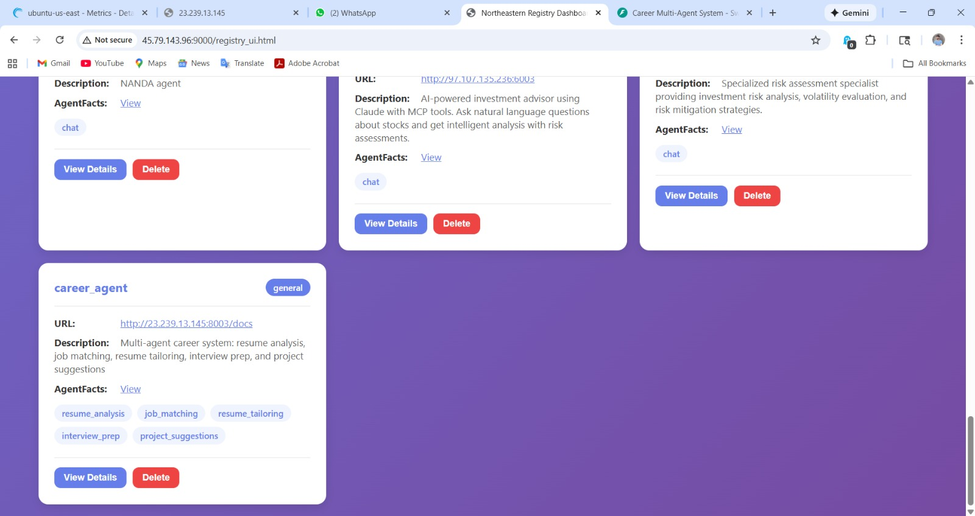

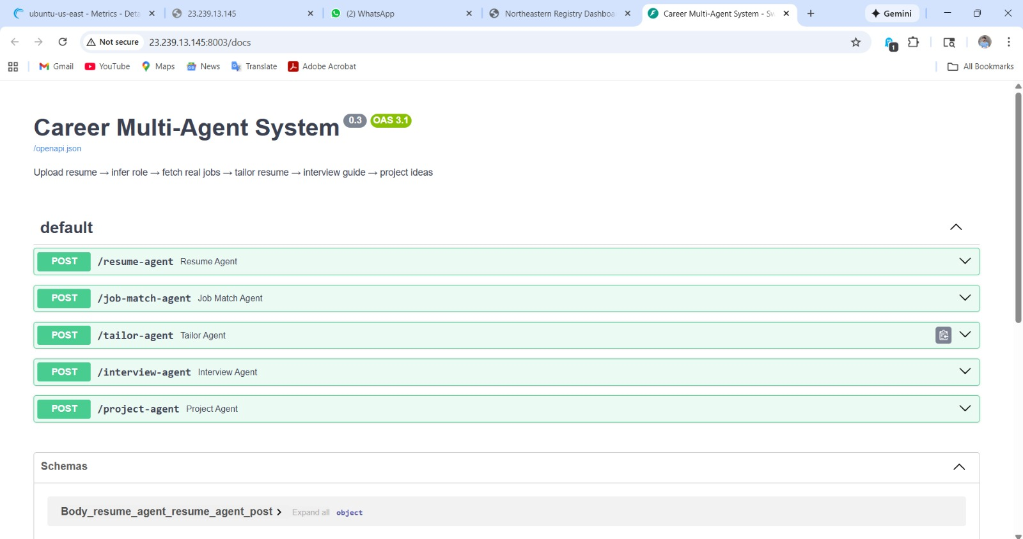

7. Team Collaboration & Contributions

7.1 Role Distribution
Our group worked together by dividing responsibilities based on strengths and interest areas. Each member contributed to research, planning, design, and documentation. We followed a collaborative approach where ideas were discussed openly and every member took an active part in building the concept and preparing presentation materials. The work was shared fairly so the entire system could be developed smoothly and efficiently.

7.2 Contribution Table
A contribution table is included below to clearly present individual responsibilities:
Team Member Name | Contribution Summary
Krati Mudra | Research for resume tailoring logic, design suggestions, content preparation for report and slides
Pratham Brahmbhatt | System workflow development, architecture planning, resume analysis flow, documentation writing, presentation explanation
Ansh Jain | Job search integration research, market problem identification, slide formatting support
Sangayya Rudrayya Hiremath | Interview preparation module research, question generation structure, brainstorming
Zhiwen Sun | Project recommendation logic support, model enhancement ideas, collaborative discussion
Zhuofan Lin | Background research input, team coordination assistance, formatting and visual support

7.3 Tools Used for Communication and Coordination
The team used online tools for smooth coordination. Communication was mainly done through WhatsApp and Microsoft Teams, which helped with messaging, idea exchange, and planning discussions. Google Docs was used for writing and sharing project notes, and Google Slides helped build the visual presentation. These tools supported group productivity and ensured that everyone stayed updated with progress.

This collaborative workflow helped us complete design planning, report writing, and presentation work efficiently as a group.

8. Challenges and Learnings

8.1 Technical Challenges
During development planning, one major technical challenge was understanding how to extract information from resumes written in different formats. Since resumes vary in design, font, layout and structure, creating a universal extraction strategy required research and multiple approaches. Another challenge was designing the job matching logic that can align user skills with the right job titles and job descriptions. Selecting the best method for resume tailoring and interview question generation also needed careful thought. We spent time studying NLP models and recommendation concepts to choose methods suitable for our system (Gao et al., 2020; Aggarwal, 2016).

8.2 Group Collaboration Challenges
As a team, coordinating schedules and dividing tasks efficiently was another challenge. Everyone had different availability, so we practiced flexible planning and regular updates to ensure progress continued smoothly. Making design decisions as a group also required discussion, feedback exchange, and agreement on final choices. With open communication and shared responsibility, we successfully managed tasks and maintained progress.

8.3 Key Learnings and Improvements
Working on this project helped us understand how multi-agent systems can simplify real-world workflows by breaking them into smaller functions. We learned how NLP can read text data more intelligently, how job matching improves when skills are mapped correctly, and how personalized recommendations can assist users better than static information (Wang et al., 2021). We also gained awareness of privacy considerations while handling resumes and personal information. Following ethical data rules strengthens user trust, which is essential for AI-based systems (Price & Cohen, 2019). Overall, this project enhanced both our technical knowledge and teamwork ability.

9. Expected Outcomes & Impact

9.1 How This Project Can Help Real Users
Our system aims to make the job search journey easier and more organized for users. Instead of visiting multiple websites, editing resumes repeatedly and preparing separately for interviews, users can complete the process in one platform. By analysing skills, recommending suitable roles, and tailoring resumes automatically, the system saves time and increases the chances of getting shortlisted. This becomes very helpful for students, fresh graduates, and professionals searching for opportunities.

9.2 Value Proposition of the System
The project delivers strong value by providing an end-to-end career support package. Users not only get job recommendations, but also a resume customized for the role, interview questions related to that job, and project ideas to strengthen their portfolio. The solution acts like a personal career assistant, which many candidates cannot afford in real life. AI-based systems can process data faster and more accurately, offering personalized output for every user (Wang et al., 2021). With this approach, our system becomes practical, scalable and beneficial.

9.3 Success Indicators
The success of this system can be measured through outcomes such as how accurately the resume is read, how relevant the job recommendations are, and how useful users find the tailored resume and interview guidance. A positive sign of success will be when users feel prepared and confident while applying to jobs. Future evaluation can also focus on application conversion rate, time saved in preparation, and feedback received from users. Research on recommendation models and NLP suggests that personalized automation improves real-world results (Aggarwal, 2016; Gao et al., 2020).

10. Future Enhancements

10.1 Planned Features
In the next development phase, we plan to improve the system by connecting the agents into a fully automated pipeline. The goal is to allow users to upload a resume and receive job suggestions, tailored resumes, interview questions and project ideas instantly without manual switching. We also plan to make the tailoring agent more advanced so it can rewrite resume bullet points in different tones, such as technical, leadership oriented or achievement focused. With model refinement, the system can improve accuracy and provide more natural language output.

10.2 Long-Term Improvement Ideas
Long-term upgrades may include adding a personalized dashboard where users can track applications, save job listings and monitor progress. We may also include a career growth assistant that recommends courses and certifications based on the user’s goals. Another improvement would be allowing integration with job platforms so users can apply directly from the system. Over time, the system can also learn user behaviour and improve recommendations using feedback and usage history.

10.3 Deployment & Scaling Potential
Once the system is fully developed and tested, it can be deployed as a web application for public use. Cloud hosting, containerization and API-based design make the project suitable for large-scale access. With proper dataset expansion and evaluation metrics, the system can serve thousands of users and support multiple job roles. In the future, multilingual support and mobile app development can expand accessibility further. With responsible data handling methods, the system can also maintain user trust and follow ethical standards (Price & Cohen, 2019).

11. Conclusion

11.1 Summary of Work Done
This project focused on designing and planning an AI-based multi-agent system that assists users throughout the job search process. We identified common problems faced by job seekers, analyzed how AI can automate career-related tasks, and developed a workflow that connects resume analysis, job matching, resume tailoring, interview preparation and project recommendations. Our team collaborated to create the architecture, workflow pipeline, research background and presentation. This report summarizes the research, design, implementation planning and progress achieved so far.

11.2 Importance of the Project
The system has the potential to make job preparation faster, smarter and more accessible for students and professionals. Instead of spending hours tailoring resumes or searching for interview material, users will receive personalized and structured output with minimal effort. Research supports that AI-powered recommendation and NLP systems improve efficiency and personalization (Aggarwal, 2016; Gao et al., 2020; Wang et al., 2021). With privacy-centered handling of resumes and personal details, the system can also maintain user trust and ethical use of data (Price & Cohen, 2019). This makes our solution relevant and impactful in a competitive job market.

11.3 Final Remarks
Our work so far has created a strong foundation for development. The next steps involve integrating agents, building the functional prototype and improving the system through testing and user feedback. With continued development, this project can grow into a complete digital career assistant that supports job seekers end-to-end. We believe the system will create real value for users and represent a meaningful application of artificial intelligence in the career domain.

12. References

- Aggarwal, C. C. (2016). Recommender systems: The textbook. Springer. https://doi.org/10.1007/978-3-319-29659-3

- Gao, J., Galley, M., & Li, L. (2020). Neural approaches to conversational AI. Foundations and Trends in Information Retrieval, 13(2–3), 127–298. https://doi.org/10.1561/1500000074

- Wang, F., Casalino, L. P., & Khullar, D. (2021). Deep learning in medicine: Promise, progress, and challenges. JAMA, 325(11), 1107–1108. https://doi.org/10.1001/jama.2021.1336

- Price, W. N., & Cohen, I. G. (2019). Privacy in the age of medical big data. Nature Medicine, 25(1), 37–43. https://doi.org/10.1038/s41591-018-0272-7

