The Basics

The Breadboard
For prototyping electronic circuits, the breadboard allows standard electronic components to be connected via a series of interconnected holes. The two lines of holes along each edge are connected vertically and those in the centre are connected horizontally in two ranks.

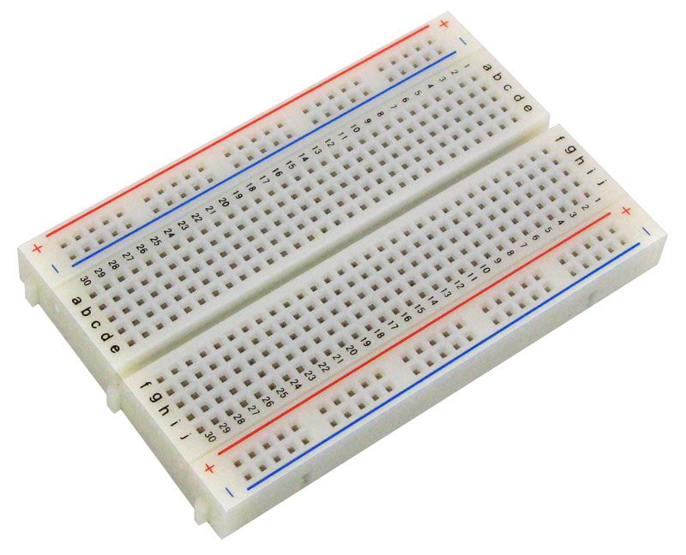
Typically the outer columns are used for power and ground.
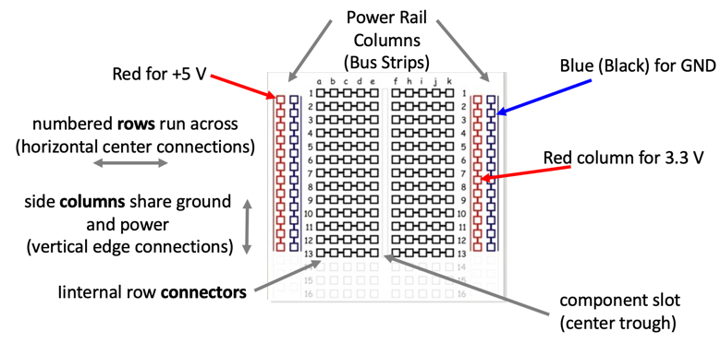
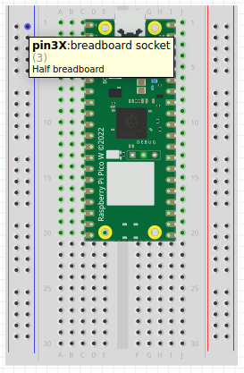
The central slot isolates the rows into two sets of 5 holes, allowing for micro controllers like the Raspberry Pi Pico to be placed with access to all pins.

Blink
An easy way of testing if a micro controller is working, is to flash an LED. LED stands for Light Emitting Diode and they are found in most electronic items typically to show power is applied or some other function is happening.
The Pico has a built-in LED and it can be flashed using a simple micro-python program.
import machine
import time

LED_PIN = 25
led = machine.Pin(LED_PIN, machine.Pin.OUT)

while True:
led.high()
time.sleep(0.5)
led.low()
time.sleep(0.5)
Connect an LED as shown and change the above to use pin 13.
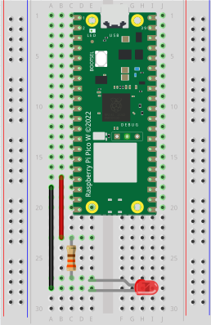
While you could connect the LED directly, it is better to limit the voltage across the LED to preserve the life expectancy of the component. Use a 330 ohm resistor in series with the output of the pico.
The time.sleep function takes a value in seconds, so 0.5 is half a second. Try varying the on/off time. Try replacing the high/low method calls with a single led.toggle() call.

