The Basics

Micro-controllers
A micro-controller combines a microprocessor and several peripherals in a single package. These peripherals are typically memory, storage and one or more forms of input and output interface.
Examples of micro-controller boards would be the Arduino range, the ESP32 range and the Pico series. In most cases these are “development boards” ideally suited to hobby electronics.

Raspberry Pi Pico (and Pico W)
The pico is a 40 pin micro-controller some pins have specific roles others can be programmed to perform various tasks.
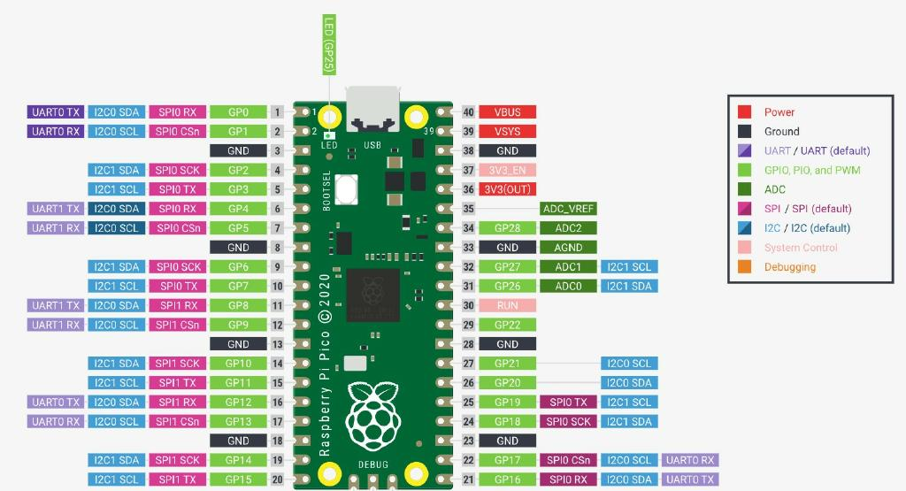
The grey numbers represent the physical pins on the board while when programming pins are referenced by their GP number (in light green) so GP13 is actually physical pin 17. Notice that most GP pins can also be used for other tasks. The Pico W is a WiFi version of the Pico has a near identical pin out except for the builtin LED has moved to GP 0 rather than 25.

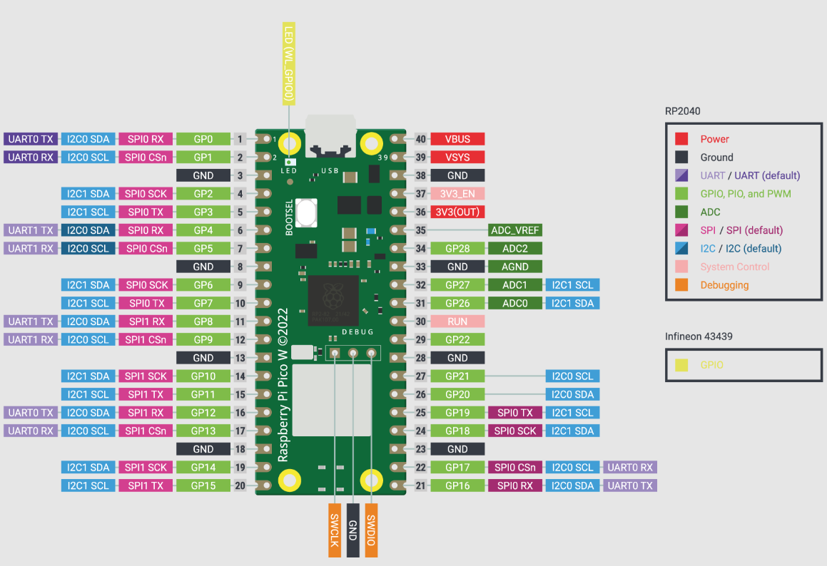
Apart from choosing the correct version, they both run micro python equally well.

Other micro controller development boards that run Micro Python
There is a long list of boards that will run Micro Python some are listed here:
BBC micro bit | ESP 32 | Feather M4
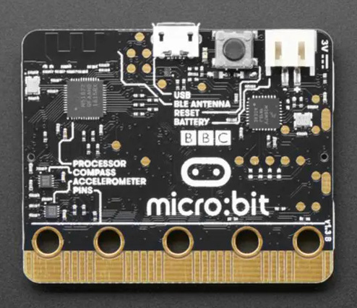 | 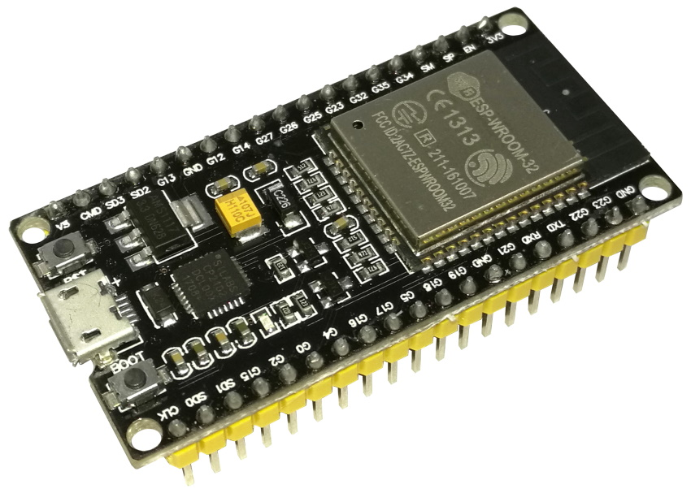 | 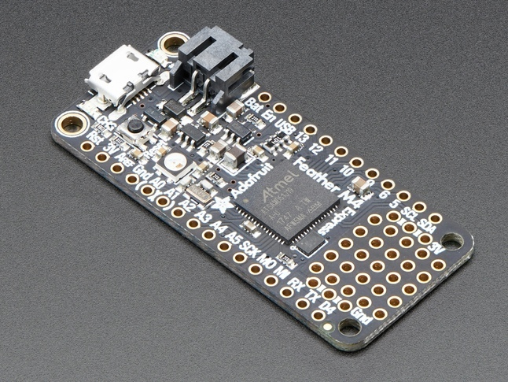

See https://micropython.org/download/ for more details.

