The Basics

PWM
PWM or Pulse Width Modulation, is a signal that rapidly turns on and off giving the illusion of an average value.
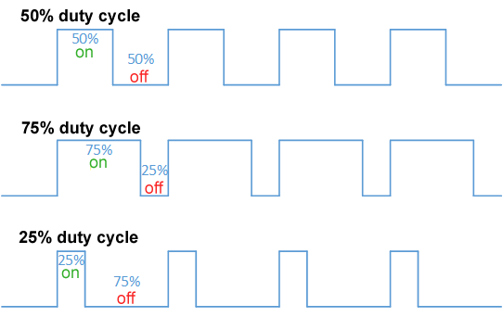
By controlling the width of the on part of the signal the brightness of an LED (or speed of a motor) can be made to vary. With a PWM design there are two things we need to tell the microcontroller:
- How often do you want a square wave to go on and off?
- How wide should the on part of the pulse be (relative to the total width). This is called the duty cycle.
The rate of change of the pulse is call the frequency. You can set the frequency to be 1,000 changes per second, which is much faster than the human eye can detect.
Using the blink circuit.
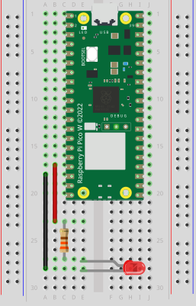

import machine
import time

pwm = machine.PWM(machine.Pin(13))

pwm.freq(1000)

while True:
for duty in for duty in range(0, 65025, 1):
pwm.duty_u16(duty)
time.sleep(0.0001)
for duty in range(65025, 0, -1):
pwm.duty_u16(duty)
time.sleep(0.0001)
Note the loops in the above program.
A while loop will continue until the condition is False, so while True: will loop forever.
A for loop typically will loop over a range of values, in these cases the range is defined as range(start, end, step). When defining a range the default value for start is 0 and the default step is 1 so the line could be rewritten as for duty in range(65025):
The u16 in the duty_u16(duty) method stands for unsigned 16 bit integer and means that the value it accepts will be a positive number between 0 and 65535.

Exercises
Change the frequency from 1,000 to 500, 100, 50, 40, 30, 25, 20, and 10. When can you just barley see it flicker? What does this tell you about the human eye?
Can you add a delay so that the LED stays on at full brightness for one second before it starts to dim again?
Can you add a delay so that the LED is completely off for five seconds and then goes to full brightness and off in one second?

