Micro Python Sensors

The Ultrasonic Distance Sensor (HC-SRO4)
The HC-SR04 is a low cost (£1.50) sensor that measures the distance to an object in front of it.
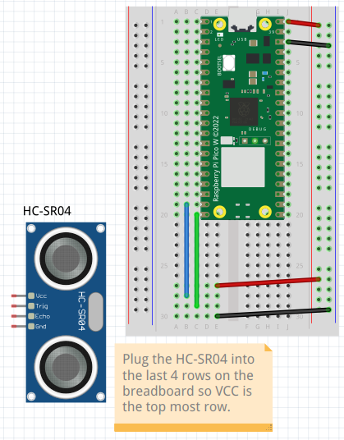
The sensor sends an ultra sonic pulse out which is reflected from an object and detected by the sensor, the time taken for the echo to return can be used to calculate the distance if the speed of sound is known.
distance = (duration * 0.0343) / 2

The sensor is super inexpensive however not especially accurate at distances less than 2cm and above 1 metre.
When adding the sensor to the circuit ensure that the metal cans are pointing out from the breadboard and that the all the connections are correct.

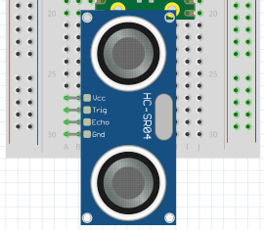 | 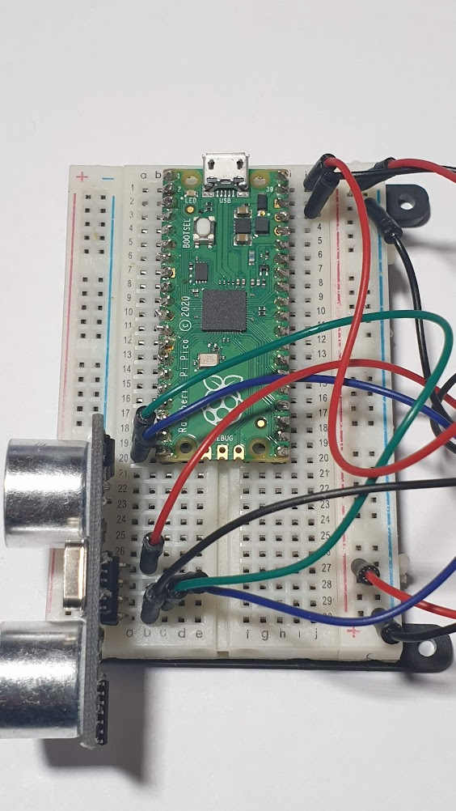

Add code to read the distance in centimetres
import machine
import utime

TRIGGER_PIN = 15 # With USB on the top, this pin is the bottom left corner
ECHO_PIN = 14 # One up from bottom left corner

# Init HC-SR04 pins
trigger = machine.Pin(TRIGGER_PIN, machine.Pin.OUT) # send trigger out to sensor
echo = machine.Pin(ECHO_PIN, machine.Pin.IN) # get the delay interval back

def ping():
trigger.low()
utime.sleep_us(2) # Wait 2 microseconds low
trigger.high()
utime.sleep_us(5) # Stay high for 5 miroseconds
trigger.low()
while echo.value() == 0:
signaloff = utime.ticks_us()
while echo.value() == 1:
signalon = utime.ticks_us()
timepassed = signalon - signaloff
distance = (timepassed * 0.0343) / 2
return distance

while True:
print("Distance:", ping(), " cm")
utime.sleep(.25)

Exercise
Check the accuracy of the detector in the real world.
Can you trace the area that the sensor can “see”.

