Micro Python Sensors

The Photoresistor
With no light the sensor has a high resistance, but when illuminated the resistance drops. When the resistance gets lower the voltage is lowered across the photoresistor.

Connect a multi-meter across the two legs of the photo resistor and set the multi-meter to the 200k range, and observe how the value changes with the amount of light falling on the sensor.

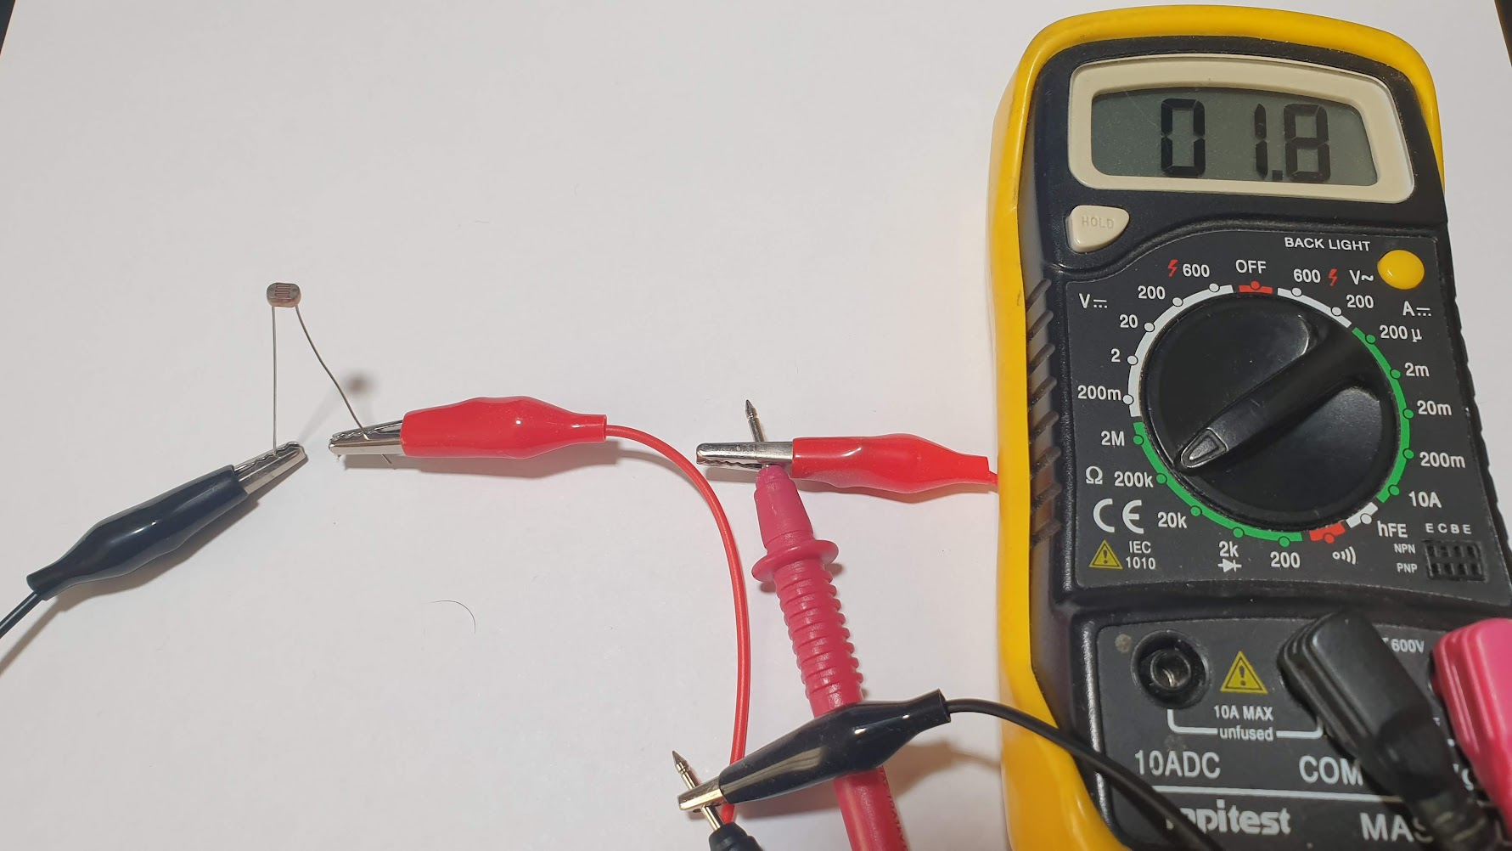 | 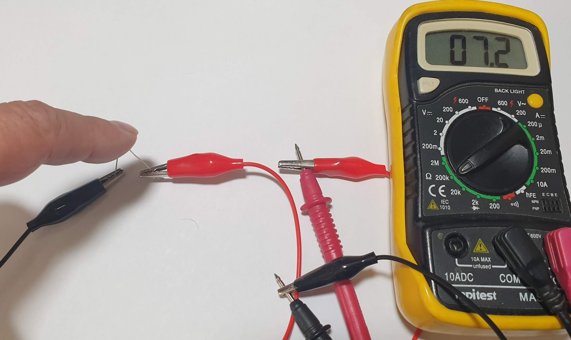

A basic circuit called a resistive divider, used with an analog input to sense a voltage and hence the light level falling on the sensor.
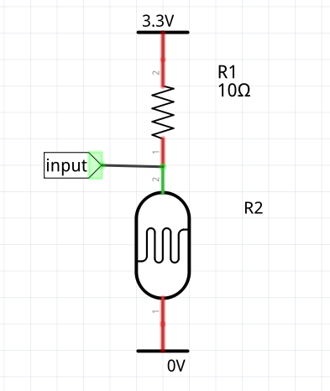

The voltage across the two resistors will always be 3.3V but the share of the voltage measured at the input will increase as the value of R2 increases.

Make the following circuit on a bread board with the a Pico, double check that the wiring is correct before adding power!
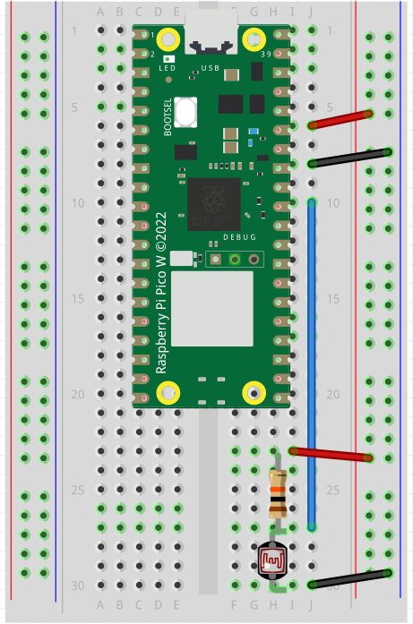
Finally create a new program in Thonny and run it on the Pico.
import machine
import time
photo_pin = machine.ADC(26)

while True:
val = photo_pin.read_u16()
print(val)
time.sleep(.2)
As the sensor is covered and uncovered the printed value changes.
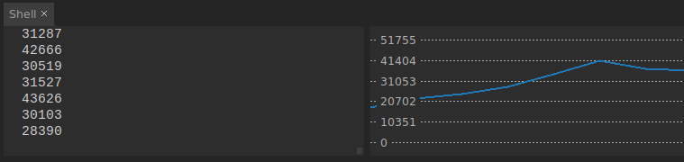
Exercise:
Modify the above code to turn on an LED connected to pin 13 when the light level drops.

Hint 1:
EXTERNAL_LED_PIN = 13
external_led = machine.Pin(EXTERNAL_LED_PIN, machine.Pin.OUT)

Hint 2:
if val > 40000:
external_led.high()
else:
external_led.low()

