|  |
| --- |
| Food Violations Report |
| THANH CONG PHAN7810ICT Software TechnologiesJanuary 2, 2019 |

# Abstract

Health violations in facilities are one of the biggest concerns of California’s government. A bunch of inspections were processed in a wide range of restaurants and a set of data (inspections and violations) are created based on those activities. By using that data, the report detects that in overall, the average number of food violations per month are not stable but having downward trend. However, it also shows the fact that non-food things were received the less attention from most of restaurants and they created the most proportion in health violations. Furthermore, the statistic in some postal codes and the comparison of two famous brands (McDonald and Burger King) are given to get diverse views for the state of food violations in California.

# Introduction

The purpose of the report is to show how food inspections and health violations in California’s facilities are managed. It also helps government gain better understanding of the current situation so that they can set more actions and improvements later. The report is structured into two parts. The first part of report describes the way data is processed and stored in related database. The last part involves how data is analyzed where tables and plots are used to give the overall numbers as well as the trend over periods for restaurant’s violations.

The collection of inspections and violations data from July 2015 to December 2017 is used in this report and it is kept in database as described in following database structure.

## Database Structure

There are 2 main tables: Inspections and Violations in database schema.

**Inspections**

CREATE TABLE Inspections

(

ActivityDate datetime,

EmployeeId varchar(50) NOT NULL,

FacilityAddress varchar(256),

FacilityCity varchar(256),

FacilityId varchar(10),

FacilityName varchar(256),

FacilityState varchar(10),

FacilityZip varchar(20),

Grade varchar(5),

OwnerId varchar(20),

OwnerName varchar(256),

PEDescription varchar(256),

ProgramElementPE int,

ProgramName varchar(256),

ProgramStatus varchar(20),

RecordId varchar(20),

Score int,

SerialNumber varchar(10),

ServiceCode int,

ServiceDescription varchar(30),

CONSTRAINT PK_Inspections PRIMARY KEY (SerialNumber)

);

**Violations**

CREATE TABLE Violations

(

Points int,

SerialNumber varchar(10),

ViolationCode varchar(5),

Description varchar(256),

Status varchar(20),

CONSTRAINT PK_Violations PRIMARY KEY (SerialNumber,ViolationCode),

CONSTRAINT FK_SerialNumber FOREIGN KEY(SerialNumber) REFERENCES

Inspections(SerialNumber)

);

In Inspections table, the field SerialNumber is chosen as primary key. Each time a facility is inspected, a new SerialNumber is generated to keep track for that record.

With Violations, the primary key is a combination between SerialNumber and ViolationCode , SerialNumber should be a foreign key to Inspections table. There are some Violations with “missing” SerialNumber in Inspections (the samples are listed in Table 1) therefore removal of them after inserting data is a necessary cleaning step in data preprocessing. (The option PRAGMA foreign_keys = ON; can be used but experiments showed that checking the existence of SerialNumber in Inspections table before inserting takes more time, hence I go with DELETE command option after inserting).

Table 1. Invalid SerialNumber foreign key samples

|  |  |  |  |  |
| --- | --- | --- | --- | --- |
| 2 | DAX2XF9F0 | F007 | # 07. Proper hot and cold holding temperatures | OUT OF COMPLIANCE |
| 0 | DAX2XF9F0 | F049 | # 50. Impoundment of unsanitary equipment or food | OUT OF COMPLIANCE |
| 4 | DADMZNE4D | F014 | # 14. Food contact surfaces: clean and sanitized | OUT OF COMPLIANCE |
| 1 | DADMZNE4D | F026 | # 26. Approved thawing methods used, frozen food maintained frozen | OUT OF COMPLIANCE |
| 1 | DADMZNE4D | F039 | # 39. Wiping cloths: properly used and stored | OUT OF COMPLIANCE |

Besides, the data in Violations worksheet contains duplicate records for SerialNumber and ViolationCode. It can be caused by some mistakes when collecting data, so I eliminated them by using INSERT OR IGNORE command. That means when inserting, if primary constrain is invalid, that record will be ignored. The examples in Table 2 below give more details for this problem.

Table 2. Duplicate SerialNumber And ViolationCode Samples in Violations Sheet

|  |  |  |  |  |
| --- | --- | --- | --- | --- |
| 2 | DA7XLSCMN | F001 | # 01a. Demonstration of knowledge | OUT OF COMPLIANCE |
| 2 | DA7XLSCMN | F001 | # 01a. Demonstration of knowledge | OUT OF COMPLIANCE |
| 2 | DAZULLZ7F | F009 | # 09. Proper cooling methods | OUT OF COMPLIANCE |
| 2 | DAZULLZ7F | F009 | # 09. Proper cooling methods | OUT OF COMPLIANCE |

# **Violation counts**

905885 violations are found after 191371 inspections are processed. These violations are separated into 116 distinct Violation Codes. The Table 3 gives the statistic of violations by their code, description and the number of each type.

Table 3. Summary of violation codes.

|  |  |  |
| --- | --- | --- |
| Code | Description | Count |
| F044 | # 44. Floors, walls and ceilings: properly built, maintained in good repair and clean | 102009 |
| F033 | # 33. Nonfood-contact surfaces clean and in good repair | 100080 |
| F035 | # 35. Equipment/Utensils - approved; installed; clean; good repair, capacity | 80010 |
| F040 | # 40. Plumbing: Plumbing in good repair, proper backflow devices | 50868 |
| F036 | # 36. Equipment, utensils and linens: storage and use | 49742 |
| F037 | # 37. Adequate ventilation and lighting; designated areas, use | 48042 |
| F043 | # 43. Premises; personal/cleaning items; vermin-proofing | 42943 |
| F007 | # 07. Proper hot and cold holding temperatures | 41105 |
| F030 | # 30. Food properly stored; food storage containers identified | 39854 |
| F039 | # 39. Wiping cloths: properly used and stored | 35845 |
| F014 | # 14. Food contact surfaces: clean and sanitized | 34441 |
| F006 | # 06. Adequate handwashing facilities supplied & accessible | 33952 |
| F023 | # 23. No rodents, insects, birds, or animals | 29722 |
| F034 | # 34. Warewashing facilities: Adequate, maintained, properly use, test strips available | 19208 |
| F052 | # 01b. Food safety certification | 18359 |
| F029 | # 29. Toxic substances properly identified, stored, used | 17986 |
| F027 | # 27. Food separated and protected | 17866 |
| F042 | # 42. Toilet facilities: properly constructed, supplied, cleaned | 16153 |
| F046 | # 46. Signs posted; last inspection report available | 15735 |
| F025 | # 25. Personal cleanliness and hair restraints | 11878 |
| F038 | # 38. Thermometers provided and accurate | 11060 |
| F009 | # 09. Proper cooling methods | 7993 |
| F026 | # 26. Approved thawing methods used, frozen food maintained frozen | 7798 |
| F001 | # 01a. Demonstration of knowledge | 6874 |
| F021 | # 21b. Water available | 6786 |
| F032 | # 32. Food properly labeled & honestly presented | 6734 |
| F049 | # 50. Impoundment of unsanitary equipment or food | 5926 |
| F048 | # 47. Permits Available | 5510 |
| F005 | # 05. Hands clean and properly washed; gloves used properly | 5151 |
| F013 | # 13. Food in good condition, safe and unadulterated | 5009 |
| F041 | # 41. Garbage and refuse properly disposed; facilities maintained | 4742 |
| F008 | # 08. Time as a public health control; procedures & records | 4706 |
| F053 | # 21a. Hot Water Available | 4218 |
| F004 | # 04. Proper eating, drinking, or tobacco use | 3364 |
| F050 | # 51. Permit Suspension | 2950 |
| F022 | # 22. Sewage and wastewater properly disposed | 1636 |
| F055 | # 01a. Demonstration of knowledge | 1515 |
| F054 | # 52. Multiple Major Critical Violations / Increased Risk to Public Health | 1214 |
| F016 | # 16. Compliance with shelf stock tags, condition, displayed | 1087 |
| F024 | # 24. Person in charge present and performs duties | 983 |
| F011 | # 11. Proper reheating procedures for hot holding | 854 |
| F031 | # 31. Consumer self service facilities properly constructed and maintained | 669 |
| F015 | # 15. Food obtained from approved source | 622 |
| F047 | # 48. Plan Review required for new or remodel construction | 607 |
| F045 | # 45. Sleeping quarters | 437 |
| F019 | # 19. Consumer advisory provided for raw or undercooked foods | 255 |
| F018 | # 18. Compliance with variance, specialized process, & HACCP Plan | 213 |
| F028 | # 28. Fruits and vegetables washed as required | 207 |
| F058 | # 19. Consumer advisory provided for raw or undercooked foods | 185 |
| W048 | Permits Available | 121 |
| F010 | # 10. Proper cooking time & temperatures | 51 |
| F017 | # 17. Compliance with Gulf Oyster Regulations | 44 |
| F057 | # 18. Compliance with variance, specialized process, & HACCP Plan | 43 |
| W009 | Cockroaches | 42 |
| F051 | # 49. Samples Collected | 40 |
| F002 | # 02. Communicable disease; reporting, restrictions & exclusions | 38 |
| F003 | # 03. No discharge from eyes, nose, and mouth | 36 |
| W053 | Permit Suspension | 35 |
| W051 | Walls, Floors, Ceilings: approved, maintained clean and in good repair | 32 |
| W052 | Equipment, Shelving, Cabinets: approved, maintained clean and in good repair | 31 |
| F012 | # 12. Returned and reservice food | 28 |
| W023 | Floor maintained clean | 23 |
| W017 | Hot and cold water available | 18 |
| W019 | Plumbing approved and maintained in good repair. | 15 |
| W050 | Food properly labeled | 14 |
| F056 | # 10. Proper cooking time & temperatures | 12 |
| W005 | Food elevated | 11 |
| W001 | Proper hot and cold holding temperatures | 9 |
| W020 | Wall(s) maintained clean | 9 |
| W042 | Garbage / Rubbish receptacles approved type | 7 |
| W047 | Thermometer: available, maintained in good repair | 7 |
| W003 | Food storage separated and protected | 6 |
| W008 | Rodent | 6 |
| W021 | Wall(s) maintained in good repair | 6 |
| W041 | Premises maintained clean and sanitary | 6 |
| W014 | Fly Breeding | 5 |
| W024 | Floor maintained in good repair | 5 |
| W027 | Ceiling constructed of smooth, durable, and non-absorbent material | 5 |
| W049 | Food from an approved source | 5 |
| W029 | Toilet maintained clean / sanitary | 4 |
| W031 | Hand sink maintained clean / sanitary | 4 |
| W034 | Toilet room with toilet paper / soap / towels / trash receptacle | 4 |
| W044 | Garbage / Rubbish receptacles maintained clean and sanitary | 4 |
| W004 | Food storage space | 3 |
| W012 | Fly Breeding Material | 3 |
| W016 | Building rodent proof | 3 |
| W018 | Waste water or sewage properly disposed or not discharged on the ground. | 3 |
| W026 | Ceiling maintained in good repair | 3 |
| W028 | Toilet in good repair | 3 |
| W032 | Toilet room floor / walls / ceiling in good repair | 3 |
| W043 | Garbage / Rubbish receptacles maintained in good repair | 3 |
| W006 | Food packaging protected | 2 |
| W011 | Storage of materials 18 inches above the floor. | 2 |
| W025 | Ceiling maintained clean | 2 |
| W033 | Toilet room floor / walls / ceiling clean | 2 |
| W035 | Toilet room well ventilated | 2 |
| W036 | Toilet room well lighted | 2 |
| W040 | Compliance with shellfish tag requirements | 2 |
| CL21 | Public Health Permit/License valid | 1 |
| F020 | # 20. Licensed health care facilities/public & private schools; prohibited foods not offered | 1 |
| MF07 | # 07. Adequate handwashing facilities supplied & accessible | 1 |
| MF42 | # 42. Garbage and refuse properly disposed; facilities maintained | 1 |
| SF15 | No Health Code Violations Observed At The Time Of Inspection | 1 |
| SS33 | Garbage / rubbish receptacles not maintained clean and sanitary | 1 |
| W002 | Food in good condition, safe and unadultered | 1 |
| W022 | Wall(s) constructed of approved material | 1 |
| W030 | Hand sink in good repair | 1 |
| W037 | Toilet available | 1 |
| W038 | Hand sink available | 1 |
| W039 | Proper storage or use of hazardous materials | 1 |
| W045 | No unapproved sleeping accomodations | 1 |
| W046 | Live animals | 1 |
| WP13 | # 13. Disease Transmission - Carrier / Lesion / Rash | 1 |
| WP15 | # 15. Tobacco / Eating / Drinking / Habits / Behaviors | 1 |
| WP16 | # 16. Hair Restraints / Outer Garments / Nails / Rings | 1 |
| WP18 | # 18. Personal Hygiene | 1 |
|  | Total Violations | 905885 |

As can be observed from the table, the non-food things were the most violated problems. The top 3 are *“F044-# 44. Floors, walls and ceilings: properly built, maintained in good repair and clean”, “F033-# 33. Nonfood-contact surfaces clean and in good repair”, “F035-# 35. Equipment/Utensils - approved; installed; clean; good repair, capacity****”***with the total *102.009, 100.080 and 80.010* respectively*.* Besides, there were about 39 codes with above 1000 number of violated times. That means many facilities had same issues or these kinds of issues were not solved completely from previous inspections. The government should give some more punishments or warnings to help improving the awareness of the facilities in those stuffs.

# **Violations over time**

## Highlight Postal Codes

The facilities in 3.037 postal codes were inspected from July 2015 to December 2017. During this period, the highest number of violations were detected in postal code ***91748*** with 10.564 times. That number was summarized after 2011 inspections were processed in 494 facilities. Especially, the violations in this postal code reached the peak on June 2017 with nearly 700 times. In the contrast, about 51 postal codes having only 1 violation during same period were found. The following Figure 1 shows the trending of violations in postal code ***91748*** and ***91801-7461*** (one of the postal codes have lowest rate of food violations).

Figure 1. Trending of food violations in 91748 and 91801-7461 postal codes.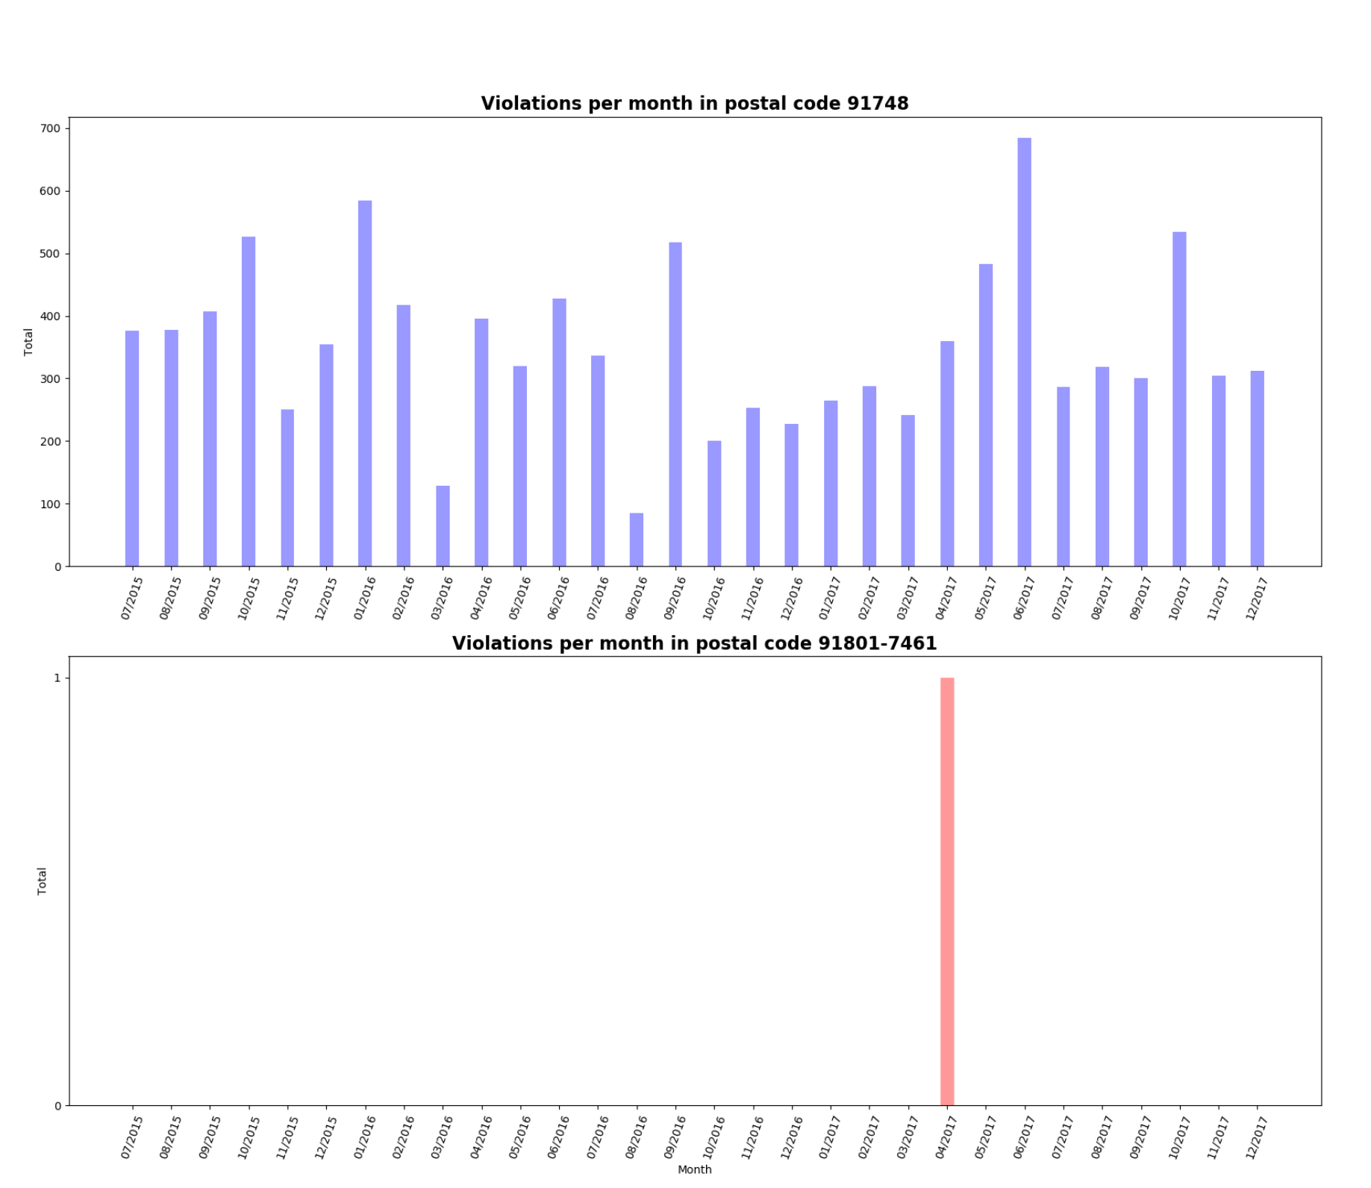

## Average Violations in California

Figure 2. The average violations in California

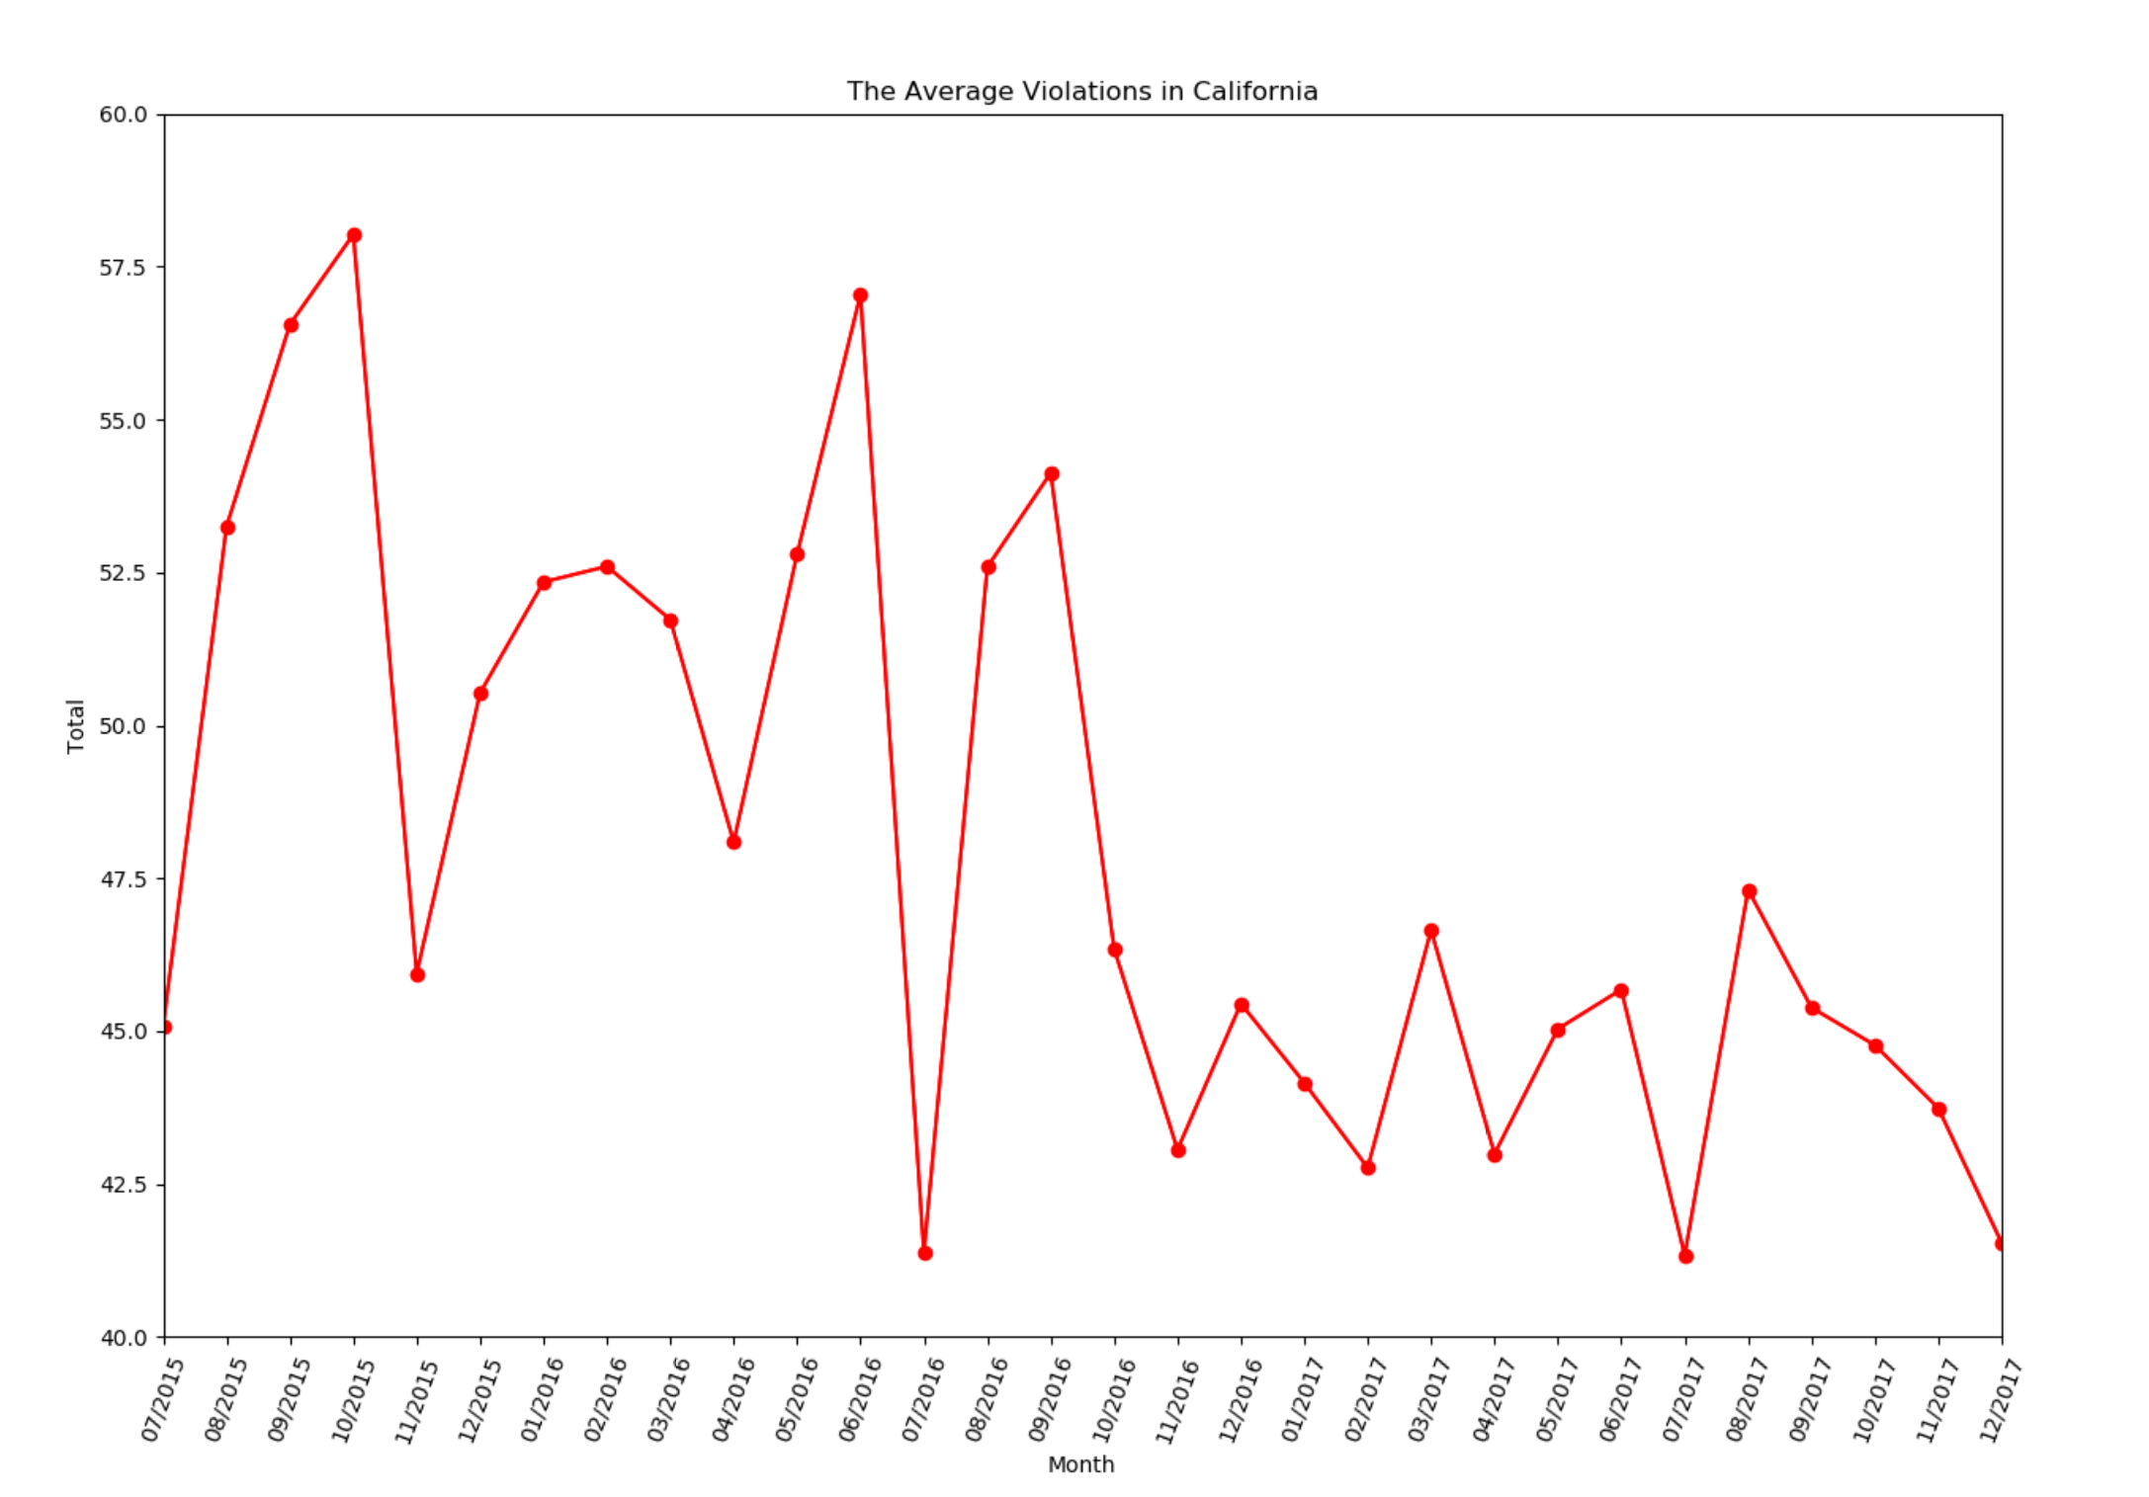

The average violations per month are calculated by getting the division between total numbers of violations and total numbers of postal codes which violations are detected inside those. Overall, this number had downward trend in California. Starting with 45 times on July 2015, it raised and reached the peak on October 2015 with about 58 times per month. Then, it fluctuated in the range between 41 and 57 times per month from last months of 2015 to the end of 2016. This trend became more steady from 2017 with approximate 43 times per month.

## McDonalds vs Burger Kings

Fast food is convenient and delicious. However, because the dishes need to be prepared very fast, it can be the reason for a lot of food violations. To give an example of it, the violations of McDonalds and Burger Kings are compared in Figure 3.

Figure 3. Comparison between McDonalds and Burger Kings

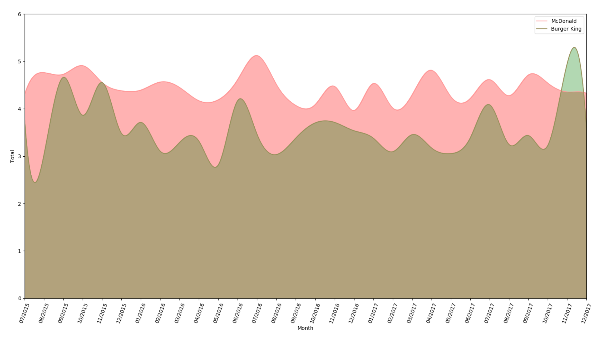

According to the chart, the average number of violations in McDonalds were often higher than in Burger Kings. During the time from 07/2015 to 12/2017, government processed 1529 inspections in 345 different branches of McDonalds with 6600 violations were detected. Per month, about 50 McDonald restaurants were inspected and approximate 220 issues were found which creates the mean for whole period is 4.4 times.

In the meanwhile, Burger King had less stable trend. In each month, the average number of examined restaurants were 19. With 1992 violations in total, there were about 66.4 violations per month. That means for each inspection in Burger King chain, above 3.5 mistakes were discovered.

Appendix

# Appendix 1: Food Violations

|  |  |
| --- | --- |
| **Code** | **Description** |
| F012 | # 12. Returned and reservice food |
| F013 | # 13. Food in good condition, safe and unadulterated |
| F014 | # 14. Food contact surfaces: clean and sanitized |
| F015 | # 15. Food obtained from approved source |
| F019 | # 19. Consumer advisory provided for raw or undercooked foods |
| F020 | # 20. Licensed health care facilities/public & private schools; prohibited foods not offered |
| F026 | # 26. Approved thawing methods used, frozen food maintained frozen |
| F027 | # 27. Food separated and protected |
| F030 | # 30. Food properly stored; food storage containers identified |
| F032 | # 32. Food properly labeled & honestly presented |
| F033 | # 33. Nonfood-contact surfaces clean and in good repair |
| F049 | # 50. Impoundment of unsanitary equipment or food |
| F052 | # 01b. Food safety certification |
| F058 | # 19. Consumer advisory provided for raw or undercooked foods |
| W002 | Food in good condition, safe and unadultered |
| W003 | Food storage separated and protected |
| W004 | Food storage space |
| W005 | Food elevated |
| W006 | Food packaging protected |
| W049 | Food from an approved source |
| W050 | Food properly labeled |

# Appendix 2: Top 40 most violated facilities

|  |  |
| --- | --- |
| **Name** | **Total** |
| DODGER STADIUM | 1140 |
| STAPLES CENTER (LEVY) | 845 |
| LA COLISEUM | 693 |
| UNIVERSAL STUDIOS HOLLYWOOD | 417 |
| SIX FLAGS MAGIC MOUNTAIN & SIX FLAGS HURRICANE HARBOR | 372 |
| STUB HUB CENTER | 309 |
| LA CONVENTION CENTER | 283 |
| LMU | 282 |
| TERRANEA | 220 |
| SUPER H MART | 179 |
| LA ZOO | 165 |
| ZION MARKET DELI & ISLAND | 162 |
| VALLARTA SUPERMARKET #27 | 152 |
| LA FIESTA MARKET | 147 |
| QANTAS AIRWAYS LOUNGE | 145 |
| VALLARTA SUPERMARKET #17 | 144 |
| USC GALEN CENTER | 142 |
| 168 MARKET #806 | 142 |
| BUY LOW MARKET | 142 |
| BAJA RANCH SUPERMARKET-DEFBK | 141 |
| SODEXO @ THE HOLLYWOOD BOWL | 141 |
| NORTHGATE GONZALEZ MARKET #25 | 140 |
| VALLARTA SUPERMARKET #9 | 140 |
| BAJA RANCH MARKET-DELI/BAKER | 139 |
| WHOLE FOODS MARKET #29 | 139 |
| BAJA RANCH SUPERMARKET | 137 |
| REG BEV WILSHIRE | 135 |
| SUPERIOR GROCERS | 134 |
| 99 RANCH MARKET | 133 |
| AMAPOLA DELI & MARKET | 131 |
| AMERICAN RANCH & SEAFOOD MKT | 129 |
| HAZEL MEAT MARKET | 129 |
| SUPER A FOODS | 128 |
| RALPHS MARKET #648 | 128 |
| RALPHS MARKET #759 | 128 |
| SEAFOOD CITY NORTH HILLS | 128 |
| 168 MARKET #805 | 128 |
| BRISTOL FARMS MARKET #21 | 127 |
| FORUM | 126 |
| CANDELARIO'S MARKET | 123 |