Margin of C in SVM

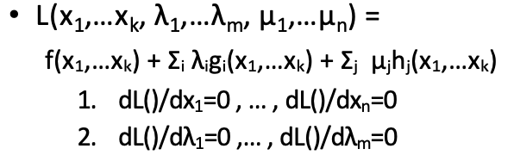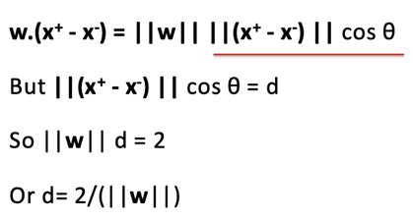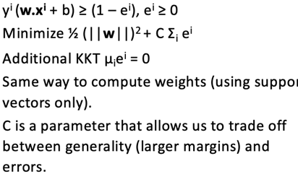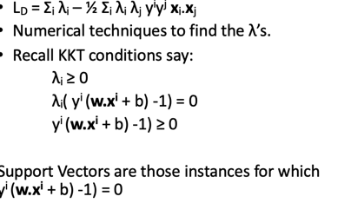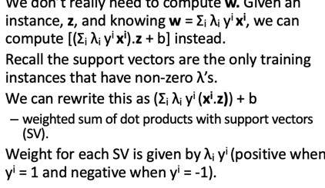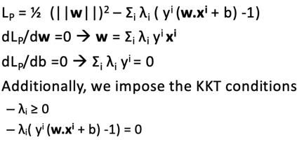

Different kernels: linear, quad, higher order polynomials

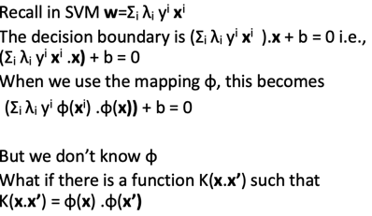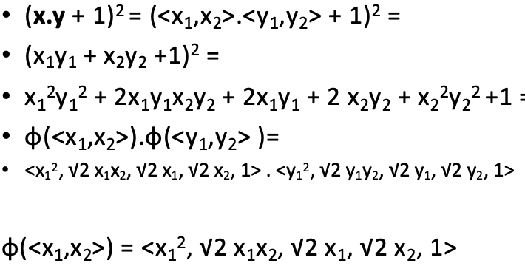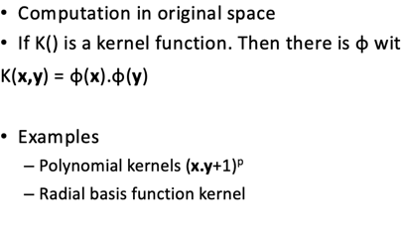

Pruning is to generalize unseen data- Don’t prune random forrest- explain why -

Bagging - just use error rate

Algomerative clustering - k-means – knn

