

Capstone Project Report
Report 4 — Software Design Document
PTE Prep
FA26SE182
Version 1.0 · 06 October 2026

— Ho Chi Minh City, October 2026 —

Table of Contents
I. Record of Changes
II. Software Design Document
1. System Design
1.1 Design goals and boundaries
1.2 Context and channel design
1.3 Deployment topology
1.4 Application package ownership
1.5 Authentication, authorization, and tenant scope
1.6 External integration design
1.7 Cross-cutting state principles
1.8 Design decisions and unresolved items
2. Database Design
2.1 Data ownership principles
2.2 Conceptual entity catalogue
2.3 Entity relationship model
2.4 Fixed-version and provenance invariants
2.5 Keys, uniqueness, and query needs
2.6 Lifecycle and retention classification
2.7 Data protection rules
3. Detailed Design
3.1 Detailed design notation
3.2 Onboarding and Host activation
3.3 Content, media, and Score Template preparation
3.4 Exam draft, validation, generation, and scheduling
3.5 Student delivery, local save, synchronization, and submission
3.6 Proctoring and integrity audit
3.7 Examiner assignment, scoring, and publication
3.8 Error handling and retry design
3.9 Design acceptance and open points
Page numbers are intentionally omitted from this generated outline so the cached page references cannot become stale.

I. Record of Changes
Version | Date | A / M / D** | In charge | Change description | Reference
1.0 | 2026-10-06 | A, M | Ngô Đăng Quang — Project Leader | Replaced the generic design template with the PTE Prep architecture, data, interaction, and deployment baseline; preserved the source DOCX section order. | Report 3 SRS, pte-doc/report/_foundation/section-map.md

* A — Added; M — Modified; D — Deleted.

II. Software Design Document
Product: PTE Prep · Independent organization-based PTE-style practice and mock-exam simulation platform.
Document baseline: Version 1.0 · Owner: Ngô Đăng Quang — Project Leader · Group: FA26SE182.

1. System Design
This section maps the original DOCX heading 1. System Design. It realizes the Report 3 requirements as a business-readable technical design. The design distinguishes the current repository/deployment baseline from planned or TBD behavior.

1.1 Design goals and boundaries
The design must keep the four high-risk flows understandable and traceable:
- organization registration → approval → Host access → package readiness;
- content/media/Score Template → exam draft → validation → fixed version → schedule;
- device check → timed Student tasks → local answer save → synchronization/retry → submission and Proctor audit;
- objective/AI/Examiner score → Host source review → report readiness → publication → Student visibility.
The production backend is designed as one Spring/Java modular-monolith application behind the public edge. The package boundaries inside the application describe ownership and dependency direction; they are not separate public deployment units. PostgreSQL is the shared relational database for this application baseline. Redis and RabbitMQ are supporting infrastructure, not user-facing product portals.
Status/evidence: The application and Compose boundaries are supported by EVD-FOUNDATION-003 and EVD-FOUNDATION-006 (verified 2026-10-06). Detailed future event/provider behavior is Planned/Future or TBD under EVD-FOUNDATION-005, EVD-FOUNDATION-007, and the TBD register.

1.2 Context and channel design
Figure — PTE Prep process/design diagram
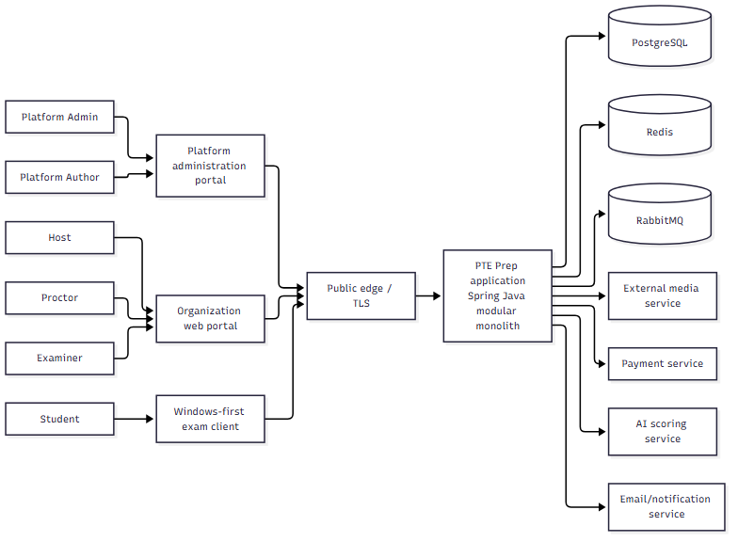
Diagram ID: SD-ARCH-CONTEXT-001 Caption: PTE Prep channels, application boundary, and external services Status: Current architecture boundary with Partial/Planned external feature slices. Evidence/source: EVD-FOUNDATION-003, EVD-FOUNDATION-004, EVD-FOUNDATION-006. Related Report 3 IDs: FR-ONBOARD-001, FR-INTEGRATION-001–FR-INTEGRATION-006, NFR-19.

1.2.1 Public and internal boundaries
- Public edge: terminates TLS and routes web/API traffic by supported domain/path. Users access the supported public edge, not internal application ports.
- Web clients: tenant/organization and platform/vendor web applications provide role-specific workspaces and call the application contract.
- Windows client: receives the fixed exam snapshot through the supported delivery contract and sends answer/heartbeat/submission state with safe correlation.
- Application: authenticates, authorizes, validates, coordinates domain operations, persists state, and exposes business-readable results.
- Database/support: PostgreSQL is the source of relational business state; Redis supports configured cache/rate-limit/single-flight behavior; RabbitMQ supports configured asynchronous work.
- External services: media, payment, AI scoring, email/notification are isolated at integration boundaries. No provider credential appears in a client or report.

1.3 Deployment topology
Figure — PTE Prep process/design diagram
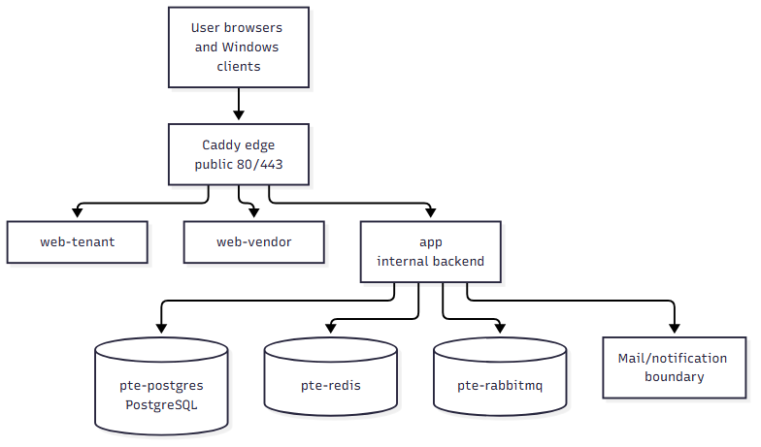
Diagram ID: SD-ARCH-DEPLOY-001 Caption: Single-stack Docker Compose deployment boundary Status: Current deployment topology; availability/capacity targets remain unverified. Evidence/source: pte-api/docker-compose.yml, pte-api/docker-compose.services.yml, pte-api/docker-compose.deploy.yml, EVD-FOUNDATION-006. Related Report 3 IDs: FR-INTEGRATION-004, FR-HARDENING-002, NFR-05–NFR-08, NFR-19.
The hosted stack uses one Oracle VPS and one Docker network for the application, web clients, edge, PostgreSQL, Redis, and RabbitMQ. The deployment overlay applies restart and memory policy. A healthcheck or local Compose status is operational evidence for that environment only; it is not automatically evidence of the SRS availability target.

1.4 Application package ownership
Each package owns one business concern and exposes a small public service/API surface to other packages. Internal repository, mapper, controller, and vendor details stay inside the owning package.
ID | Package/module owner | Main responsibility | Owns | May depend on
PKG-IDENTITY | Identity/access | Sign-in, session, account status, role assignment, recovery | Credential/session and role policy | Shared security/config
PKG-TENANCY | Organization/tenant | Organization lifecycle, ownership, Host scope, Student quota | Organization and tenant boundaries | Identity, audit
PKG-ITEMBANK | Shared content | Task catalog, questions, revisions, media requirements | Question/revision lifecycle | Media integration, audit
PKG-SCORETEMPLATE | Score Template | Task composition, timing, weights, source eligibility, lifecycle | Template revisions | Item bank, audit
PKG-BILLING | Package/license | Packages, orders, callbacks, subscriptions, limits | License and usage rules | Tenant, payment integration, audit
PKG-SESSION | Exam setup | Draft, candidate selection, validation, generation, scheduling, lifecycle | Exam and schedule state | Tenant, item bank, Score Template, billing, audit
PKG-ASSESSMENT | Fixed assessment version | Blueprint/snapshot generation and provenance | Immutable form/version content | Session, item bank, Score Template
PKG-ATTEMPT | Student delivery | Attempt, timer, answer, local-sync contract, submit, heartbeat | Attempt/answer states | Assessment, identity, tenant, audit
PKG-PROCTORING | Supervision/integrity | Proctor assignment, monitoring state, violation/audit events | Proctor session/violation state | Session, attempt, audit, notification
PKG-SCORING | Scoring | Objective/AI/Examiner source state, queue, score results | Score-source records | Attempt, Score Template, provider boundaries
PKG-REPORTING | Reports/publication | Aggregation, readiness, score-source selection, publication | Report/publication state | Attempt, scoring, session, audit
PKG-NOTIFICATION | Notification | Supported event-to-message delivery and retry state | Notification attempt state | Reporting, proctoring, identity, email boundary
PKG-SUPPORT | Support/audit access | Support tickets and controlled assistance | Support request and audit reference | Identity, tenant, audit
PKG-SHARED | Cross-cutting shared utilities | Error/message/correlation/time abstractions | Shared contracts only | No business ownership

Package diagram ID: PKG-DIAGRAM-001 Caption: Ownership map for the modular-monolith application Status: Current package map from source inventory with feature-specific slices classified separately. Evidence/source: pte-api/app/src/main/java/com/pte, EVD-FOUNDATION-003. Related Report 3 IDs: FR-HARDENING-002, FR-HARDENING-003, CR-AUTH-001, NFR-19.

Dependency direction
- Web/client controllers call the owning public application service, not another package’s repository.
- A package may request another package’s public decision/check or consume an explicit event/contract; it must not reach into the other package’s internal objects.
- Domain rules and state transitions live in the owning package. Client validation is helpful feedback, never the final authorization or integrity check.
- Provider SDKs and provider payloads stay behind External Integration Services adapters; domain packages use a project contract/result rather than a vendor type.
- Audit is appended from the operation owner with actor/scope/target/outcome; it is not reconstructed from UI logs.

1.5 Authentication, authorization, and tenant scope

Authentication boundary
The identity package establishes a signed-in principal and account status. It handles sign-in, sign-out, session renewal, password change/reset, lock, and suspension. A successful authentication does not grant access to every tenant or assignment.

Authorization boundary
Every protected operation evaluates:
- authenticated principal and active account;
- human role;
- organization/tenant scope;
- Proctor or Examiner assignment scope when applicable;
- ownership of the target record;
- current lifecycle state and allowed transition;
- action-specific policy (for example, publication or score-source selection).
Public identifiers are lookup keys, not authorization. Repository/query methods that access organization or assignment data require the relevant scope in the owning service contract.

Visibility matrix
Data | Platform Admin | Platform Author | Host | Proctor | Examiner | Student
Organization registration | Platform-wide | No | Own post-approval context | No | No | No
Shared content drafts/revisions | Platform-wide policy scope | Assigned draft scope | Select published only | No | No | Delivered snapshot only
Student roster | Controlled support | No | Own organization | Assigned exam subset | Assigned work context | Own identity/attempt
Answers/audio | Authorized operational/audit purpose | No | Own organization policy | Assigned attempt policy | Assigned answers | Own answers
Scores/reports | Platform audit/support | No | Own organization | Assigned status only | Assigned score context | Own published report

1.6 External integration design

Media
The browser/client requests a short-lived signed upload/access instruction from the application, uploads directly to Cloudinary (the configured initial media service) where enabled, and reports the resulting media reference. The application validates media completion and associates it with a question revision. A failed or expired link returns a retryable status. Credentials never travel through the report or client.

Payment
The application creates a provider-correlated order. The provider callback is verified and processed idempotently. Browser return is not payment proof. The billing package owns subscription/license activation; the payment adapter owns provider-specific request/response translation.

AI scoring
The scoring package creates a correlated provider request when the task and policy allow it. A worker or asynchronous handler records pending, success, failure, retry, or review-needed status. Provider quality thresholds, final provider, and task-level Examiner review remain TBD-AI-001/TBD-AI-002. A failed provider response does not become a valid final score.

Notification
Notification consumes an approved business event/state and records delivery attempt. It does not own the report, subscription, exam, or score state. Retries are bounded and do not roll back the originating business operation.
Integration decision ID: ADR-INTEGRATION-001 Decision: isolate provider contracts behind adapters and keep the business result in the owning package. Status: Current boundary; provider-specific coverage is Partial/Planned/TBD. Evidence/source: EVD-FOUNDATION-003, EVD-FOUNDATION-005, EVD-FOUNDATION-007. Related requirements: FR-INTEGRATION-001–FR-INTEGRATION-006, BR-INTEGRATION-044–BR-INTEGRATION-048, NFR-19.

1.7 Cross-cutting state principles

Fixed exam version
The session package validates and asks the assessment package to create a fixed version. The version contains the selected task/prompt/media revisions, Score Template revision, form mode, candidate snapshot, integrity policy, and provenance. The attempt package reads the fixed version; it does not rebuild a question from the current shared bank during a running attempt.

Idempotency
Operations with possible retry use a business correlation key or deterministic existing-state lookup:
Operation | Duplicate-safe outcome
Registration approval | Existing organization/Host state is returned; no duplicate tenant.
Payment callback/license redemption | Existing order/subscription state is returned; no second activation.
Candidate enrollment | Existing enrollment is returned or conflict is reported.
Version generation | Existing successful/pending/error generation is returned or safely resumed.
Answer synchronization | Accepted answer is returned; a duplicate request does not add a second accepted answer.
Attempt submission | Existing final state is returned.
Score provider result | Correlated result is upserted once and retains source status.
Report publication | Existing publication state is returned; notification retry is separate.

Audit
The owning package produces an audit record for a sensitive state change. The record includes actor, actor role, organization/assignment scope, action, target type/ID, previous/result status where safe, time, correlation reference, and outcome. Raw answer/media content and credentials are not copied into ordinary audit text.

1.8 Design decisions and unresolved items
ID | Decision/status | Consequence
ADR-ARCH-001 | One deployed Spring/Java modular-monolith application behind an edge; Current topology. | Package ownership and public boundaries must remain explicit.
ADR-ARCH-002 | One PostgreSQL database for the application baseline; Current topology. | Cross-package access uses public service/API boundaries, not unrelated repositories.
ADR-EXAM-001 | Fixed assessment snapshot before delivery; requirement/design baseline. | Shared content edits do not rewrite attempts.
ADR-ANSWER-001 | Local-first answer persistence with retryable synchronization; Partial/Planned pending end-to-end evidence. | Client and server tests must cover interruption, duplicate, and recovery.
ADR-PROCTOR-001 | Proctor events are assignment-scoped and auditable; exact synchronization remains TBD-PROCTOR-001. | Do not claim guaranteed live delivery timing.
ADR-SCORE-001 | Host chooses final score source after objective/AI/Examiner sources are visible; AI/provider policy TBD. | Publication readiness must block incomplete sources.
ADR-DATA-001 | Contract-based retention; exact period and jurisdiction are TBD. | Guides and operations cannot promise a universal deletion date.

2. Database Design
This section maps the original DOCX heading 2. Database Design. It describes the relational ownership and invariants needed for PTE Prep. It does not invent columns that were not supported by the reviewed source. Detailed table/column migrations remain implementation evidence or TBD items.

2.1 Data ownership principles
- Every organization-owned row carries an organization/tenant ownership path that the owning service checks on read and write.
- Assignment-owned Proctor and Examiner data carries both the exam/attempt scope and the assigned actor scope.
- A published or running exam references immutable content/template revisions rather than current mutable drafts.
- Attempt answers are append/update controlled by attempt/task state and an idempotent client correlation key.
- Score sources remain separate until Host source selection; the report stores the selected source and provenance.
- Audit events are append-oriented and reference the action target without copying unnecessary sensitive payloads.
- Retention classification is contract-based; no universal period is encoded in this document (TBD-RETENTION-001).
Evidence/status: Entity ownership follows the approved requirement and repository domain inventory (EVD-FOUNDATION-001, EVD-FOUNDATION-003). Exact schema support is Current only where source/migration evidence confirms it; future relationships are Planned/Future or TBD.

2.2 Conceptual entity catalogue
ID | Entity/concept | Owner | Key relationships | Lifecycle/invariant
DB-ORGANIZATION | Organization/tenant | PKG-TENANCY | Has registrations, users, Students, packages, exams | Only approved organization can operate; tenant ID is required for private data.
DB-REGISTRATION | Public organization registration | PKG-TENANCY | May materialize one organization and first Host | PENDING/approved/rejected state; approval is idempotent.
DB-USER | Account/principal | PKG-IDENTITY | Role/membership links, assignments | Account status and role are separate from organization data.
DB-USER-MEMBERSHIP | User-to-organization role/scope | PKG-IDENTITY/PKG-TENANCY | User, organization, role | Role must be one approved human role; scope is enforced.
DB-STUDENT | Organization Student profile | PKG-TENANCY | Organization, classes, enrollments, attempts | One organization in this release; duplicates/capacity checked before commit.
DB-PROGRAM | Organization program | PKG-TENANCY | Organization, classes/Students | Active state controls selection.
DB-CLASS | Organization class | PKG-TENANCY | Program, Student membership | Membership changes are explicit/auditable.
DB-REGISTRATION-MEMBERSHIP | Student/program/class membership | PKG-TENANCY | Student, class/program | No duplicate active membership; published audience is independent snapshot.
DB-PACKAGE | Package definition | PKG-BILLING | Subscription/license/order | Platform-controlled version/effective state.
DB-ORDER | Organization package order | PKG-BILLING | Organization, provider correlation | Callback/browser distinction; idempotent status.
DB-SUBSCRIPTION | Activated organization package/license | PKG-BILLING | Organization, package, license, usage | Active/date/limit checked before exam.
DB-QUESTION | Logical shared question | PKG-ITEMBANK | Revisions, task type, media | Logical identity persists across revisions.
DB-QUESTION-REVISION | Immutable question revision | PKG-ITEMBANK | Question, media, Score Template use | Locked exam references do not change.
DB-MEDIA-REFERENCE | Image/audio metadata/provider reference | PKG-ITEMBANK/media boundary | Revision, provider status | Completion/access state and safe renewal.
DB-SCORE-TEMPLATE | Logical Score Template | PKG-SCORETEMPLATE | Revisions, task catalog | Active/retired lifecycle; historical versions remain readable.
DB-SCORE-TEMPLATE-REVISION | Fixed task/weight/timing/source configuration | PKG-SCORETEMPLATE | Task rows, exam version | Version is immutable after exam lock.
DB-EXAM | Exam/session business aggregate | PKG-SESSION | Organization, package, version, audience | Draft/validated/generated/published/open/closed/cancelled states.
DB-EXAM-CANDIDATE-SNAPSHOT | Frozen audience membership | PKG-SESSION | Exam, Student | Changes after publication do not rewrite snapshot.
DB-EXAM-VERSION | Fixed content/policy snapshot | PKG-ASSESSMENT | Exam, revisions, template | Contains provenance/form mode and cannot mutate for active attempt.
DB-EXAM-FORM | Shared/unique form assignment | PKG-ASSESSMENT | Exam version, Student/attempt | Form mode and no-duplicate rule are enforced.
DB-EXAM-STAFF-ASSIGNMENT | Proctor/Examiner assignment | PKG-SESSION | Exam, user, scope | Assignment checked before action.
DB-EXAM-ATTEMPT | Student delivery instance | PKG-ATTEMPT | Student, exam, form, answers | One active/final attempt per policy; state transition explicit.
DB-ATTEMPT-ANSWER | Task response and sync state | PKG-ATTEMPT | Attempt, task/revision | Local correlation/idempotency and accepted/retry/rejected state.
DB-ATTEMPT-HEARTBEAT | Client liveness/status signal | PKG-ATTEMPT | Attempt, time | Does not replace answer acceptance or submission.
DB-SECURITY-EVENT | Device/lockdown/attempt security event | PKG-ATTEMPT | Attempt, policy | Sensitive event is auditable and retention-classified.
DB-PROCTOR-SESSION | Proctor monitoring session | PKG-PROCTORING | Exam, Proctor | Only assigned Proctor; pending/error state allowed.
DB-VIOLATION-EVENT | Integrity violation/assistance record | PKG-PROCTORING | Proctor session, attempt | Actor/time/policy/detail preserved; outcome is policy-driven.
DB-SCORING-ASSIGNMENT | Examiner work assignment | PKG-SCORING | Exam/attempt/answer, Examiner | One active owner unless review policy permits otherwise.
DB-SCORE-SOURCE | Objective/AI/Examiner result | PKG-SCORING | Answer, source, provider/rubric | Source status and provenance retained separately.
DB-SCORE-SELECTION | Host final source decision | PKG-REPORTING | Report/task/section/source | Narrower scope overrides broader only by policy.
DB-REPORT | Aggregated result/readiness | PKG-REPORTING | Attempt, exam version, template | Not visible to Student until published.
DB-PUBLICATION | Host publication action/state | PKG-REPORTING | Report/exam, Host | Idempotent and auditable.
DB-NOTIFICATION | Notification attempt/status | PKG-NOTIFICATION | Source business event, recipient | Failure does not roll back source action.
DB-AUDIT-EVENT | Sensitive operation audit | Owning package/audit surface | Actor, tenant/assignment, target | Append-oriented, protected, contract-retained.

2.3 Entity relationship model
Figure — PTE Prep process/design diagram
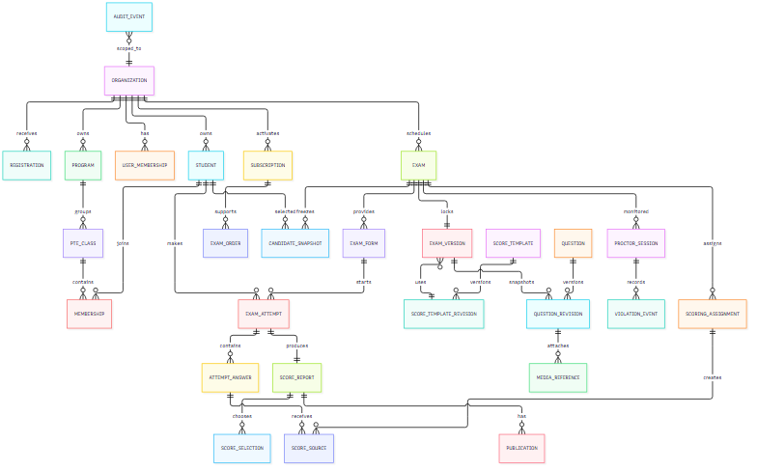
ERD ID: DB-ERD-001 Caption: PTE Prep organization, fixed exam, attempt, scoring, and publication relationships Status: Planned/Future conceptual design; exact columns and migrations require source/schema evidence. Evidence/source: EVD-FOUNDATION-003, EVD-FOUNDATION-005. Related Report 3 IDs: FR-EXAM-004, FR-EXAM-009, FR-DELIVERY-005–FR-DELIVERY-008, FR-SCORE-007, FR-REPORT-003–FR-REPORT-005, NFR-09, NFR-13.

2.4 Fixed-version and provenance invariants

`DB-INV-001` — Exam version immutability
Once a published exam has a generated version or an attempt has started, the version cannot be changed in place. A correction creates a new draft/version according to the lifecycle policy.

`DB-INV-002` — Revision provenance
Each fixed task stores or references the logical question, question revision, media reference/revision, Score Template revision, and effective policy used for delivery. The current question-bank row is not enough to reconstruct an old attempt.

`DB-INV-003` — Audience snapshot
The exam stores the Student set used for publication. Later class/program membership changes do not add/remove a Student from the published exam automatically.

`DB-INV-004` — Form uniqueness
The selected form policy is stored for the exam. A form cannot contain the same question revision twice under the current business rule. Unique per-Student assignments use the exam/form/Student key to prevent duplicate assignment.

`DB-INV-005` — Attempt state
An attempt moves through explicit states such as eligible, in progress, submitting, submitted, scored/pending, published/closed according to the approved state model. An invalid transition is rejected with a business message.

`DB-INV-006` — Answer correlation
An answer includes task identity, attempt identity, client correlation/idempotency key, local/server sync state, and accepted/rejected reason where applicable. A repeated request returns the existing accepted/rejected outcome.

`DB-INV-007` — Score-source separation
Objective, AI, and Examiner results are stored as separate source records. Host selection creates/updates a separate selection decision; it does not erase unselected source history.

`DB-INV-008` — Publication gate
Publication requires required score sources and source-selection conditions to be ready. A report may exist in pending/draft form but is not Student-visible until a publication record exists.

2.5 Keys, uniqueness, and query needs
The following logical constraints are required even when physical names differ:
Constraint | Purpose | Failure message
Organization name/code uniqueness within platform policy | Prevent duplicate tenant identity. | Organization already exists or needs review.
User/Student identity uniqueness within organization policy | Prevent duplicate roster entries. | Student matches an existing record.
Active membership uniqueness | Prevent duplicate class/program membership. | Student is already assigned.
Order/provider correlation uniqueness | Prevent duplicate payment activation. | Payment result was already processed.
License redemption uniqueness | Prevent code reuse. | License code is unavailable/already used.
Exam/package overlap constraint | Enforce same-license schedule policy. | Exam time conflicts with an existing package use.
Exam candidate uniqueness | Prevent repeated Student in one audience. | Candidate was listed more than once.
Exam version one-to-one lock | Make fixed snapshot explainable. | Exam version is already locked.
Attempt/exam/Student policy uniqueness | Prevent unauthorized duplicate attempt. | An attempt already exists or retake is not allowed.
Answer/attempt/task/correlation idempotency | Prevent duplicate accepted answer. | Answer was already accepted or rejected.
Active scoring assignment uniqueness | Avoid conflicting Examiner ownership. | Answer is assigned to another Examiner.
Report/publication idempotency | Prevent duplicate publication. | Report already has the requested publication state.

Large roster, candidate, queue, report, and audit queries must be paginated or bounded. The query boundary must carry organization/assignment scope and must not expose the entire table by default (NFR-04, NFR-09).

2.6 Lifecycle and retention classification
Data family | Active use | Historical use | Retention statement
Registration/account | Onboarding/access | Decision/support audit | Contract and platform policy; do not retain secrets in notes.
Questions/media/revisions | Content/exam generation | Fixed-version provenance | Retain revisions needed to explain locked exams; provider media deletion policy is TBD.
Package/order/subscription | Activation/limits | Billing/audit | Contract and payment record policy; provider payload minimization.
Exam/version/audience | Scheduling/delivery | Report/provenance | Retain according to organization contract.
Answers/audio/attempt state | Delivery/scoring | Review/report | Contract-based retention; local client recovery has separate device risk.
Scores/reports/publication | Review/Student visibility | Audit/export | Contract-based retention; exact period and legal hold TBD.
Proctor/Examiner/audit events | Integrity/scoring/publication | Investigation | Contract-based retention; append/tamper evidence policy TBD.

TBD-RETENTION-001 is a blocking policy decision before a production data-lifecycle guide can promise a universal deletion date. The database design must support future deletion/export/legal hold without weakening the fixed-version/report provenance requirement.

2.7 Data protection rules
- Do not store provider credentials, tokens, or passwords in business tables.
- Mask Student identity, audio, answers, and reports in test fixtures and screenshots.
- Keep raw provider payloads only when the contract and data policy permit, and minimize fields otherwise.
- Restrict audit access separately from ordinary Host/Student views.
- Include time zone/offset meaning for exam scheduling and audit timestamps.
- Treat local client answer storage as sensitive and document device cleanup/recovery boundaries.

3. Detailed Design
This section maps the original DOCX heading 3. Detailed Design. It explains how the most important PTE Prep flows cooperate across owned packages. The descriptions are implementation-oriented but remain tied to the Report 3 business requirements. A future or TBD step is labelled rather than presented as a working product behavior.

3.1 Detailed design notation
Notation | Meaning
PKG-* | Owning application package from System Design.
DB-* | Logical data entity/invariant from Database Design.
SEQ-* | Interaction sequence in this section.
SD-* | Design element/decision.
FR-* / BR-* | Requirement/business-rule link from Report 3.
Current | Source/configuration/UI/API evidence supports the claim.
Partial | An implementation slice exists but the complete journey or safeguard is incomplete.
Planned/Future | Approved design direction without current end-to-end evidence.
TBD | A policy, contract, or recovery decision is not fixed.

3.2 Onboarding and Host activation

Components and responsibilities
Component | Responsibility
Public registration controller | Accepts and validates registration input; creates only DB-REGISTRATION in pending state.
PKG-TENANCY registration service | Owns approval transition, organization materialization, tenant scope, and first Host relationship.
PKG-IDENTITY | Creates/activates the Host principal and applies sign-in/session policy.
PKG-BILLING | Keeps package/order/subscription separate from registration; checks package state later.
Audit writer | Records registration decision, materialization, account state, and support actions.
Notification boundary | May inform the registrant/Host after an approved state; does not own activation.

`SEQ-ONBOARD-001` — Registration to active Host
Figure — PTE Prep process/design diagram
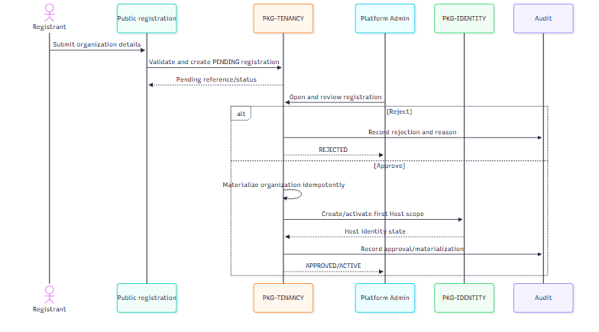
Sequence ID: SEQ-ONBOARD-001 Caption: Idempotent organization approval and first Host creation Status: Partial/Planned/Future depending on the verified end-to-end route; the state rule is approved. Evidence/source: EVD-FOUNDATION-003, EVD-FOUNDATION-004; incomplete recovery remains TBD-GENERATION-001 only for later exam generation, not onboarding. Related Report 3 IDs: FR-ONBOARD-001–FR-ONBOARD-004, BR-ACCESS-007–BR-ACCESS-008, NFR-10–NFR-12.

Error and concurrency rules
- A duplicate approval request returns the existing organization/Host state instead of creating another tenant.
- Registration rejection records a reason; it does not delete the original request from audit history.
- Host creation failure leaves the organization in a visible recovery state; a retry must not create a second Host relationship.
- Package activation is deliberately not called inside registration approval. It is a later Host action with its own payment/license evidence.

3.3 Content, media, and Score Template preparation

Responsibilities
- PKG-ITEMBANK owns logical questions, revisions, task catalog validation, and media requirement state.
- Media adapter owns signed provider access and provider error translation.
- PKG-SCORETEMPLATE owns task rows, timing, weights, score-source eligibility, and template lifecycle.
- Platform Author can create/submit drafts; Platform Admin owns approval/publication.
- A generated exam references immutable revisions; no later edit mutates the running exam.

`SEQ-CONTENT-001` — Draft to published revision
Figure — PTE Prep process/design diagram
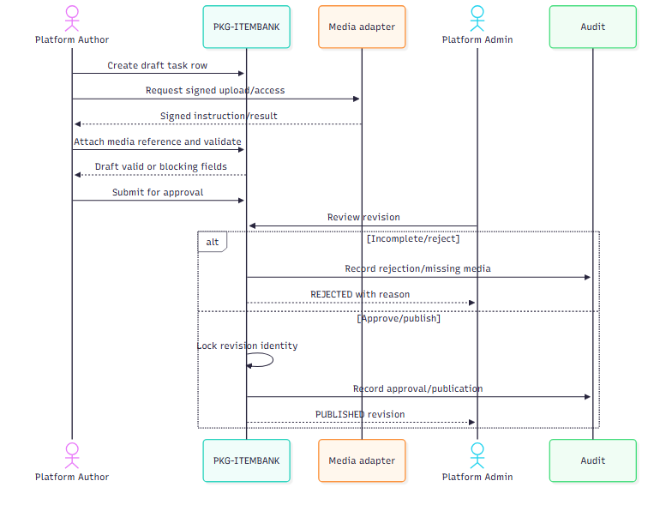
Sequence ID: SEQ-CONTENT-001 Caption: Shared question/media revision governance Status: Partial/Planned/Future by source slice; media provider quality remains external. Evidence/source: EVD-FOUNDATION-003, EVD-FOUNDATION-005. Related IDs: FR-CONTENT-001–FR-CONTENT-005, BR-CONTENT-012–BR-CONTENT-016, NFR-12, NFR-19.

Template activation rules
PKG-SCORETEMPLATE validates that each task row belongs to the canonical 23-row catalog, that required timing/response/source fields exist, and that the treatment of Personal Introduction is explicit. Platform Admin approval creates an active revision. Retirement prevents new exam selection but does not invalidate historical fixed versions.

3.4 Exam draft, validation, generation, and scheduling

Component responsibilities
Component | Inputs | Outputs
PKG-SESSION draft service | Host draft fields, package/template/mode, candidate source | Draft and candidate preview
Candidate resolver | Student/class/program selection | Deduplicated candidate snapshot with reasons
Validation service | Draft, package, content, schedule, assignments, policy | Blocking/warning result
PKG-ASSESSMENT generation service | Validated draft, revisions, Score Template, form mode, provenance | Fixed DB-EXAM-VERSION, forms, generation status
Audit writer | Every material transition | Actor/time/scope/outcome record

`SEQ-EXAM-001` — Host creates a fixed exam version
Figure — PTE Prep process/design diagram
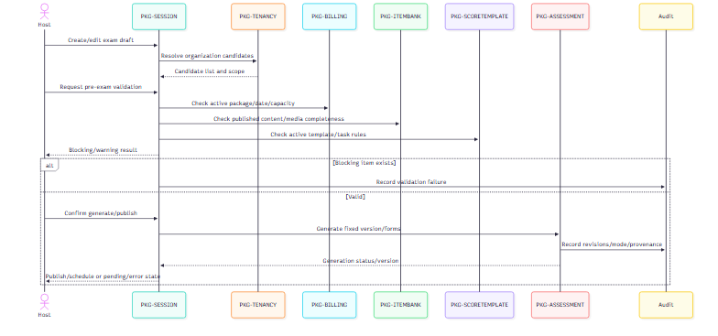
Sequence ID: SEQ-EXAM-001 Caption: Pre-exam validation, fixed snapshot generation, and publication Status: Partial/Planned/Future; current source contains assessment/session slices, while end-to-end recovery is not assumed. Evidence/source: EVD-FOUNDATION-003, EVD-FOUNDATION-005, TBD-GENERATION-001, TBD-VERSION-001. Related IDs: FR-EXAM-001–FR-EXAM-009, FR-HARDENING-001, BR-EXAM-023–BR-EXAM-029, NFR-04, NFR-09.

Generation state model
Figure — PTE Prep process/design diagram
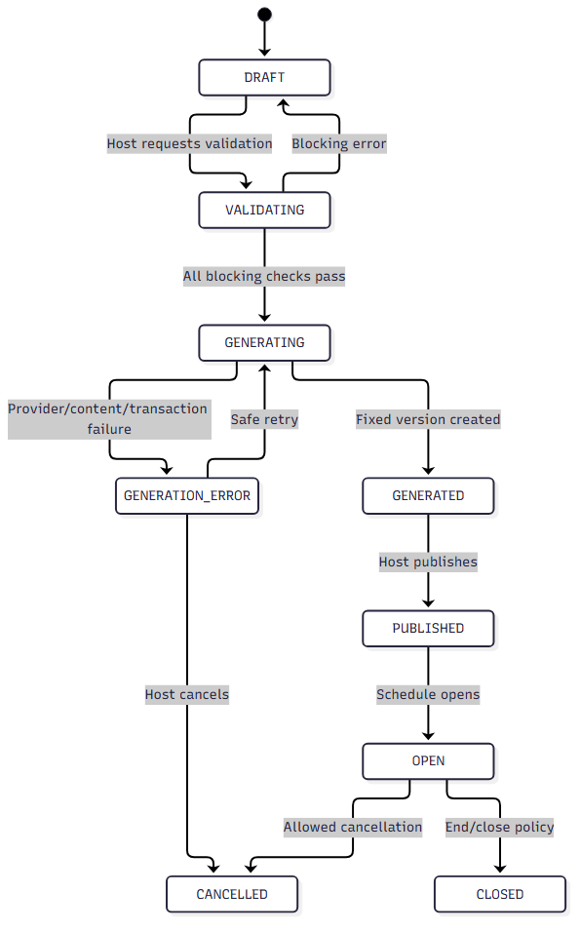
State ID: SD-EXAM-STATE-001 Caption: Exam draft and generation lifecycle Status: Planned/Future state contract; exact transitions need implementation/evidence review. Evidence/source: Report 3 FR-EXAM-006–FR-EXAM-007, TBD-GENERATION-001. Related IDs: BR-EXAM-023, BR-EXAM-027, CR-IDEMPOTENCY-001.

Validation result contract
Each validation item includes a stable category, affected object, severity (blocking or warning), safe user message, and correction hint. Categories include:
- missing/incomplete question or media;
- inactive/retired Score Template;
- package inactive/expired/date mismatch/capacity exceeded;
- duplicate/inactive/conflicting Student;
- shared-license schedule overlap;
- missing Proctor/Examiner assignment required by policy;
- unsupported mode or device policy;
- generation provenance unavailable.
The validation service must not mutate the final published audience or content while merely previewing a draft.

3.5 Student delivery, local save, synchronization, and submission

Component responsibilities
Component | Responsibility
Windows client | Device check, task display, timers, local answer store, queued sync, user-visible state.
PKG-ATTEMPT access service | Admit eligible Student, resolve attempt/form, enforce timer/policy.
Answer service | Validate task/version/attempt/ownership and accept idempotently.
Local outbox/sync coordinator | Retry transient failures with bounded backoff; preserve correlation key and result.
Heartbeat service | Record liveness/status separately from answer acceptance.
PKG-PROCTORING | Expose assigned monitoring/allowed intervention state.
Audit/security event service | Record device/policy/violation/submit events without logging raw sensitive payload unnecessarily.

`SEQ-DELIVERY-001` — Answer save and retry
Figure — PTE Prep process/design diagram
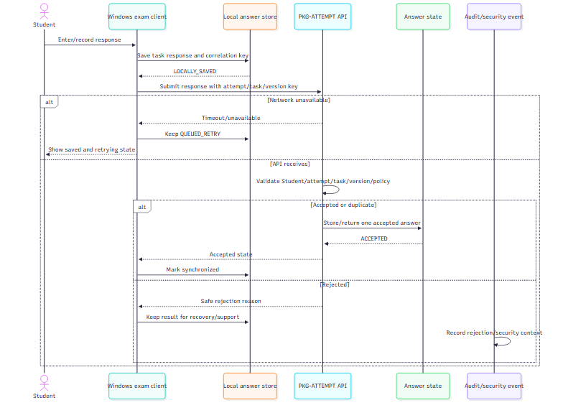
Sequence ID: SEQ-ANSWER-SYNC Caption: Local-first answer persistence and idempotent retry Status: Partial/Planned/Future; exact Windows client offline evidence is TBD-CLIENT-001. Evidence/source: EVD-FOUNDATION-003, approved Student delivery plan, TBD-PROCTOR-001 for related violation sync. Related IDs: FR-DELIVERY-003–FR-DELIVERY-009, BR-DELIVERY-030–BR-DELIVERY-034, NFR-02, NFR-03, NFR-06, NFR-12.

Attempt state and timer invariant
The attempt service is the authority for admission, timer/policy state, and final submission. The client displays and locally tracks state for user feedback, but it cannot extend time, accept an answer for another Student, or change a submitted attempt by itself. Heartbeat absence is a status signal; it is not automatically a score or violation without policy.

3.6 Proctoring and integrity audit

`SEQ-PROCTOR-AUDIT` — Assigned monitoring and violation
Figure — PTE Prep process/design diagram
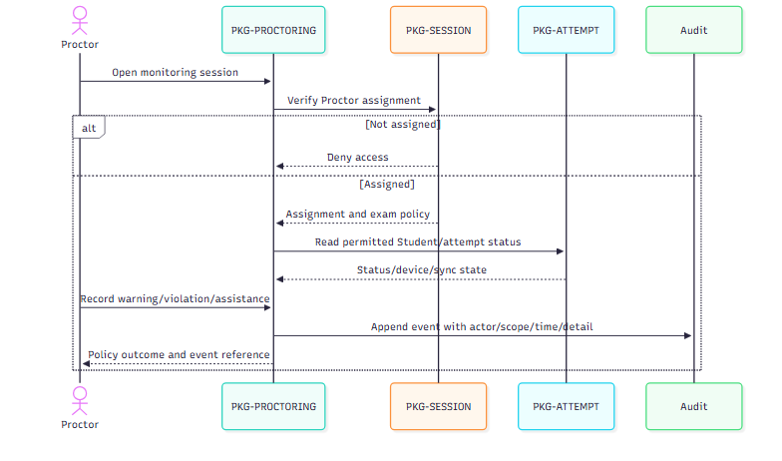
Sequence ID: SEQ-PROCTOR-AUDIT Caption: Assignment-scoped Proctor monitoring and audit event Status: Partial/Planned/Future; exact live synchronization remains TBD-PROCTOR-001. Evidence/source: Proctor implementation/plan evidence under EVD-FOUNDATION-003, EVD-FOUNDATION-005. Related IDs: FR-INTEGRITY-001–FR-INTEGRITY-005, BR-INTEGRITY-035, BR-INTEGRITY-039, NFR-09, NFR-10.
The first Practice policy records a violation and warning without automatic invalidation. A stricter policy may issue an allowed command such as extend time or force submit only when the fixed attempt policy contains that behavior. Any command must be idempotent and visible in audit.

3.7 Examiner assignment, scoring, and publication

Responsibilities
- PKG-SCORING creates assignment/queue state and owns score-source records.
- Examiner workspace reads only assigned prompt/response/rubric and submits a score once per allowed unit.
- Objective scoring is deterministic for supported task types; unsupported responses remain pending rather than receiving a fake result.
- AI adapter records provider state and does not own publication.
- PKG-REPORTING owns readiness, Host source selection, aggregation, and publication.

`SEQ-SCORE-PUBLISH-001` — Score, review, and publish
Figure — PTE Prep process/design diagram
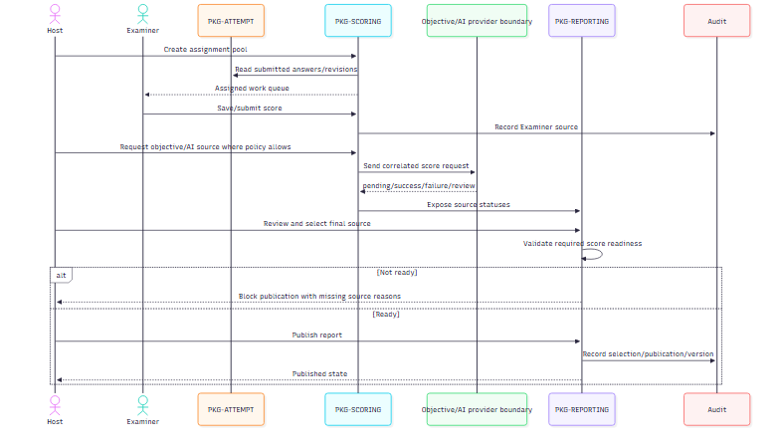
Sequence ID: SEQ-SCORE-PUBLISH-001 Caption: Examiner/automated scoring, Host source review, and report publication Status: Partial/Planned/Future; source/provider policies include TBD items. Evidence/source: EVD-FOUNDATION-003, EVD-FOUNDATION-005, TBD-AI-001, TBD-AI-002. Related IDs: FR-SCORE-001–FR-SCORE-007, FR-REPORT-001–FR-REPORT-005, BR-SCORE-036–BR-SCORE-038, BR-REPORT-040–BR-REPORT-043, NFR-10.

Publication gate
The report service evaluates required tasks, source statuses, Host selection scope, locked Score Template, and attempt/report ownership. It returns a blocking list if any required item is missing, pending, invalid, failed, or unreviewed. Publication is an explicit Host action, idempotent on retry, and independent of notification delivery.

3.8 Error handling and retry design
Failure | Owning package | Retry? | State visible to user | Invariant
Invalid registration | Tenancy | No until corrected | Field/reason | No active tenant created.
Duplicate approval/callback | Tenancy/Billing | Safe replay | Existing state/duplicate message | One materialization/activation.
Missing content/media | Item bank/assessment | After correction | Blocking validation | No incomplete published version.
Generation timeout/error | Session/assessment | Yes, bounded and correlated | Pending/error/retry/cancel | No partial publication.
Answer network timeout | Attempt/client | Yes, bounded/backoff | Local saved/queued/retrying | No silent loss/duplicate acceptance.
Device check failure | Client/attempt | After correction/escalation | Failed item | No timed work before required check.
Proctor event interruption | Proctoring | Safe retry; exact delivery TBD | Pending/error | Event is not silently lost.
AI/provider timeout | Scoring/integration | Yes per provider policy | Pending/failed/review | No fake valid score.
Missing Examiner score | Scoring/reporting | Complete/reassign | Report blocked | No partial publication.
Notification failure | Notification | Bounded retry | Delivery failed | Business result remains.

Retries must exclude validation, authorization, and conflict failures. External calls require timeout and provider correlation. Queue consumers/processors must tolerate at-least-once delivery where that infrastructure is used.

3.9 Design acceptance and open points
- The single application boundary, package ownership, PostgreSQL/Redis/RabbitMQ support, public edge, and no-secret rule are documented.
- Fixed version, provenance, tenant/assignment scope, answer retry, score-source separation, and publication gating are explicit.
- Requirement links called out for review include FR-DELIVERY-006 (answer retry), FR-INTEGRITY-003 (violation recording), and FR-SCORE-005 (Host score-source review).
- Every sequence/diagram has ID, caption, status, source/evidence, and Report 3 links.
- Exact AI provider/threshold/review policy remains TBD-AI-001/TBD-AI-002.
- Exact violation delivery/recovery remains TBD-PROCTOR-001.
- Exact generation recovery and form/audience policy remain TBD-GENERATION-001/TBD-VERSION-001.
- Exact database columns/migrations and client device matrix require source or execution evidence before being labelled Current.

