Scope Tutorial > Introduction

Author: Scope PM Team

Date: 11/27/2018

# Introduction

The Scope Tutorial covers the basics of batch querying in Cosmos. You will get familiar with the language while running Scope scripts on your machine. You DO NOT need access to a Cosmos Virtual Cluster.

## Scope

Scope in general refers to the compute/query system in Cosmos which includes the Scope query language, the Scope optimizer, the Scope runtime. The Scope Tutorial is focused on the Scope query language. Unless otherwise speificied, when this document mentions “Scope” it refers to the Scope query language.

## Scope Is Not SQL

Scope queries look similar to SQL queries. Many fundamental concepts and syntactic expressions will be very familiar to those with a background in SQL. However, Scope is a distinct language. Many of the expectations you might have from SQL DO NOT carry over into Scope.

## Finding the Scope tutorial

You can always find the latest version of the Scope here: <http://aka.ms/ScopeTutorial>

## Send your questions to Cosmos Discussion

* Click here to [[SEND EMAIL TO COSMOS DISCUSSION](mailto:cosmdisc@microsoft.com)]
* Click here to [[JOIN COSMOS DISCUSSION](http://idwebelements/GroupManagement.aspx?Group=CosmDisc&Operation=join)]

## Sample Scope scripts

* Many samples are available at <http://aka.ms/CosmosCodeSamples>
* Also for a searchable repository of scripts try <http://aka.ms/scriptlibrary> or <http://cosmossearch>

# Prerequisites

* An x64 Windows installation. The Scope compiler, runtime, optimizer only works on an x64 system.
* Windows PowerShell
* Visual Studio 2017

# Core Concepts

Before we actually run a script, we’ll take a look review some basics.

At a first level of approximation, a Scope script maps some input to some output via a processing step.

INPUT -> PROCESS -> OUTPUT

**Inputs** and **Outputs** are **Cosmos Streams**. A stream is a file-like data stored in Cosmos. If you run a script locally as stream is just a normal file like any other on your machine.

A typical Scope script has at least one Input and at least one Output – though there are special cases where they can have zero inputs or zero outputs.

During the Process phase an input stream is transformed into a **rowset.** Rowsets are how Scope internally passes data during script execution**.** That rowset may be transformed to other rowsets.

## Script Walkthrough

Below is an example of the conceptually smallest Scope script.

rs0 = EXTRACT

FirstName : string,

LastName : string,

Age : int

FROM

"/my/SampleData/test_input.tsv"

USING DefaultTextExtractor();

OUTPUT rs0

TO "/my/output.tsv"

USING DefaultTextOutputter();

### Script Structure

* There are two Scope statements. The first uses EXCTRACT command to build a RowSet called rs0 from an input stream and the second statement uses the OUTPUT command to write that RowSet to an output stream.

### Reading Data

* The **EXTRACT** command transforms a stream into a rowset.
* The **EXTRACT** command uses **DefaultTextExtractor** to parse the stream. By default DefaultTxtExtractor assumes it is reading a TSV (tab-separated-value) file.
* The **DefaultTextExtractor** command does not know the schema of the file it is reading, so we must always provide the schema.

### Writing Data

* The rows that are read from the EXTRACT statement flow into a rowset we named **rs0**.
* The **OUTPUT** command sends the rows from rowset **rs0** to an output stream.
* The **OUTPUT** command uses **DefaultTextOutputter** to format the row into a TSV format.

### Scope Keywords are Upper-Case

Notice that some keywords are capitalized. For example: **EXTRACT**, **FROM**, and **USING**. Scope takes capitalization very seriously, so writing **extract** instead of **EXTRACT** will cause a compilation error. Just remember to capitalize every Scope keyword in your scripts.

### Other Notes

* Calling **DefaultTextExtractor** without any arguments is equivalent to **DefaultTextExtractor**( delimiter: 't' ) which explicitly identifies that the file is delimited by tabs.
* Assume that all stream names are case-sensitive. Sure, when running locally it doesn't matter but when running in the cluster it does. Likewise, stick to the "/" separator. It works both locally and for remote execution unlike "\" which only works on local execution.

## Streams

Ultimately reading data means reading from a stream. There are two kinds: Structured and Unstructured.

**Structured Streams**

Structured streams are streams that are optimized for storage and access. These are special Cosmos format that Cosmos understands. The format contains the schema. Because Cosmos knows about the schema in Structured Streams there is a special syntax to read and write to them (EXTRACT and OUTPUT aren’t used)

**Unstructured Streams**

These are any stream that isn’t structured. The key characteristic of these streams is that Cosmos does NOT inherently know about their schema or format. Thus, the schema must be defined by the user.

## **Views**

A **VIEW** simplifies reading from streams. A great example of why you would use a VIEW is that it can take on the responsibility of reading multiple rowsets, doing all the joining, filtering, etc for you. We’ll get into VIEWs shortly in this tutorial.

## Extractors and Outputters

As mentioned already, unstructured streams require an extractor for reading and an outputter for writing. For TSV/CSV data Scope comes with a **DefaultTextExtractor** and a **DefaultTextOutputter**. Also users can create their own custom Extractors and Outputters.

# Running Scope on your own Machine

## Download the Cosmos Samples

Go here: <http://aka.ms/CosmosCodeSamples>

Click on **Repos > Files > Cosmos Samples > … > Download as Zip.**

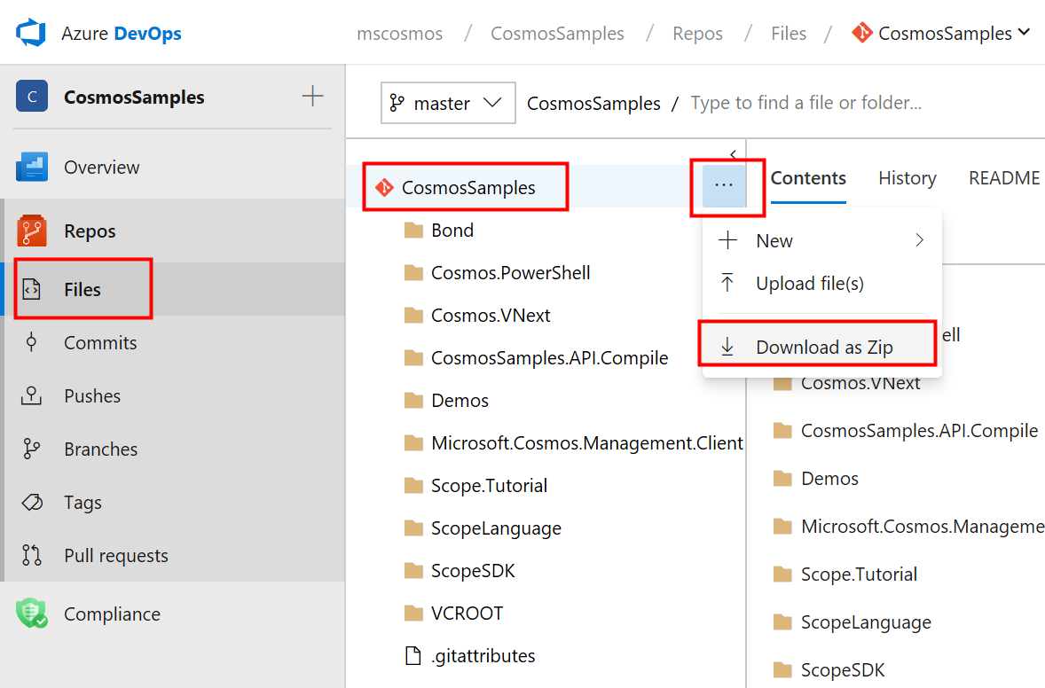

Move the **CosmosSamples.zip** files to **d:\CosmosSamples.zip**

Right-click on the zip file and select **Extract All...**

Extracting the zip will create a folder called D:\CosmosSamples.

## Installing the Scope SDK

Using Windows PowerShell run the script called InstallScopeSdk.ps1 in the d:\CosmosSamples\Scope.Tutorial folder.

The script creates three folders:

* d:\ScopeSDK
* d:\VcRoot
* d:\ScopeTemp

The **ScopeSDK** folder is where the Scope compiler and related binaries are store.

We will tell scope.exe to write its temporary files in **ScopeTemp**.

We will use the **VcRoot** folder to represent the root path of a “vc” running on our machine.

## Setting up VcRoot with Sample Data

Use the command line below to copy files from D:\CosmosSamples\VcRoot to d:\VcRoot. Note that this will "reset" the VcRoot folder.

Robocopy d:\CosmosSamples d:\VcRoot /MIR

## Running your fist script

Copy the following code to d:\test.script

searchlog =

EXTRACT UserId : int,

Start : DateTime,

Region : string,

Query : string,

Duration : int,

Urls : string,

ClickedUrls : string

FROM "/my/SampleData/SearchLog.txt"

USING DefaultTextExtractor();

OUTPUT searchlog

TO "/my/output.tsv"

USING DefaultTextOutputter();

This script is very similar to the very first script we saw.

Let’s run the script:

d:\ScopeSDK\scope.exe run -i d:\test.script -INPUT_PATH d:\vcroot -OUTPUT_PATH d:\vcroot -workingRoot d:\ScopeTemp -RESOURCE_PATH d:\VcRoot

Key points:

* The **run** parameter means compile & run a script
* The **-i** parameter indicates the input script
* The **-INPUT_PATH** and **-OUTPUT_PATH** tell the compiler where to read and write files – essentially we are using this to indicate the root folder of the “local” vc.
* The **-RESOURCE_PATH** is where other resources (views, DLLs, will be found) – We’ll re-use the vcroot for this also
* The **-workingRoot** identifies where Scope will put its temp files

If you run the script this file will be created: **d:\VcRoot\my\output.csv**

When you run the script, it will create a *LOT* of output on the console. At the very end it will say "Done" for a successful result.

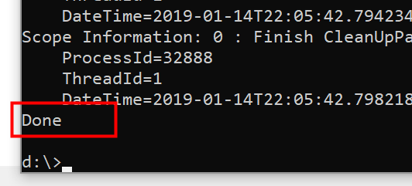

## Looking at compiler errors

Now that you've seen a successful compile. Let's see what an unsuccessful compile looks like. In the script below we’ve removed the semicolon by commenting it out.

rs0 = EXTRACT

FirstName : string,

LastName : string,

Age : int

FROM

"/my/SampleData/test_input.tsv"

USING DefaultTextExtractor() **// ;**

OUTPUT rs0

TO "/my/output.tsv"

USING DefaultTextOutputter();

The result is will be long. But if you scroll down eventually, you’ll see the details of interest.

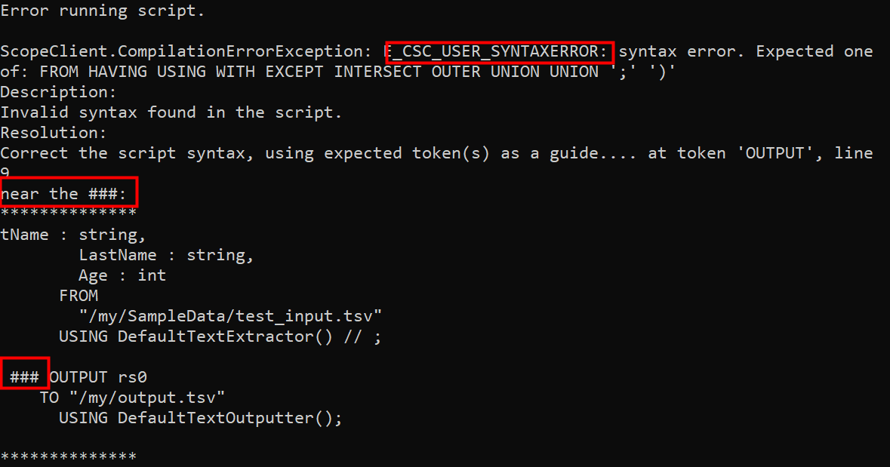

Here are the key points:

* You can see that there's an error code: **E_CSC_USER_SYNTAXERROR.**
* The **USER** part of **E_CSC_USER_SYNTAXERROR** indicates that the source of the error is the script written by the user – on other words the script has bad code and it is the users fault.
* The **###** sequence is used to draw your attention to the point in the script with the error. Syntax Errors will generally use ###. Other errors may not be able to pinpoint the error this way.
* These syntax errors happen when the script is compiled – this compilation failed and the script never started running.

## Compiling a Script without executing it

If you just want to verify that the Scope script compiles correctly – perhaps to check the syntax then the command looks like this

d:\scopesdk\scope.exe **compile** –i test.script *<Add the other parameters here>*

## The SearchLog Sample Data

There are quite a few sample data sets in the Scope Tutorial. The one we will initially work with is called "/my/SampleData/SearchLog.txt". It is slightly more complex than the rest and is useful for demonstrating many aspects of Scope so we'll spend some time understanding it.

The SearchLog sample dataset represents user activity on a search engine. It is a simple text file you can open in Notepad.

This file doesn't contain a header row so we'll have to document the columns below:

* **UserId** – this is an integer representing an anonymized user
* **Start** – when started a session with the search engine
* **Region** – What geographical region the user is searching from
* **Query** – What the user searched for
* **Duration** – How long their search session lasted
* **Urls** – A semicolon-separated list All the URLs that were shown to the user in the session
* **ClickedUrls** – A subset of **Urls** that the user actually clicked on (also a semicolon-separated list)

To EXTRACT data from this file, we would use this Scope statement

searchlog =

EXTRACT UserId : int,

Start : DateTime,

Region : string,

Query : string,

Duration : int,

Urls : string,

ClickedUrls : string

FROM "/my/SampleData/SearchLog.txt"

USING DefaultTextExtractor();

OUTPUT searchlog

TO "/my/output.tsv"

USING DefaultTextOutputter();

## The SearchLog View

In Scope for unstructured streams, you'll have to repeat that same extract statement over and over again. However, the Scope Tutorial comes with a VIEW – a topic we'll cover in greater depth later - that lets you avoid having to type this into every script.

See how simple this becomes with a view.

**searchlog = VIEW "/my/Views/SearchLog.view";**

OUTPUT searchlog

TO "/my/output.tsv"

USING DefaultTextOutputter();

[SCRIPT2]

# Data types

## Native data types

Scope supports most .NET data types. The full list is shown below.

* **Numeric**: Byte, sbyte, int, uint, long, ulong, float, double, decimal, short, ushort
* **Miscellaneous**: bool, Guid, datetime, byte[]
* **Text**: char, string
* **Complex**: MAP<k,v>, ARRAY<v>
* **Nullable**s: bool?, Guid?, datetime?, byte?, sbyte?, int?, uint?, long?, ulong?
* float?, double?, decimal?, short?, ushort?

## User-defined data types

Scope also allows you to create your own user-defined types that you can use for columns in rowsets. Consult Part 2 of the Scope Tutorial to learn more.

# Selection and filtering

searchlog = VIEW "Views/SearchLog.view";

// Find all the session dates, Durations

rs1 =

SELECT Start, Region, Duration

FROM searchlog;

OUTPUT rs1

TO "/my/output.txt";

And again, as with SQL, the **WHERE and HAVING** clauses allow you to filter data. Logical operators such as **AND** and **OR** are supported.

searchlog = VIEW "Views/SearchLog.view";

// Find all the sessions in the en-gb region

rs1 =

SELECT Start, Region, Duration

FROM searchlog

WHERE Region == "en-gb";

OUTPUT rs1

TO "/my/output.txt";

Notice the use of "==" in the example above instead of "=". This is because expressions in the **SELECT** statement are true C# expressions.

The **AND** operator and **OR** operator can be combined with parentheses for more complex expressions

// Find all the sessions lasting between 2 and 5 minutes OR that are in the en-gb Region

rs1 =

SELECT Start, Region, Duration

FROM searchlog

WHERE (Duration >= 2*60 AND Duration <= 5*60) OR (Region == "en-gb");

OUTPUT rs1

TO "/my/output.txt";

Because there is no C# literal for the **DateTime** type we have to make use of the **DateTime.Parse()** method as shown below.

// Find all the sessions occurring between two dates

rs1 =

SELECT Start, Region, Duration

FROM searchlog

WHERE Start >= DateTime.Parse("2012/02/16") AND Start <= DateTime.Parse("2012/02/17");

OUTPUT rs1

TO "/my/output.txt";

# Refining RowSets

A rowset can be created from itself – this allows you to refine a rowset one statement at a time which may be useful for debugging or simply to make your script easier to use.

rs1 =

SELECT Start, Region, Duration

FROM searchlog;

rs1 =

SELECT *

FROM rs1

WHERE Start >= DateTime.Parse("2012/02/16") AND Start <= DateTime.Parse("2012/02/17");

# Scope expressions

## Understanding Scope expressions

Clauses such as SELECT, WHERE, and HAVING (and others) allow you to enter **expressions** – in particular **Scope Expressions**.

An **expression** in a programming language is a combination of *explicit values*, *constants*, *variables*, *operators*, and *functions* that are interpreted according to the particular rules of precedence and of association for a particular programming language, which computes and then produces another value.

The simplest way of thinking of a Scope expression is that it is a merely C# expression with some Scope extensions such as the AND, OR, NOT operators.

## A tip for SQL developers

Lots of people come to Scope from SQL and ask how Scope accomplishes things they are familiar with in SQL. A great example in creating an uppercase string.

A SQL developer will expect to write the following in Scope

rs1 = SELECT UPPER( Region ) AS NewRegion

FROM searchlog;

But will be disappointed to find out that Scope has no **UPPER()** method. The C# developer knows what to do: just use the string type's intrinsic **ToUpper()** method.

rs1 =

SELECT

Region.ToUpper() AS NewRegion

FROM searchlog;

# Expressions in SELECT

Specific columns can be picked for the output rowset. In the example below two columns are retrieved and a third is calculated. Note that when an expression is used to calculate a value then you must assign that column a name via the AS keyword.

rs1 =

SELECT

Start,

Region,

Duration + 1.0 **AS Duration2**

FROM searchlog;

## Type casting

Expressions can also be converted to a different type

rs1 =   
 SELECT

Start,

Region,

**((double) Duration) AS DurationDouble**

FROM searchlog;

## Using .NET types

Rowset columns are strongly typed. Scope allows you to call methods defined on those types in the **SELECT** clause.

// Find what day of year each session took place

rs1 =   
 SELECT

Start,

Region,

Start.DayOfYear AS StartDayOfYear

FROM searchlog;

## Creating new objects with constructors

You can use standard C# expressions to create new objects

rs1 =

SELECT

Foo,

new MyType( Bar ) AS Beer

FROM data;

There's even support for using Type Initializers with constructors:

rs1 =

SELECT

Foo,

new MyType { MyProperty=Bar } AS Beer

FROM data;

## Creating .NET collections

Similar to the ability to create new objects, even collections can be created and initialized.

rs1 =

SELECT

Foo,

**new List<int> {1,2,3} AS Beer**

FROM data;

e  
rs2 =

SELECT

Foo,

**new int[] {1,2,3} AS Beer**

FROM data;

rs3 =

SELECT

Foo,

**new [] {1,2,3} AS Beer**

FROM data;

## #CS blocks and user-defined functions

A calculation can be implemented in C# code then later used in an expression. The code can be stored in a separate DLL or as part of a #CS block as shown below

rs1 =   
 SELECT

Start,

Region,

MyHelper.SecondsToMinutes(Duration) AS DurationInMinutes

FROM searchlog;

OUTPUT rs1

TO "/my/output.txt";

#CS

public static class MyHelper

{

public static double SecondsToMinutes(int seconds)

{

double minutes = seconds/60.0;

return minutes;

}

}

#ENDCS

## Filtering on calculated Columns in SELECT: WHERE versus HAVING

As in SQL, keep in mind that **WHERE** operates on input rows and **HAVING** on output rows. Consider a case in which we've used an expression to create a new column:

rs1 =   
 SELECT Start, Region, Duration/60.0 AS DurationInMinutes

FROM searchlog

WHERE DurationInMinutes >= 20;

OUTPUT rs1

TO "/my/output.txt";

This doesn't work even though the intention seems very clear. The code above will result in this error:

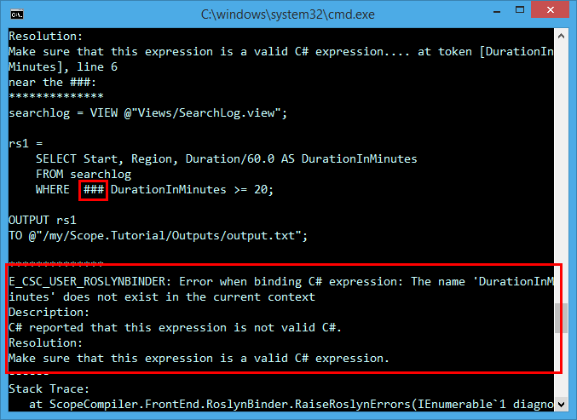

This is a concrete example of the difference between the **WHERE** and **HAVING** clauses. DurationInMinutes is NOT part of the input rows, it is created as part of the output rows. Thus to achieve filtering of these expressions we must use the **HAVING** clause.

rs1 =   
 SELECT

Start,

Region,

Duration/60.0 AS DurationInMinutes

FROM searchlog

HAVING DurationInMinutes >= 20;

Alternatively, you could use a new rowset to achieve the same effect.

rs1 =   
 SELECT

Start,

Region,

Duration,

Duration /60.0 AS DurationInMinutes

FROM searchlog;

rs2 =   
 SELECT *

FROM rs1

WHERE DurationInMinutes >= 20;

# LINQ and lambdas in expressions

Scope supports **Language-Integrated Query** (LINQ) in expressions.

In the example below, the **Where()** LINQ extension method is used to filter for a particular set of URLs. **Where()**, like most LINQ methods, returns an **IEnumerable<T>** value. Because Scope does not support interfaces as column types, the **ToList()** LINQ extension method is used to convert it to a collection type that Scope does support.

rs1 =   
 SELECT

Urls.Split(';').Where(u=> u.StartsWith("http:")).ToList() AS HttpUrls

FROM searchlog;

NOTE: **DefaultTextOutputter** does not automatically serialize Collection types such as List<T>. You'll need to convert this back to a type that it supports such as a string as shown below.

rs1 =

Urls.Split(';').Where(u=> u.StartsWith("http:")).ToList() AS HttpUrls

FROM searchlog;

rs2 =

SELECT

string.Join

( ";" , HttpUrls) AS HttpUrls

FROM rs1;

NOTE: a **REFERENCE** to **System.Linq** is automatically added to your scripts

To learn more about what can be expressed in linq consult: [**101 LINQ Samples**](http://code.msdn.microsoft.com/101-LINQ-Samples-3fb9811b)

## Anonymous types are not supported

Creating anonymous types is valid, however it is NOT supported in Scope. For example the following script will not work:

rs1 =

SELECT

Foo,

new {a=1, n=2} AS Beer

FROM data;

## LINQ query syntax

The **LINQ Method Syntax** was demonstrated above, but Scope also supports the **LINQ Query Syntax**.

rs =   
 SELECT

(from u in urls where u.StartsWith("http:")).ToList() AS HttpUrls

FROM clicks;

To learn more go here: [http://msdn.microsoft.com/en-us/library/vstuindio/bb397947.aspx](http://msdn.microsoft.com/en-us/library/vstudio/bb397947.aspx)

# Extension Methods in Expressions

You can also create your own custom extension methods and use them in a Scope expression. Simply create an extension method in a separate C# DLL and then

the DLL from your Scope script.

rs =   
 SELECT

urls.GetHttpUrls() AS HttpUrls

FROM clicks;

// This must be present in a separate DLL

public static class MyExtensions

{

public static List<string> GetHttpUrls(this IList<string> urls)

{

return urls.Where(u=> u.StartsWith("http:")).ToList();

}

}

In the future, support may be enabled for extension methods in the #CS code blocks

## Testing for membership with the IN operator

You can use the **IN** operator as shown below to test for membership in a set of values.

rs =

SELECT FirstName, LastName, JobTitle

FROM People

WHERE JobTitle IN ("Design Engineer", "Tool Designer", "Marketing Assistant");

Keep in mind that the Scope **IN** operator does not offer all the features of the SQL **IN** operator.

See [IN Operator Documentation here](https://microsoft.sharepoint.com/teams/Cosmos/Wiki/IN%20Operator.aspx)

# Order of evaluation for expressions

**Read this section. No joke, it's really important.**

There's a pattern C# developers are used to, as shown below:

if ((QueryString!=null) && (QueryString.StartsWith("bing"))

{

// do something

}

This pattern depends on a C# behavior (common to many languages) called "short-circuiting." Simply put, in the above example, when the code runs there's no logical reason to check both conditions if the first one returns **false**. Short circuiting is useful because evaluating each condition may be expensive. Thus, it is a technique that compilers use to improve the performance of C# code.

When trying to do the same thing in Scope there are two paths you can pick. Both are valid expressions, but one will cause problems that may not be obvious at first.

The right choice: use **&&** to keep the desired short-circuiting behavior

rs1 =

SELECT *

FROM data

WHERE ((Name!=null) && (Name.StartsWith("bing"));

The wrong choice: use AND which does NOT match the short-circuiting behavior.

rs1 =

SELECT *

FROM data

WHERE ((Name!=null) AND (Name.StartsWith("bing"));

The second translation that uses AND will **sometimes** fail saying that a NullReference has occurred. (sometimes it might work on your local box but might fail in the cluster)

The reason is simple and by-design: with AND/OR Scope will try to perform certain optimizations that result in better performance – for example it may evaluate the second part of the expression first because it assumes that there is no relationship between the two conditions.

This is a standard optimization technique and the same thing is done in many systems such as SQL. The gain this optimization provides in performance is well worth the occasional confusion it causes for new Scope users – so this behavior will never change.

Summary: if you need this short-circuiting behavior use **&&** and **||**.

As an alternative you can use the SQL-like ALL/ANY operators which are equivalent to &&/||.

**You CANNOT circumvent the order of evaluation by using multiple statements**

Of course, then you'll be tempted to write your script by splitting apart the expression as shown below.

rs1 =

SELECT *

FROM data

WHERE Name!=null;

rs2 =

SELECT *

FROM rs1  
 WHERE Name.StartsWith("bing");

The assumption here is

***First*** *I'll get the non-null objects and* ***then*** *I can avoid the null reference issue.*

This won’t work either. Scope is declarative language not an imperative one. Just because rs1 is defined earlier than rs2 in the script above it **does NOT imply** that the WHERE condition in rs1 is evaluated before the WHERE in rs2. Scope reserves the right to combine multiple statements together and perform optimizations. **You MUST use the && operator if you want to perform short-circuiting.**

# Picking specific columns in Rows

rs1 =   
 SELECT

Region

FROM searchlog;

|  |
| --- |
| en_ca |
| en_ch |
| en_fr |
| en_gb |
| en_gr |
| en_mx |
| en_us |

# Logical Operators in Expressions

## The C# logical operators: ||, &&, and !

To make it more straightforward for SQL developers, the equivalents to the C# logical operators are supported as shown below

|  |  |  |
| --- | --- | --- |
|  | **C#** | **SQL** |
| **Logical AND with short-circuiting** | (a && b && c) | ALL( a, b, c) |
| **Logical OR with short-circuiting** | (a || b || c) | ANY( a, b, c) |
| **Logical NOT** | !a | NOT(a) |

We still prefer you to use the C# expressions over the SQL style.

## The conditional operator and ternary IF

Just like C, C++, and C#, Scope has the conditional operator, whose form is shown below:

cond ? a : b

So, for example, it is possible to write:

rs1 =

SELECT

Region,

**(Duration>300 ? "long" :"short") AS DwellType**

FROM searchlog;

Scope has as another way of expressing this same construct with its **TERNARY IF** operator.

The general form for **TERNARY IF** is

IF (<cond>, <a>, <b> )

An example is below:

de

SELECT

Region,

**IF (Duration>300, "long", "short") AS DwellType**

FROM searchlog;

There's really no difference in using the conditional operator versus TERNARY IF, but the Scope team would prefer you to use the conditional operator as this is a standard C# expression.

PROTIP: Enclose :? In parenthesis

Consider the following two expressions – they are not equivalent:

// Case 1

IF(c1, true, false) AND IF(c2, true, false)

// Case 2

c1 ? true : false AND c2 ? true : false

The reason is that with C# precedence rules, the second expression will 32 as:

c1 ? true : (false AND c2 ? True : false)

To match the original Case, use parentheses.

(c1 ? True : false) AND (c2 ? True : false)

# Sorting

You can sort rowsets by using the **ORDER BY** operator. Specifying the **ASC** and **DESC** keyword controls whether the sort is ascending or descending, respectively.

// List the sessions in increasing order of Duration

rs1 =

SELECT

Start,

Region,

Duration

FROM searchlog

ORDER BY Duration ASC;

OUTPUT rs1

TO "/my/output.txt";

// List the sessions in decreasing order of Duration

rs1 =

SELECT

Start,

Region,

Duration

FROM searchlog

ORDER BY Duration DESC;

OUTPUT rs1

TO "/my/output.txt";

# Getting exactly N Rows or the TOP N based on a column

You can use the TOP operator to limit the number of rows you get

rs1 =   
 SELECT TOP 5

Region,

Duration

FROM searchlog;

Without an **ORDER BY** clause though the above statement is simply fetching *any* 5 rows it can. This is often not what you want. Instead add an **ORDER BY** on some field as shown below.

rs1 =   
 SELECT TOP 5

Region,

Duration

FROM searchlog  
 ORDER BY Duration DESC;

# Numbering rows

Using the **ROW_NUMBER** windowing function aggregate is how to assign row numbers. ROW_NUMBER is part of Windowing Functions and that topic too complex for this tutorial – See the Windowing Functions documentation ([LINK](https://microsoft.sharepoint.com/:w:/r/teams/Cosmos/_layouts/15/Doc.aspx?sourcedoc=%7BEF27EDBC-F02D-496D-A782-F9CF51219022%7D&file=Scope-Windowing-Functions.docx&action=default&mobileredirect=true&DefaultItemOpen=1)) for details. However, for now we do want to show you the proper way to number rows in Scope using ROW_NUMBER because it is a popular topic.

@rs1 =

SELECT

ROW_NUMBER() OVER ( ) AS RowNumber,

Start,

Region

FROM @searchlog

ORDER BY Start;

|  |  |  |
| --- | --- | --- |
| 1 | 2/16/2012 11:53:50 AM | en_ca |
| 2 | 2/16/2012 12:12:35 PM | en_ch |
| 3 | 2/16/2012 11:54:01 AM | en_fr |
| 4 | 2/15/2012 11:53:18 AM | en_gb |
| 5 | 2/16/2012 11:53:20 AM | en_gb |
| 6 | 2/16/2012 12:11:55 PM | en_gr |
| 7 | 2/16/2012 12:00:33 PM | en_mx |
| 8 | 2/16/2012 12:15:55 PM | en_us |
| 9 | 2/16/2012 12:13:56 PM | en_us |
| 10 | 2/16/2012 12:17:00 PM | en_us |
| 11 | 2/16/2012 12:18:17 PM | en_us |
| 12 | 2/16/2012 12:19:55 PM | en_us |
| 13 | 2/16/2012 12:20:03 PM | en_us |
| 14 | 2/16/2012 12:20:33 PM | en_us |
| 15 | 2/16/2012 12:21:03 PM | en_us |
| 16 | 2/15/2012 11:53:16 AM | en_us |
| 17 | 2/16/2012 11:54:01 AM | en_us |
| 18 | 2/16/2012 11:54:02 AM | en_us |
| 19 | 2/16/2012 11:54:03 AM | en_us |
| 20 | 2/16/2012 11:54:04 AM | en_us |
| 21 | 2/16/2012 11:59:01 AM | en_us |
| 22 | 2/16/2012 12:00:55 PM | en_us |
| 23 | 2/16/2012 12:13:55 PM | en_us |

# Grouping and aggregation

Grouping, in essence, collapses multiple rows into single rows based on some criteria. Hand-in-hand with performing a grouping operation, some fields in the output rowset must be aggregated into some meaningful value (or discarded if no possible or meaningful aggregation can be done).

We can witness this behavior by building up to it in stages.

// list all session durations.

rs1 =

SELECT

Duration

FROM searchlog;

OUTPUT rs1

TO "/my/output.txt";

This creates a simple list of integers.

|  |
| --- |
| 73 |
| 614 |
| 74 |
| 24 |
| 1213 |
| 241 |
| 502 |
| 60 |
| 1270 |
| 610 |
| 422 |
| 283 |
| 305 |
| 10 |
| 612 |
| 1220 |
| 691 |
| 63 |
| 30 |
| 119 |
| 732 |
| 183 |
| 630 |

Now, let's add all the numbers together. This yields a rowset with exactly one row and one column.

// Find the total duration for all sessions combined

rs1 =

SELECT

SUM(Duration) AS TotalDuration

FROM searchlog;

OUTPUT rs1

TO "/my/output.txt";

|  |
| --- |
| 9981 |

Now let's use the **GROUP BY** operator to break apart the totals by Region.

// find the total Duration by Region

rs1 =

SELECT

Region,

SUM(Duration) AS TotalDuration

FROM searchlog

GROUP BY Region;

OUTPUT rs1

TO "/my/Outputs/output.txt";

|  |  |
| --- | --- |
| en_ca | 24 |
| en_ch | 10 |
| en_fr | 241 |
| en_gb | 688 |
| en_gr | 305 |
| en_mx | 422 |
| en_us | 8291 |

This is a good opportunity to explore a common use of the **HAVING** operator. We can use **HAVING** to restrict the output rowset to those rows that have aggregate values we are interested in. For example, perhaps we want to find all the Regions where total dwell time is above some value.

// find all the Regions where the total dwell time is > 200

rs1 =

SELECT

Region,

SUM(Duration) AS TotalDuration

FROM rs1

GROUP BY Region

HAVING TotalDuration > 200;

OUTPUT rs1

TO "/my/output.txt";

|  |  |
| --- | --- |
| en-fr | 241 |
| en-gb | 688 |
| en-gr | 305 |
| en-mx | 422 |
| en-us | 8291 |

// group the number of total sessions.

rs1 =

SELECT

COUNT() AS NumSessions

FROM searchlog;

OUTPUT rs1

TO "/my/output.txt";

|  |
| --- |
| 23 |

Count the number of total sessions by Region.

rs1 =

SELECT

COUNT() AS NumSessions,

Region

FROM searchlog

GROUP BY Region;

OUTPUT rs1

TO "/my/output.txt";

|  |  |
| --- | --- |
| 1 | en_ca |
| 1 | en_ch |
| 1 | en_fr |
| 2 | en_gb |
| 1 | en_gr |
| 1 | en_mx |
| 16 | en_us |

Count the number of total sessions by Region and include total duration for that language.

rs1 = SELECT

COUNT() AS NumSessions,

Region,

SUM(Duration) AS TotalDuration,

AVG(Duration) AS AvgDwellTtime,

MAX(Duration) AS MaxDuration,

MIN(Duration) AS MinDuration

FROM searchlog

GROUP BY Region;

OUTPUT rs1

TO "/my/output.txt";

|  |  |  |  |  |  |
| --- | --- | --- | --- | --- | --- |
| NumSessions:long | Region | TotalDuration:long | AvgDuration:double? | MaxDuration:int | MinDuration:int |
| 1 | en_ca | 24 | 24 | 24 | 24 |
| 1 | en_ch | 10 | 10 | 10 | 10 |
| 1 | en_fr | 241 | 241 | 241 | 241 |
| 2 | en_gb | 688 | 344 | 614 | 74 |
| 1 | en_gr | 305 | 305 | 305 | 305 |
| 1 | en_mx | 422 | 422 | 422 | 422 |
| 16 | en_us | 8291 | 518.1875 | 1270 | 30 |

## A note: data types coming from aggregations

You should be aware of how some aggregation operators deal with data types.

­­­­For example, the input data type is double:

* SUM(double) -> double
* COUNT(double) -> long(int64)

But if the input data type is numeric (long/int/short/byte, etc.):

* SUM(type) -> long(int64)
* COUNT(type) -> long(int64)

## Where you can use aggregates in a query

Aggregates can ONLY appear in a SELECT clause.

## DISTINCT with aggregates

Every aggregate function can take a **DISTINCT** qualifier.

For example

COUNT(DISTINCT x)

**DISTINCT** also works for user-defined aggregates.

MyAggregator(DISTINCT x,y,z).

# System-Defined aggregates

Scope contains several common aggregation functions:

* string
* AVG
* COUNT
* COUNTIF
* ANY_VALUE
* ­­LAST
* LIST
* MAX
* MIN
* STDEV *

## Getting a value with ANY_VALUE and FIRST

**ANY_VALUE** gets a value for that column with no implications about where inside that rowset the value came from. It could be the first value, the last value, or any value in between. It is useful in some scenarios where you don't care which value you receive as long as you get one.

rs1 =

SELECT

ANY_VALUE(Start) AS FirstStart,

Region

FROM searchlog

GROUP BY Region;

**FIRST** is badly named. It does NOT guarantee you will receive the first value in a rowset. Instead it behaves exactly like **ANY_VALUE**. Avoid using **FIRST**, instead use **ANY_VALUE**.

rs1 =

SELECT

FIRST(Start) AS FirstStart,

Region

FROM searchlog

GROUP BY Region;

## There is one key difference between **ANY_VALUE** and **FIRST**

* **ANY_VALUE** on some type T will return T?
* **FIRST** on some type T will return T

## Conditionally counting with COUNTIF

Sometimes we need to count things, but only if a certain condition holds. For example, let's start with getting the total sessions per Region.

rs1 =

SELECT

Region,

COUNT() AS NumSessions

FROM searchlog

GROUP BY Region;

Now we want to compare the total count with the count of sessions that had a large dwell time, more than 600 seconds. We can accomplish this via **COUNTIF**.

rs2 =

SELECT

Region,

COUNT() AS NumSessions,

COUNTIF( Duration > 600 ) AS NumLongSessions

FROM searchlog

GROUP BY Region;

|  |  |  |
| --- | --- | --- |
| Region | NumSessions:long | NumLongSessions:long |
| en-ca | 1 | 0 |
| en-ch | 1 | 0 |
| en-fr | 1 | 0 |
| en-gb | 2 | 1 |
| en-gr | 1 | 0 |
| en-mx | 1 | 0 |
| en-us | 16 | 8 |

## ARGMAX

The **ARGMAX** function is simple:

**ARGMAX(a, b)** = Find the row with the maximum value for column a, from that row return the value for b.

Imagine we have some employee data:

|  |  |  |  |  |
| --- | --- | --- | --- | --- |
| **FirstName** | **LastName** | **Tenure:int** | **Title** | **Department** |
| Joe | Smith | 3897 | Paralegal | Legal |
| Sally | Johnson | 8897 | CFO | Exec |
| Trent | Michaels | 43 | Intern | Engineering |
| Joshua | Phillips | 373 | Developer | Engineering |
| Alice | Edwards | 513 | Tester | Engineering |

What's the last name of the employee who has the longest tenure? This is simply answered with ARGMAX.

rs0 =

EXTRACT

FirstName:string,

LastName:string,

Tenure:int,

Title:string

FROM "/my/SampleData/tenures.tsv"

USING DefaultTextExtractor();

rs1 =

SELECT

ARGMAX( Tenure, LastName ) AS MostTentured

FROM rs0;

If you OUTPUT rs1 you will get this:

|  |
| --- |
| **MostTentured** |
| Johnson |

**ARGMAX** like all the other aggregates works with **GROUP BY** letting us find the most tenured employee by department.

rs2 =

SELECT

Department,

ARGMAX( Tenure, LastName ) AS MostTentured

GROUP BY Department

FROM rs0;

|  |  |
| --- | --- |
| **Department** | **MostTentured** |
| Engineering | Edwards |
| Exec | Johnson |
| Legal | Smith |

rs3 =

SELECT

Department,

ARGMAX( Tenure, LastName ) AS MostTenured,

ARGMAX( Tenure, Tenure ) AS Tenure

GROUP BY Department

FROM rs0;

|  |  |  |
| --- | --- | --- |
| **Department** | **MostTenured** | **Tenure:int** |
| Engineering | Edwards | 513 |
| Exec | Johnson | 8897 |
| Legal | Smith | 3897 |

PROTIP: Instead of ARGMAX, use the ROW_NUMBER() and DENSE_RANK() Analytic Windowing Functions. They are more powerful.

## An Important fact about VAR and STDEV

For the Statisticians, variance (**VAR**) and standard deviation (**STDEV**) are the **sample version** with Bessel's correction, **not** the better-known **population version**.

# Regular Expressions

Regular expressions provide advanced text matching capabilities in a terse specification. Regular Expressions are supported in the WHERE and HAVING clauses.

## Finding simple patterns

// Find all the sessions where the query contained the word pizza (but not pizzeria, for example)

rs1 =

SELECT

Start,

Region,

Duration

FROM searchlog

WHERE REGEX(@"\bpizza.*\b").IsMatch(Query);

OUTPUT rs1

TO "/my/output.txt";

## Extracting a REGEX match

Sometimes you'll need to "pull" out a substring and promote that to a column.

For example, if there is a column called Name and its value can look like "--------Cosmos01------", "foooCosmos11bar," etc. and we want to pull out the "Cosmos<number>" parts, then REGEX and Scope make this pretty easy to do.

rs1 =

SELECT

Name,

REGEX(@"Cosmos[0-9]*").Match(Name).Value AS CosmosCluster

FROM data;

NOTE: That the above example is case-sensitive, so it won't match "cosmos08" but will match "Cosmos08".

# Notes on Rowsets

## You cannot extract a single scalar value from a rowset

This is a common question for developers new to Scope. Often they want to store a value from a rowset in a scalar value. For example, they may want the MAX for some column in a rowset and then re-use that value some

else and will try to write code like this:

maxcost =

SELECT

MAX( Cost ) As MaxCost

FROM data;

There’s nothing wrong with this syntactically – it will compile. However, maxcost will not be a double it will be a rowset with a single row and a single column called MaxCost.

There is no way in Scope to return a single scalar value like this. Your alternative is to get a one-row rowset and then combine (JOIN) that with another rowset to achieve the computation you want.

# Breaking rows apart with CROSS APPLY

Let's examine the search log again.

rs1 =

SELECT

Region,

Urls

FROM searchlog;

The query above returns something like this:

|  |  |
| --- | --- |
| Region | Urls |
| en-us | A;B;C |
| en-gb | D;E;F |

The **Urls** column contains

strings, but each string is a semicolon-separated list of URLs. What happens if we want to break apart the **Urls** field so that only a URL is present on every row? For example, below is what we want to see:

|  |  |
| --- | --- |
| Region | Urls |
| en-us | A |
| en-us | B |
| en-us | C |
| en-gb | D |
| en-gb | E |
| en-gb | F |

This is a perfect job for the **CROSS APPLY**

operator.

rs1 =

SELECT

Region,

Urls

    FROM searchlog;

rs2 =

SELECT

Region,

**SplitUrls AS Url**

FROM rs1

**CROSS APPLY** **Urls.Split(';') AS SplitUrls;**

NOTE: The transformation above is possible to perform programmatically with **PROCESSORS** – but **CROSS APPLY** is always preferred to custom processors.

# CROSS APPLY with multiple columns

Occasionally you'll see data organized in the manner shown below:

|  |  |
| --- | --- |
| Regions | Urls |
| en-us;en-us;en-us | A;B;C |
| en-gb;en-gb;en-gb | D;E;F |

In this structure, each value in the Region column is a set of values that correspond 1-to-1 with a value in the Urls column.

What you clearly want is to "zip" the pairs of values together to get this:

|  |  |
| --- | --- |
| Region | Result |
| en-us | A |
| en-us | B |
| en-us | C |
| en-gb | D |
| en-gb | E |
| en-gb | F |

With a little bit of extra code, **CROSS APPLY** works in this case also.

rs1 =

SELECT

Tup.Item1 AS Region,

Tup.Item2 AS Result

FROM rs0

CROSS APPLY Regions.Split(';').Zip(Urls.Split(';'), Tuple.Create) AS Tup;

# Putting rows together with LIST

The **LIST** Multiple Columns aggregate operator performs the opposite of **CROSS APPLY**.

For example, if we start with this:

|  |  |
| --- | --- |
| Region | Result |
| en-us | A |
| en-us | B |
| en-us | C |
| en-gb | D |
| en-gb | E |
| en-gb | F |

But we want this as the output:

|  |  |
| --- | --- |
| Region | Urls |
| en-us | A;B;C |
| en-gb | D;E;F |

This is exactly what the **LIST** operator does. In the example below, you will see rowset rs1 taken apart by **CROSS APPLY** and then reconstructed as rowset rs3 via the **LIST** operator.

rs1 =

SELECT

Region,

Urls

FROM searchlog;

rs2 =

SELECT

Region,

SplitUrls AS Url

FROM rs1

CROSS APPLY Urls.Split(';') AS SplitUrls;

rs3 =

SELECT

Region,

String.Join(";" , LIST(Url).ToArray() ) AS Urls

FROM rs2

GROUP BY Region;

PROTIP: LIST offers no guarantees on order. So you may end up with C;A;B for example for en-us.

PROTIP: In general, Cosmos treats data homogenously with no respect for order unless explicit ordering instructions are provided. Keep this in mind anytime you find yourself relying on order.

# Putting rows together with ARRAY_AGG

**ARRAY_AGG** works a lot like **LIST** but is the preferred way – for reasons will get into – for merging lists of column values

rs1 =

SELECT

Region,

Urls

FROM searchlog;

rs2 =

SELECT

Region,

SplitUrls AS Url

FROM rs1

CROSS APPLY Urls.Split(';') AS SplitUrls;

rs3 =

SELECT

Region,

string.Join(";" , ARRAY

_AGG(Url) ) AS Urls

FROM rs2

GROUP BY Region;

## ARRAY_AGG versus LIST

The general guidance is: **always choose ARRAY_AGG if possible** because it is more efficient and more optimizable than LIST.

The functional difference between **ARRAY_AGG** and **LIST** is:

* **LIST** can handle *any* type
* **ARRAY_AGG** can handle only the native Scope types.

## ARRAY_AGG versus Array<T> and List<T>

Array<T> and List<T> are collections from the **System.Collections** namespace. You are free to use them in scope, but again **always choose ARRAY_AGG if possible** because it is more efficient and more optimizable than using the standard .Net collection types.

# Miscellaneous

## Writing debug Information in C# code

Sometimes you need to log output in your C# code. The correct way to do this is to use the Debug Streams feature.

Consult [this document for more information](https://microsoft.sharepoint.com/teams/Cosmos/Documents/Scope/Scope-User-Code-Debug-Streams.docx?Web=1):

## String literals

This tutorial uses different kinds of string literals.

* The Regular C# String Literal
* The Verbatim C# String Literal – these string literals begin with an @ character

You may use either in Scope. The key differences are in the handling of embedded quotation marks, backslashes, and newlines as shown in the table below.

|  |  |  |
| --- | --- | --- |
|  | Regular | Verbatim |
| Simple string | "Foo" | @"Foo" |
| Quotation marks | "\"Hello\" I said" | @"""Hello"" I said"stac |
| Slashes | "a/b/c" | @"a/b/c" |
| Backslashes | "a\\b\\c" | @"a\b\c" |
| newlines | "a\r\nb\r\nc" | @"a  b  c" |