## Unit 7 | Assignment - Distinguishing Sentiments

## Background

Choose __one__ of the following two assignments, in which you will do just that. Good luck!

## News Mood

In this assignment, you'll create a Python script to perform a sentiment analysis of the Twitter activity of various news oulets, and to present your findings visually.

Your final output should provide a **visualized summary** of the sentiments expressed in Tweets sent out by the following news organizations: __BBC, CBS, CNN, Fox, and New York times__.

![output_10_0.png](output_10_0.png)

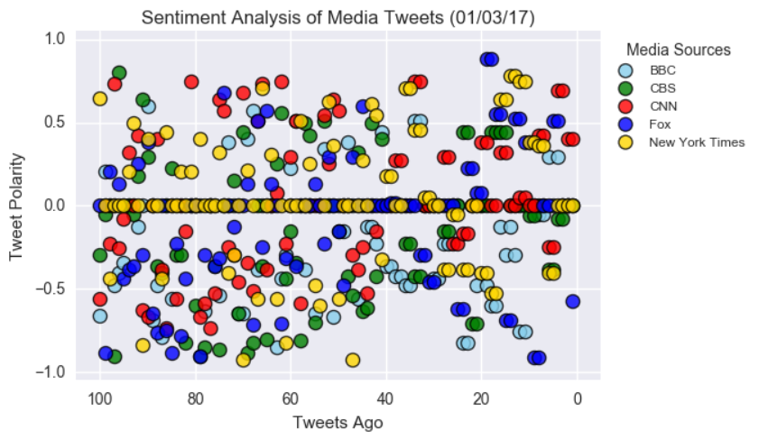

![output_13_1.png](output_13_1.png)

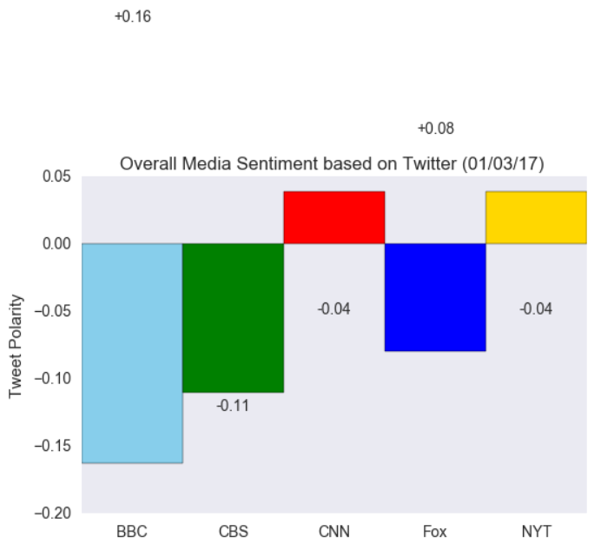

The first plot will be and/or feature the following:

* Be a scatter plot of sentiments of the last __**100__ tweets sent out by each news organization**, ranging from -1.0 to 1.0, where a score of 0 expresses a neutral sentiment, -1 the most negative sentiment possible, and +1 the most positive sentiment possible.

* Each plot point will reflect the _**compound_ sentiment** of a tweet.

* Sort each plot point by its relative timestamp.

The second plot will be a bar plot visualizing the _overall_ sentiments of the last 100 tweets from each organization. For this plot, you will again aggregate the compound sentiments analyzed by VADER.

The tools of the trade you will need for your task as a data analyst include the following: tweepy, pandas, matplotlib, and VADER.

Your final Jupyter notebook must:

* Pull last 100 tweets from each outlet.

* Perform a sentiment analysis with the compound, positive, neutral, and negative scoring for each tweet.

* **Pull into a DataFrame the tweet's source acount, its text, its date, and its compound, positive, neutral, and negative sentiment scores**.

* Export the data in the DataFrame into a CSV file.

* Save PNG images for each plot.

As final considerations:

* Use the Matplotlib library.

* Include a written description of three observable trends based on the data.

* Include proper labeling of your plots, including plot titles (with date of analysis) and axes labels.

* Include an exported markdown version of your Notebook called `README.md` in your GitHub repository.

## PlotBot

In this activity, more challenging than the last, you will build a Twitter bot that sends out visualized sentiment analysis of a Twitter account's recent tweets.

Visit [https://twitter.com/PlotBot5](https://twitter.com/PlotBot5) for an example of what your script should do.

The bot receives tweets via mentions and in turn performs sentiment analysis on the most recent twitter account specified in the mention

For example, when a user tweets, __"@PlotBot Analyze: @CNN,"__ it will trigger a sentiment analysis on the CNN twitter feed.

A plot from the sentiment analysis is then tweeted to the PlotBot5 twitter feed. See below for examples of scatter plots you will generate:

![@juanitasoranno.png](@juanitasoranno.png)

![@nancypwong.png](@nancypwong.png)

![nytimes.png](nytimes.png)

Hints, requirements, and considerations:

* Your bot should scan your account every __five minutes__ for mentions.

* Your bot should pull 500 most recent tweets to analyze for each incoming request.

* Your script should prevent abuse by analyzing __only__ Twitter accounts that have not previously been analyzed.

* Your plot should include meaningful legend and labels.

* It should also mention the Twitter account name of the requesting user.

* When submitting your assignment, be sure to have at least __three__ analyses tweeted out from your account (enlist the help of classmates, friends, or family, if necessary!).

* Notable libraries used to complete this application include: Matplotlib, Pandas, and Tweepy.

* You may find it helpful to organize your code in function(s), then call them.

* If you're not yet familiar with creating functions in Python, here is a tutorial you may wish to consult: [https://www.tutorialspoint.com/python/python_functions.htm](https://www.tutorialspoint.com/python/python_functions.htm).

Control width and space in barplots- python

|  |
| --- |
| # library |

|  |
| --- |
| import matplotlib.pyplot as plt |

|  |
| --- |
|  |

|  |
| --- |
| # Make fake dataset |

|  |
| --- |
| height = [3, 12, 5, 18, 45] |

|  |
| --- |
| bars = ('A', 'B', 'C', 'D', 'E') |

|  |
| --- |
|  |

|  |
| --- |
| # Choose the position of each barplots on the x-axis (space=1,4,3,1) |

|  |
| --- |
| y_pos = [0,1,5,8,9] |

|  |
| --- |
|  |

|  |
| --- |
| # Create bars |

|  |
| --- |
| plt.bar(y_pos, height) |

|  |
| --- |
|  |

|  |
| --- |
| # Create names on the x-axis |

|  |
| --- |
| plt.xticks(y_pos, bars) |

|  |
| --- |
|  |

|  |
| --- |
| # Show graphic |

|  |
| --- |
| plt.show() |