**Prompt Part 2**

How to use the TLC Python tool! (Instructions for Windows OS)

Step 1 – Download and install Python

1. Find the correct download for your Operating System here: <https://www.python.org/downloads/>
2. Before clicking “Install Now”, select “Add Python 3.8 to PATH”

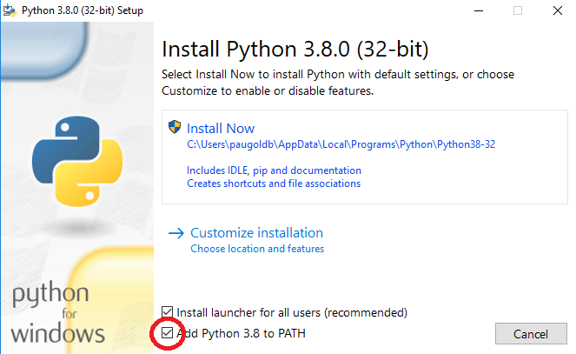

Step 2 – Create your save folder

1. Create a folder somewhere easily accessible (Desktop or My Documents will work)
2. Save the TLC.py file in this folder
3. Save the Excel file from the NYC TLC website to this same folder

Step 3 – Open Command Prompt

1. In the Windows search bar, type “cmd”, and select Command Prompt
2. Open the folder you created and copy down the file path

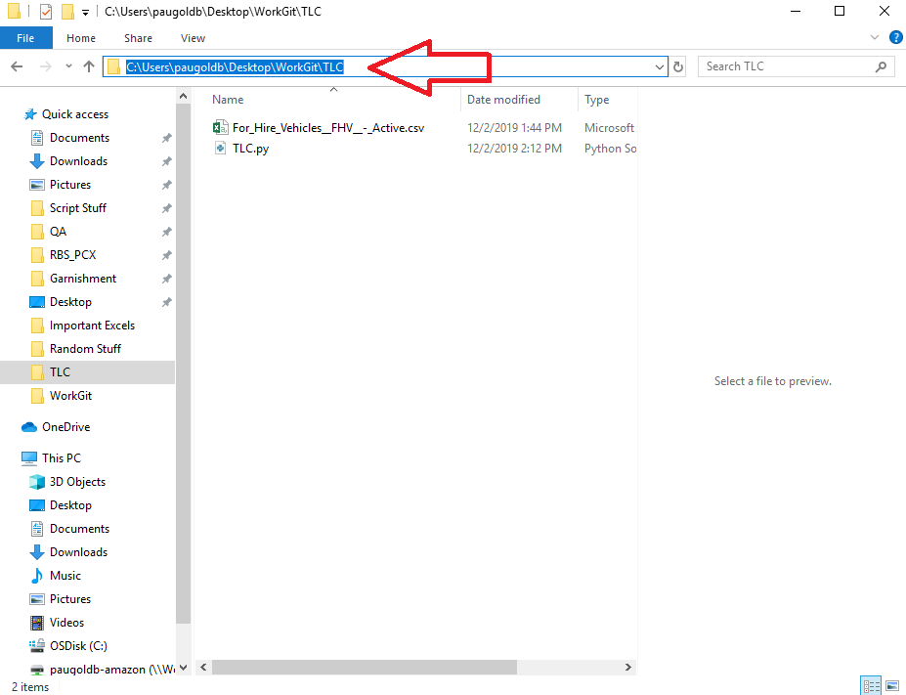

1. In the Command Prompt window, type “cd “ and paste your file path **(#1 in image)**
2. On the next line, type “py TLC.py” **(#2 in image)**

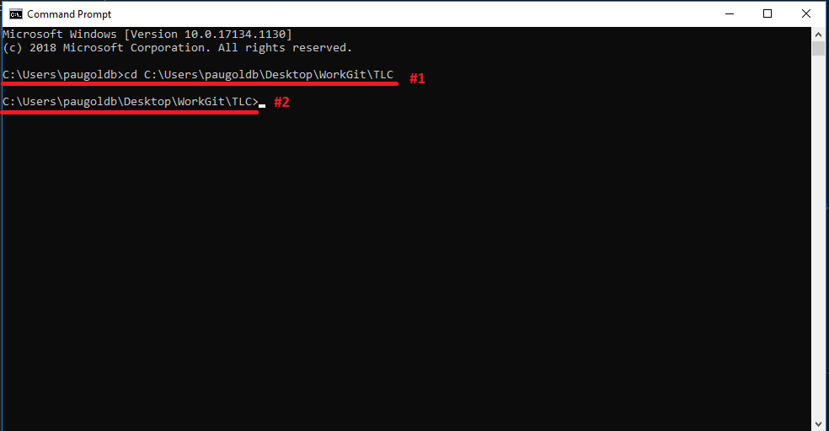

1. Follow the prompts as follows:
   1. “Paste file name here: “ – paste the name of the Excel file where you are pulling your data from – (this example: For_Hire_Vehicles__FHV__-_Active.csv) **(#3 in image)**
   2. “Input what column data name you are looking for: “ - paste the name of the column you are filtering by. (this example: DMV License Plate Number) **(#4 in image)**
   3. “Input the search data for [column data name]: “ – paste the data you are searching for in that column – (this example: 05REGION) **(#5 in image)**

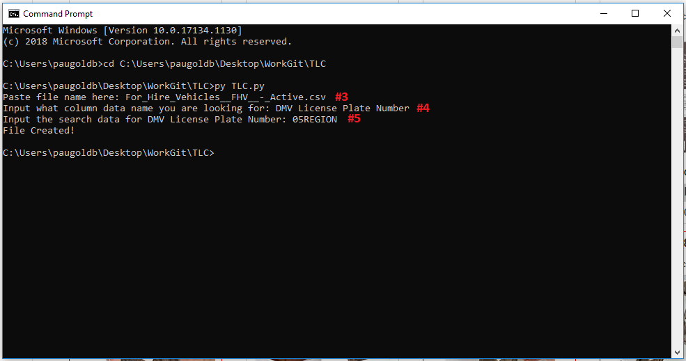

Step 4 – Check the file that is created

1. The file output should be created in the same folder that the script and source Excel document are saved in, it will be saved with the following naming format: **(#6 in image)**
   1. Example: 05REGION_output_1575328433.csv
   2. Breakdown: [Search data input]_output_[timestamp of when the file was created].csv
      1. The timestamp is used so that this script will never try to overwrite the previous file, to keep your data output safe!
2. The file is saved in a CSV format with the data columns as the headers **(#7 in image)**

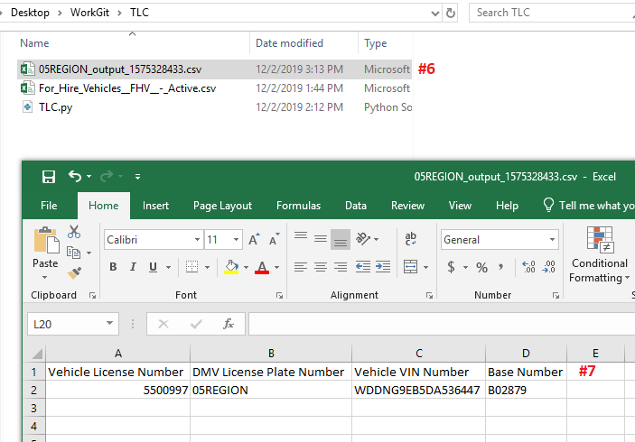

**Prompt Part 3**

Since the team is seeking more detailed information about individual vehicles, I suggest we make use of the VIN data available from NYC For Hire. There are several sites allowing single searches for information connected to a VIN, however I would caution against using sites like these for ad hoc requests, as they may store search information. Although this information is freely available on the City of New York website, we want to protect customer data by not using free search options.

Instead, I recommend looking into Federal / Government databases, such as <https://vpic.nhtsa.dot.gov/> , that allow for API queries. Ideally this would allow us to automate these kinds of data queries. Given the large amount of data contained in a single VIN, we could ultimately build a tool allowing us to complete search requests and target specific data to reduce search load. Further research would be needed to narrow down what VIN-specific information is useful for our purposes.