**ĐỒ THỊ**

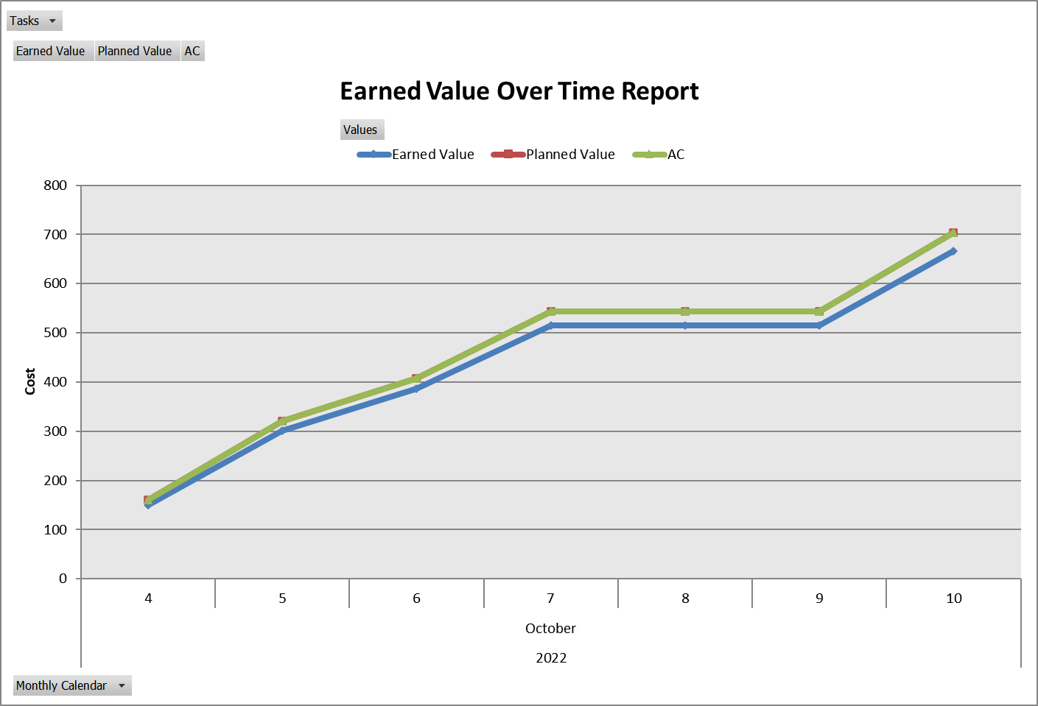

**DỮ LIỆU**

|  |  |  |  |  |  |
| --- | --- | --- | --- | --- | --- |
| Tasks | All |  |  |  |  |
|  |  |  |  |  |  |
|  |  |  | Data |  |  |
| Year | Month | Day | Earned Value | Planned Value | AC |
| 2022 | October | 4 | 150.4 | 160 | 160 |
|  |  | 5 | 300.8 | 320 | 320 |
|  |  | 6 | 386.4 | 408 | 408 |
|  |  | 7 | 515.2 | 544 | 544 |
|  |  | 8 | 515.2 | 544 | 544 |
|  |  | 9 | 515.2 | 544 | 544 |
|  |  | 10 | 665.6 | 704 | 704 |
| Grand Total |  |  | 665.6 | 704 | 704 |