Gesture Controlled Rock Paper Scissors Game
AI Lab Project Report

Title Page
Project Title:
Gesture Controlled Rock Paper Scissors Game
Student Name:
- Praveen Thanvi (233501167)
- Khush Purohit (233501093)
- Yuvraj Suthar (233501236)
Course Code:
CCBCA521
Course Name:
AI Lab
Faculty Guide:
Dr. Sharad Mathur
Department:
Faculty of Computer Science
Semester / Year:
5th semester (2023-2026)

ABSTRACT
The Gesture Rock-Paper-Scissors Game is an interactive computer vision-based project developed using Python and OpenCV. The system enables users to play the classic Rock-Paper-Scissors game using real-time hand gestures through a webcam instead of traditional keyboard or mouse input.
The model detects hand gestures using contour detection, convex hulls, and convexity defects to classify the user’s gesture as rock, paper, or scissors. A countdown timer ensures fair play, while the results and score are displayed in real time. The game compares the user’s gesture with the computer’s randomly generated move and determines the winner.
This system demonstrates the practical application of real-time image processing and human-computer interaction and provides an engaging platform for learning fundamental computer vision concepts. The project is lightweight, requires no machine learning training datasets, and runs efficiently on any device with a webcam.

1. INTRODUCTION

1.1 Background
Human-computer interaction using gestures has gained significant attention due to its intuitive and natural operation. Traditional input devices such as keyboards and mice limit interactivity, whereas gesture-based systems enhance user experience and reduce physical dependency on external hardware.
The Gesture Rock-Paper-Scissors Game was developed to apply real-time computer vision techniques for gesture recognition. It uses OpenCV to capture hand movements, analyze contours, detect convexity defects, and classify gestures based on finger count patterns.

1.2 Problem Statement
Most existing Rock-Paper-Scissors games rely on button-based or graphical selections. These lack physical interaction and do not provide users with real-time gesture-based control. There is a need for an automated hand gesture recognition system that detects natural hand shapes and allows engaging interaction with the computer.

1.3 Objectives
- To implement a gesture-controlled Rock-Paper-Scissors game using Python and OpenCV.
- To detect and classify hand gestures in real time using contour-based detection.
- To enhance human-computer interaction without using hardware buttons.
- To generate and display real-time scoring and results.
- To demonstrate real-time processing, image segmentation, and convexity defect detection.

2. SYSTEM OVERVIEW
The Gesture Rock-Paper-Scissors Game uses a webcam to capture hand gestures within a Region of Interest (ROI). The system processes the gesture through contour extraction, convex hull detection, and gap (defects) counting to determine the gesture type.

System Capabilities
- Real-time gesture detection
- Countdown timer for fair play
- Computer vs. User gameplay
- Scoreboard and results display
- Interactive UI with debug calibration window

3. TECHNOLOGIES AND TOOLS USED

Frontend / Display
- OpenCV GUI Windows
- Webcam Interface

Backend / Processing
- Python 3.13
- OpenCV
- NumPy
- Random library

Tools
- VS Code
- Python Interpreter
- Webcam Hardware
- GitHub (Version Control)

4. WORKFLOW OF SYSTEM
Step | Description
1. Webcam Input | System captures live video frames.
2. ROI Detection | User places hand inside a bounded region.
3. Mask & Thresholding | Hand segmentation for analysis.
4. Gesture Classification | Count convexity defects to detect Rock/Paper/Scissors.
5. Computer Selection | Random move generation.
6. Result Generation | Compare and determine winner.
7. Score Update | Display live score and winner overlay.

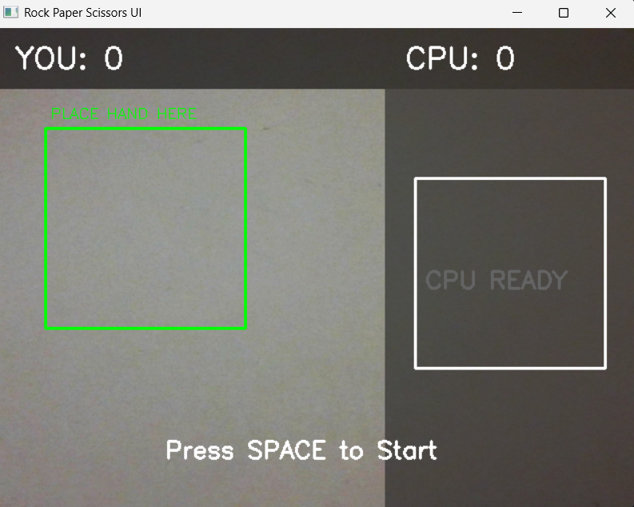

5. FEATURES IMPLEMENTED

Game Features
- Real-time gesture recognition
- Countdown timer & ready-signal display
- Live score counter
- Overlay text for Round Winner
- Debug mode to calibrate hand detection

Gesture Classification Logic
Move | Finger Gaps / Defects
Rock | 0
Scissors | 1
Paper | 2+

6. PYTHON FILE STRUCTURE
File | Description
gesture_rps.py | Main program containing gesture detection and game logic
readme.md | Project guide and setup instructions

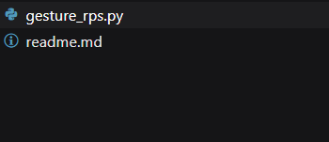

7. RESULTS & ANALYSIS
- Hand gestures successfully detected through convex hull and convexity defect method.
- Game performance is smooth with minimal processing delay.
- Gesture recognition accuracy increases under proper lighting conditions.
- No physical input devices required—improves user engagement and interactivity.
- Useful as a demo of computer vision processing, segmentation, and interactive UI.

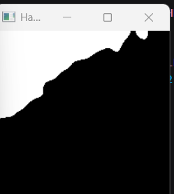

8. CONCLUSION
The Gesture Rock-Paper-Scissors Game effectively demonstrates the application of computer vision for gesture-based interaction. The system successfully meets its objectives by recognizing hand gestures and enabling interactive gameplay against the computer.
The project proves that traditional ML models are not always necessary for practical gesture recognition, and simple vision-based techniques can yield efficient results. With further enhancements such as advanced gesture detection models, UI improvements, and multiplayer functionality, the project can be expanded and deployed for broader use.
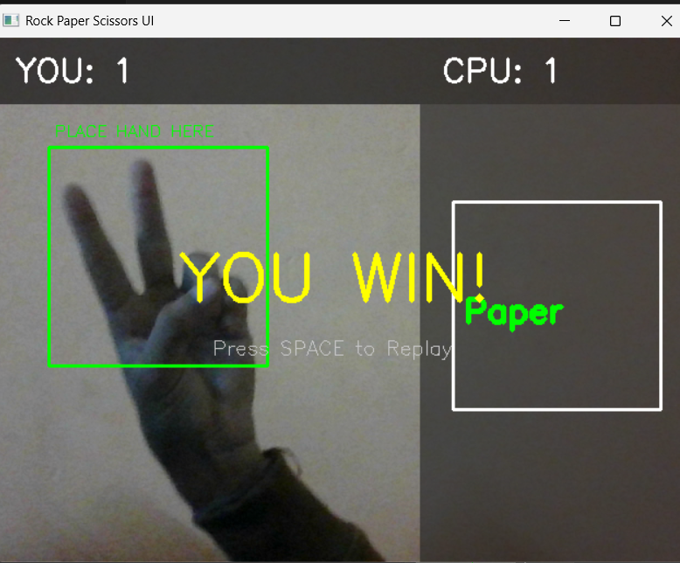

9. FUTURE SCOPE
- Integrate Machine Learning-based gesture classification for higher accuracy
- Add additional moves (Lizard-Spock)
- Add multiplayer mode or online player mode
- Build a mobile / web version
- Add game sound effects & animation UI
- Create packaged executable (.exe) for easy installation

10. REFERENCES
- OpenCV Python Documentation
- NumPy Python Documentation
- Hand Gesture Recognition Research Articles
- GitHub Project Repository

11. APPENDIX

GitHub Repository Link
https://github.com/pthanvi10/rock-paper-scissors-game

