FPT UNIVERSITY
SWP391 — Software Development Project
SOFTWARE REQUIREMENTS
SPECIFICATION
AITA-Intelligent
AI-Powered Teaching Assistant & AST Code Analytics Platform

Table of Contents
Document Control | —
Revision History | —
Approval Record | —
1. Introduction | —
1.1 Purpose | —
1.2 Product Scope | —
1.3 Intended Audience | —
1.4 Document Conventions | —
1.5 Definitions and Acronyms | —
1.6 References | —
2. Overall Description | —
2.1 Product Perspective | —
2.2 Product Goals | —
2.3 Product Functions | —
2.4 User Classes and Characteristics | —
2.5 Operating Environment | —
2.6 Design and Implementation Constraints | —
2.7 Assumptions and Dependencies | —
2.8 Out of Scope / Explicit Limitations | —
3. External Interface Requirements | —
3.1 User Interface Inventory | —
3.2 Role / Screen Authorization | —
3.3 Software and Service Interfaces | —
3.4 Communications Interfaces | —
3.5 File and Data Interfaces | —
4. Functional Requirements | —
4.1 Portal, Authentication and Profile | —
4.2 Class, Roster and Bulk Import | —
4.3 Exam, Assignment, Rubric and Team Management | —
4.4 Submission Intake and Queueing | —
4.5 Docker Sandbox Autograding and Result Viewing | —
4.6 GenAI Core and Review | —
4.7 AST/Winnowing Plagiarism Analysis | —
4.8 Git Teamwork Analytics and Personal Scoring | —
4.9 Grade Appeals, Notifications and Audit | —
5. Non-Functional Requirements | —
6. Data Requirements | —
6.1 Logical Data Model | —
6.2 Entity Catalog | —
6.3 Data Integrity Constraints | —
6.4 Data Privacy and Retention | —
7. Business Rules and Scoring Computations | —
8. Use Case Specifications | —
8.1 UC01 — Register / Login | —
8.2 UC02 — Manage User Profile | —
8.3 UC03 — Bulk Import Students | —
8.4 UC04 — View Role-Based Dashboard & Authorized Administration | —
8.5 UC05 — Create / Manage Class | —
8.6 UC06 — Create Exam / Assignment | —
8.7 UC07 — Configure Rubric / Test Cases | —
8.8 UC08 — Submit Assignment | —
8.9 UC09 — Execute Submission in Sandbox | —
8.10 UC10 — View Autograde Result / Diagnostics | —
8.11 UC11 — AI Generate Assignment / Rubric | —
8.12 UC12 — AI Semantic Code Review | —
8.13 UC13 — AI Explain Compilation Errors | —
8.14 UC14 — Manage AI API Key Rotation | —
8.15 UC15 — Parse Submission to AST | —
8.16 UC16 — Compute Winnowing Fingerprint & Similarity | —
8.17 UC17 — View Plagiarism Report | —
8.18 UC18 — Enqueue Submission for Grading | —
8.19 UC19 — Analyze Git Contribution | —
8.20 UC20 — View Teamwork Contribution Report | —
8.21 UC21 — Submit Grade Appeal | —
8.22 UC22 — Resolve Appeal | —
8.23 UC23 — Receive Real-time Notification | —
8.24 UC24 — Manage Teams | —
9. System Models (Informative, Non-Normative) | —
9.1 Submission Evaluation Flow | —
9.2 Submission Lifecycle State Model | —
9.3 Exam Lifecycle State Model | —
9.4 Appeal Lifecycle State Model | —
9.5 Component / Deployment Perspective | —
10. UI Behavior and Non-UI System Functions | —
10.1 Principal Screen Flow | —
10.2 Backend / Event-Driven Functions | —
11. Traceability and Verification | —
11.1 User Story Traceability | —
11.2 Functional Requirement Traceability Matrix | —
11.3 Verification Strategy | —
12. Requirements Decision Register — Resolved for Phase 1 | —
13. Approved Requirements Acceptance Checklist | —
Appendix A — Initial Language and Runtime Baseline | —
Appendix B — Score Formula Examples (Non-Normative) | —
Appendix C — Source-to-Baseline Normalization Principles | —

1. Introduction

1.1 Purpose
This document specifies the externally observable behavior, functional capabilities, data constraints, quality attributes, interfaces and business rules of AITA-Intelligent for the approved Phase 1 release. It is the normative specification for implementation, verification and acceptance.

1.2 Product Scope
AITA-Intelligent is an academic platform for programming-assignment/exam administration and automated evaluation. Phase 1 combines role-based class/exam management, secure ZIP submission intake, asynchronous grading, isolated Docker execution, GenAI-assisted qualitative review, AST/Winnowing structural-similarity analysis, GitHub-based team contribution analytics, grade appeals and real-time notifications. Phase 1 provides a Web App only. A React Native Mobile App is deferred to a later phase and is not part of Phase 1 implementation or acceptance.
Scope protection: This approved SRS does not create new end-user modules beyond the established AITA scope. For Phase 1, the client scope is Web App only; the React Native Mobile App is deferred. No Peer P2P review workflow is added: the Peer P2P scoring component is removed from Phase 1 scoring rather than creating a new data-entry module. The CI/CD coverage gate remains an external project/course constraint.

1.3 Intended Audience
- Project owner and course evaluators reviewing the system boundary and completeness.
- Developers implementing client, backend services, sandbox, GenAI, AST and analytics components.
- QA engineers deriving test cases and acceptance tests from requirement identifiers.
- Lecturers and administrators validating roles, grading policies and operational constraints.

1.4 Document Conventions
Convention | Meaning
FR-xxx | Functional requirement
NFR-xxx | Non-functional/quality requirement
UCxx | Use case
US-xx | User story identifier inherited from source
BR-xx | Business rule inherited from source
ISS-xx / Deferred | Source inconsistency or future-phase item documented with an approved Phase 1 resolution.
MUST HAVE / SHOULD HAVE | Priority terms inherited from the source material; functional requirements use “shall” as the normative form.

1.5 Definitions and Acronyms
Term | Definition
AITA | AI-Powered Teaching Assistant & AST Code Analytics Platform.
AST | Abstract Syntax Tree.
Winnowing | Document fingerprinting technique using k-gram hashes and window-based minimum selection.
GenAI | Generative AI service used for content drafting, semantic review and error explanation.
SSO | Single Sign-On.
JWT | JSON Web Token.
RBAC | Role-Based Access Control.
StdIn / StdOut / StdErr | Standard input, standard output and standard error streams.
LOC | Lines of code additions/deletions used as one Git contribution metric.
PR | Pull request; merged PR count is used as one contribution metric.
TLE | Time Limit Exceeded.
OOM | Out of Memory.
PII | Personally Identifiable Information.
P95 | 95th percentile latency/turnaround metric.
Group Exam | Exam/assignment in which one Team Leader submits on behalf of a team and personal grades may be adjusted by contribution.

1.6 References
- AITA_Revised.docx — source baseline supplied by the project team.
- Schleimer, Wilkerson & Aiken (2003), Winnowing: Local Algorithms for Document Fingerprinting — referenced in the supplied source as the conceptual basis of the AST similarity subsystem.
- Project/course deployment technologies named in the source: Docker, Redis/BullMQ, GitHub, Google OAuth, OpenAI/Gemini, PostgreSQL/SQL Server.

2. Overall Description

2.1 Product Perspective
AITA-Intelligent sits between university users and several external/runtime services. It is not a full Learning Management System and not an in-browser IDE. Its core purpose is to receive programming work, evaluate it through deterministic sandbox testing and assisted analysis, expose evidence to authorized reviewers, and provide transparent team-contribution and appeal workflows.
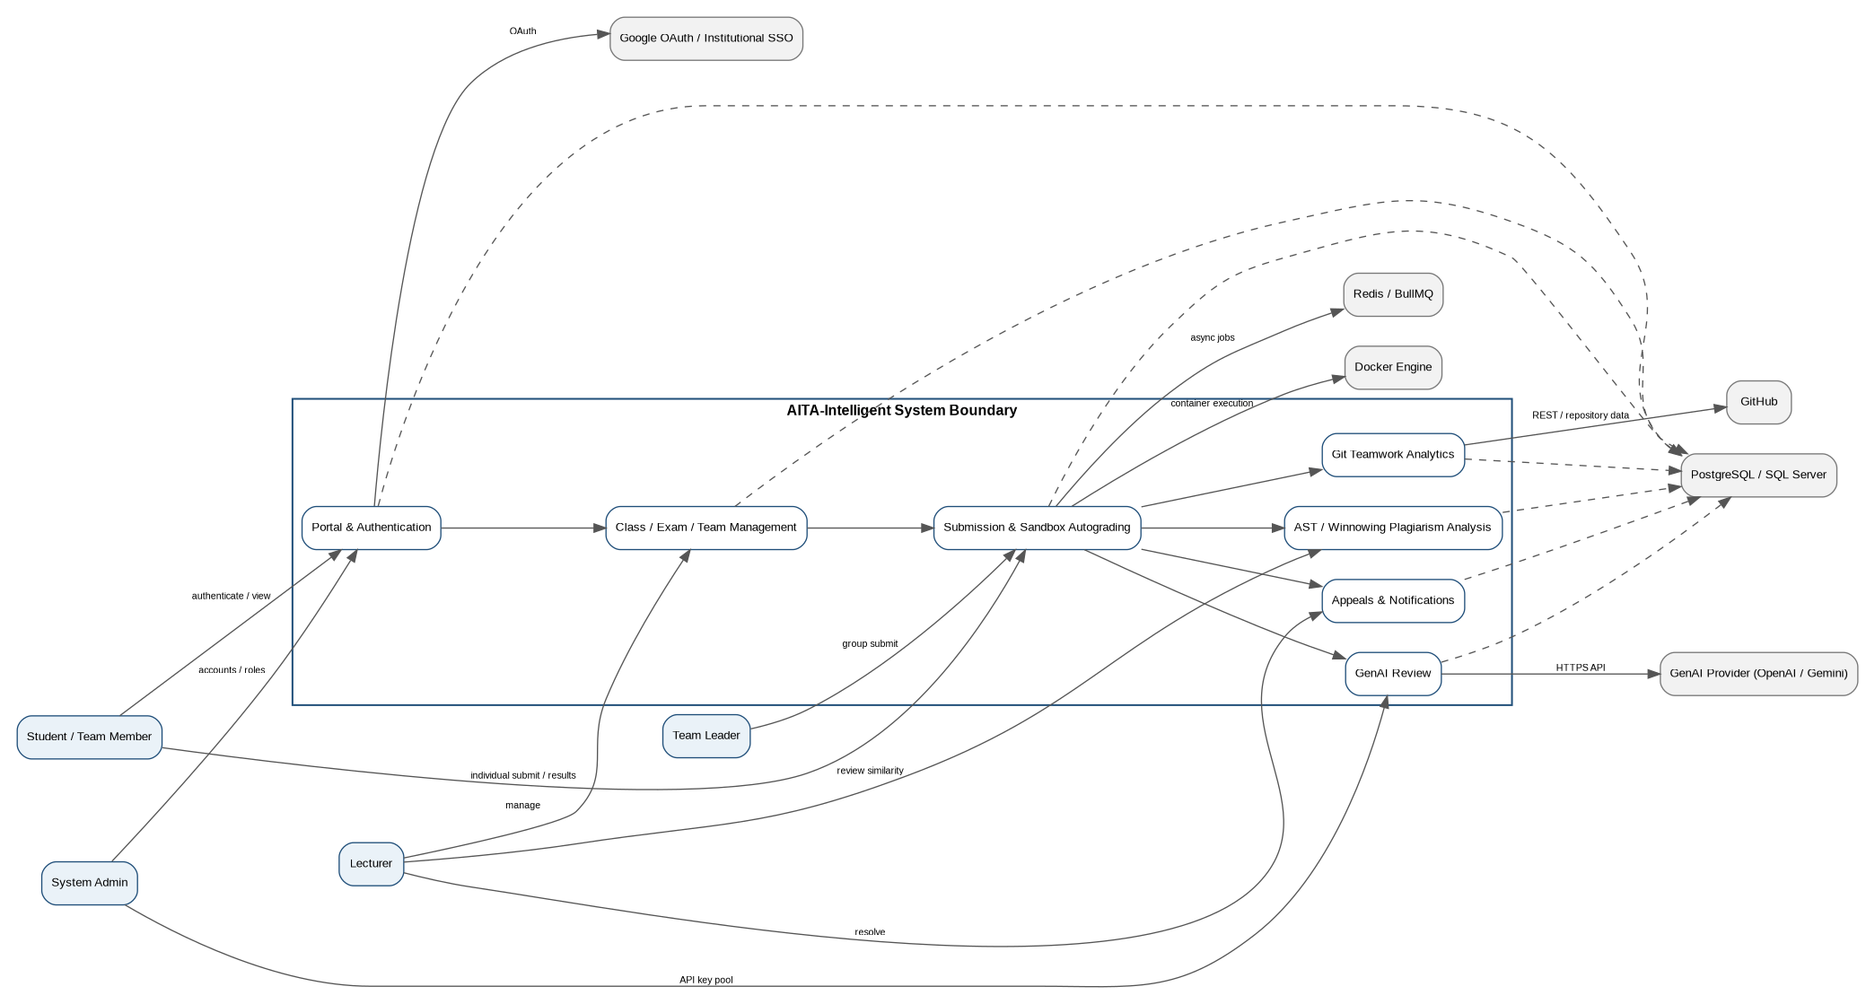
Figure 2-1. AITA-Intelligent system context and external dependencies

2.2 Product Goals
- Reduce manual programming-grading workload while preserving transparent evidence.
- Execute untrusted student code with explicit isolation and resource limits.
- Provide qualitative GenAI-assisted feedback without exposing student identity to the external model payload.
- Detect structural similarity using AST normalization and Winnowing rather than only raw-text comparison.
- Make Group Exam contribution differences visible using GitHub activity metrics and a defined personal-score computation.
- Provide bounded, auditable grade-appeal handling and real-time status communication.

2.3 Product Functions
Feature Area | Summary
Portal & Authentication | Institutional SSO/local login, RBAC, profile, dashboard, admin account/role support.
Class & Roster | Class metadata, enrollment, Excel roster import.
Exam & Teams | Individual/Group exams, tests/rubrics, team formation, leader designation.
Submission & Queue | Secure ZIP intake, integrity hash, duplicate/late rules, asynchronous queue.
Sandbox Autograding | Compile/run tests in isolated Docker containers, capture pass/fail and resource metrics.
GenAI Review | Draft assignment/rubric content, semantic review, error explanations, API key rotation/degradation handling.
AST Plagiarism | Normalize AST, Winnowing fingerprints, pairwise similarity matrix, side-by-side inspection.
Git Analytics | GitHub commit/LOC/PR metrics, contribution warning and personal score.
Appeals & Notifications | 48-hour appeals, Lecturer resolution/override, WebSocket/in-app updates.

2.4 User Classes and Characteristics
Actor | Type | Responsibilities / Access
Student / Team Member | Primary | Enrolled learner. Submits individual work, views own/team results, receives feedback and notifications, views own team contribution metrics, and may appeal an individual result or own personal score.
Team Leader | Primary | A Student designated by the Lecturer for a Group Exam. Inherits Student permissions and is the only team member authorized to submit the official team package and appeal the team grade.
Lecturer | Primary | Owns classes; manages rosters, exams, rubrics, test cases and teams; reviews grading, plagiarism and Git analytics; resolves appeals; publishes grades.
System Admin | Primary | Manages user roles/account status and GenAI API key pool; has support visibility for system operations and authorized class data.
Google OAuth / Institutional SSO | External | Authenticates institutional accounts for @fpt.edu.vn and @fe.edu.vn.
GenAI Provider | External | OpenAI or Google Gemini API used for assignment/rubric drafting, semantic review, and compilation-error explanation.
GitHub | External | Provides repository commit, lines-of-code and merged pull-request data for Group Exam contribution analytics.
Docker Engine | External runtime | Runs submitted code in isolated, resource-capped containers.

2.5 Operating Environment
- Web frontend: React + Vite + Tailwind. Phase 1 is Web App only and shall support the two latest stable versions of Google Chrome, Microsoft Edge and Mozilla Firefox.
- Backend services: Node.js/TypeScript and FastAPI are named in the source architecture artifact.
- Sandbox runtime: Docker Engine.
- Queue: Redis/BullMQ.
- Persistence: PostgreSQL or SQL Server.
- Initial supported submission languages: .NET 8 (C#) and Java JDK 17.
- GenAI provider: OpenAI or Google Gemini.
- Git analytics provider: GitHub.
Phase 1 client scope: Web App only. The React Native Mobile App shown in the source architecture is explicitly deferred to a later phase; no mobile-specific functional requirements, screens or acceptance criteria apply to Phase 1.

2.6 Design and Implementation Constraints
- Untrusted source execution must remain inside the sandbox limits defined by BR-01/NFR-ENV-001.
- Initial AST and sandbox language support is limited to .NET 8/C# and Java JDK 17.
- Git contribution analytics uses GitHub; GitLab/Bitbucket are excluded from the baseline.
- Cross-student source code and plagiarism investigation evidence must be authorization-protected.
- The grading pipeline is asynchronous and must use a persistent queue model with retry behavior.
- All team submission/score logic must preserve exactly one active Team Leader and one active Group Exam submission.

2.7 Assumptions and Dependencies
ID | Assumption / Dependency
AS-01 | Stable pre-built Docker base images for .NET 8 and Java JDK 17 are available before sandbox milestones.
AS-02 | Each Group Exam team has one GitHub repository and GitHub identities can be mapped to registered Team Members.
AS-03 | GenAI provider availability/quota/pricing is sufficient for expected class-wide volume; degraded mode handles provider failure.
AS-04 | Lecturer configures team-size limits and designates one Team Leader before the Group Exam submission window opens.
DE-01 | Redis/BullMQ and the selected relational database are provisioned and reachable by backend services.
DE-02 | Docker host has enough concurrent-container capacity to avoid sustained queue starvation.

2.8 Out of Scope / Explicit Limitations
ID | Limitation / Exclusion
OS-01 | No real-time collaborative code editor or browser IDE; source-code submission is asynchronous ZIP upload.
OS-02 | No initial language support beyond .NET 8/C# and Java JDK 17.
OS-03 | No pre-execution malicious-intent classifier; containment relies on Docker isolation/resource/network controls.
OS-04 | AITA appeal records support Lecturer decision-making but do not constitute the university’s official administrative grade-change process.
OS-05 | Git analytics supports GitHub only in the baseline.
OS-06 | No Peer P2P review workflow or Peer Review score-entry interface is included in Phase 1. BR-10 uses only Sandbox and AI Semantic Review scores.
OS-07 | React Native Mobile App is not part of Phase 1. Mobile feature parity and mobile acceptance criteria are deferred to a later phase.

3. External Interface Requirements

3.1 User Interface Inventory
Screen / View | Authorized Roles | Purpose
Login / SSO | All roles | Institutional Google SSO and local login entry.
Role-based Dashboard | All roles | Role-filtered classes, grading/appeal status and notifications.
Class List / Class Detail | Student: own/read-only; Lecturer: own; Admin: support | Class roster, exams and analytics links.
Bulk Import Students | Lecturer/Admin | Excel upload, mapping preview and transactional import.
Exam / Assignment Editor | Lecturer/Admin support | Exam metadata, type, runtime/language, deadline, tests/rubric; AI draft action.
Team Management | Student: own/read-only; Lecturer/Admin | Teams, members, repository, leader designation/replacement.
Submission Upload | Student individual; Team Leader group | ZIP package upload and submission receipt.
Submission Result Detail | Owner/team, Lecturer, Admin | Sandbox result + AI review + plagiarism/status indicators.
Plagiarism Similarity Matrix | Lecturer/Admin | Heat map and side-by-side structural comparison.
Git Teamwork Analytics | Own team, Lecturer/Admin | Contribution metrics, warning and personal score.
Appeal List / Detail | Own appeals, Lecturer/Admin | Submit/review/resolve appeals.
Admin User Management | Admin | Accounts, roles and status.
Admin AI API Key Rotation | Admin | Manage provider keys and status/quota.

3.2 Role / Screen Authorization
Screen | Student / Team Member | Lecturer | Admin
Login / SSO | Allowed | Allowed | Allowed
Dashboard | Own/role data | Own classes | System/admin data
Class List / Detail | Own classes read-only | Own classes | All/support
Bulk Import Students | No | Own classes | Support
Exam Editor | No | Own classes | Support
Team Management | Own team read-only | Own classes | Support
Submission Upload | Individual / Team Leader only for Group | No | No
Submission Result | Own/team | Own classes | Authorized
Plagiarism Matrix | No | Own classes | Authorized
Git Analytics | Own team read-only | Own classes | Authorized
Appeals | Own appeals | Own classes | Authorized
User Management | No | No | Allowed
AI Key Rotation | No | No | Allowed

3.3 Software and Service Interfaces
External / Runtime Interface | Used By | Interface Requirement
Google OAuth / SSO | Authentication | OAuth-based institutional sign-in and email-domain validation.
GenAI Provider (OpenAI / Gemini) | GenAI review | HTTPS completion/generation API; structured response expected; external retention policy constraints apply.
GitHub | Teamwork analytics | Repository commit, LOC and merged PR retrieval; member username mapping required.
Docker Engine | Sandbox runtime | Create isolated containers, apply CPU/RAM/network restrictions, compile/run code, terminate processes.
Redis / BullMQ | Asynchronous queue | Persist and dispatch grading jobs; retry/heartbeat behavior required.
PostgreSQL or SQL Server | Persistence | Stores users/classes/exams/submissions/results/analytics/appeals and audit-related data.
WebSocket | Realtime client updates | Grading progress/result and appeal notifications.
REST API | Client/backend communication | API gateway for authenticated Web App/backend communication in Phase 1.

3.4 Communications Interfaces
- Browser/client to API Gateway: authenticated REST over HTTPS; real-time updates use WebSocket as named in the source architecture.
- API Gateway to domain services: internal service/API calls consistent with modular backend architecture.
- Backend to GenAI/GitHub/Google: provider-specific HTTPS APIs.
- Submission Service to workers: Redis/BullMQ job messages; jobs shall remain persistent/recoverable according to NFR-REL-002.

3.5 File and Data Interfaces
Artifact | Format / Constraint | Purpose
Student roster | .xlsx; source state model also specifies <10 MB for the import file | Bulk import users/enrollments with column mapping and transaction rollback.
Source submission | .zip; normative upload limit 25 MiB; archive safety controls apply | Primary assignment/exam submission artifact.
Test cases | StdIn + expected StdOut pairs with weight and visibility | Sandbox evaluation.
GenAI review response | Structured JSON expected | Per-criterion score/comments.
Git repository | GitHub repository URL + member GitHub usernames | Teamwork analytics; not the baseline submission artifact.

4. Functional Requirements
All requirements in this section are written as system-level “shall” statements. They formalize capabilities already present in the supplied source material; no new feature family has been introduced. An asterisk in a related UC/US reference indicates an identifier conflict explained in Section 12.

4.1 Portal, Authentication and Profile
Requirement ID | Normative Requirement | Related UC | Related US | Verification
FR-AUTH-001 | The system shall authenticate institutional users through Google SSO and accept only authorized institutional email domains defined by the deployment configuration, including @fpt.edu.vn and @fe.edu.vn. | UC01 | US-01 | Test
FR-AUTH-002 | The system shall support local email/password authentication for registered local or administrative accounts described in the source baseline. | UC01 | US-01 | Test
FR-AUTH-003 | Upon successful authentication, the system shall establish a role-based session using short-lived JWT access tokens and secure refresh tokens. | UC01 | US-01 | Test
FR-AUTH-004 | The system shall invalidate or blacklist the active authentication session when the user logs out or when an administrator removes privileges. | UC01 | US-01 / US-04 | Test
FR-AUTH-005 | The system shall enforce role-based authorization for Student/Team Member, Team Leader, Lecturer and System Admin operations. | UC01 / UC04 | US-04 | Test
FR-AUTH-006 | The system shall allow a System Admin to manage user role and account status as described by the Admin User Management screen. | UC04* | US-04 | Test
FR-PROF-001 | The system shall allow authenticated users to view and update the profile fields exposed by the profile screen, including avatar, contact information and notification preferences. | UC02 | US-02 | Test
FR-PROF-002 | The system shall validate profile avatar uploads as PNG/JPG files smaller than 2 MB, as specified by the source acceptance criteria. | UC02 | US-02 | Test
FR-DASH-001 | The system shall present a role-based dashboard summarizing the user's relevant classes, active or pending work, grading status/queue information and recent notifications. | UC04 | US-04* | Inspection/Test

4.2 Class, Roster and Bulk Import
Requirement ID | Normative Requirement | Related UC | Related US | Verification
FR-CLS-001 | The system shall allow a Lecturer to create and manage class metadata including class/section identifier, course code and semester. | UC05 | US-05 | Test
FR-CLS-002 | The system shall allow Lecturers to manage enrolled students and shall restrict students to read-only access to classes in which they are enrolled. | UC05 | US-05 | Test
FR-CLS-003 | When a class is created, the system shall associate the creating Lecturer as the primary instructor; the source also specifies generation of an enrollment join-code. | UC05 | US-05 | Test
FR-IMP-001 | The system shall accept an Excel .xlsx roster upload and display a column-mapping preview before import. | UC03 | US-03 | Test
FR-IMP-002 | The system shall validate required columns, institutional email format/domain, duplicates and enrollment eligibility for every roster row before commit. | UC03 | US-03 | Test
FR-IMP-003 | The system shall execute the bulk roster import atomically so that an unrecoverable validation/database failure rolls back the entire batch. | UC03 | US-03 | Test
FR-IMP-004 | The system shall return an import result summary including added/skipped records and row-level errors when applicable. | UC03 | US-03 | Test

4.3 Exam, Assignment, Rubric and Team Management
Requirement ID | Normative Requirement | Related UC | Related US | Verification
FR-EXM-001 | The system shall allow a Lecturer to create an Individual or Group Exam/Assignment with title, target language/runtime, grading weight and submission deadline. | UC06 | US-06 | Test
FR-EXM-002 | For Group Exams, the system shall capture minimum/maximum team size and require a linked GitHub repository for each team. | UC06 / UC24 | US-06 / US-25 | Test
FR-EXM-003 | The system shall allow a Lecturer to configure public and hidden StdIn/expected-StdOut test cases with score weights. | UC07 | US-07 | Test
FR-EXM-004 | The system shall allow a Lecturer to configure qualitative rubric criteria used by GenAI semantic review. | UC07 | US-07 | Test
FR-EXM-005 | The system shall preserve test-case visibility so hidden test cases are not exposed to Students during an active exam. | UC07 | US-07 | Test
FR-EXM-006 | The system shall support the exam lifecycle Draft → Scheduled → Active/Open → Submission Closed → Grading Pending → Grades Published → Archived. | UC06 | US-06 | Test/Inspection
FR-EXM-007 | The system shall allow a Lecturer to request GenAI to draft an assignment statement, rubric and starter/sample test cases from a topic prompt, and shall require Lecturer review before saving. | UC11 | US-11 | Test
FR-TEAM-001 | The system shall allow a Lecturer to create or import Group Exam teams and assign only students enrolled in the related class. | UC24 | US-25 | Test
FR-TEAM-002 | The system shall enforce configured team-size limits and prevent duplicate membership within the same Group Exam. | UC24 | US-25 | Test
FR-TEAM-003 | Each Group Exam team shall have exactly one active Team Leader. | UC24 | US-25 | Test
FR-TEAM-004 | The system shall store the team repository link and member GitHub identities required by Git contribution analytics. | UC24 | US-25 | Test
FR-TEAM-005 | The system shall allow only a Lecturer to replace a Team Leader and shall record the old leader, new leader, reason and timestamp in an audit trail. | UC24 | US-27 | Test/Inspection
FR-TEAM-006 | Team Members shall be able to view their own team composition and designated leader. | UC24 | US-25 | Test

4.4 Submission Intake and Queueing
Requirement ID | Normative Requirement | Related UC | Related US | Verification
FR-SUB-001 | The system shall accept source-code submissions as ZIP archives up to the normative 25 MiB baseline defined by the functional/security requirements. | UC08 | US-08 / US-24 | Test
FR-SUB-002 | Before extraction, the system shall reject unsafe archives that exceed the defined decompression/file-count limits or contain path-traversal entries. | UC08 | US-08 | Security Test
FR-SUB-003 | The system shall compute and persist a SHA-256 integrity hash for every accepted submission. | UC08 | US-08 | Test
FR-SUB-004 | The system shall reject a duplicate SHA-256 submission hash within the scope defined by BR-07. | UC08 | US-08 | Test
FR-SUB-005 | For an Individual Exam, the system shall accept submissions only from an enrolled Student; for a Group Exam, only the designated Team Leader may submit on behalf of the team. | UC08 | US-08 / US-24 | Authorization Test
FR-SUB-006 | For a Group Exam, a later valid pre-deadline team submission shall supersede the earlier active team submission while preserving audit history. | UC08 | US-24 | Test
FR-SUB-007 | A submission received after the deadline shall be flagged Late and shall not be processed until a Lecturer explicitly approves it, as required by BR-02. | UC08 | US-08 | Test
FR-SUB-008 | After a valid upload is persisted, the system shall create a queued Submission record and return a submission identifier/receipt to the client. | UC08 | US-08 | Test
FR-QUE-001 | The system shall publish accepted submissions to an asynchronous Redis/BullMQ grading queue so request handling is decoupled from evaluation work. | UC18 | US-18 | Test
FR-QUE-002 | The system shall expose the submission pipeline state to authorized users through status updates without requiring page refresh. | UC23* | US-20 | Test

4.5 Docker Sandbox Autograding and Result Viewing
Requirement ID | Normative Requirement | Related UC | Related US | Verification
FR-SBX-001 | The system shall execute submitted code in an isolated Docker container with external networking disabled, 512 MiB RAM limit, 1.0 virtual CPU limit and a 10-second execution limit per test case. | UC09 | US-09 | Security/Performance Test
FR-SBX-002 | The Sandbox Worker shall compile the submission when required by the target language and capture compiler diagnostics. | UC09 | US-09 | Test
FR-SBX-003 | For each configured test case, the Sandbox Worker shall supply StdIn, capture StdOut/StdErr, compare actual and expected output, and record pass/fail. | UC09 | US-09 | Test
FR-SBX-004 | The system shall record execution time and peak memory usage per test case. | UC09 | US-09 | Test
FR-SBX-005 | The system shall classify timeout, memory-limit and compilation failures using explicit result/status values and continue or terminate processing according to the defined lifecycle. | UC09 | US-09 | Test
FR-SBX-006 | The Sandbox Worker shall destroy the execution container after processing completes or fails. | UC09 | US-09 | Inspection/Test
FR-RES-001 | Authorized Students/Team Members and Lecturers shall be able to view autograde results including pass/fail, execution time and memory metrics. | UC10 | US-10 | Test
FR-RES-002 | While evaluation is running, the system shall stream sanitized execution/diagnostic information to authorized users via WebSocket where available. | UC10 | US-10 | Test

4.6 GenAI Core and Review
Requirement ID | Normative Requirement | Related UC | Related US | Verification
FR-AI-001 | When qualitative rubric criteria are configured, the system shall send sanitized source code and rubric criteria to a configured GenAI Provider for semantic review. | UC12 | US-12 | Test
FR-AI-002 | The system shall request and persist structured per-criterion scores on a 0–10 scale together with qualitative comments. | UC12 | US-12 | Test
FR-AI-003 | The system shall validate the structured GenAI response; if the first response is invalid JSON, it shall perform one corrective retry before flagging manual review. | UC12 | US-12 | Test
FR-AI-004 | The system shall maintain a pool of GenAI API keys and select active keys using round-robin rotation. | UC14 | US-14 | Test
FR-AI-005 | A key that receives a rate-limit response shall be removed from active rotation and placed in a 24-hour cooldown before a successful probe can return it to service. | UC14 | US-14 | Test
FR-AI-006 | The Admin shall be able to add, validate, disable, replace or renew GenAI API keys and view key status/quota metadata. | UC14 | US-14 | Test
FR-AI-007 | If all available GenAI keys fail after the configured retries, the system shall mark the submission as AI evaluation degraded, retain completed sandbox/AST results, and expose a provisional result state. | UC12 / UC14 | US-12 / US-14 | Resilience Test
FR-AI-008 | When a submission fails compilation, the system shall support generation of a natural-language explanation of the compiler diagnostics for the Student, subject to GenAI availability. | UC13 | US-13* | Test

4.7 AST/Winnowing Plagiarism Analysis
Requirement ID | Normative Requirement | Related UC | Related US | Verification
FR-AST-001 | For supported languages, the system shall parse submitted source files into an Abstract Syntax Tree representation and derive a normalized structural token stream. | UC15 | US-15 | Test
FR-AST-002 | AST normalization shall remove or abstract surface-level elements identified in the baseline, including identifier names, comments, whitespace/formatting and literal values. | UC15 | US-15 | Test
FR-AST-003 | The system shall generate k-gram hashes and apply the Winnowing minimum-selection rule to create compact structural fingerprints. | UC16 | US-16 | Algorithm Test
FR-AST-004 | The system shall store AST fingerprints and compute pairwise containment similarity for submissions belonging to the same Exam. | UC16 | US-16 | Algorithm Test
FR-AST-005 | For Group Exams, the system shall compare submissions across different teams only and shall skip intra-team comparisons. | UC16 | US-16 | Test
FR-AST-006 | The system shall flag similarity >= 80% as Plagiarism Suspected and 50% <= similarity < 80% as Moderate Similarity (informational). | UC16 / UC17 | US-16 / US-17 | Boundary Test
FR-PLG-001 | The system shall provide authorized Lecturers/Admins with a similarity matrix/heat map and side-by-side comparison view highlighting matched structural regions. | UC17 | US-17 | Test
FR-PLG-002 | Students shall not have access to cross-student similarity matrices or side-by-side plagiarism investigation views. | UC17 | US-17 | Authorization Test
FR-PLG-003 | If AST generation is incomplete for a submission, the plagiarism report shall display an incomplete/unavailable status without preventing the rest of the report from rendering. | UC17 | US-17 | Exception Test

4.8 Git Teamwork Analytics and Personal Scoring
Requirement ID | Normative Requirement | Related UC | Related US | Verification
FR-GIT-001 | For Group Exams, the system shall retrieve repository commits, lines-of-code additions/deletions and merged pull requests from GitHub. | UC19 | US-19 | Integration Test
FR-GIT-002 | The system shall map GitHub authors to registered Team Members and surface unmapped identities to the Lecturer for correction. | UC19 | US-19 | Test
FR-GIT-003 | The system shall compute raw contribution percentage C_i = (0.35 × Commit Share + 0.40 × LOC Share + 0.25 × PR Share) × 100%, excluding auto-generated files. | UC19 | US-19 | Calculation Test
FR-GIT-004 | A member with raw contribution below 5% shall receive an Under-Contribution Warning unless the Lecturer approves a justification. | UC19 | US-19 | Boundary Test
FR-GIT-005 | After a Group Exam team score is final, the system shall calculate each member's Personal Score using the BR-12 contribution-factor formula and default clamp bounds. | UC19 | US-26 | Calculation Test
FR-GIT-006 | Lecturers and Team Members shall be able to view the authorized contribution report containing commits, LOC, PR metrics, contribution percentage, contribution factor, warning state and personal score. | UC20 | US-26 | Test

4.9 Grade Appeals, Notifications and Audit
Requirement ID | Normative Requirement | Related UC | Related US | Verification
FR-APL-001 | The system shall permit a grade appeal only within 48 hours after the relevant result is published. | UC21 | US-21 | Boundary Test
FR-APL-002 | For an Individual Exam, the Student may appeal their result; for a Group Exam, the Team Leader may appeal the team grade and any Team Member may appeal only their own personal score. | UC21 | US-21 | Authorization Test
FR-APL-003 | An appeal shall capture its scope, justification and supporting evidence and shall prevent duplicate active appeals for the same scope. | UC21 | US-21 | Test
FR-APL-004 | The system shall allow the responsible Lecturer to review an appeal with the relevant result/execution evidence and optionally re-run grading. | UC22 | US-22 | Test
FR-APL-005 | The Lecturer shall be able to accept an appeal with score override or reject it with feedback; every decision shall be auditable. | UC22 | US-22 | Test/Inspection
FR-NOT-001 | The system shall send in-app/WebSocket notifications for grading results, pipeline state changes and appeal status changes to affected users. | UC23 | US-23 | Test
FR-NOT-002 | For Group Exams, team-result and relevant appeal notifications shall be delivered to every affected Team Member. | UC23 | US-23 | Test
FR-AUD-001 | The system shall maintain an audit trail for score overrides, Team Leader replacement and other security/administrative events explicitly identified by the requirements baseline. | UC22 / UC24 | US-22 / US-27 | Inspection/Test

5. Non-Functional Requirements
The non-functional requirements below define the approved Phase 1 quality targets used for verification and acceptance. Values that were previously missing have been resolved only where the project team supplied an explicit Phase 1 decision.
NFR ID | Category | Requirement | Acceptance / Verification Target
NFR-PERF-001 | Concurrency / Throughput | The submission ingestion API shall accept at least 300 concurrent ZIP submissions within a 60-second deadline window without dropping requests. | HTTP 5xx < 0.1%; accepted requests are queued.
NFR-PERF-002 | Ingestion Latency | For files up to the normative 25 MiB limit, the time from submit action to receipt generation (hash + persistence) shall not exceed 3.0 seconds at P95. | P95 <= 3.0 s.
NFR-PERF-003 | Grading Queue Latency | Under a peak of 300 queued submissions, at least 95% of compilation/sandbox evaluations shall complete within 180 seconds. | P95 queue turnaround <= 180 s.
NFR-REL-001 | Worker Fault Tolerance | A grading job interrupted by worker/container/host failure shall be retried up to three times with exponential backoff. | Maximum 3 retries; backoff 5 s, 15 s, 45 s.
NFR-REL-002 | Job Persistence | The queue configuration shall prevent grading-job loss across Redis or worker restarts. | 0 dropped persisted grading jobs in recovery test.
NFR-AVL-001 | Availability | The core submission ingestion service shall maintain 99.5% uptime during active semester examination windows. | >= 99.5% measured uptime.
NFR-ENV-001 | Sandbox Resource Bound | Sandbox containers shall enforce a 10-second CPU/execution limit per test case and 512 MiB peak RAM. | Process is terminated on violation.
NFR-SEC-001 | Password Security | Local/admin passwords shall contain at least 10 characters and be hashed using Argon2id or bcrypt with cost factor >= 12. | Automated complexity/hash inspection.
NFR-SEC-002 | Account Lockout | Local/admin accounts shall be locked for 15 minutes after 5 consecutive failed authentication attempts. | Brute-force simulation.
NFR-SEC-003 | Session Security | JWT access tokens shall expire after 15 minutes; refresh tokens after 7 days and be stored in secure HttpOnly SameSite=Strict cookies; logout shall invalidate active tokens. | Cookie/session inspection.
NFR-SEC-004 | Archive Safety | Upload processing shall enforce <= 25 MiB archive size, <= 100:1 decompression ratio and <= 1,000 files per archive. | Zip-bomb boundary tests.
NFR-SEC-005 | Path Traversal Defense | Archive extraction shall reject entries containing parent-directory traversal or leading absolute-path forms. | Zip-slip test payloads rejected.
NFR-SEC-006 | API Key Protection | GenAI API keys shall be encrypted at rest using AES-256-GCM and masked in client-facing APIs/logs. | Database/log inspection.
NFR-PRV-001 | Code Privacy | Students shall access only their own submissions or their team submissions; cross-student source access shall be denied at the API authorization layer. | RBAC authorization test.
NFR-PRV-002 | Plagiarism Report Privacy | Similarity matrices and side-by-side investigation views shall be restricted to authorized Lecturers and Admins. | Unauthorized request returns 403.
NFR-PRV-003 | GenAI Data Governance | Before transmission to an external GenAI Provider, source payloads shall remove direct student identifiers such as student ID, name and email, and the deployment shall use a zero-retention provider/API mode where available as specified by the project baseline. | Prompt payload and provider configuration inspection.
NFR-OBS-001 | Auditability | Security-relevant and grade-changing actions required by the functional specification shall be attributable by actor and timestamp. | Audit log inspection.
NFR-USA-001 | Browser Compatibility / Desktop Responsiveness | The Phase 1 Web App shall support the two latest stable versions of Google Chrome, Microsoft Edge and Mozilla Firefox. The user interface shall render as a responsive desktop layout for viewport widths of 1280 pixels and above without content clipping or unintended horizontal scrolling in primary workflows. | Compatibility test on the two latest stable versions of Chrome, Edge and Firefox; UI verification at desktop widths >= 1280 px.
NFR-RET-001 | Submission and Log Retention | Submission ZIP files and detailed execution/evaluation logs shall remain in active storage for 12 months after the end of the corresponding academic semester. After the 12-month active-retention period, the data shall be moved to archive/cold storage. | Retention-policy test verifies active availability through 12 months after semester end and successful transition to archive/cold storage afterward.

6. Data Requirements

6.1 Logical Data Model
The following logical model consolidates the entities present in the source ERD and table descriptions. It is requirements-facing: it identifies information that must exist and relate correctly, without prescribing final physical indexes/types beyond explicit integrity constraints.
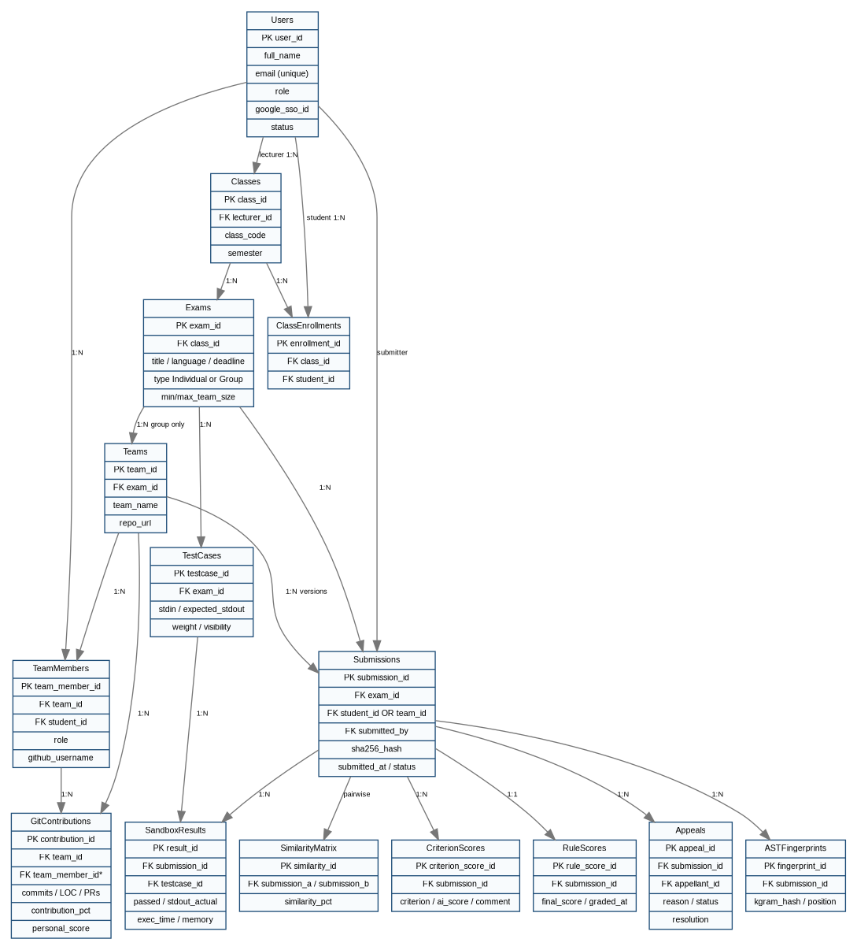
Figure 6-1. Logical data model derived from the supplied ERD

6.2 Entity Catalog
Entity / Data Object | Required Information / Purpose
Users | Identity, role, SSO/local account status.
Classes | Course section owned by Lecturer.
ClassEnrollments | Student–Class membership.
Exams | Individual/Group assignment/exam metadata and lifecycle.
Teams | Group Exam team and repository.
TeamMembers | Team membership, Leader role and GitHub identity.
TestCases | StdIn/expected StdOut, weight and visibility.
Submissions | Submission ownership, artifact/hash, timestamps and lifecycle.
SandboxResults | Per-test outcome, output and performance telemetry.
ASTFingerprints | Selected Winnowing fingerprints for structural analysis.
SimilarityMatrix | Pairwise same-exam similarity measurements.
CriterionScores | GenAI rubric scores/comments.
RuleScores | Final/team aggregate score record.
Appeals | Appeal scope, reason, status and resolution.
GitContributions | Per-member Git metrics, contribution percentage and personal score.
Audit Trail (logical) | Required by source for score overrides, Team Leader changes and security events; physical table/schema is not defined in the source.

6.3 Data Integrity Constraints
1. Exactly one active Team Leader per team.
2. Exactly one active Group Exam Submission per team; later valid pre-deadline submissions supersede earlier ones.
3. Similarity pairs shall not self-compare and shall represent submissions from the same Exam; Group Exam comparison is cross-team only.
4. Submission hash uniqueness follows BR-07.
5. Class roster import shall be atomic.
6. Score overrides and Team Leader changes shall be auditable.

6.4 Data Privacy and Retention
- Student source code must be authorization-protected and direct PII removed before GenAI transmission.
- GenAI API keys must be encrypted at rest and masked in APIs/logs.
- Submission ZIP files and detailed execution/evaluation logs are retained in active storage for 12 months after the end of the corresponding academic semester, then moved to archive/cold storage in accordance with NFR-RET-001.

7. Business Rules and Scoring Computations
Business rules below preserve the identifiers and formulas from the source. Where a rule references behavior not otherwise specified as an AITA workflow, that gap is explicitly stated rather than converted into a new feature.
ID | Type | Rule / Clarification
BR-01 | Constraint | Every Sandbox container is capped at 512 MiB RAM, 1.0 virtual CPU and 10 seconds per test case, with inbound/outbound external networking disabled during execution.
BR-02 | Action Enabler | A submission received after the Exam deadline is flagged Late; the Lecturer must explicitly approve it before grading proceeds.
BR-03 | Inference | Similarity(A,B) = |F_A ∩ F_B| / min(|F_A|,|F_B|) × 100%. Similarity >= 80% is Plagiarism Suspected; 50%–<80% is Moderate Similarity. Group Exams compare different teams only.
BR-04 | Action Enabler | GenAI keys rotate round-robin; a rate-limited key enters a 24-hour cooldown. If all keys fail after three retry attempts, the submission enters AI evaluation degraded state with provisional grading.
BR-05 | Inference | Raw Git contribution C_i = (0.35 × Commit Share + 0.40 × LOC Share + 0.25 × PR Share) × 100%, excluding auto-generated files. C_i < 5% produces an Under-Contribution Warning unless Lecturer-approved justification exists.
BR-06 | External/Project Constraint | The source states that team code must reach >=80% automated unit-test coverage before Milestone 3/final CI/CD acceptance. No AITA product workflow for collecting/enforcing this gate is specified; it is therefore not implemented as a new product feature in this SRS baseline.
BR-07 | Constraint | A Submission SHA-256 hash must be unique within the same Exam and, for Group Exams, within the same team scope; an identical duplicate-hash upload is rejected.
BR-08 | Constraint | A Grade Appeal must be submitted within 48 hours of grade publication. Team Leader appeals the team grade; any Team Member may appeal only their own personal score.
BR-09 | Constraint | Detailed execution logs/results are visible only to the owning Student/Team Members and the designated Lecturer(s)/Admin for that class.
BR-10 | Computation | Phase 1 Net Milestone Score uses only the approved Sandbox and AI Semantic Review components. To preserve the original relative weighting after removing Peer P2P Review, the score is normalized as: Net Milestone Score = (Sandbox Score × 0.4 + AI Semantic Review Score × 0.3) / 0.7, equivalently (Sandbox Score × 4/7) + (AI Semantic Review Score × 3/7). If AI review is degraded or unavailable and the Lecturer approves fallback grading, the provisional Net Score equals the Sandbox Score. Peer P2P Review is not collected or scored in Phase 1.
BR-11 | Constraint | For a Group Exam, each team has exactly one active Submission; only the designated Team Leader may submit, and a later pre-deadline valid submission supersedes the earlier one.
BR-12 | Computation | Personal Score = min(10.0, Team Score × Contribution Factor), where Contribution Factor = clamp(C_i / (100 / team size), lower, upper). Defaults: lower 0.5, upper 1.2. Penalized points are not redistributed. The optional group-normalized balancing mode is mentioned but not further specified.
BR-13 | Constraint | Only a Lecturer may reassign a Team Leader; every change records old leader, new leader, justification and timestamp.

8. Use Case Specifications
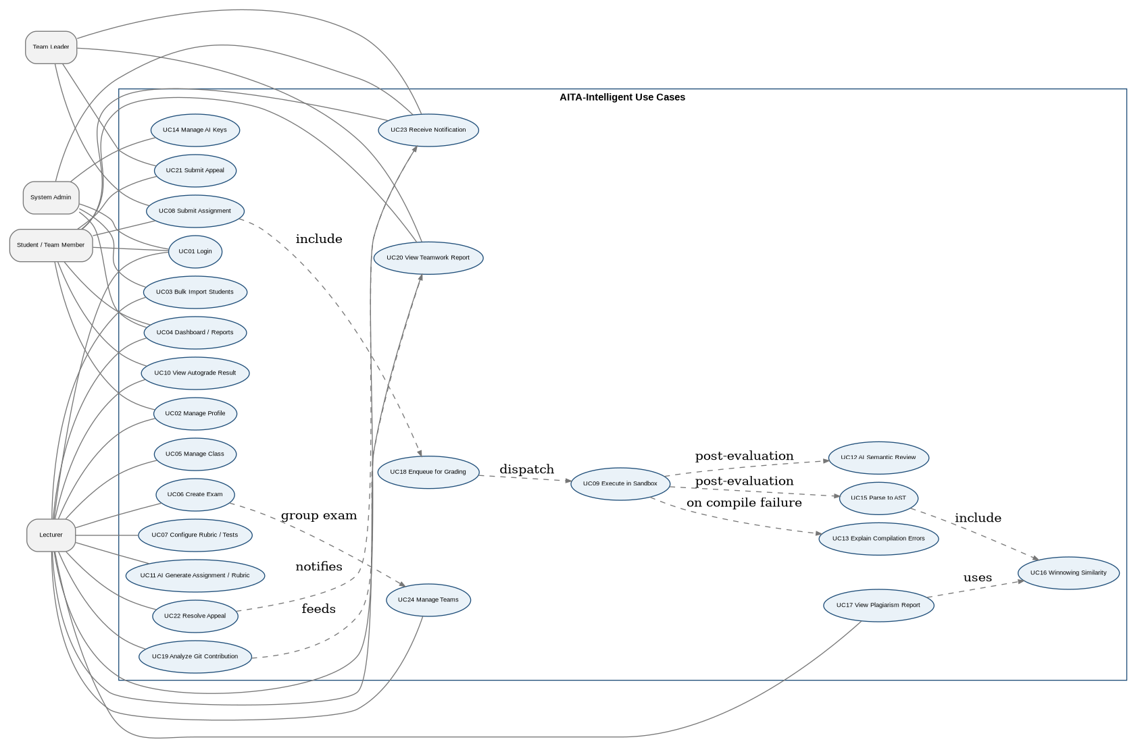
Figure 8-1. Use case overview reconstructed from the source baseline
The specifications below follow one UC Specification Template for all 24 approved use cases: Use Case Name, Use Case ID, Actor(s), Preconditions, Postconditions, Main Flow (Basic Path), Alternative Flow A, Alternative Flow B, Exception Flow, and Business Rules. Source triggers are retained within Preconditions, and no new use cases or hidden scope are introduced.

8.1 UC01 — Register / Login
UC SPECIFICATION TEMPLATE
Use Case Name | Register / Login
Use Case ID | UC01
Actor(s) | Primary / Supporting: Student, Lecturer, System Admin; Google OAuth is external
Preconditions | User has a valid institutional Google account or a registered local account.  Trigger: User opens the Login screen and chooses an authentication method.
Postconditions | Authenticated session exists with role-based authorization, or no session is created on failure.
Main Flow (Basic Path) | - User selects Google SSO or local login.  - For Google SSO, the system redirects to Google OAuth and receives the authorization result.  - The system validates the institutional email domain or verifies the local password.  - The system creates/updates the user record as applicable, establishes the JWT-based session and resolves the user role.  - The system redirects to the role-based dashboard.
Alternative Flow A | N/A
Alternative Flow B | N/A
Exception Flow | - Google OAuth is cancelled or fails: return to Login with an error.  - Email domain is not authorized: reject authentication.  - Local authentication fails repeatedly: apply the account-lockout requirement.
Business Rules | NFR-SEC-001/002/003; FR-AUTH-001..005

8.2 UC02 — Manage User Profile
UC SPECIFICATION TEMPLATE
Use Case Name | Manage User Profile
Use Case ID | UC02
Actor(s) | Primary / Supporting: All authenticated users
Preconditions | User is authenticated.  Trigger: User opens Profile Settings.
Postconditions | Profile is updated without changing user authorization role.
Main Flow (Basic Path) | - System displays editable profile fields permitted by role.  - User updates allowed fields and may upload a PNG/JPG avatar under 2 MB.  - System validates input and persists the accepted changes.  - Updated profile data is reflected in navigation/roster views.
Alternative Flow A | N/A
Alternative Flow B | N/A
Exception Flow | - Invalid image/file or field format: reject the invalid input and retain prior value.
Business Rules | FR-PROF-001/002

8.3 UC03 — Bulk Import Students
UC SPECIFICATION TEMPLATE
Use Case Name | Bulk Import Students
Use Case ID | UC03
Actor(s) | Primary / Supporting: Lecturer, System Admin (authorized class support)
Preconditions | Actor is authorized for the target class; Excel follows the expected structure.  Trigger: Actor selects Bulk Import Students.
Postconditions | Either the entire accepted batch is committed or no partial batch changes remain.
Main Flow (Basic Path) | - Upload .xlsx roster.  - System parses headers and shows mapping/preview.  - Actor confirms required column mapping.  - System validates every row for format, domain, duplicates and eligibility inside one transaction.  - If all required validations pass, system upserts users/enrollments and commits.  - System displays total/added/skipped summary.
Alternative Flow A | Existing user: update/link enrollment instead of duplicate user creation.
Alternative Flow B | N/A
Exception Flow | - Invalid/corrupt file: abort import and report parsing error.  - Unrecoverable validation/DB failure: roll back the entire batch and report affected rows.
Business Rules | FR-IMP-001..004

8.4 UC04 — View Role-Based Dashboard & Authorized Administration
UC SPECIFICATION TEMPLATE
Use Case Name | View Role-Based Dashboard & Authorized Administration
Use Case ID | UC04
Actor(s) | Primary / Supporting: Student/Team Member, Team Leader, Lecturer, System Admin
Preconditions | User is authenticated.  Trigger: Login succeeds or user navigates to Dashboard.
Postconditions | User sees only information/actions allowed for their role.
Main Flow (Basic Path) | - System loads role-filtered counts and shortcuts for classes, exams/submissions, grading/appeals and notifications.  - Student sees own/enrolled data; Lecturer sees owned-class data; Admin receives authorized support/admin views.  - Admin may navigate to user-management functions described by the source screen inventory.
Alternative Flow A | No active items: render empty states without authorization leakage.
Alternative Flow B | N/A
Exception Flow | N/A
Business Rules | FR-DASH-001, FR-AUTH-005/006

8.5 UC05 — Create / Manage Class
UC SPECIFICATION TEMPLATE
Use Case Name | Create / Manage Class
Use Case ID | UC05
Actor(s) | Primary / Supporting: Lecturer; System Admin support
Preconditions | Lecturer/Admin is authenticated and authorized.  Trigger: Lecturer chooses Create Class or opens a managed class.
Postconditions | Class and authorized roster state are persisted.
Main Flow (Basic Path) | - Enter class code/section, semester and required metadata.  - System validates and creates the class linked to the Lecturer.  - System generates the source-specified join code.  - Lecturer manages the class roster directly or via UC03.
Alternative Flow A | N/A
Alternative Flow B | N/A
Exception Flow | - Duplicate/invalid class metadata: reject with validation feedback.
Business Rules | FR-CLS-001..003

8.6 UC06 — Create Exam / Assignment
UC SPECIFICATION TEMPLATE
Use Case Name | Create Exam / Assignment
Use Case ID | UC06
Actor(s) | Primary / Supporting: Lecturer
Preconditions | Lecturer owns the target class.  Trigger: Lecturer selects Create Exam/Assignment.
Postconditions | Exam exists in Draft/Scheduled state with defined grading configuration.
Main Flow (Basic Path) | - Enter title, target language/runtime, deadline, grading weight and Individual/Group type.  - For Group type, configure min/max team size and repository requirement.  - Configure or later attach rubrics/test cases via UC07; optional UC11 may draft content.  - System validates configuration and saves Draft/Scheduled exam.  - Before Group Exam opens, valid teams must exist with exactly one Team Leader each.
Alternative Flow A | N/A
Alternative Flow B | N/A
Exception Flow | - Invalid deadline/runtime/team-size configuration: reject with validation messages.
Business Rules | FR-EXM-001/002/006; FR-TEAM-003

8.7 UC07 — Configure Rubric / Test Cases
UC SPECIFICATION TEMPLATE
Use Case Name | Configure Rubric / Test Cases
Use Case ID | UC07
Actor(s) | Primary / Supporting: Lecturer
Preconditions | Exam exists and is editable.  Trigger: Lecturer opens grading configuration.
Postconditions | Exam contains grading test cases and/or qualitative rubric criteria.
Main Flow (Basic Path) | - Create public/hidden StdIn/expected-StdOut test cases.  - Assign score weights.  - Create qualitative rubric criteria.  - System validates and persists configuration with visibility flags.
Alternative Flow A | Lecturer invokes UC11 to draft content, then reviews/edits before saving.
Alternative Flow B | N/A
Exception Flow | N/A
Business Rules | FR-EXM-003..005

8.8 UC08 — Submit Assignment
UC SPECIFICATION TEMPLATE
Use Case Name | Submit Assignment
Use Case ID | UC08
Actor(s) | Primary / Supporting: Student (Individual); Team Leader (Group)
Preconditions | Exam is open; individual student is enrolled, or group submitter is the designated Team Leader of a valid team.  Trigger: Authorized submitter selects Submit Assignment.
Postconditions | Accepted submission is persisted in queued state and evaluation job is enqueued.
Main Flow (Basic Path) | - Select/upload ZIP source package.  - System verifies submitter authority.  - System validates archive size/type/safety and computes SHA-256.  - System rejects duplicate hash if BR-07 applies.  - System persists Submission; Group submission records team_id and submitted_by and supersedes prior active team submission.  - System enqueues UC18 and returns the Submission ID/receipt; affected users receive status update.
Alternative Flow A | Resubmission before deadline supersedes the previous active submission.
Alternative Flow B | Late submission is flagged and awaits Lecturer approval.
Exception Flow | - Unsafe, oversize, duplicate or unauthorized upload is rejected.
Business Rules | BR-02, BR-07, BR-11; FR-SUB-*

8.9 UC09 — Execute Submission in Sandbox
UC SPECIFICATION TEMPLATE
Use Case Name | Execute Submission in Sandbox
Use Case ID | UC09
Actor(s) | Primary / Supporting: System Sandbox Worker; Docker Engine
Preconditions | Submission is accepted/queued; target-language image exists.  Trigger: Worker dequeues the grading job.
Postconditions | SandboxResults are persisted; sandbox score/diagnostics are available.
Main Flow (Basic Path) | - Create isolated Docker container with resource/network restrictions.  - Copy source and compile where applicable.  - Run each test case with StdIn, capture StdOut/StdErr, execution time and memory.  - Compare actual/expected output and persist per-test results.  - Destroy the container.  - Signal downstream scoring/analysis stages.
Alternative Flow A | N/A
Alternative Flow B | N/A
Exception Flow | - Compilation failure: record status/diagnostics and optionally invoke UC13.  - Timeout: terminate failing process/test and record TLE.  - Memory limit: container/process is killed and result records memory-limit failure.
Business Rules | BR-01, BR-09; FR-SBX-*

8.10 UC10 — View Autograde Result / Diagnostics
UC SPECIFICATION TEMPLATE
Use Case Name | View Autograde Result / Diagnostics
Use Case ID | UC10
Actor(s) | Primary / Supporting: Student/Team Member (own/team result), Lecturer (own classes), Admin
Preconditions | Authorized Submission exists; results may be running or complete.  Trigger: User opens Submission Result Detail.
Postconditions | User views authorized grading feedback without cross-student data exposure.
Main Flow (Basic Path) | - System displays current evaluation state.  - If available, show public pass/fail breakdown, execution time, memory usage and sanitized compiler/runtime diagnostics.  - During active processing, status/log updates may arrive via WebSocket.
Alternative Flow A | Hidden test details remain protected according to exam configuration and authorization.
Alternative Flow B | N/A
Exception Flow | N/A
Business Rules | FR-RES-001/002, BR-09

8.11 UC11 — AI Generate Assignment / Rubric
UC SPECIFICATION TEMPLATE
Use Case Name | AI Generate Assignment / Rubric
Use Case ID | UC11
Actor(s) | Primary / Supporting: Lecturer; GenAI Provider
Preconditions | Lecturer is editing an assignment; GenAI service/key is available.  Trigger: Lecturer selects Generate with GenAI.
Postconditions | Draft content is available for Lecturer review; nothing is auto-published without Lecturer action.
Main Flow (Basic Path) | - Lecturer supplies topic prompt and source-specified difficulty context.  - System sends generation request to GenAI Provider.  - System receives structured draft problem statement, sample/starter tests and rubric.  - Lecturer reviews/edits before saving to exam configuration.
Alternative Flow A | N/A
Alternative Flow B | N/A
Exception Flow | - Provider unavailable or output invalid: show failure and retain manual editor.
Business Rules | FR-EXM-007, FR-AI-004..007

8.12 UC12 — AI Semantic Code Review
UC SPECIFICATION TEMPLATE
Use Case Name | AI Semantic Code Review
Use Case ID | UC12
Actor(s) | Primary / Supporting: System GenAI Service; GenAI Provider; Lecturer/Student consume result
Preconditions | Submission exists; qualitative rubric criteria configured; at least one usable GenAI key.  Trigger: Evaluation pipeline dispatches semantic-review job.
Postconditions | Criterion scores/comments are persisted or degraded/manual-review state is recorded.
Main Flow (Basic Path) | - Select active key round-robin.  - Construct sanitized prompt with source and rubric criteria.  - Call provider requesting structured JSON.  - Validate and parse criterion scores/comments.  - Persist CriterionScores.  - Provide AI score input to score aggregation.
Alternative Flow A | Invalid JSON: perform one corrective retry; if still invalid, flag manual review.
Alternative Flow B | Rate-limited key: bench/cooldown and retry next active key.
Exception Flow | - All keys exhausted: mark AI evaluation degraded and preserve other evaluation outputs.
Business Rules | BR-04, BR-10; FR-AI-001..007

8.13 UC13 — AI Explain Compilation Errors
UC SPECIFICATION TEMPLATE
Use Case Name | AI Explain Compilation Errors
Use Case ID | UC13
Actor(s) | Primary / Supporting: Student; System GenAI Service; GenAI Provider
Preconditions | UC09 recorded compilation failure and GenAI explanation is enabled/available.  Trigger: Compilation failure is recorded or Student opens the explanation action.
Postconditions | Student receives a natural-language explanation of compiler diagnostics when GenAI is available. No multi-round chatbot or follow-up conversational workflow is provided in Phase 1.
Main Flow (Basic Path) | - System sanitizes compiler diagnostics/context.  - System requests a natural-language explanation from GenAI Provider.  - System displays explanation next to the raw compiler log.
Alternative Flow A | N/A
Alternative Flow B | N/A
Exception Flow | - Provider unavailable: raw compiler diagnostics remain available and explanation is marked unavailable.
Business Rules | FR-AI-008; ISS-01 resolved for Phase 1: compilation-error explanation only.

8.14 UC14 — Manage AI API Key Rotation
UC SPECIFICATION TEMPLATE
Use Case Name | Manage AI API Key Rotation
Use Case ID | UC14
Actor(s) | Primary / Supporting: System Admin; GenAI Provider
Preconditions | Admin is authenticated.  Trigger: Admin opens AI API Key Rotation.
Postconditions | Key pool state is updated and subsequent GenAI calls use current eligible keys.
Main Flow (Basic Path) | - Add key with provider/quota metadata.  - System validates key with lightweight probe.  - Valid key enters active round-robin pool.  - Admin views Active/Benched/Quota status and may disable/replace/renew keys.
Alternative Flow A | HTTP 429: key enters 24h cooldown.
Alternative Flow B | N/A
Exception Flow | - Invalid/expired/quota-exhausted key: remove from active use and alert Admin.
Business Rules | BR-04; FR-AI-004..007

8.15 UC15 — Parse Submission to AST
UC SPECIFICATION TEMPLATE
Use Case Name | Parse Submission to AST
Use Case ID | UC15
Actor(s) | Primary / Supporting: System AST Engine
Preconditions | Submission language is supported by an AST parser.  Trigger: AST analysis stage receives extracted source files.
Postconditions | Normalized token stream is available for fingerprinting, or AST incomplete status is recorded.
Main Flow (Basic Path) | - Select parser for target language.  - Parse source files into AST representation.  - Flatten AST using structural traversal.  - Normalize/abstract identifiers, comments, whitespace/formatting and literal values.  - Pass normalized token stream to UC16.
Alternative Flow A | N/A
Alternative Flow B | N/A
Exception Flow | - File parse fails: log incomplete/parse warning and continue available processing; Sandbox grading remains independent.
Business Rules | FR-AST-001/002

8.16 UC16 — Compute Winnowing Fingerprint & Similarity
UC SPECIFICATION TEMPLATE
Use Case Name | Compute Winnowing Fingerprint & Similarity
Use Case ID | UC16
Actor(s) | Primary / Supporting: System AST/Winnowing Engine
Preconditions | Normalized AST token stream exists.  Trigger: AST normalization completes.
Postconditions | Similarity results/flags are available for UC17.
Main Flow (Basic Path) | - Create k-gram hashes over normalized tokens.  - Apply Winnowing windows and select minimum hash (rightmost on ties) as fingerprints.  - Persist fingerprints.  - Compare against same-Exam submissions using BR-03 containment similarity.  - For Group Exams compare different teams only.  - Persist SimilarityMatrix and set threshold flags.
Alternative Flow A | N/A
Alternative Flow B | N/A
Exception Flow | - Too few tokens/incomplete AST: exclude unavailable fingerprint from pairwise comparison and retain status.
Business Rules | BR-03; FR-AST-003..006

8.17 UC17 — View Plagiarism Report
UC SPECIFICATION TEMPLATE
Use Case Name | View Plagiarism Report
Use Case ID | UC17
Actor(s) | Primary / Supporting: Lecturer; System Admin
Preconditions | At least two comparable submissions/fingerprints exist.  Trigger: Authorized user opens Similarity Matrix Viewer.
Postconditions | Authorized reviewer can investigate structural similarity; academic-integrity decision itself remains outside automated detection.
Main Flow (Basic Path) | - Render pairwise heat map/similarity matrix.  - Allow filtering/identification of Moderate and Suspected pairs.  - User selects a pair.  - Open side-by-side view highlighting matched structural regions/tokens.
Alternative Flow A | N/A
Alternative Flow B | N/A
Exception Flow | - Student access attempt: deny with 403.  - Not enough submissions: show informative empty state.  - AST incomplete entry: display incomplete status without breaking matrix.
Business Rules | BR-03, BR-09; FR-PLG-*

8.18 UC18 — Enqueue Submission for Grading
UC SPECIFICATION TEMPLATE
Use Case Name | Enqueue Submission for Grading
Use Case ID | UC18
Actor(s) | Primary / Supporting: System Submission Service / Queue
Preconditions | UC08 persisted a valid Submission.  Trigger: Submission persistence succeeds.
Postconditions | Job is available to evaluation workers or a failure state is recorded.
Main Flow (Basic Path) | - Publish grading payload containing at least submission and exam identifiers; group context is included when applicable.  - Persist/acknowledge queued job.  - Workers dequeue jobs when capacity is available.  - Queue monitor retries interrupted jobs according to NFR-REL-001.
Alternative Flow A | N/A
Alternative Flow B | N/A
Exception Flow | - Queue publication failure: record failure state and do not falsely report grading completion.
Business Rules | FR-QUE-001; NFR-PERF-001/003, NFR-REL-001/002

8.19 UC19 — Analyze Git Contribution
UC SPECIFICATION TEMPLATE
Use Case Name | Analyze Git Contribution
Use Case ID | UC19
Actor(s) | Primary / Supporting: Lecturer on-demand; System scheduled process; GitHub
Preconditions | Group Exam team has linked GitHub repository and member GitHub identities.  Trigger: Scheduled or Lecturer-triggered synchronization.
Postconditions | Current Git contribution metrics and personal-score inputs are persisted.
Main Flow (Basic Path) | - Retrieve commits, LOC deltas and merged PRs.  - Map GitHub authors to Team Members.  - Compute metric shares and C_i formula.  - Persist metrics/contribution percentage and warning state.  - After team score is final, compute BR-12 personal score.
Alternative Flow A | Unmapped author: record as Unmapped and surface to Lecturer for manual association.
Alternative Flow B | N/A
Exception Flow | - GitHub unavailable: retain prior metrics and surface sync failure.
Business Rules | BR-05, BR-12; FR-GIT-001..005

8.20 UC20 — View Teamwork Contribution Report
UC SPECIFICATION TEMPLATE
Use Case Name | View Teamwork Contribution Report
Use Case ID | UC20
Actor(s) | Primary / Supporting: Team Member/Team Leader, Lecturer, Admin
Preconditions | Group team exists; Git analytics data may be available.  Trigger: Authorized user opens Git Teamwork Analytics.
Postconditions | Authorized user can review transparent contribution metrics.
Main Flow (Basic Path) | - System displays per-member commits, LOC and merged PR metrics.  - Display contribution percentage, warning state and contribution factor.  - After team score is final, display the resulting personal score.
Alternative Flow A | N/A
Alternative Flow B | N/A
Exception Flow | - No synchronized data: show current unavailable/not-synced state.  - Users can view only authorized team/class data.
Business Rules | FR-GIT-006; source conflict with US-20 documented in Section 12

8.21 UC21 — Submit Grade Appeal
UC SPECIFICATION TEMPLATE
Use Case Name | Submit Grade Appeal
Use Case ID | UC21
Actor(s) | Primary / Supporting: Student; Team Leader; Team Member
Preconditions | Result is published and current time is within 48 hours; appellant has authority for selected scope.  Trigger: Eligible appellant selects Appeal.
Postconditions | Appeal is created and routed to Lecturer, or rejected without state change.
Main Flow (Basic Path) | - Select applicable appeal scope.  - Enter justification and attach supporting evidence.  - System validates 48-hour window, role/scope authority and duplicate active appeal.  - System creates Open/Submitted appeal and notifies Lecturer.
Alternative Flow A | N/A
Alternative Flow B | N/A
Exception Flow | - After 48 hours: action disabled/rejected.  - Team Member cannot appeal team grade; Team Leader cannot appeal another member's personal score.
Business Rules | BR-08, BR-12; FR-APL-001..003

8.22 UC22 — Resolve Appeal
UC SPECIFICATION TEMPLATE
Use Case Name | Resolve Appeal
Use Case ID | UC22
Actor(s) | Primary / Supporting: Lecturer
Preconditions | Open appeal belongs to a class owned by the Lecturer.  Trigger: Lecturer opens pending appeal.
Postconditions | Appeal is closed with an auditable outcome; score is updated if overridden.
Main Flow (Basic Path) | - Review appeal reason/evidence and relevant submission results/logs.  - Optionally re-run grading where supported.  - Choose Accept with score override or Reject with feedback.  - System validates score range, records decision/audit entry and closes appeal.  - System notifies appellant/affected users.
Alternative Flow A | N/A
Alternative Flow B | N/A
Exception Flow | - No decision reason/invalid score: reject submission of resolution until corrected.
Business Rules | BR-08, BR-09; FR-APL-004/005

8.23 UC23 — Receive Real-time Notification
UC SPECIFICATION TEMPLATE
Use Case Name | Receive Real-time Notification
Use Case ID | UC23
Actor(s) | Primary / Supporting: All authenticated users
Preconditions | Active session/subscription exists.  Trigger: Grading stage, result, team/personal score or appeal event occurs.
Postconditions | Affected users receive or can observe the latest authorized state.
Main Flow (Basic Path) | - Notification service publishes in-app/WebSocket event.  - System targets recipients by ownership/team/class role.  - Client updates relevant status/result/appeal indicators without manual refresh.
Alternative Flow A | Disconnected client: in-app state is available on the next refresh/session. Separate long-term notification-history retention is not a Phase 1 acceptance requirement.
Alternative Flow B | N/A
Exception Flow | N/A
Business Rules | FR-NOT-001/002

8.24 UC24 — Manage Teams
UC SPECIFICATION TEMPLATE
Use Case Name | Manage Teams
Use Case ID | UC24
Actor(s) | Primary / Supporting: Lecturer; System Admin support; Team Members have own-team read view
Preconditions | Group Exam exists with team-size limits and students enrolled in class.  Trigger: Lecturer opens Team Management.
Postconditions | Valid teams exist with one active Leader and required repository/member metadata.
Main Flow (Basic Path) | - Create teams manually or import team list.  - Assign enrolled members and validate uniqueness/team-size limits.  - Designate exactly one Team Leader.  - Record repository link and member GitHub identities.  - Persist teams/members atomically and notify members.  - If required, replace leader with reason and audit trail.
Alternative Flow A | Source mentions optional student self-registration subject to Lecturer confirmation; no dedicated self-registration screen/requirements are defined.
Alternative Flow B | N/A
Exception Flow | - Invalid size, duplicate membership/repository, non-enrolled user or multiple leaders: reject changes.
Business Rules | BR-11, BR-13; FR-TEAM-*

9. System Models (Informative, Non-Normative)
This section reorganizes design/model information that already appears in the source. The models help explain requirements but do not override the normative “shall” statements in Sections 4–7.

9.1 Submission Evaluation Flow
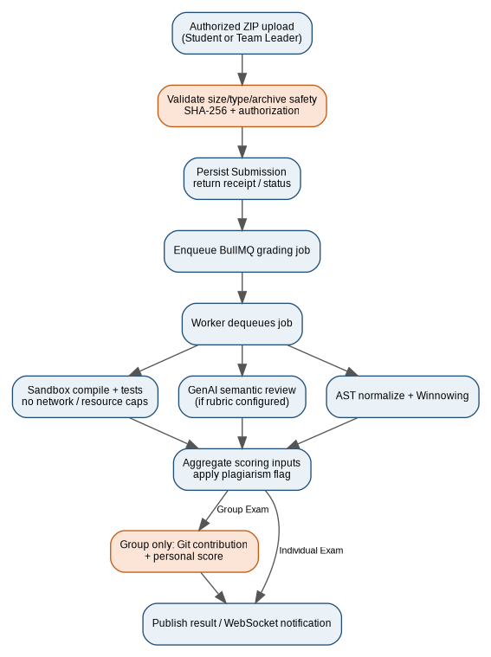
Figure 9-1. End-to-end submission evaluation flow

9.2 Submission Lifecycle State Model
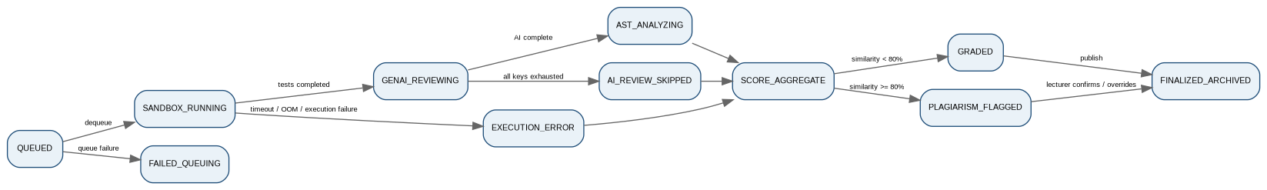
Figure 9-2. Submission evaluation state model

9.3 Exam Lifecycle State Model
Figure 9-3. Exam/assignment lifecycle state model

9.4 Appeal Lifecycle State Model
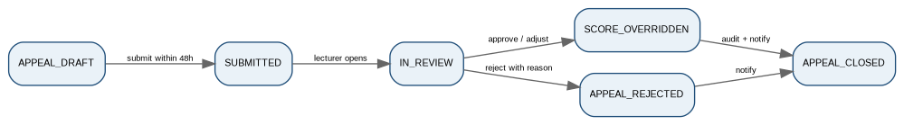
Figure 9-4. Grade appeal lifecycle state model

9.5 Component / Deployment Perspective
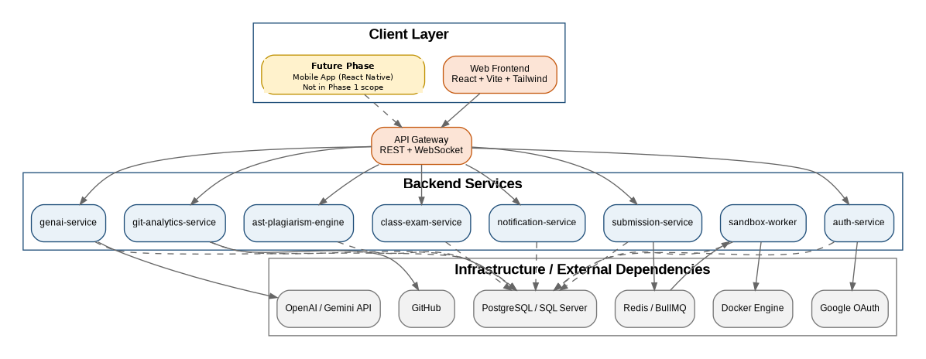
Figure 9-5. Component and dependency perspective derived from the source architecture
Architecture scope note: Phase 1 is Web App only. The React Native Mobile App is a future-phase component and is not part of the normative Phase 1 client baseline.

10. UI Behavior and Non-UI System Functions

10.1 Principal Screen Flow
The principal web flow is: Login → role-based Dashboard → Class List/Detail → exam/team/submission or analytics views. Group Exams pass through Team Management before Team Leader submission. Submission Result Detail links authorized Lecturers/Admins to plagiarism inspection and eligible appellants to Appeal Detail.
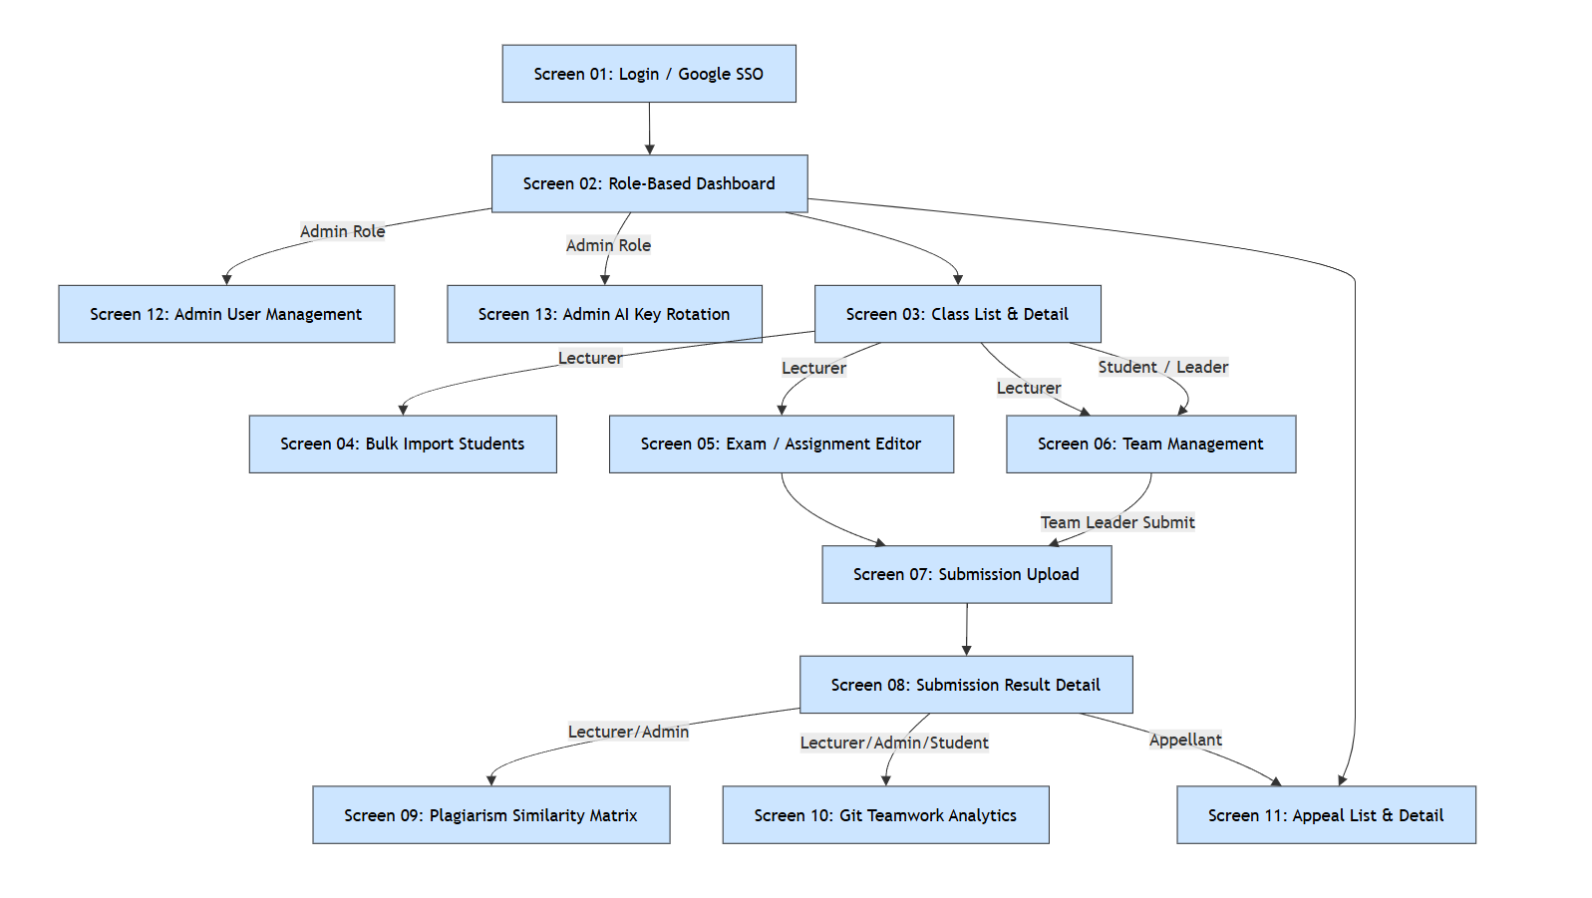
Figure 10-1. Screen Flow Diagram

10.2 Backend / Event-Driven Functions
Function | Responsibility
submission.enqueue | Publish accepted submission jobs to Redis/BullMQ.
sandboxWorker.execute | Compile/run in isolated container and persist per-test telemetry.
astParser.parse | Create normalized AST structural token stream.
winnowing.fingerprint | Generate fingerprints and compute pairwise similarity.
genai.rotateKey | Round-robin key selection, bench/cooldown/failover.
genai.semanticReview | Generate structured rubric scores/comments from sanitized code.
gitAnalytics.sync | Retrieve GitHub metrics, map authors and compute contribution.
contribution.computePersonalScore | Apply BR-12 after team score finalization.
notification.push | Publish grading/appeal/status events to affected users.
bulkImport.transaction | Validate and commit/rollback Excel roster import atomically.
team.validateSubmitter | Verify Group Exam Team Leader authorization and active submission rules.

11. Traceability and Verification

11.1 User Story Traceability
US ID | Actor | Related UC | Priority | Story Title / Source Note
US-01 | Student / Lecturer | UC01 | MUST HAVE | Institutional Google SSO & JWT Authentication
US-02 | All Users | UC02 | SHOULD HAVE | Manage User Profile & Avatar
US-03 | Lecturer | UC03 | MUST HAVE | Bulk Student Import via Excel
US-04 | Admin | UC04* | MUST HAVE | Role-Based Navigation & User Administration
US-05 | Lecturer | UC05 | MUST HAVE | Create Class & Manage Class Rosters
US-06 | Lecturer | UC06 | MUST HAVE | Create Exam with Language & Sandbox Constraints
US-07 | Lecturer | UC07 | MUST HAVE | Manage Hidden Test Cases & Rubrics
US-08 | Student | UC08-A | MUST HAVE | ZIP Submission Upload & Integrity Hashing (Individual)
US-09 | Student / Lecturer | UC09 | MUST HAVE | Automated Sandbox Compilation & Test Case Evaluation
US-10 | Student / Lecturer | UC10 | SHOULD HAVE | Live Execution Log Streaming & Diagnostics
US-11 | Lecturer | UC11 | SHOULD HAVE | GenAI Exam Question & Rubric Generator
US-12 | Lecturer | UC12 | MUST HAVE | AI Semantic Code Review & Rubric Scoring
US-13 | Student | UC13 | SHOULD HAVE | AI Compilation Error Explanation (single-turn explanation of compiler diagnostics; no multi-round chatbot in Phase 1)
US-14 | Admin | UC14 | MUST HAVE | AI API Key Rotation Pool & Fault Tolerance
US-15 | Lecturer/System | UC15 | MUST HAVE | Parse Source Files to Normalized AST Token Streams
US-16 | Lecturer/System | UC16 | MUST HAVE | Winnowing Fingerprinting & Similarity Matrix
US-17 | Lecturer | UC17 | MUST HAVE | Visual Side-by-Side Plagiarism Heatmap & Alignment
US-18 | Student/System | UC18 | MUST HAVE | Resilient Submission Enqueuing & Asynchronous Dispatch
US-19 | Lecturer | UC19 | MUST HAVE | GitHub Commit & LOC Teamwork Analytics
US-20 | Student / Lecturer | UC20* | SHOULD HAVE | Source text says live evaluation tracker; canonical UC20 elsewhere is teamwork contribution report
US-21 | Eligible Appellant | UC21 | MUST HAVE | Submit Grade Appeal with Supporting Justifications
US-22 | Lecturer | UC22 | MUST HAVE | Review Appeals & Override Final Scores
US-23 | All Users | UC23 | MUST HAVE | Real-time WebSocket & In-App Notifications
US-24 | Team Leader | UC08-B | MUST HAVE | Team Submission on Behalf of Group
US-25 | Lecturer | UC24 | MUST HAVE | Team Formation & Leader Designation
US-26 | Team Member | UC19/UC20 | MUST HAVE | Contribution-Based Personal Score Visibility
US-27 | Lecturer | UC24 | MUST HAVE | Team Leader Replacement & Audit Trail

11.2 Functional Requirement Traceability Matrix
FR ID | Use Case | User Story | Related Business Rule | Verification Method
FR-AUTH-001 | UC01 | US-01 | — | Test
FR-AUTH-002 | UC01 | US-01 | — | Test
FR-AUTH-003 | UC01 | US-01 | — | Test
FR-AUTH-004 | UC01 | US-01 / US-04 | — | Test
FR-AUTH-005 | UC01 / UC04 | US-04 | — | Test
FR-AUTH-006 | UC04* | US-04 | — | Test
FR-PROF-001 | UC02 | US-02 | — | Test
FR-PROF-002 | UC02 | US-02 | — | Test
FR-DASH-001 | UC04 | US-04* | — | Inspection/Test
FR-CLS-001 | UC05 | US-05 | — | Test
FR-CLS-002 | UC05 | US-05 | — | Test
FR-CLS-003 | UC05 | US-05 | — | Test
FR-IMP-001 | UC03 | US-03 | — | Test
FR-IMP-002 | UC03 | US-03 | — | Test
FR-IMP-003 | UC03 | US-03 | — | Test
FR-IMP-004 | UC03 | US-03 | — | Test
FR-EXM-001 | UC06 | US-06 | — | Test
FR-EXM-002 | UC06 / UC24 | US-06 / US-25 | — | Test
FR-EXM-003 | UC07 | US-07 | — | Test
FR-EXM-004 | UC07 | US-07 | — | Test
FR-EXM-005 | UC07 | US-07 | — | Test
FR-EXM-006 | UC06 | US-06 | — | Test/Inspection
FR-EXM-007 | UC11 | US-11 | — | Test
FR-TEAM-001 | UC24 | US-25 | BR-11 / BR-13 | Test
FR-TEAM-002 | UC24 | US-25 | BR-11 / BR-13 | Test
FR-TEAM-003 | UC24 | US-25 | BR-11 / BR-13 | Test
FR-TEAM-004 | UC24 | US-25 | BR-11 / BR-13 | Test
FR-TEAM-005 | UC24 | US-27 | BR-11 / BR-13 | Test/Inspection
FR-TEAM-006 | UC24 | US-25 | BR-11 / BR-13 | Test
FR-SUB-001 | UC08 | US-08 / US-24 | BR-02 / BR-07 / BR-11 | Test
FR-SUB-002 | UC08 | US-08 | BR-02 / BR-07 / BR-11 | Security Test
FR-SUB-003 | UC08 | US-08 | BR-02 / BR-07 / BR-11 | Test
FR-SUB-004 | UC08 | US-08 | BR-02 / BR-07 / BR-11 | Test
FR-SUB-005 | UC08 | US-08 / US-24 | BR-02 / BR-07 / BR-11 | Authorization Test
FR-SUB-006 | UC08 | US-24 | BR-02 / BR-07 / BR-11 | Test
FR-SUB-007 | UC08 | US-08 | BR-02 / BR-07 / BR-11 | Test
FR-SUB-008 | UC08 | US-08 | BR-02 / BR-07 / BR-11 | Test
FR-QUE-001 | UC18 | US-18 | — | Test
FR-QUE-002 | UC23* | US-20 | — | Test
FR-SBX-001 | UC09 | US-09 | BR-01 / BR-09 | Security/Performance Test
FR-SBX-002 | UC09 | US-09 | BR-01 / BR-09 | Test
FR-SBX-003 | UC09 | US-09 | BR-01 / BR-09 | Test
FR-SBX-004 | UC09 | US-09 | BR-01 / BR-09 | Test
FR-SBX-005 | UC09 | US-09 | BR-01 / BR-09 | Test
FR-SBX-006 | UC09 | US-09 | BR-01 / BR-09 | Inspection/Test
FR-RES-001 | UC10 | US-10 | BR-01 / BR-09 | Test
FR-RES-002 | UC10 | US-10 | BR-01 / BR-09 | Test
FR-AI-001 | UC12 | US-12 | BR-04 / BR-10 | Test
FR-AI-002 | UC12 | US-12 | BR-04 / BR-10 | Test
FR-AI-003 | UC12 | US-12 | BR-04 / BR-10 | Test
FR-AI-004 | UC14 | US-14 | BR-04 / BR-10 | Test
FR-AI-005 | UC14 | US-14 | BR-04 / BR-10 | Test
FR-AI-006 | UC14 | US-14 | BR-04 / BR-10 | Test
FR-AI-007 | UC12 / UC14 | US-12 / US-14 | BR-04 / BR-10 | Resilience Test
FR-AI-008 | UC13 | US-13* | BR-04 / BR-10 | Test
FR-AST-001 | UC15 | US-15 | BR-03 | Test
FR-AST-002 | UC15 | US-15 | BR-03 | Test
FR-AST-003 | UC16 | US-16 | BR-03 | Algorithm Test
FR-AST-004 | UC16 | US-16 | BR-03 | Algorithm Test
FR-AST-005 | UC16 | US-16 | BR-03 | Test
FR-AST-006 | UC16 / UC17 | US-16 / US-17 | BR-03 | Boundary Test
FR-PLG-001 | UC17 | US-17 | BR-03 | Test
FR-PLG-002 | UC17 | US-17 | BR-03 | Authorization Test
FR-PLG-003 | UC17 | US-17 | BR-03 | Exception Test
FR-GIT-001 | UC19 | US-19 | BR-05 / BR-12 | Integration Test
FR-GIT-002 | UC19 | US-19 | BR-05 / BR-12 | Test
FR-GIT-003 | UC19 | US-19 | BR-05 / BR-12 | Calculation Test
FR-GIT-004 | UC19 | US-19 | BR-05 / BR-12 | Boundary Test
FR-GIT-005 | UC19 | US-26 | BR-05 / BR-12 | Calculation Test
FR-GIT-006 | UC20 | US-26 | BR-05 / BR-12 | Test
FR-APL-001 | UC21 | US-21 | BR-08 / BR-09 | Boundary Test
FR-APL-002 | UC21 | US-21 | BR-08 / BR-09 | Authorization Test
FR-APL-003 | UC21 | US-21 | BR-08 / BR-09 | Test
FR-APL-004 | UC22 | US-22 | BR-08 / BR-09 | Test
FR-APL-005 | UC22 | US-22 | BR-08 / BR-09 | Test/Inspection
FR-NOT-001 | UC23 | US-23 | — | Test
FR-NOT-002 | UC23 | US-23 | — | Test
FR-AUD-001 | UC22 / UC24 | US-22 / US-27 | — | Inspection/Test

11.3 Verification Strategy
Verification Type | Applied To | Examples
Functional Test | User-visible or API behavior | Authentication, roster import, submission, appeal, result viewing.
Boundary Test | Thresholds/limits | 25 MiB, 10 s, 512 MiB, 48 h, 5%, 50/80% similarity.
Security Test | Authorization/isolation/input safety | 403 access control, zip-slip/zip-bomb, session/cookie, sandbox network isolation.
Integration Test | External/runtime dependencies | Google OAuth, GenAI provider, GitHub, Docker, Redis/BullMQ.
Algorithm/Calculation Test | Deterministic formulas | Winnowing, containment similarity, Git contribution, BR-12 personal score.
Resilience Test | Failure/degraded paths | Worker retry, GenAI key exhaustion, queue recovery.
Inspection | Configuration/data governance | API key encryption/masking, audit trails, PII removal.

12. Requirements Decision Register — Resolved for Phase 1
The source material contained several internal inconsistencies. The decisions below are approved for Phase 1 and are normative for implementation. Deferred items are explicitly outside Phase 1 scope and must not be implemented by assumption.
ID | Issue | Evidence / Conflict | Approved Resolution / Phase 1 Decision
ISS-01 | UC13 definition conflict | Use-case catalog/detailed spec define UC13 as “AI Explain Compilation Errors”; US-13 describes multi-round interactive code explanations. | RESOLVED — UC13 is limited to AI explanation of compilation errors. Multi-round interactive chatbot behavior is not included in Phase 1.
ISS-02 | UC20 definition conflict | Use-case catalog/detailed spec define UC20 as Teamwork Contribution Report; US-20 describes live pipeline progress. | RESOLVED — UC20 is the Teamwork Contribution Report. Live evaluation progress remains status/notification behavior under UC23/FR-QUE-002.
ISS-03 | ZIP size conflict | FR/SEC/US-08 acceptance repeatedly state 25 MB/MiB; one submission state table states <20 MB. | RESOLVED — The normative maximum ZIP upload size is 25 MiB throughout Phase 1.
ISS-04 | Appeal window conflict | BR-08, UC21 and detailed state table use 48 hours; one exam lifecycle diagram text says 7-day appeal window. | RESOLVED — Grade Appeals may be submitted only within 48 hours after grade publication.
ISS-05 | Peer P2P score source undefined | BR-10 requires Peer P2P Review Score but no use case, screen, entity or interface specifies how AITA receives it. | RESOLVED — No Peer P2P review workflow or manual Peer Review score-entry feature is added in Phase 1. Peer P2P weighting is removed; BR-10 is normalized across Sandbox and AI Semantic Review only.
ISS-06 | BR-06 CI/CD coverage gate | Source defines >=80% automated unit-test coverage gate, but no AITA use case/system function implements it. | RESOLVED / EXTERNAL — The >=80% unit-test coverage gate remains an external course/project CI/CD constraint and is not implemented as an AITA Phase 1 product workflow.
ISS-07 | Mobile application scope | Architecture artifact lists a React Native mobile app, but no mobile-specific use cases/screens/NFRs are defined. | RESOLVED / DEFERRED — Phase 1 supports the Web App only. React Native Mobile App is deferred to a later phase.
ISS-08 | Repository/commit submission wording | One screen description mentions entering repository link and commit SHA, while UC08/FR-SUB requirements define ZIP upload. | RESOLVED — The normative submission artifact is ZIP upload. Repository link/commit data is used only for Git teamwork analytics where applicable.
ISS-09 | GitContributions FK discrepancy | ERD image labels GitContributions with student_id while table description uses team_member_id. | RESOLVED AT REQUIREMENTS LEVEL — Git contribution is associated logically with the Team Member. The physical foreign-key representation is a design decision and does not alter approved behavior.
ISS-10 | Optional normalized score balancing | BR-12 mentions optional group-normalized score balancing but provides no formula or activation rules. | RESOLVED / DEFERRED — Phase 1 uses only the default BR-12 clamp formula. Optional group-normalized score balancing is not part of Phase 1.
ISS-11 | Retention/browser/accessibility gaps | Source has no retention period, backup/RTO/RPO, browser matrix or accessibility target. | RESOLVED — Phase 1 supports the two latest stable versions of Chrome/Edge/Firefox, desktop responsive layouts at >=1280 px, and 12-month active retention of ZIP submissions and detailed logs followed by archive/cold storage.

13. Approved Requirements Acceptance Checklist
Check | Acceptance Condition
Scope | Every implemented Phase 1 feature is traceable to a requirement/use case in this SRS; deferred future-phase items are not implemented without an approved change request.
Functional Completeness | All MUST HAVE source capabilities selected for the release pass their mapped functional tests.
Security | Upload-safety, RBAC, session, API-key protection, PII removal and sandbox isolation tests pass.
Performance | NFR-PERF-001..003 targets are measured in a representative environment.
Reliability | Queue persistence and retry behavior satisfy NFR-REL-001/002.
Data Integrity | Team leader, active submission, similarity-pair and roster transaction constraints hold.
Traceability | Every implemented FR is linked to verification evidence and any deviations are approved.
Decision Register | All Phase 1 blocking requirement conflicts are resolved in Section 12; deferred items are explicitly outside Phase 1 and require a future approved change request before implementation.

Appendix A — Initial Language and Runtime Baseline
Language | Runtime / Toolchain | Notes
C# | .NET 8 SDK | Sandbox and AST support assumed by source baseline.
Java | JDK 17 | Sandbox and AST support assumed by source baseline.

Appendix B — Score Formula Examples (Non-Normative)
The formulas themselves are normative in BR-03, BR-05, BR-10 and BR-12. Numeric examples are intentionally omitted here because the source does not provide official example values and this SRS avoids creating policy assumptions.

Appendix C — Source-to-Baseline Normalization Principles
- Use-case catalog and detailed use-case specification were treated as primary behavioral evidence when a user-story title contradicted them.
- Repeated quantified requirements were finalized by project decision: 25 MiB is the upload limit and 48 hours is the Grade Appeal window.
- Design artifacts were preserved as informative context only; they do not create requirements without supporting functional evidence.
- Previously missing Phase 1 deployment-quality targets were added only from explicit project decisions: browser compatibility, desktop responsiveness and submission/log retention.
- Peer P2P Review is removed from Phase 1 scoring rather than expanded into a new workflow; the CI/CD coverage gate remains external, and the React Native Mobile App is deferred to a later phase.

