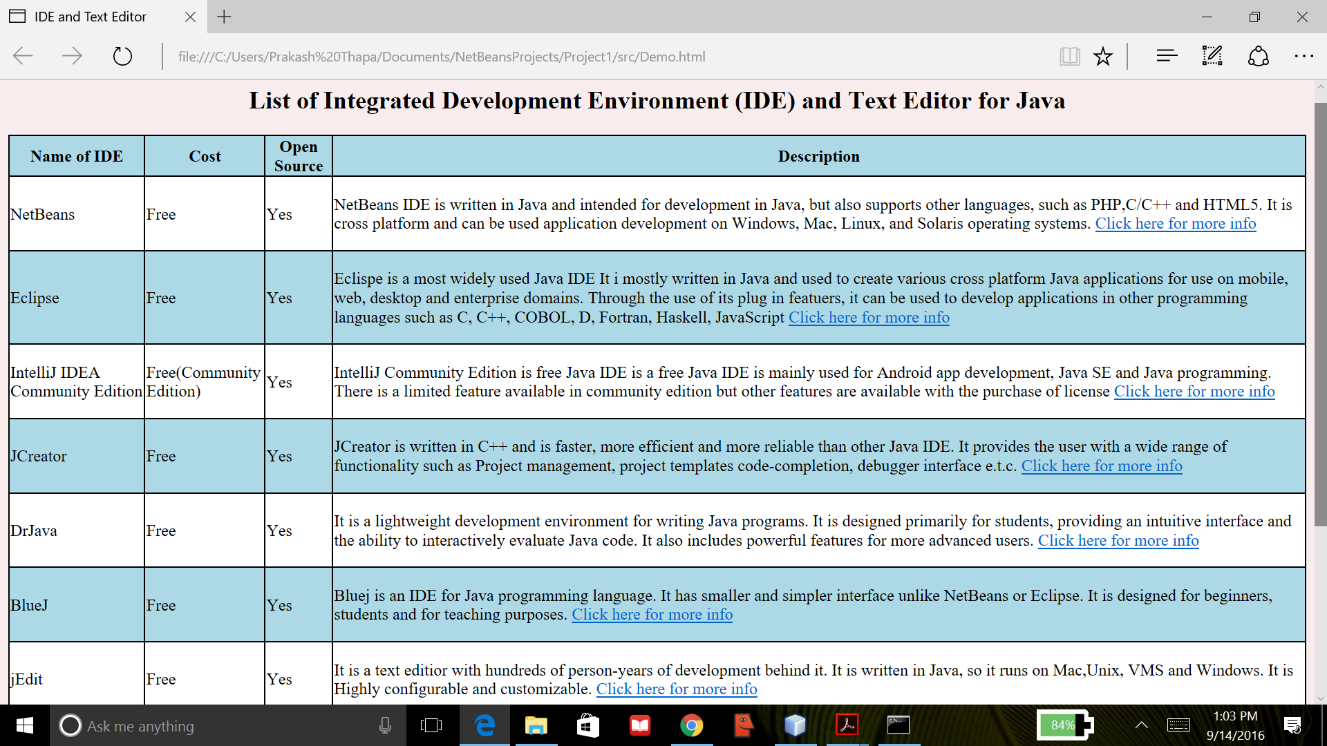

This program creates HTML page containing HTML table tags using java. The html page shows some lists of Integrated Development Environment (IDE) and text editor for java with table head containing Name of IDE, Cost, shows if the IDE is open source and brief information about the IDE with link to its website. The html Table tag is created by using Table class, Table Data class, TableDataItem class, TableRow class, and Table HeadItems class. This program allows to construct table with variable rows and column. This program was created using NetBeans IDE and compiled by the Java compiler version “javac 1.8.0_91 “.