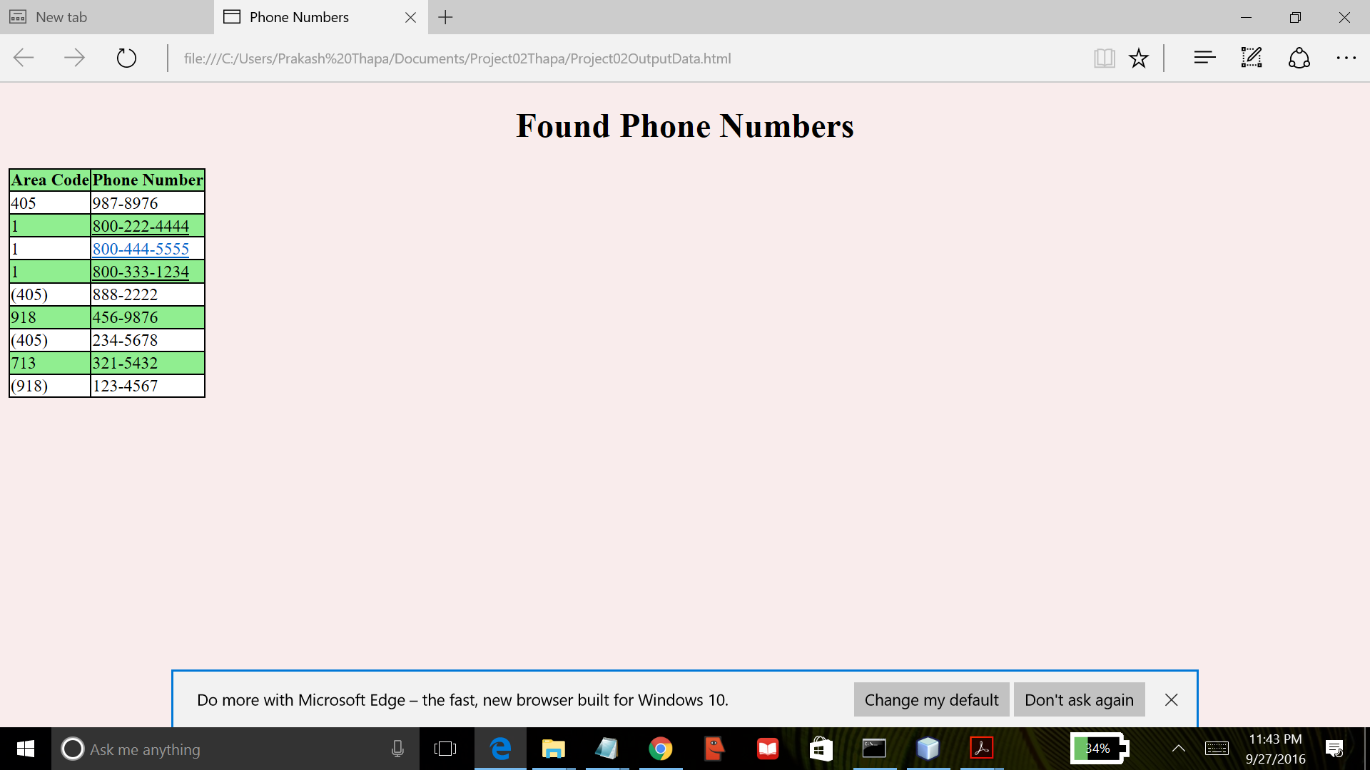

This program opens and reads file “Phone02Data.txt” for extracting valid phone numbers using regular expressions. It splits the extracted phone number into area code and phone number. Then it creates html file “Project02OuputData.html” where it directly writes the extracted phone numbers. The output is a HTML page with a table with two columns; the first column is area code and the other column is phone number. This project used previous project (project01) for creating HTML page with table. This program was created using NetBeans IDE and compiled by the Java compiler version “javac 1.8.0_91 “.