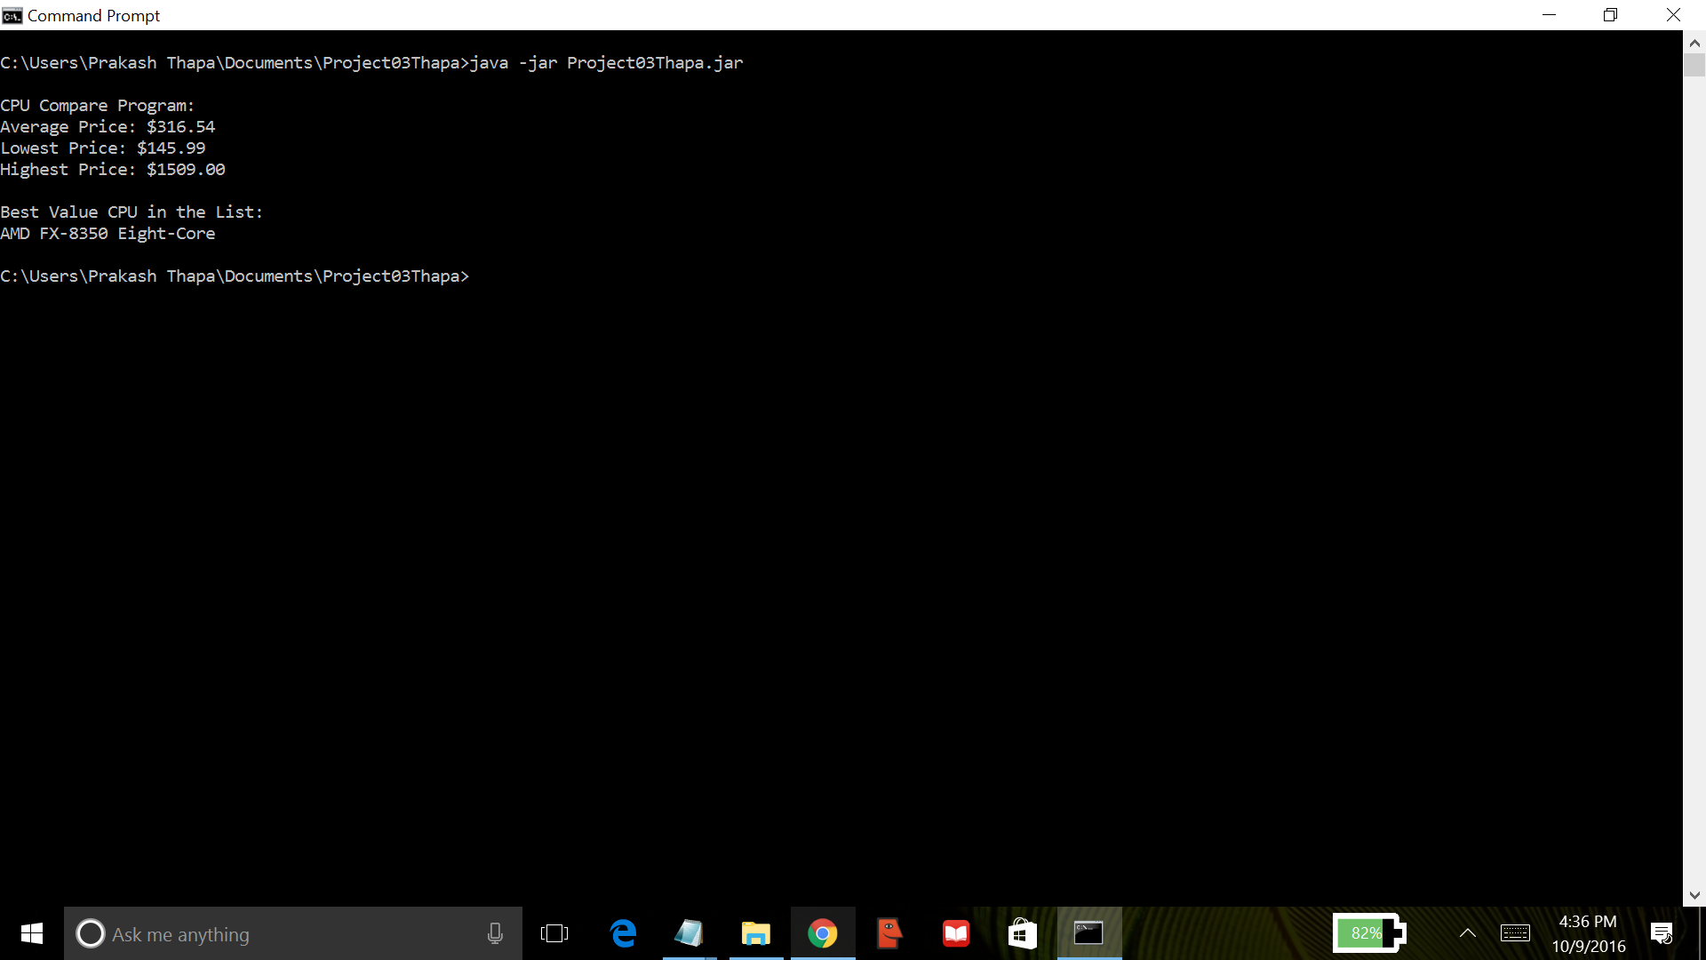

Project03 opens and reads csv file “Project03Data.csv”. It extracts a list of CPU names, its performance level and its price into a List data structure. Then using stream and functional Interface, it calculates and displays average price, highest price and lowest price of the CPU in the list. Also, it performs comparisons between CPUs based on their performance level and its price and displays the best value CPU in the list. This program was created using NetBeans IDE and compiled by the Java compiler version “javac 1.8.0_91 “.