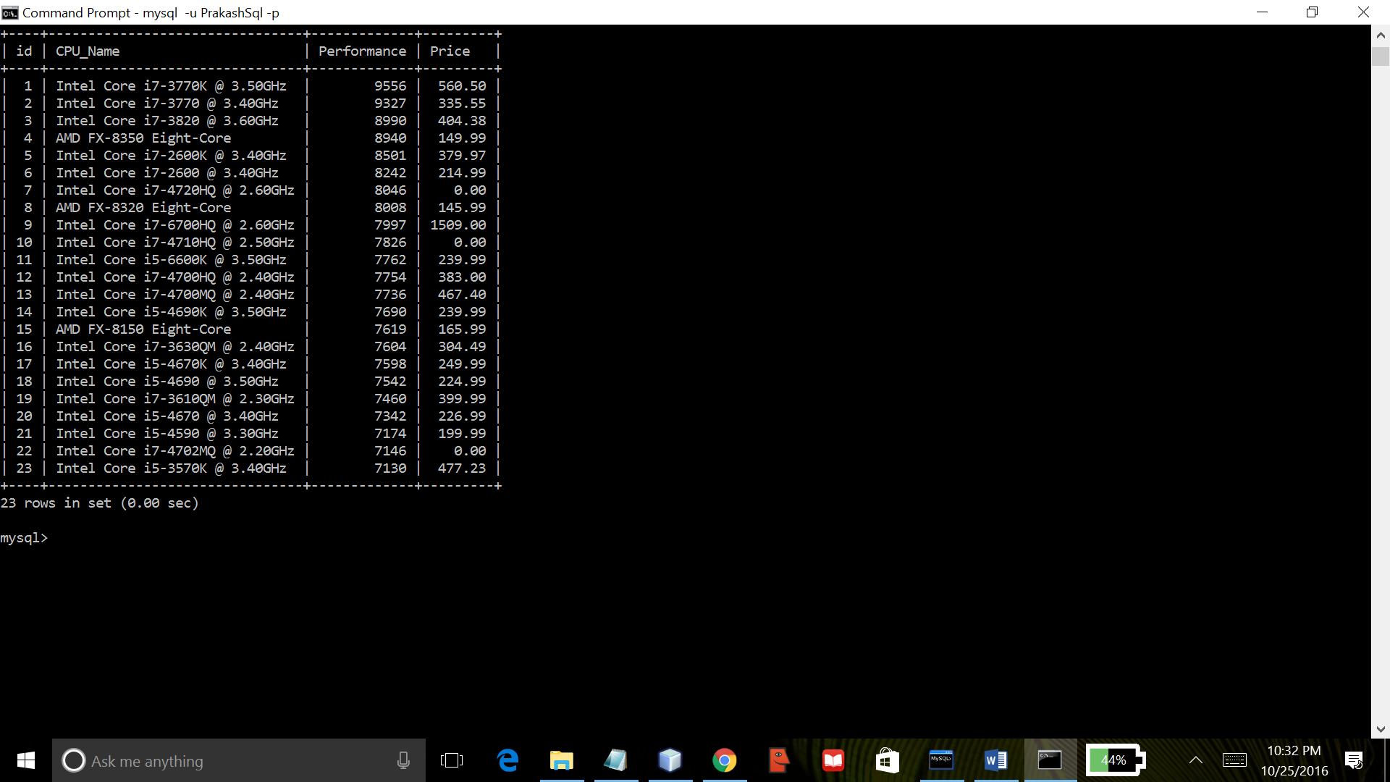

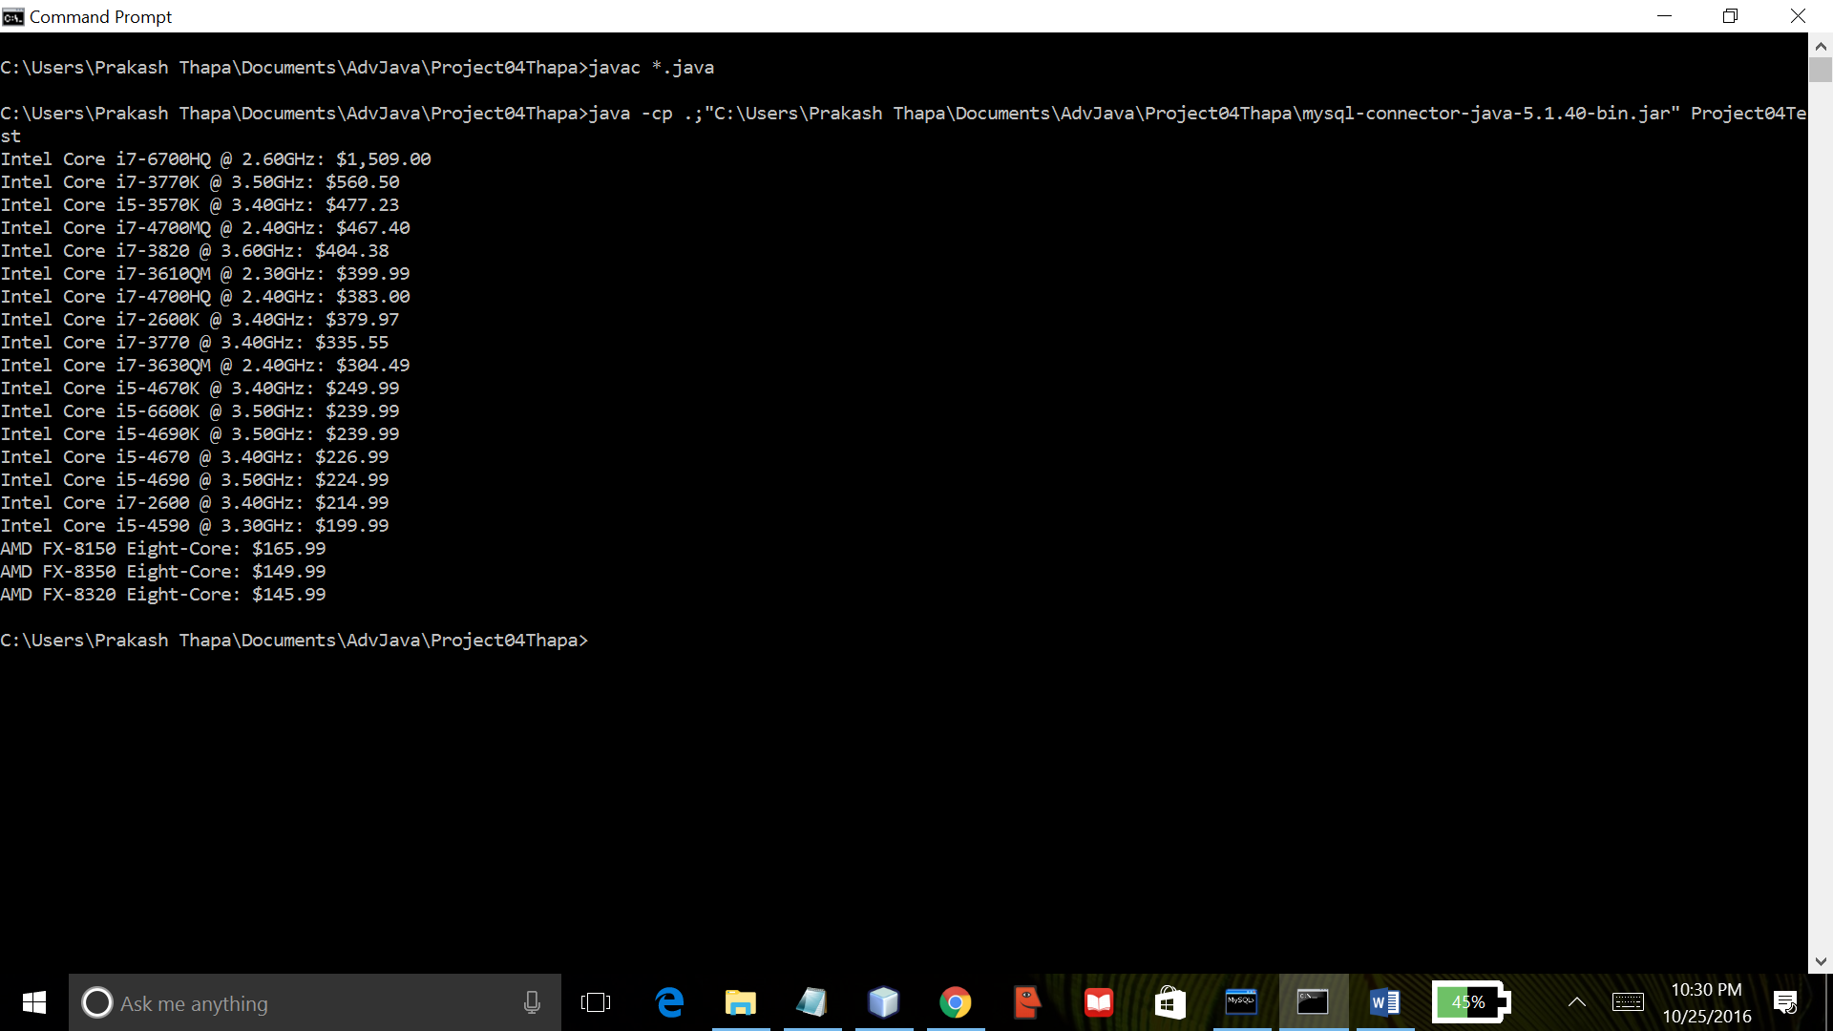

Project04 shows interaction between mysql Database Management System and Java. Using Sql commands, a database is created named “project04”. Also, a table “CpuList” is created with fields Id, CPU_Name, Performance and Price. The program opens and reads csv file “Project04Data.csv” using Java. It inserts all the data retrieved from the csv file into the database. Then, it retrieves all the data from “project04” database and displays the data sorted by CPU price descending. This program was created using NetBeans IDE and compiled by the Java compiler version “javac 1.8.0_91 “.