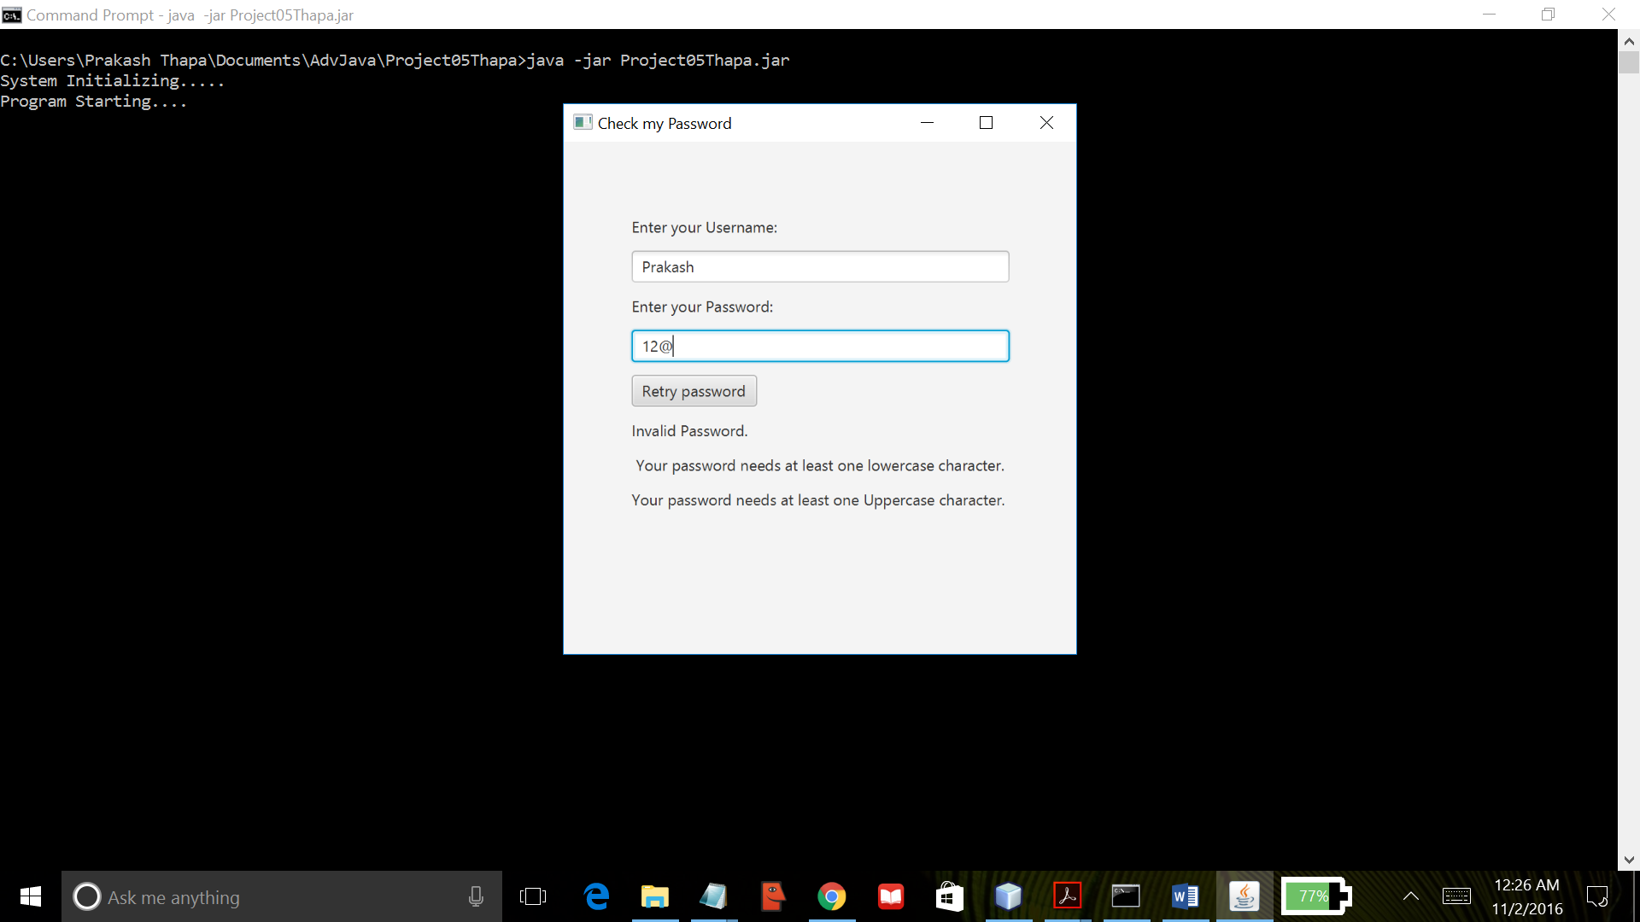

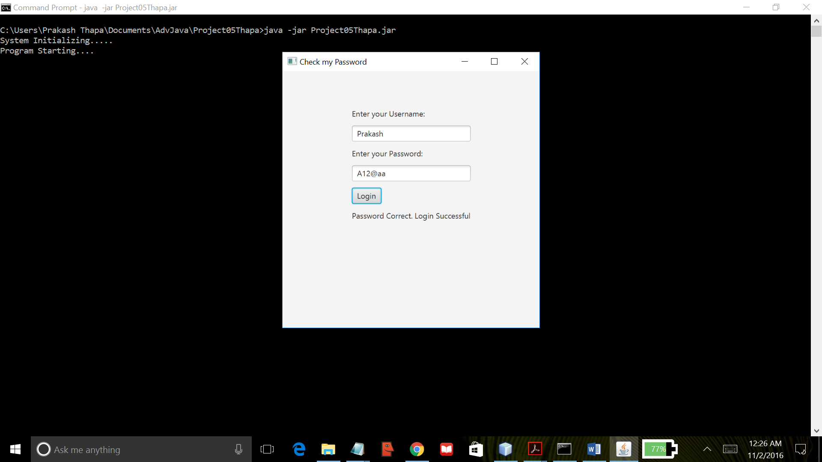

This program uses JavaFx API to create a basic GUI program. It creates a small window for accepting a user name and a password. It checks for the validity of the password entered when pressed “Login” button. It checks whether the password contains at least one lowercase character, one uppercase character, one special character and at least one digit. If the password typed in the password text field does not contain those listed requirements, then it is considered invalid and a list of error(s) is displayed. If the password test is successful, then it displays “Password Correct. Login Successful”. This program was created using NetBeans IDE and compiled by the Java compiler version “javac 1.8.0_91 “.