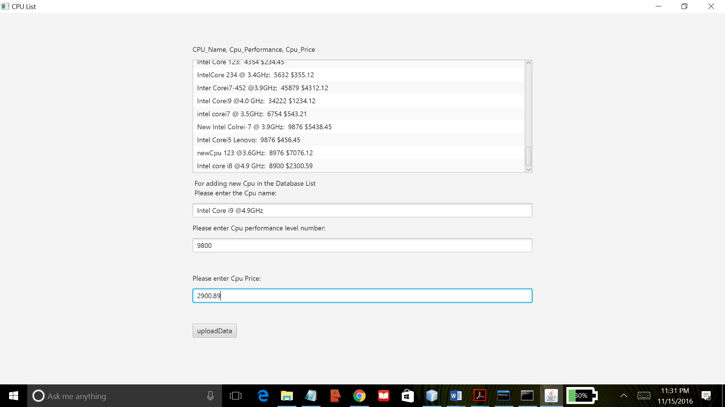

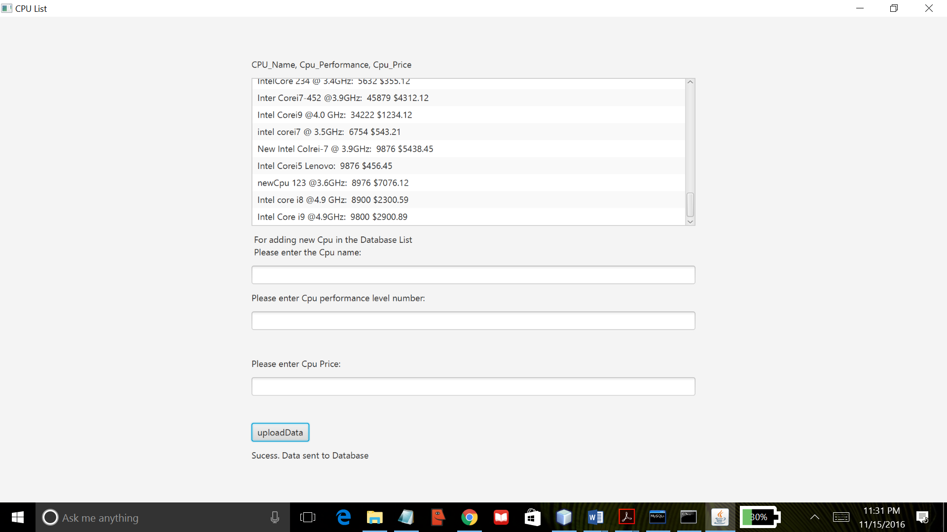

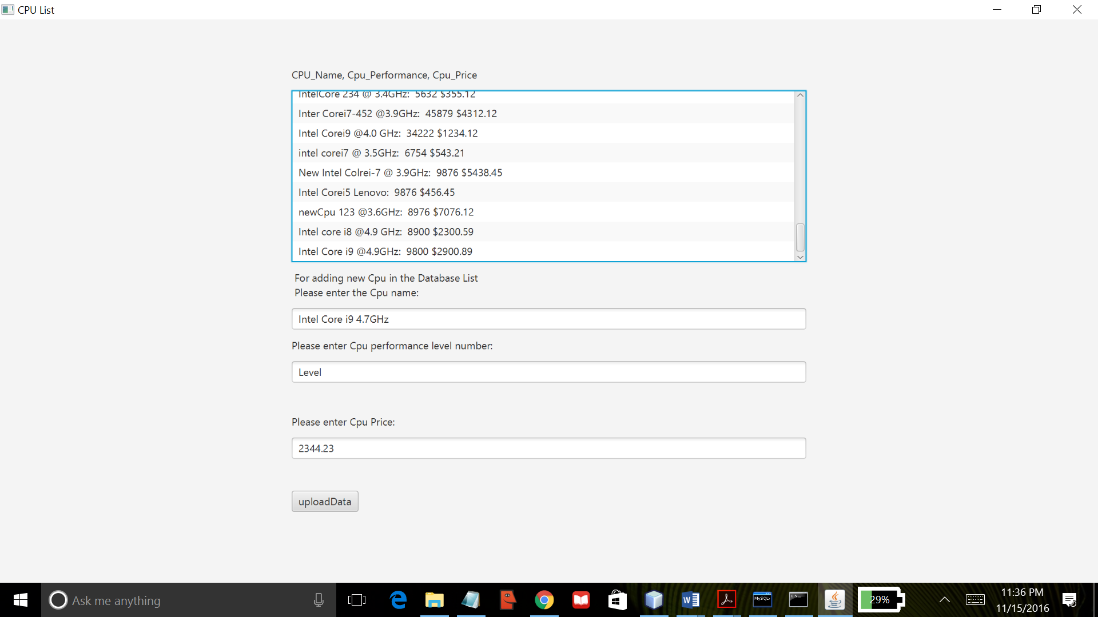

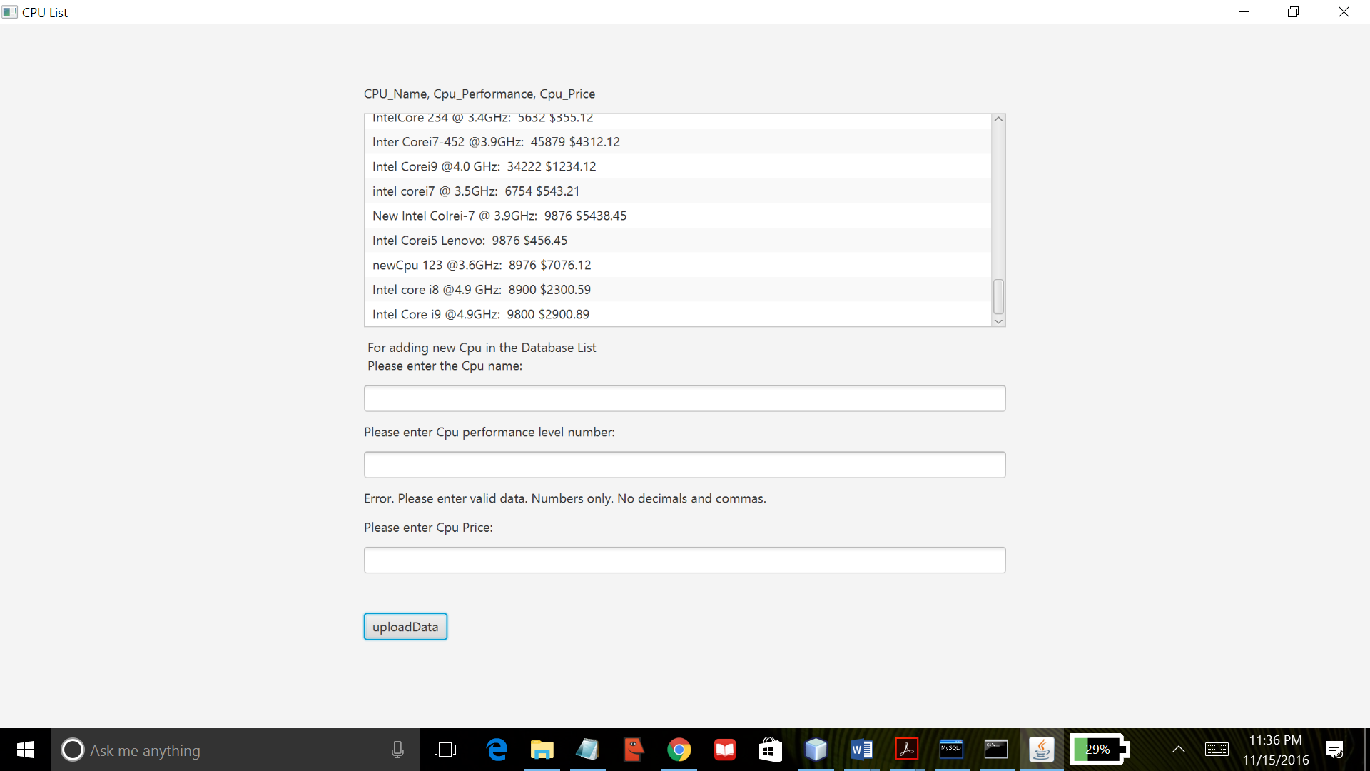

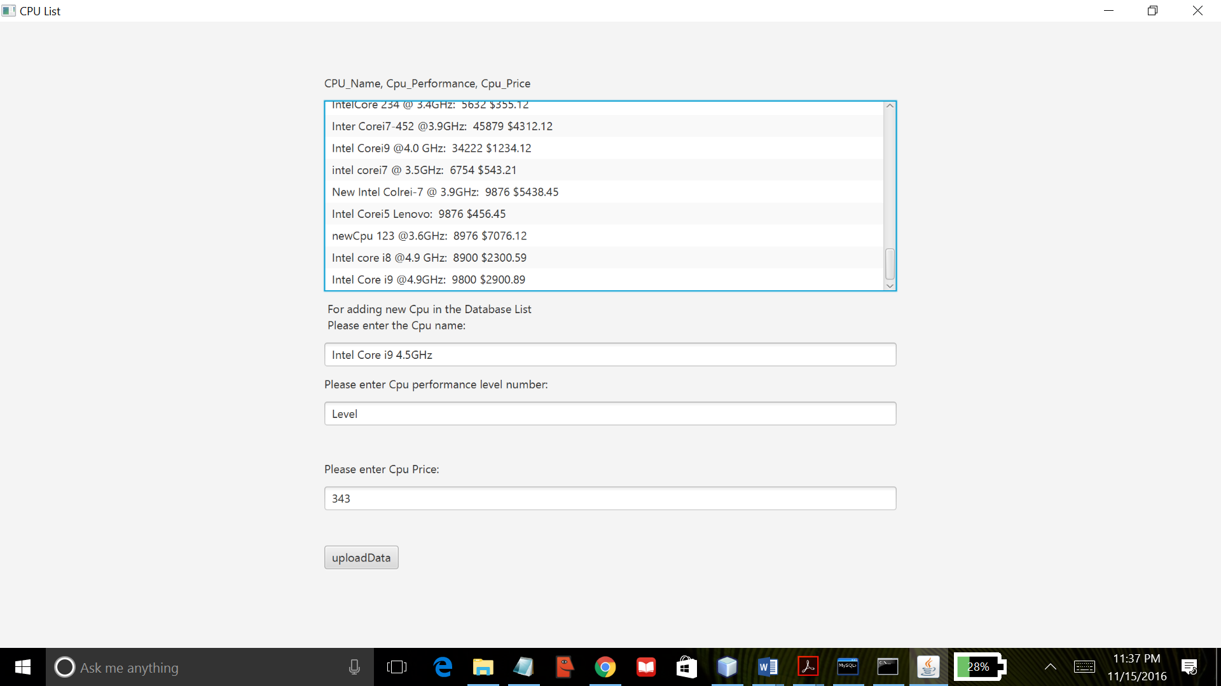

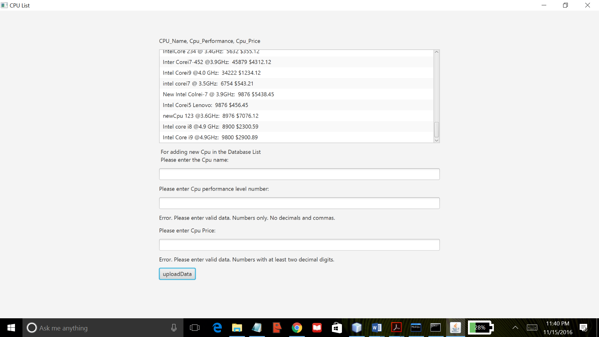

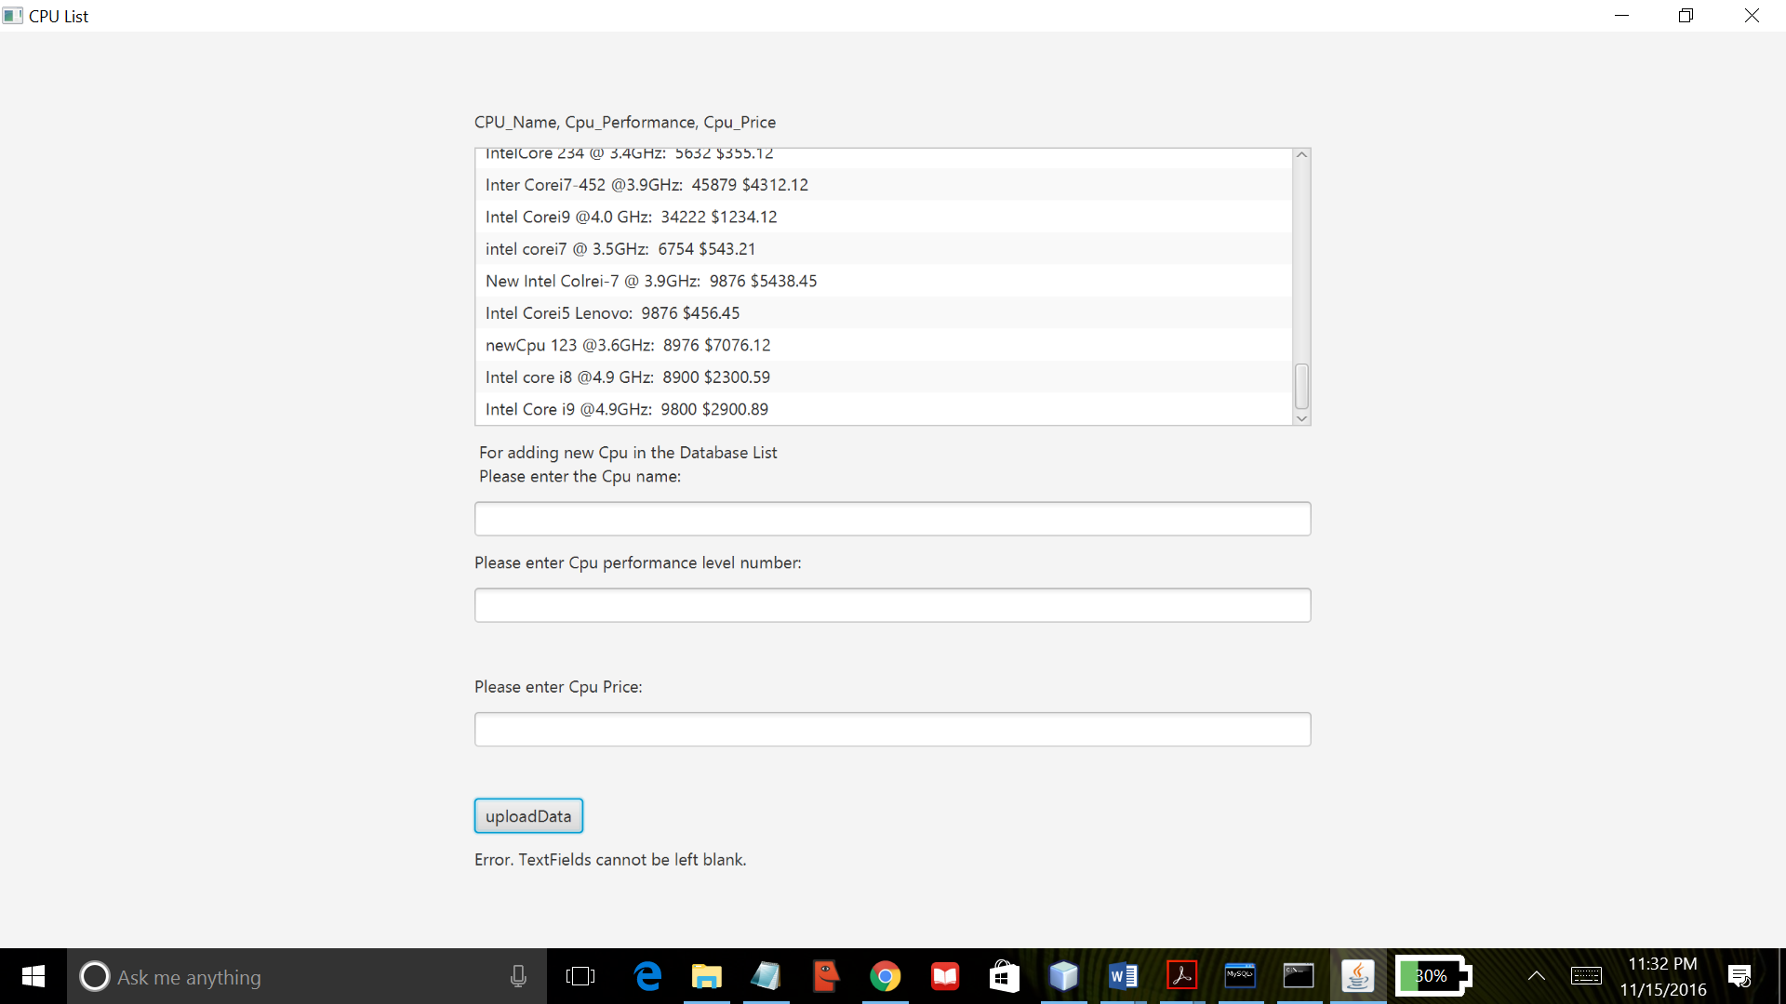

Project06 uses JavaFx API to create a basic GUI program that allows the user to insert data into database. Using Sql commands, a database is created named “project04”. This program creates a Listview component and reads all the data from the database in use. The data is displayed at the launch of the program. It also creates three textfields for users to enter data to be inserted in the database. When the “upload” button is pressed, it attempts to insert the data into the database. Data entered in the textfields are validated before it is sent to the database. It checks if the data contains numbers, texts or only blanks. If the data entered is invalid, type of error(s) is displayed via label component. Data is inserted to database if it passes the validation check and a message is displayed indicating valid data and successful data transmission to the database. Also, the current list is updated to include the entered data. This program was created using NetBeans IDE and compiled by the Java compiler version “javac 1.8.0_91 “.