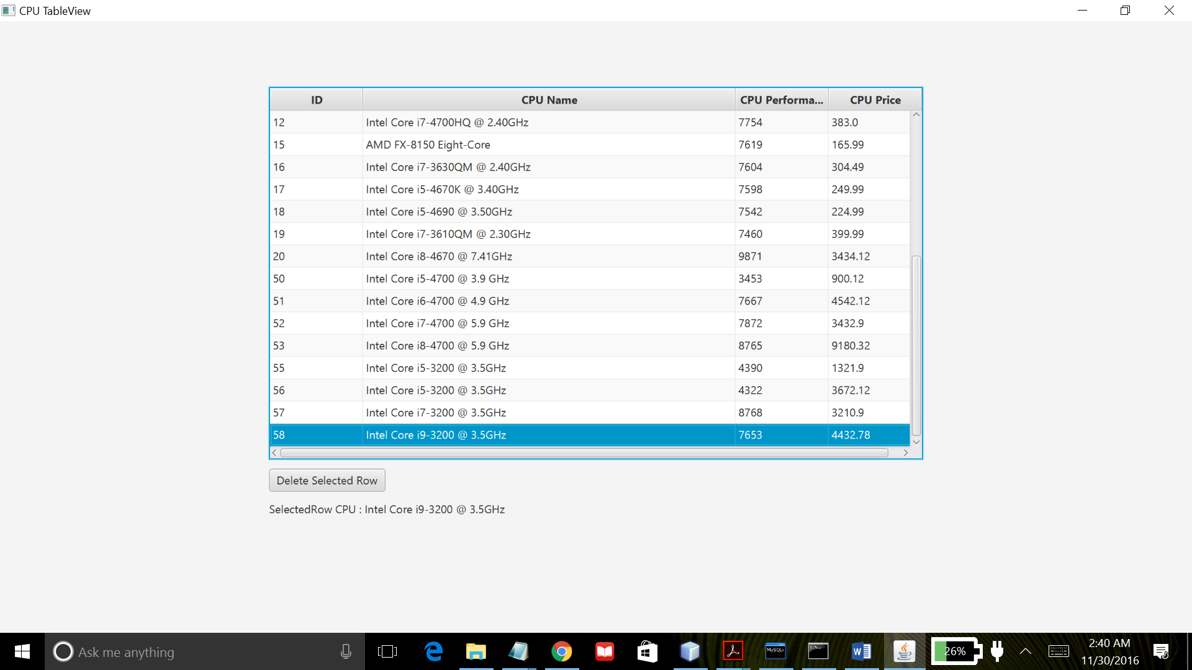

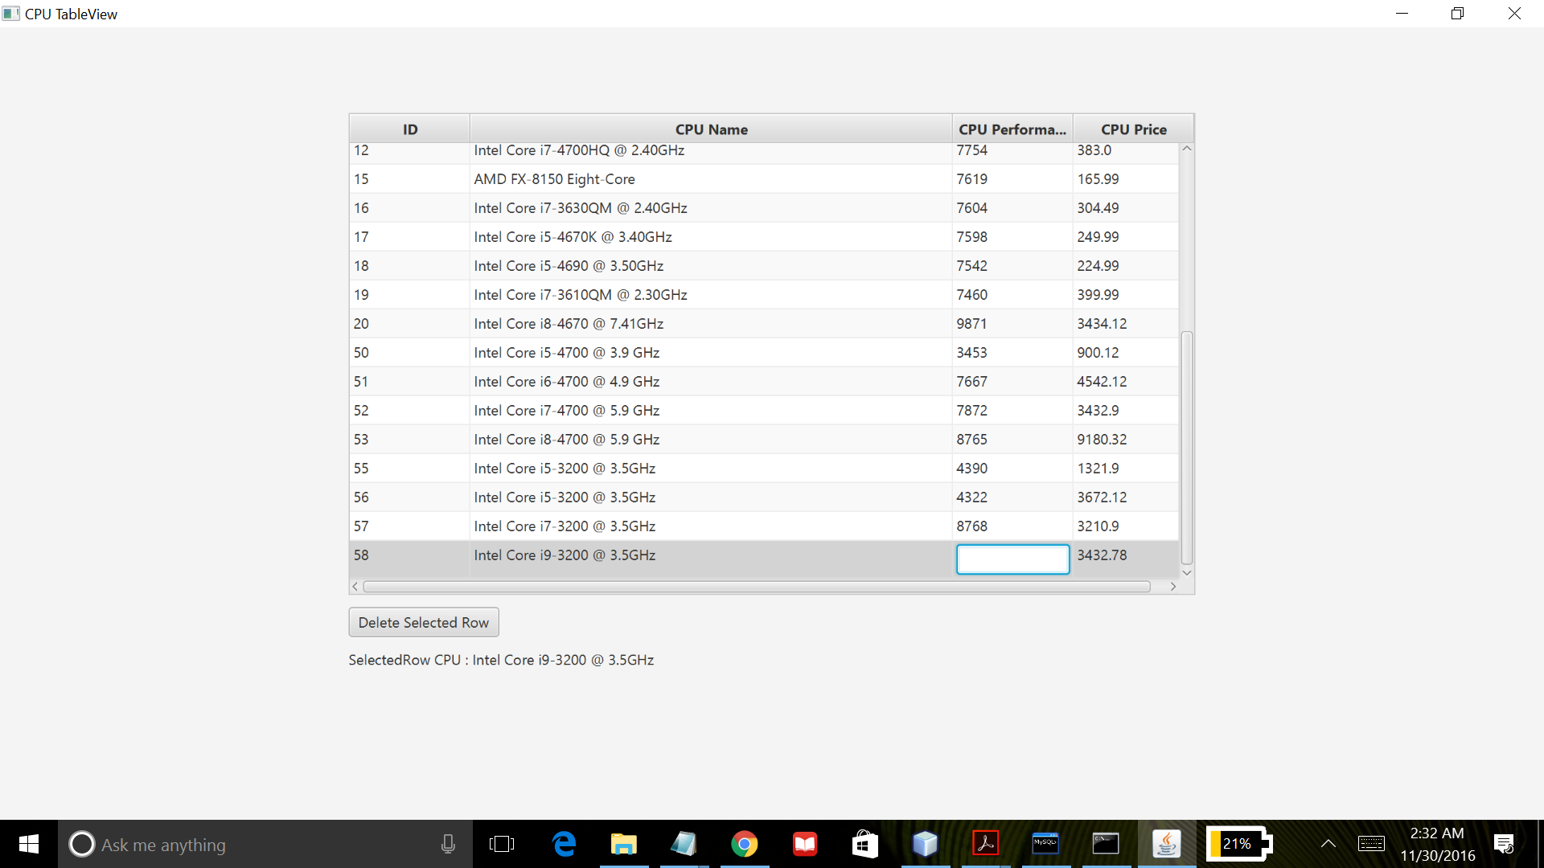

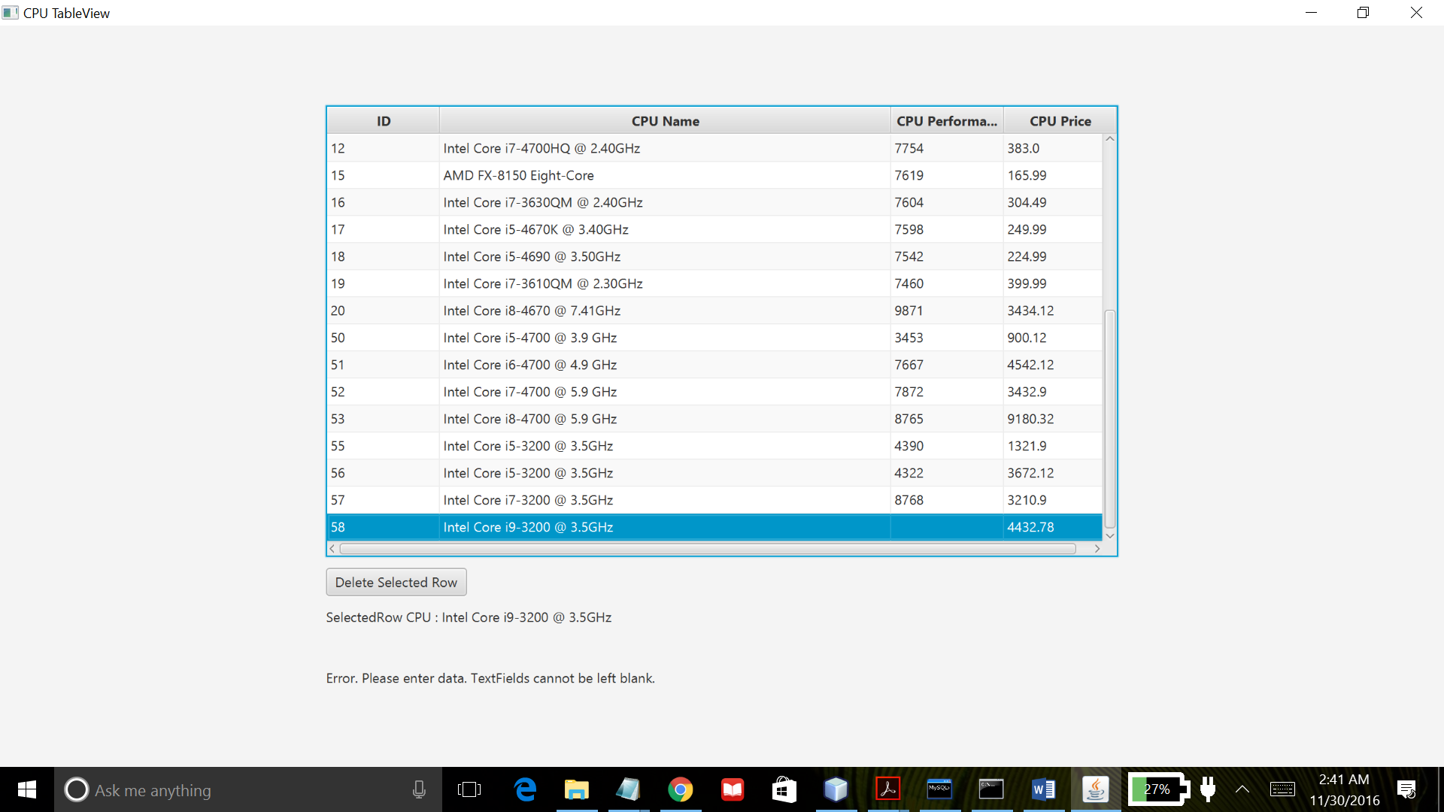

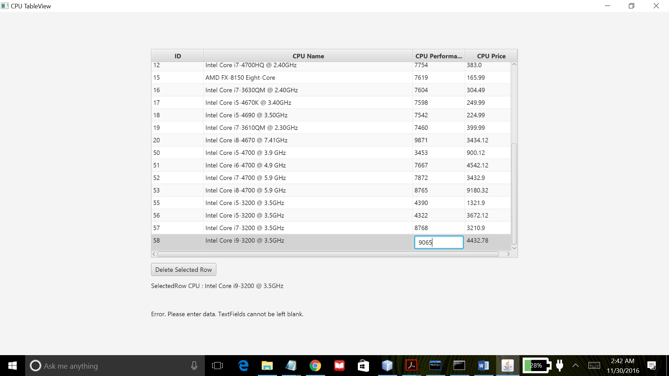

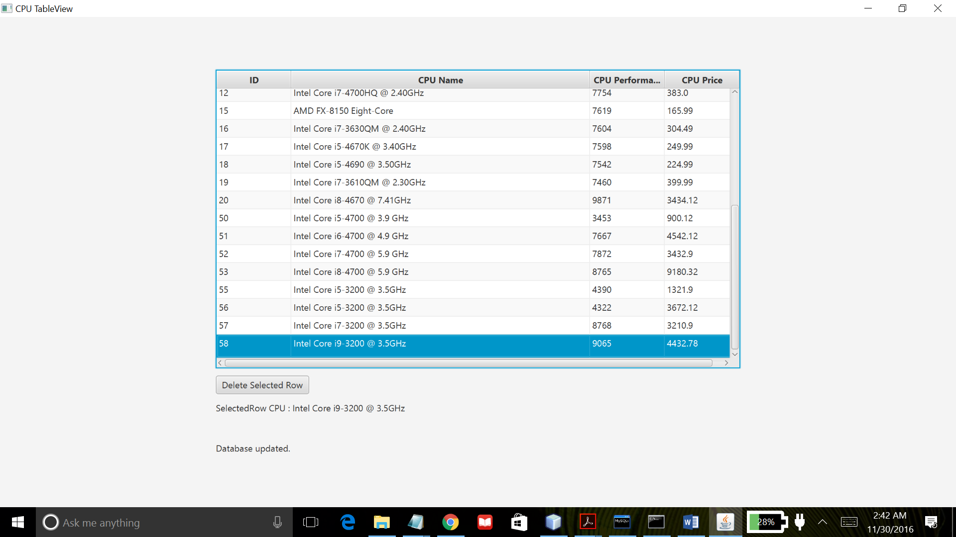

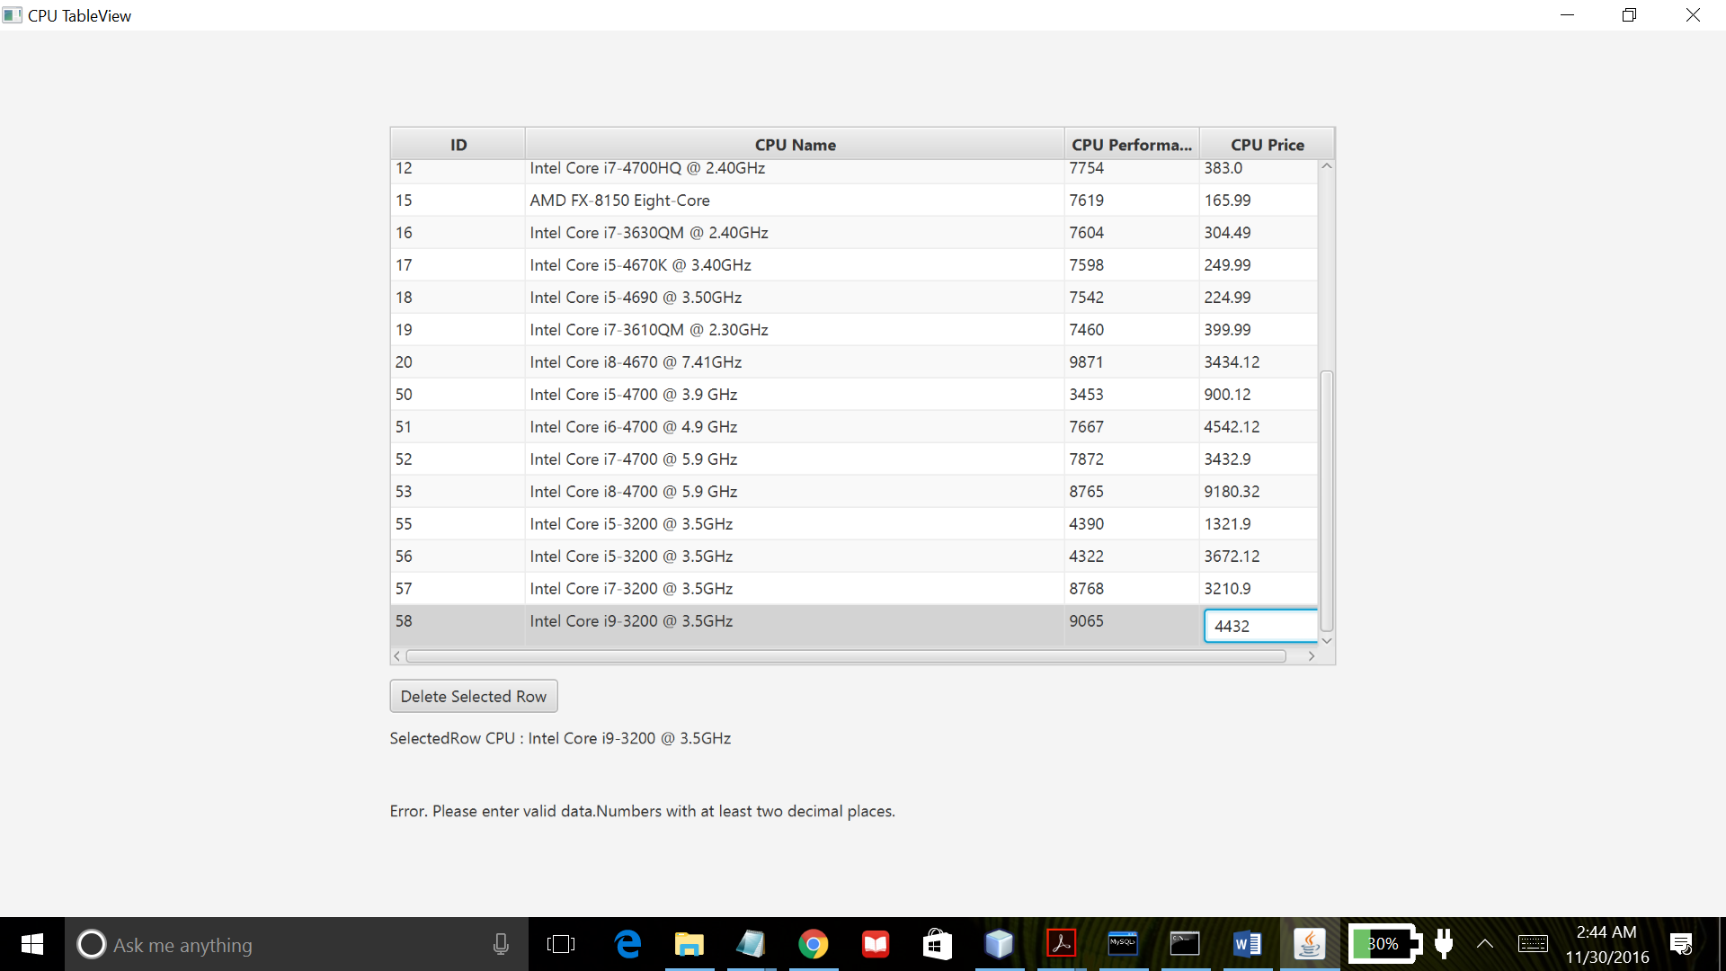

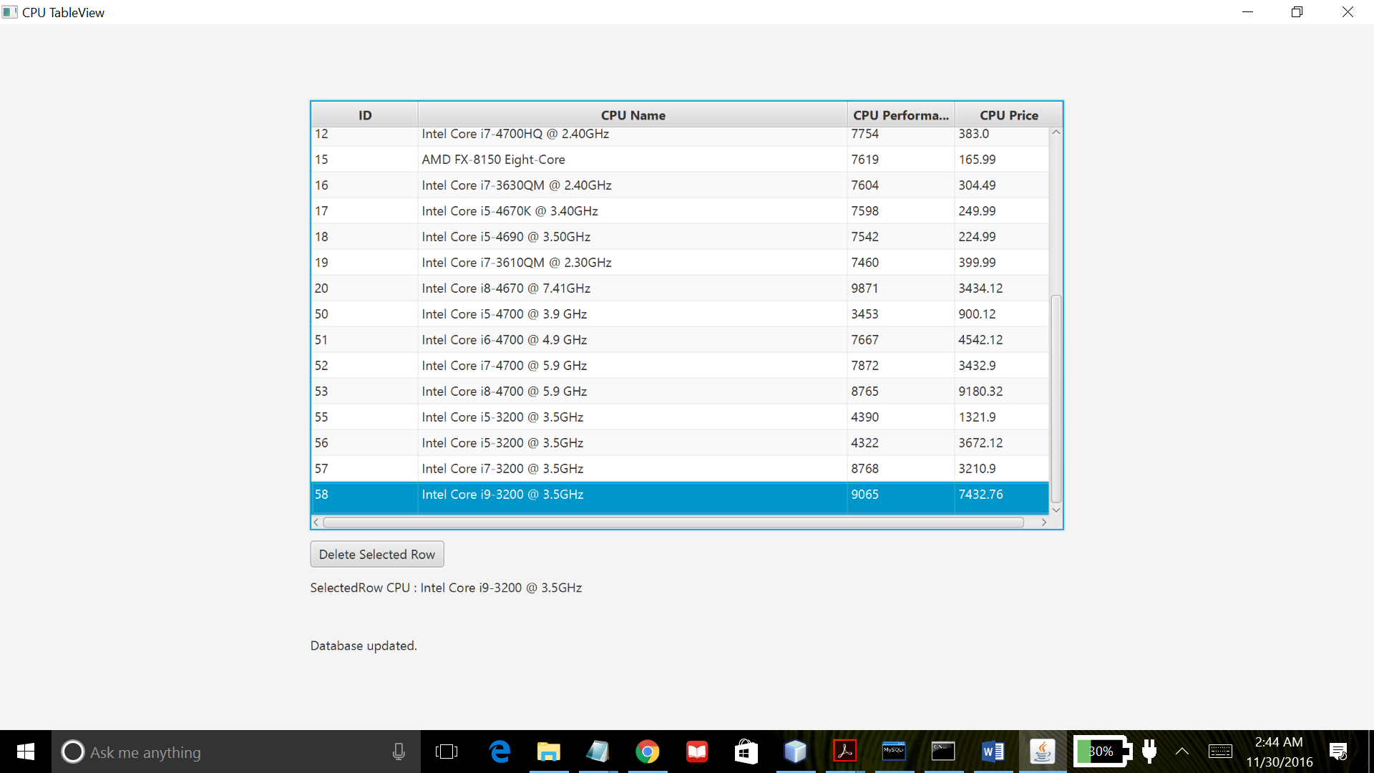

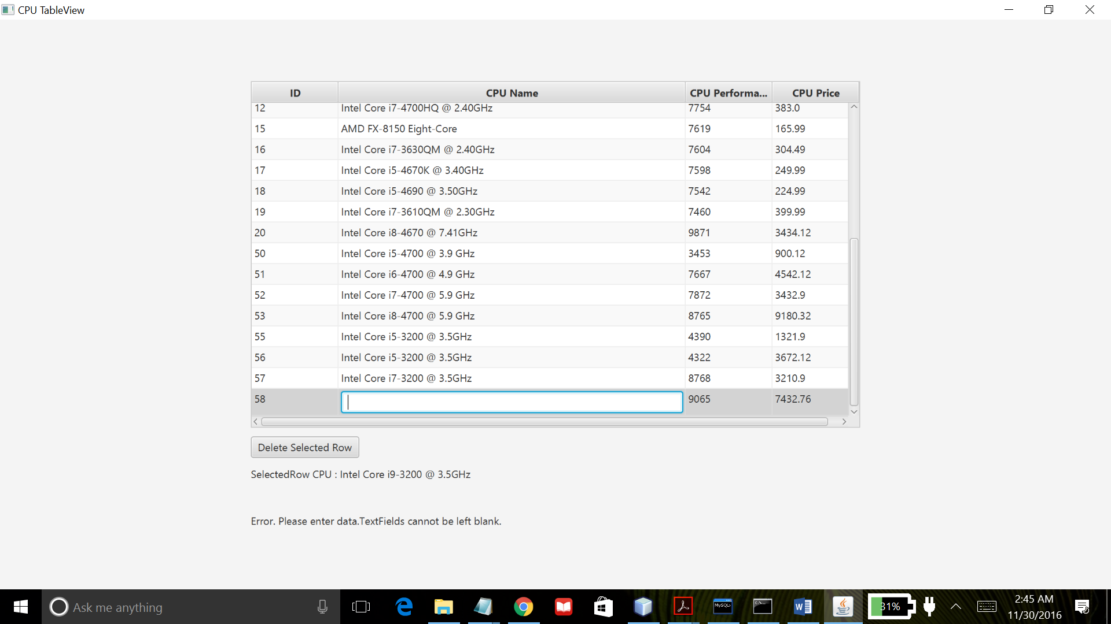

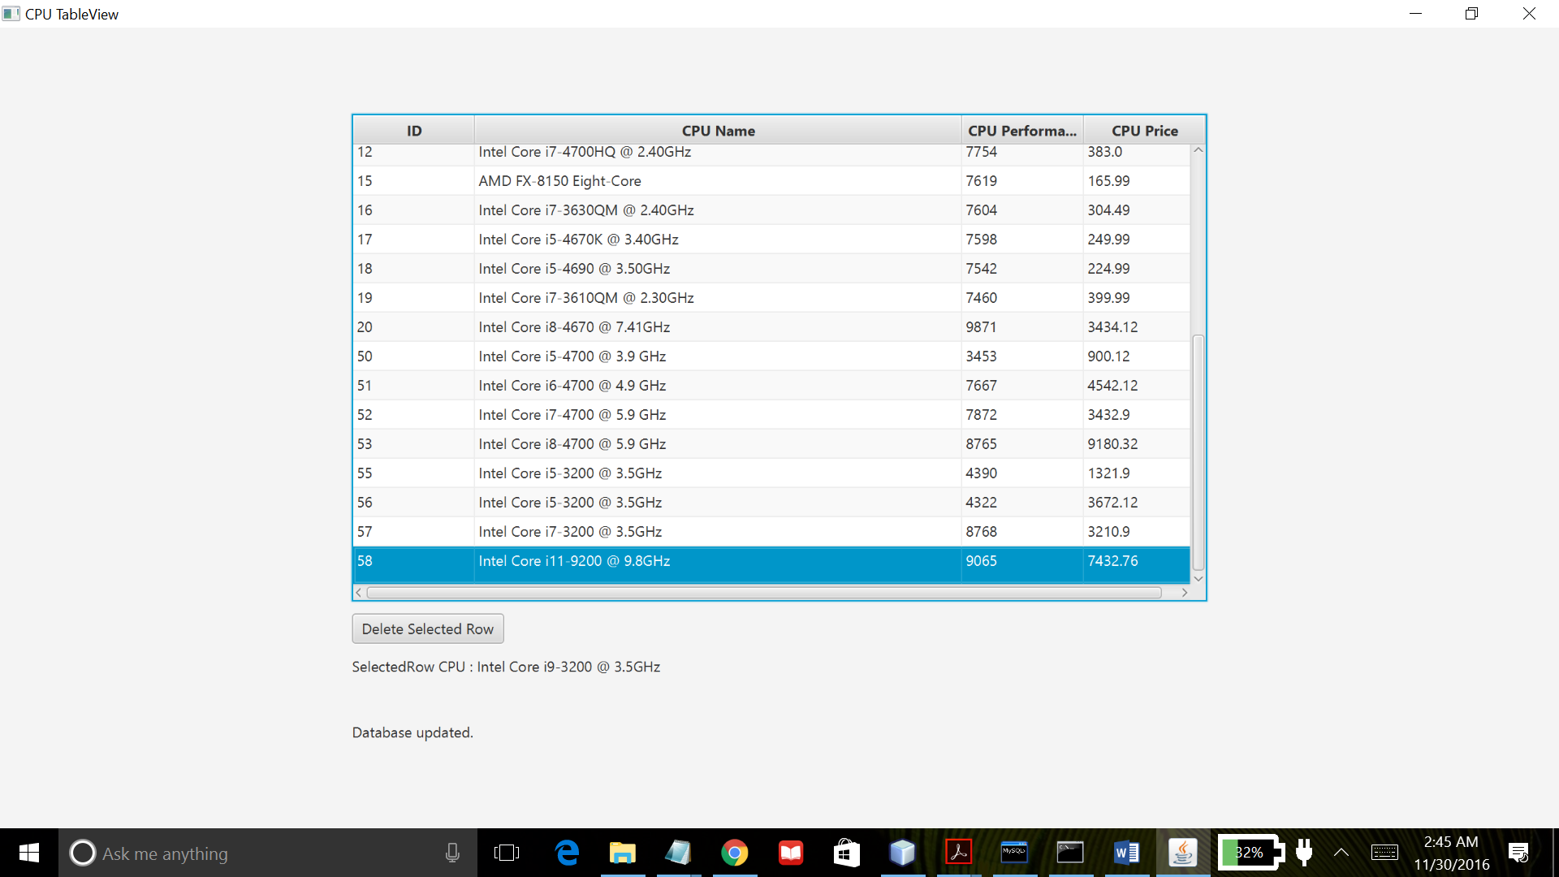

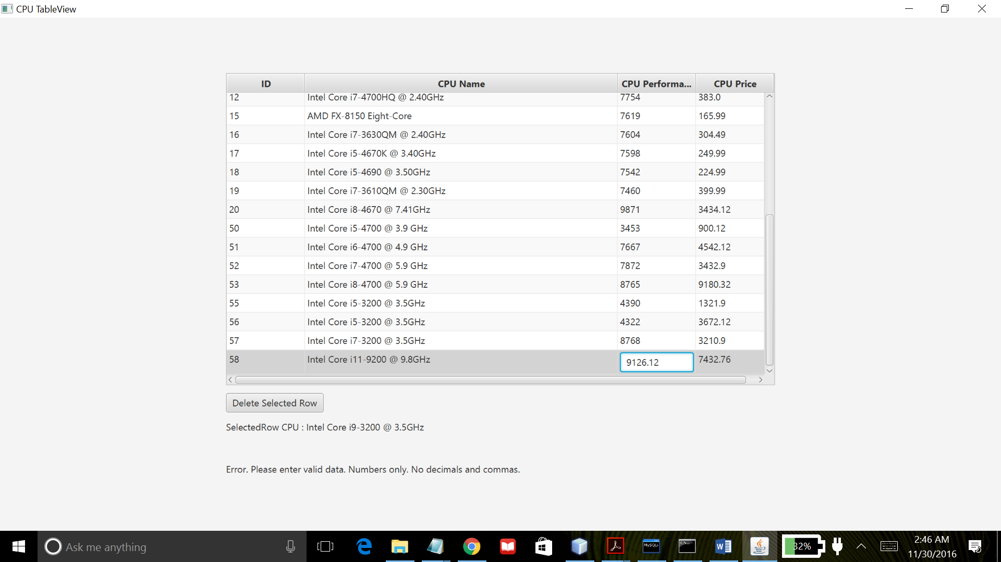

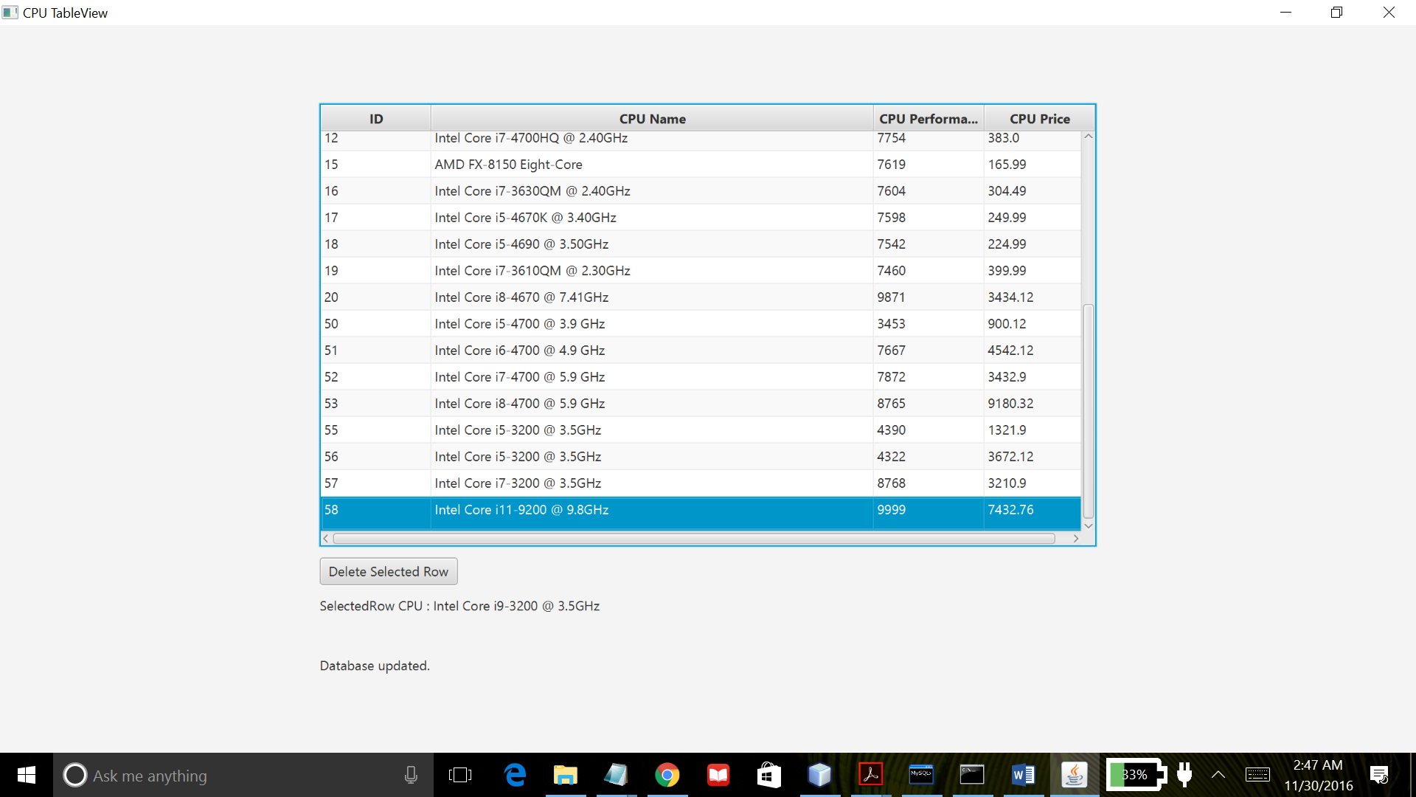

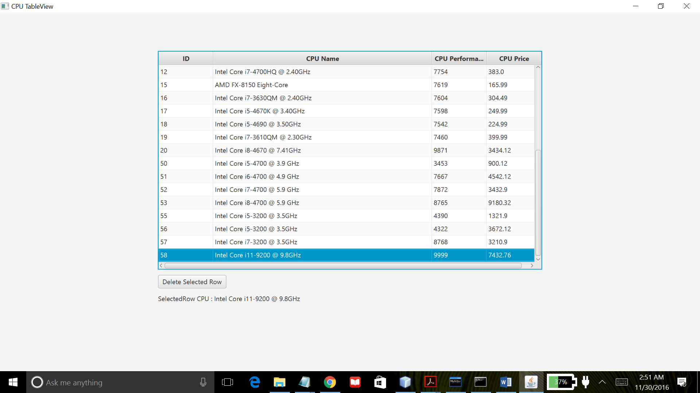

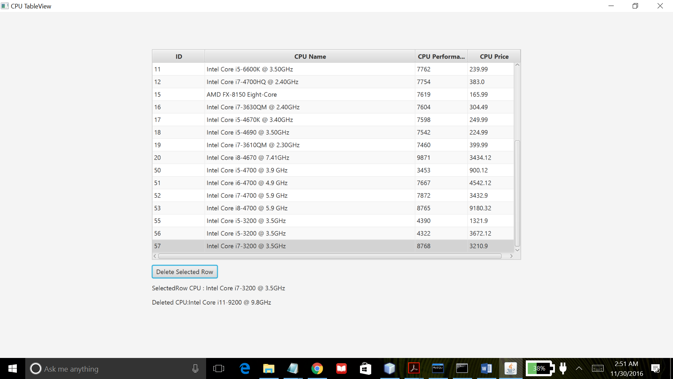

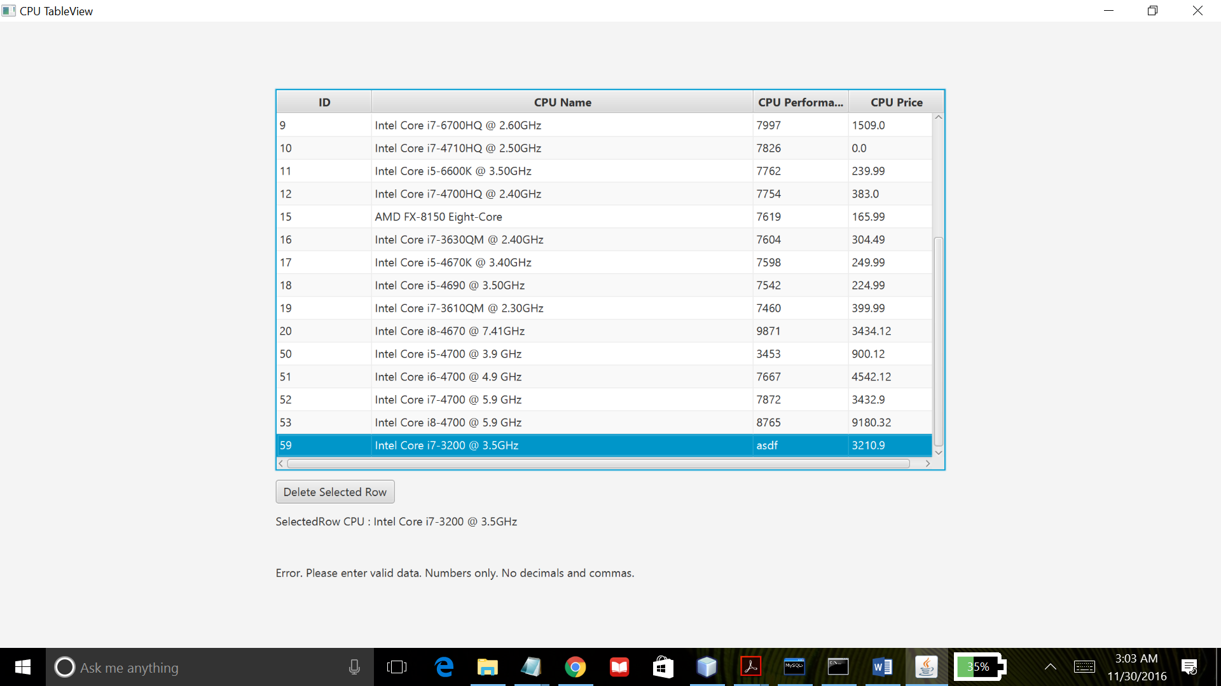

Project07 uses JavaFx API to create a basic GUI program that allows the user to delete and edit data in a table cell as well as updates both the database and the TableView if any changes are made. Using Sql commands, a database was created named “project04”. This program creates an editable TableView component and reads all the data from the database in use. The data is displayed at the launch of the program. It allows the user to select each item and selected item is displayed as a label. It also lets the user to delete selected item in the TableView through a “Delete Selected Row” button. After deletion, both the database and the TableView is updated. When double clicked on any cell of the column except the first column(i.e. “ID”), it provides a Textfield that allows to edit the content of the cell. When “Enter-Key” is pressed after editing a cell, it attempts to make changes to the content of the cell and also attempts to send the edited data to the database. Edited data are validated before it updates the TableView and sends the data to the database. It checks if the data contains numbers, texts or only blanks. If the data entered is invalid, type of error(s) is displayed via label component. Both the TableView and database is updated if it passes the data validation check and a message is displayed indicating valid data and successful update. This program was created using NetBeans IDE and compiled by Java compiler version “javac 1.8.0_91 “.