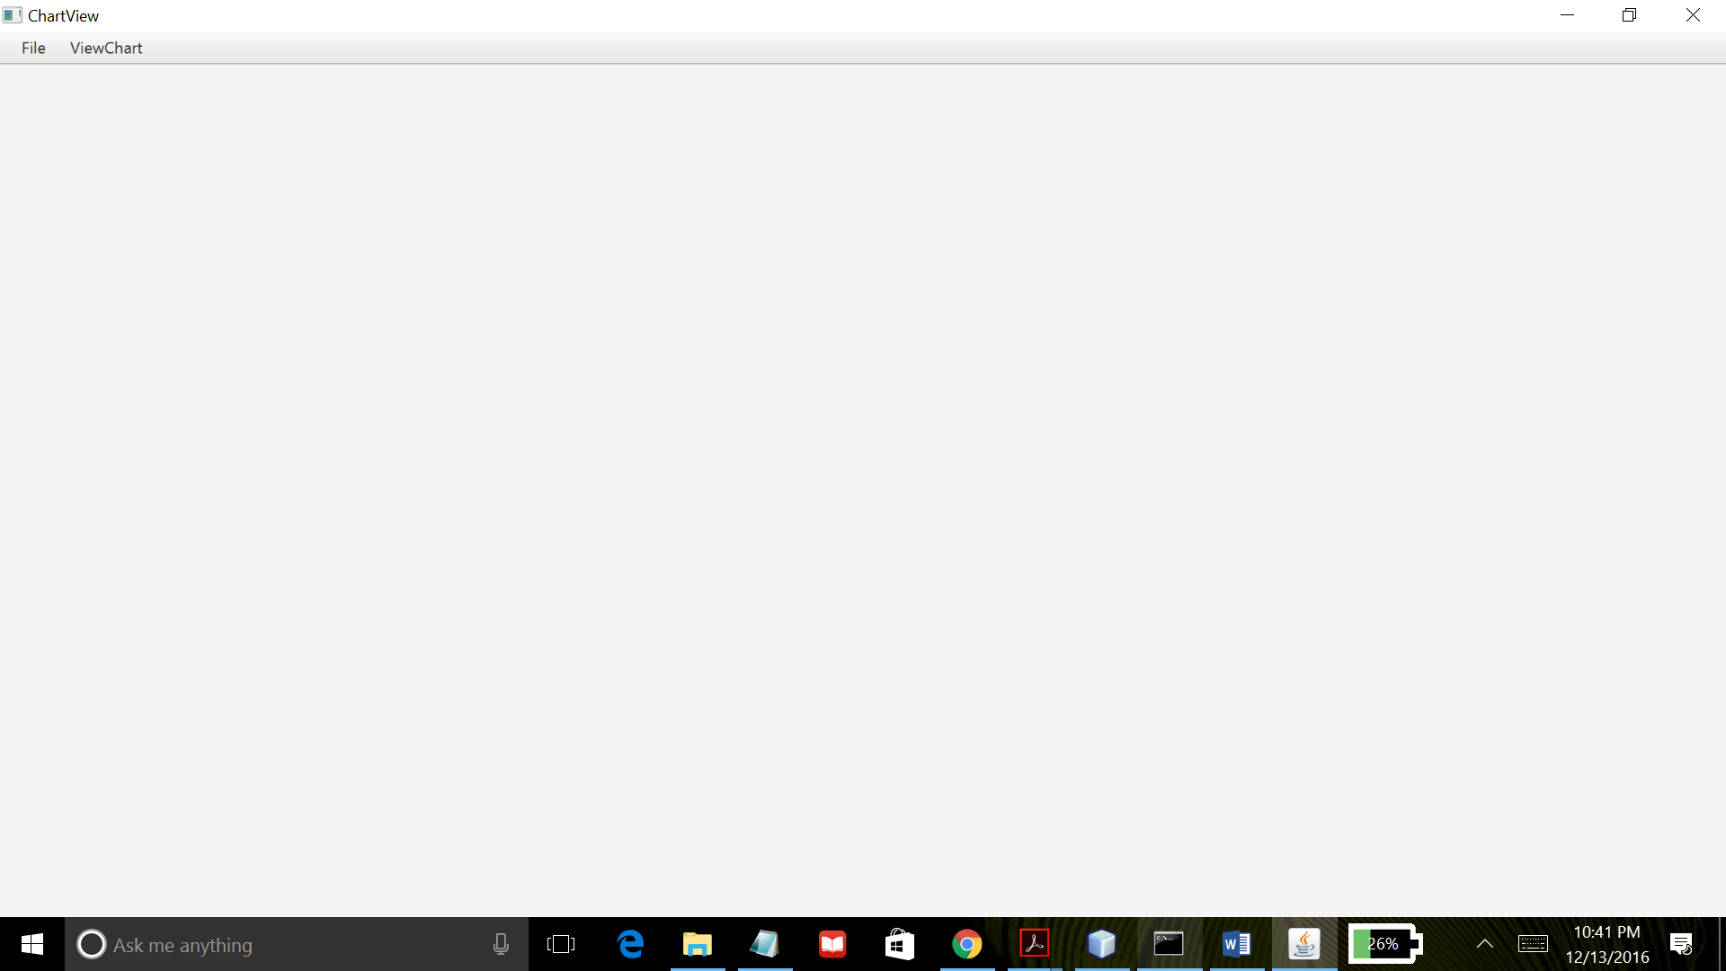

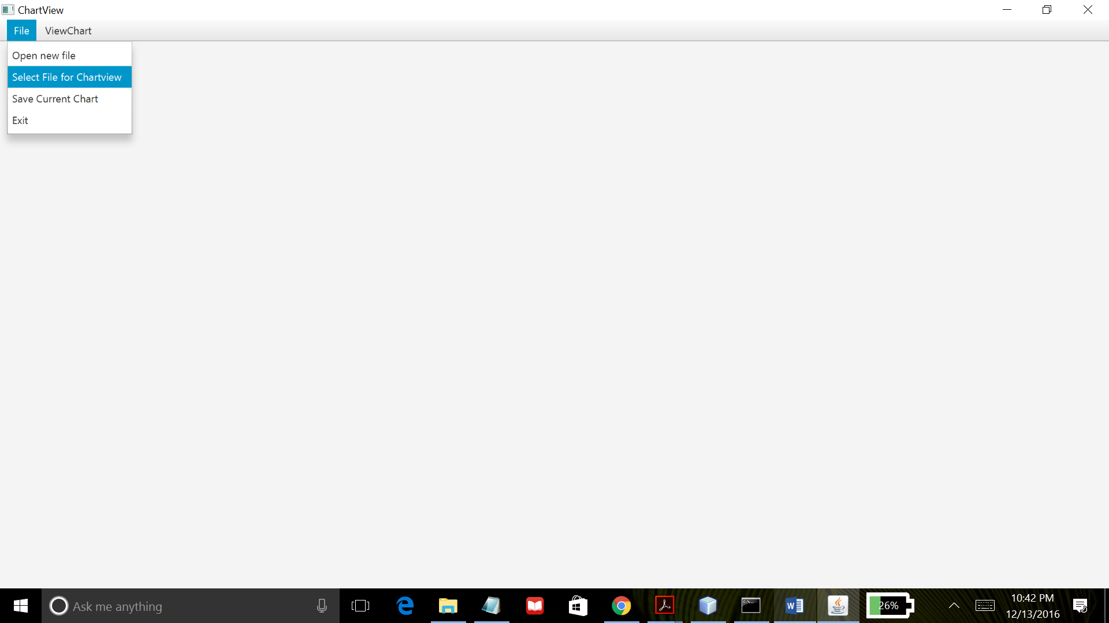

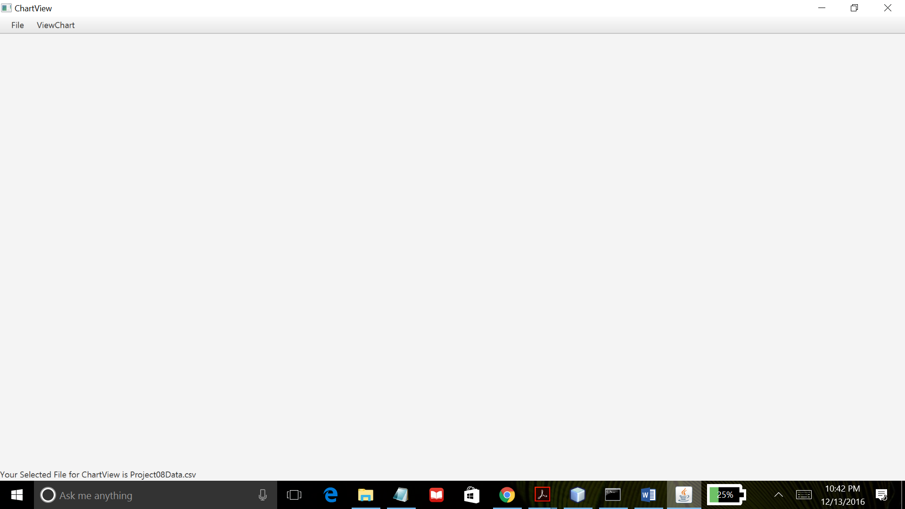

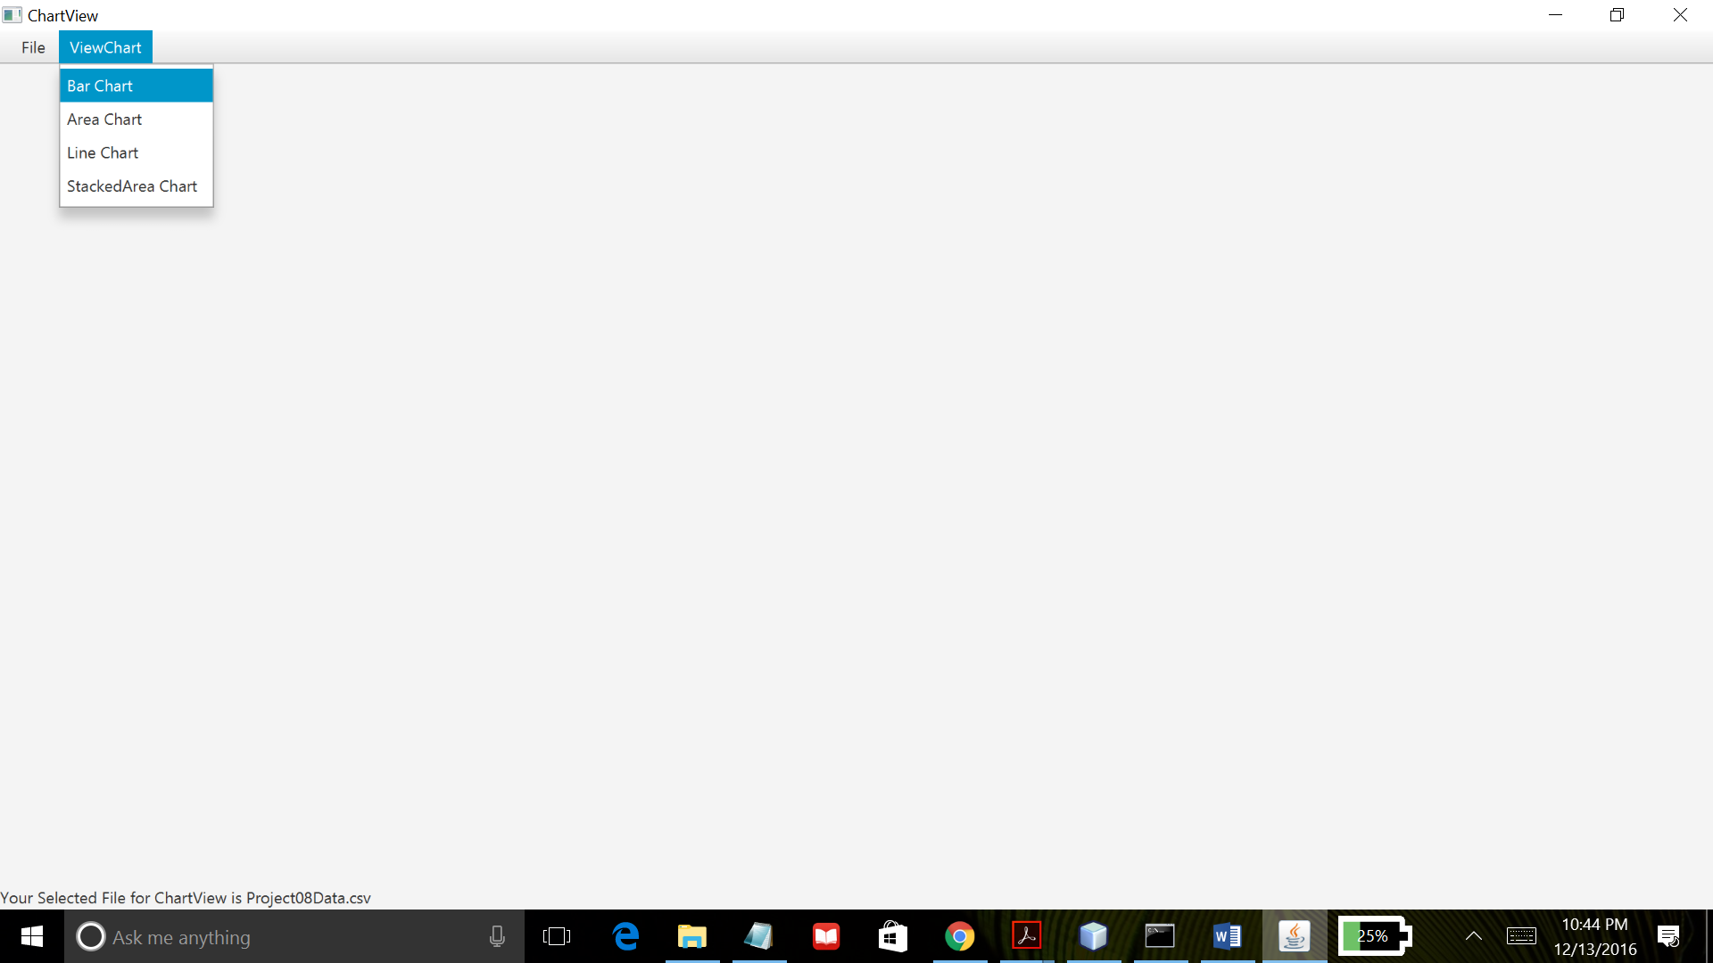

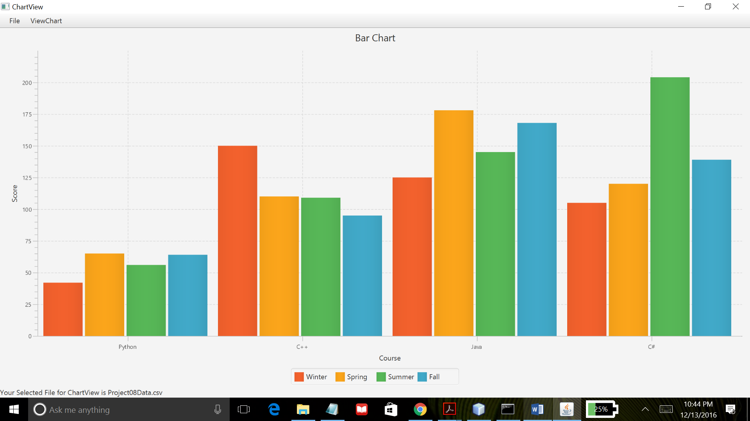

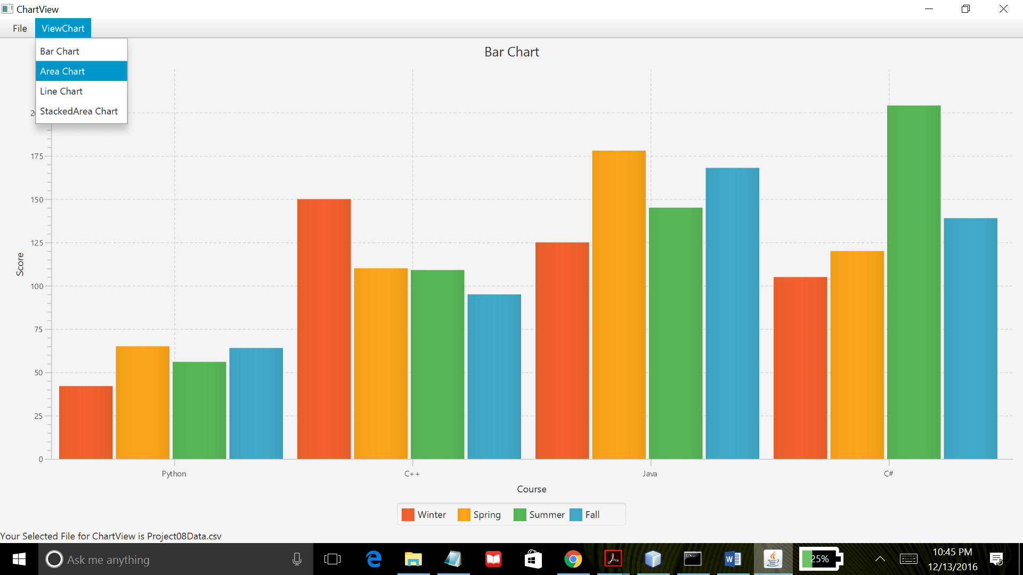

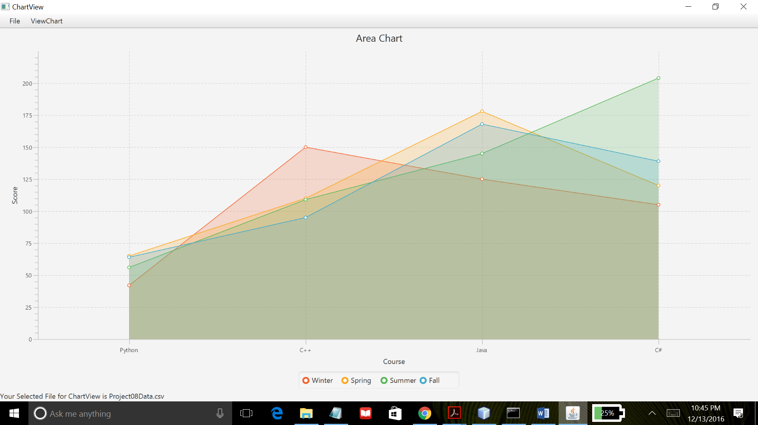

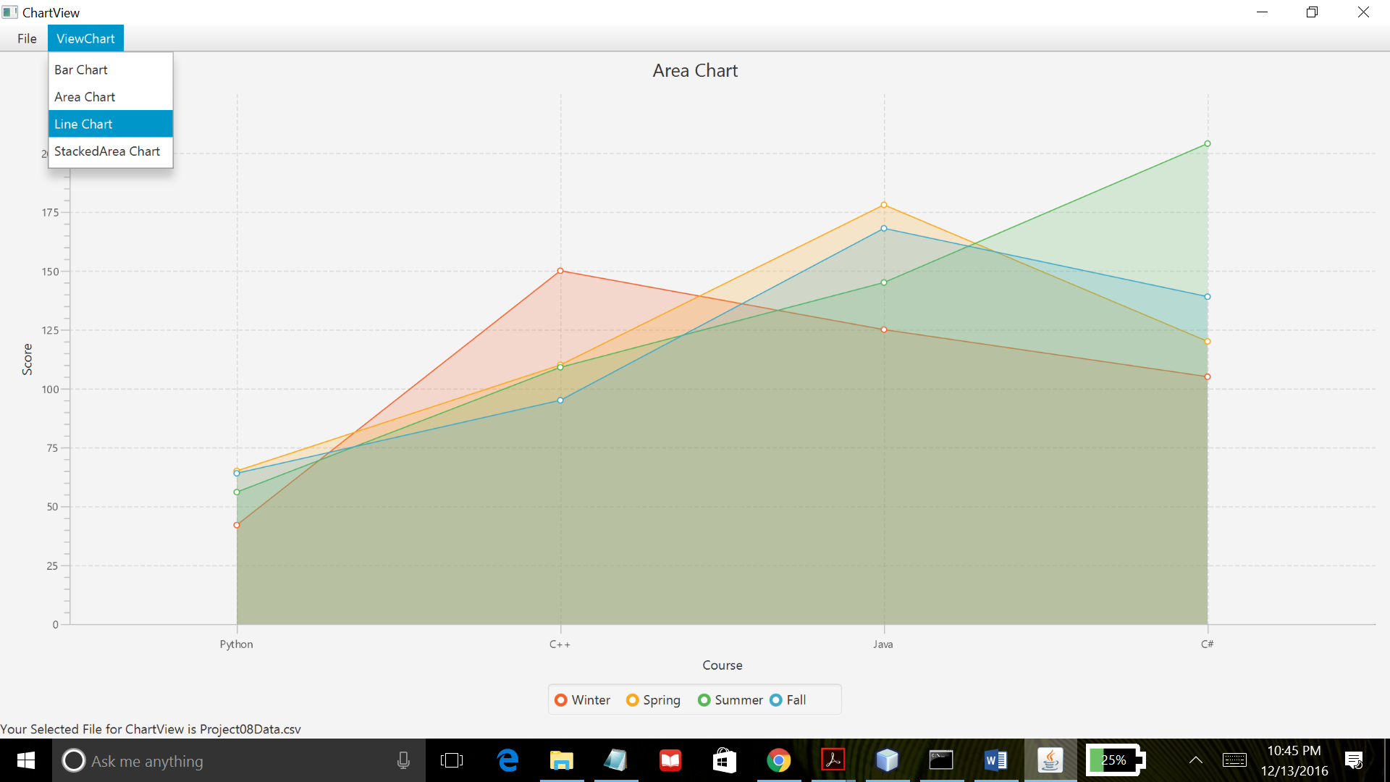

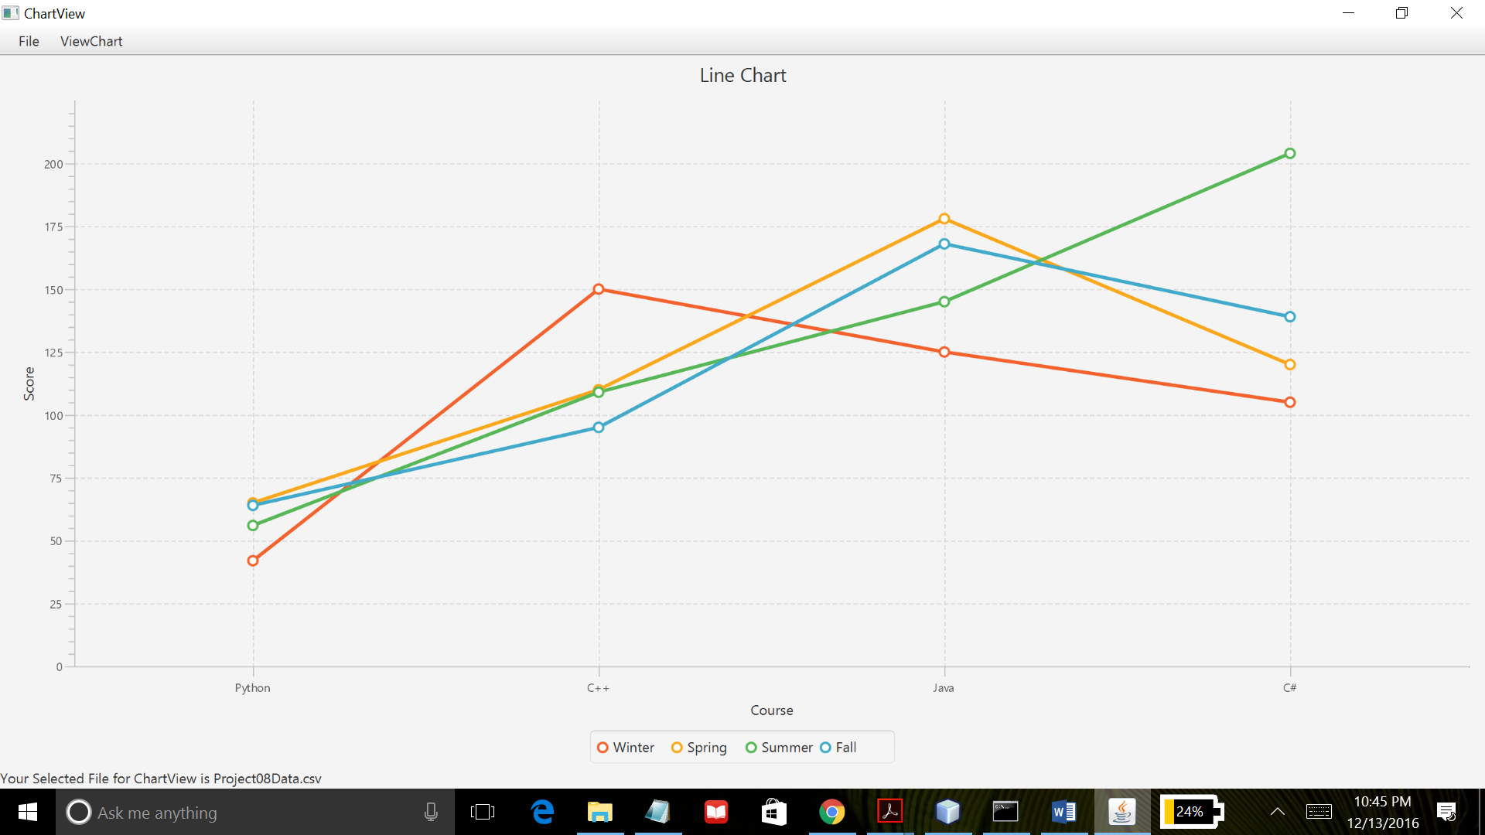

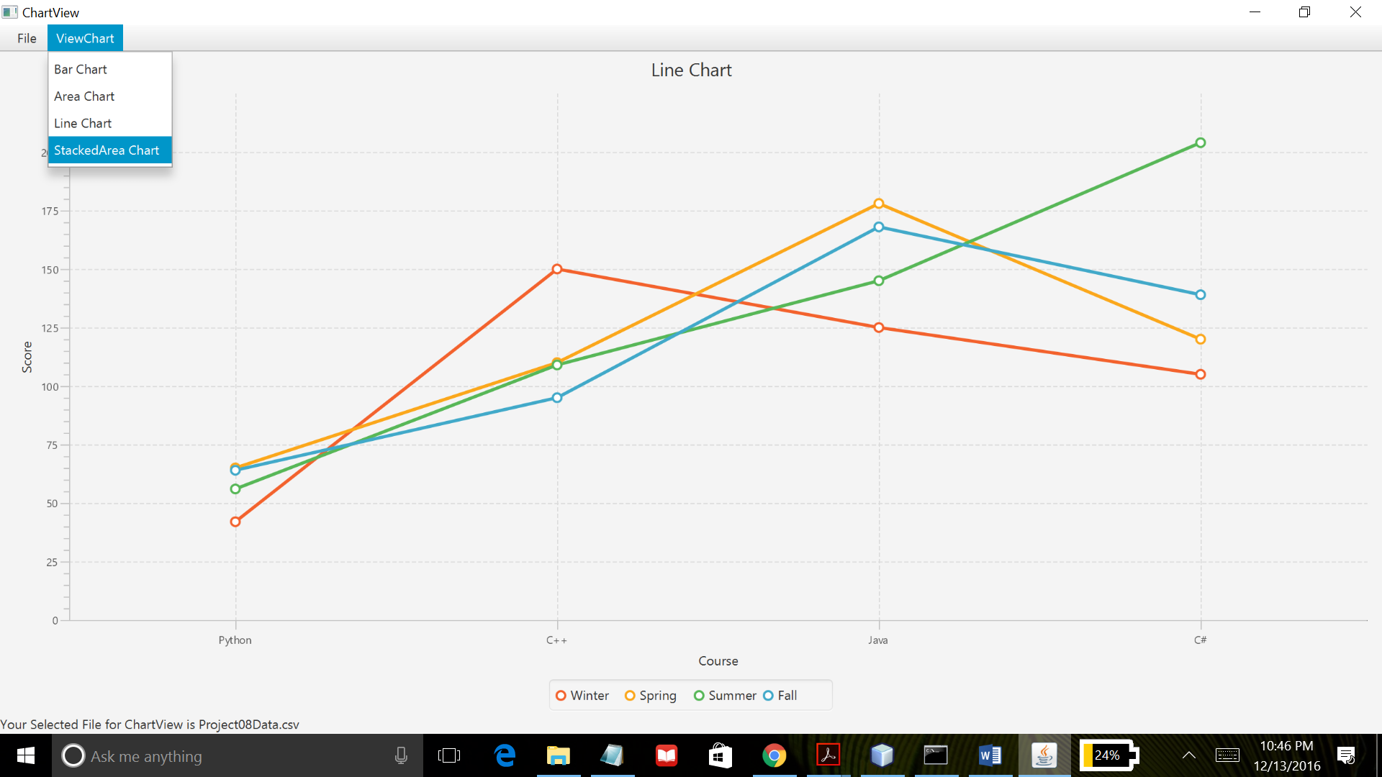

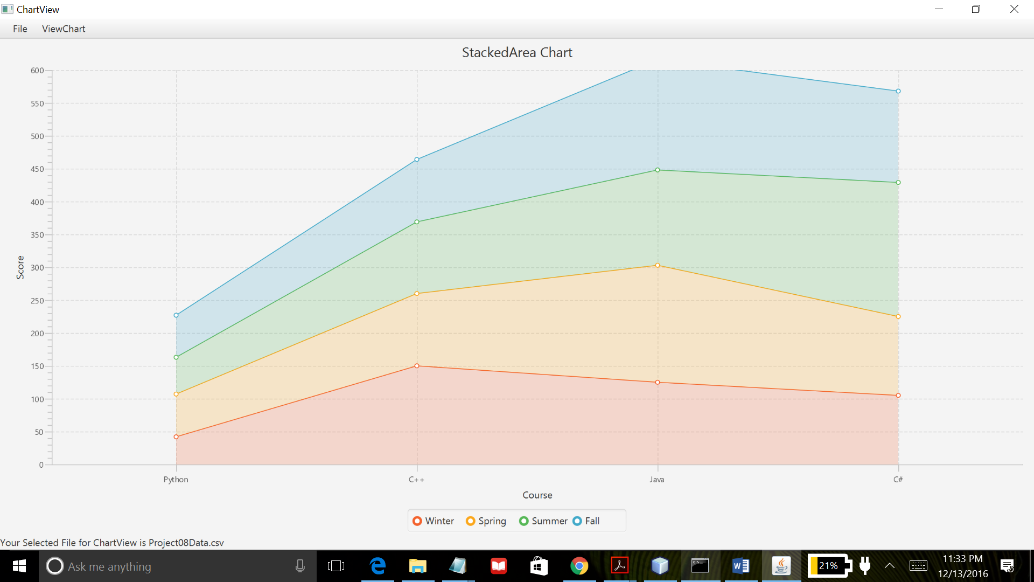

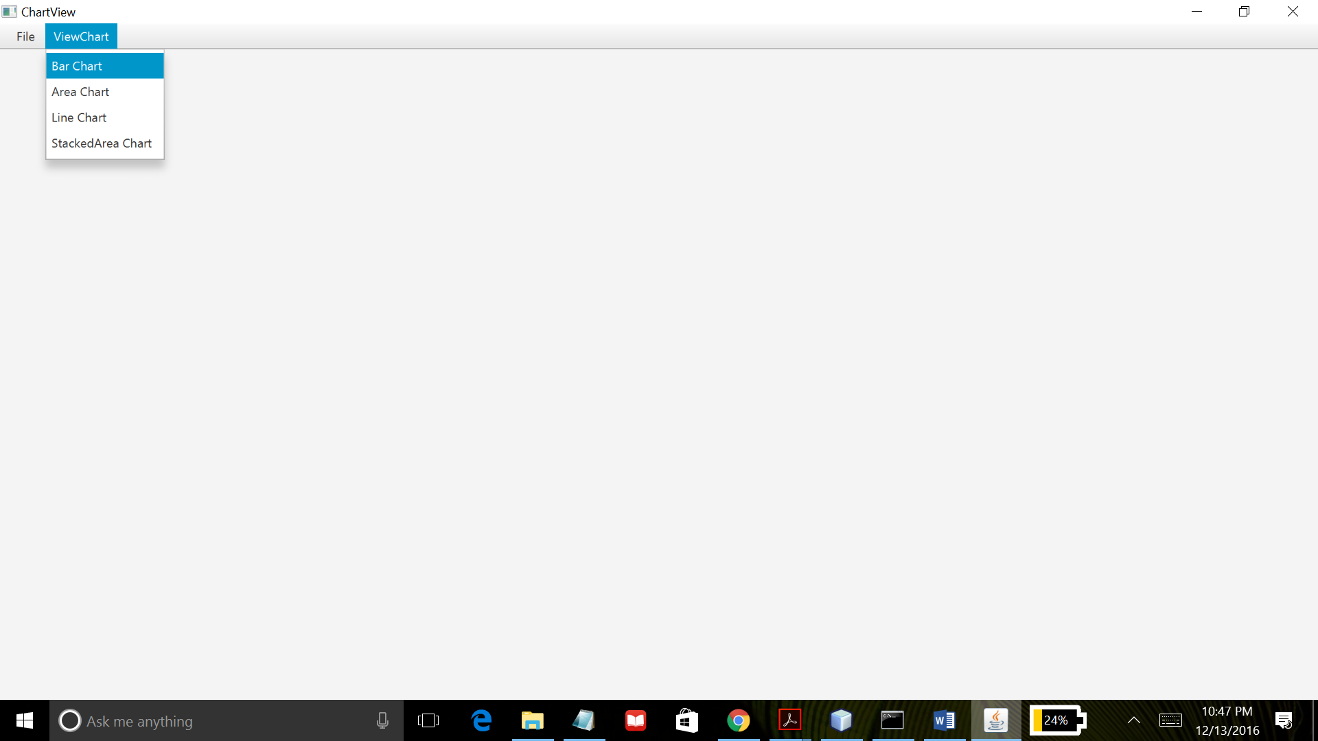

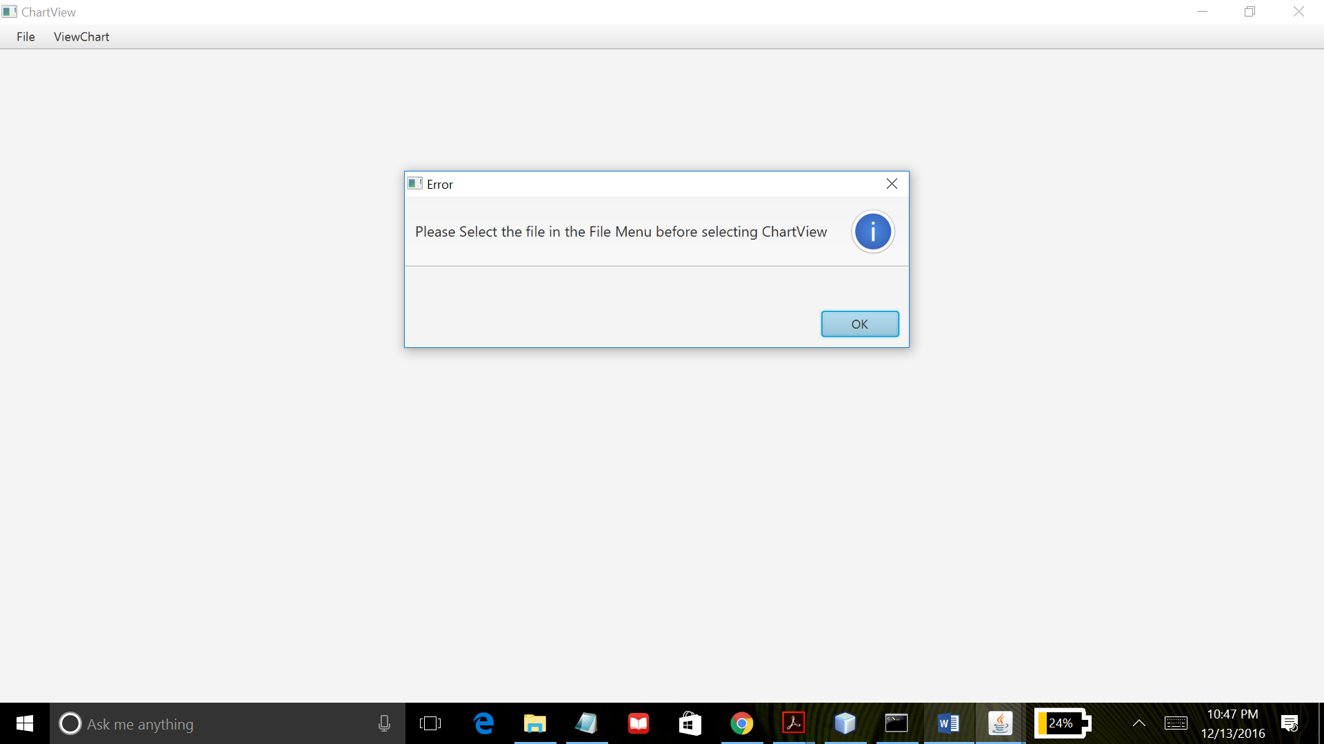

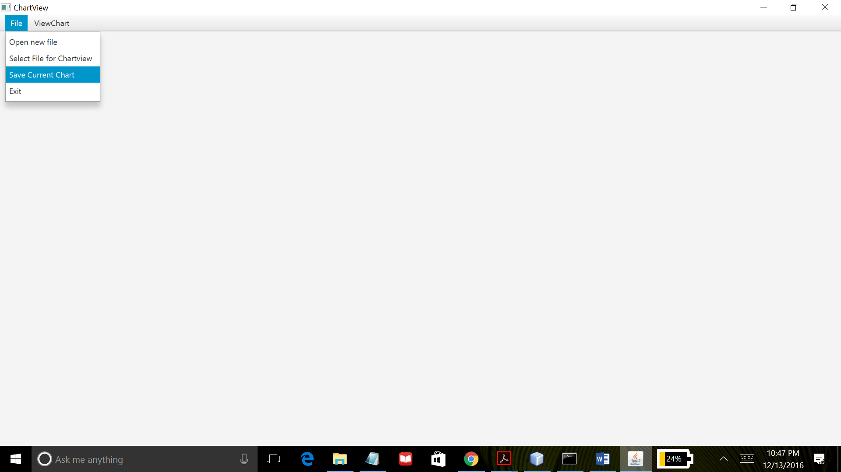

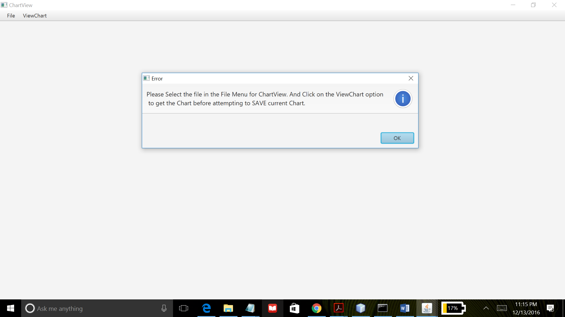

Project08 uses JavaFx API to create a GUI program that demonstrates the use of Menu to control various functionality of the program such as opening the selected file, saving file and exiting the application. Additionally, project08 allows the user to select a file that meets its file format specification, to display the file’s data in a form of chart. It also gives the users options to select and view the chart in 4 different JavaFX charts i.e. Bar Chart, Area Chart, Line Chart and Stacked Area Chart. If the file is not selected before viewing the file’s data in a chart or attempting to save the chart will throw an error. A message box is displayed prompting the user to select the file either for the chart view or saving the current chart. After the file is selected successfully, name of the selected file is shown at the bottom left of the application window. When ViewChart option is clicked on the menu bar, it will give 4 different options for chart display. This program was created using NetBeans IDE and compiled by Java compiler version “javac 1.8.0_91 “.