01.DeepLearning Introduce

01-1 introduce AI ability

1)Strong AI

* Strong AI have strong ability simular human.
* Now It is implemented impossible this ability

2)Weak AI

* Possible ablity in Specific part
* MI,DI is to be included WA

3)WA,MI,DA relation

* WA>MI>DA
* DA is consist of artificial neural network algorithm
* Artificial neural network of basic consist is developed other MI algorithm

01-2 introduce MI

1)MI can self Revised rule

* In the pase, progrmmer can possible program rule makeing, revised, delete. And Computer can conduct maked rule
* But AI programs is that computer can self finding rule and possible revising. This work is called 'trainning' of 'learning'.

2) Learning of MI is classified supervised learning, unsupervise learning, reinforcement learning. Among these I will be learning about supervised learning.

* Supervised learning: AI study Traing data. Traing data consist of input, target.
* Unsupervised learning: no target training.
* Reinforcement learning: no input, no target. In practice experience trial and error. Through vartiey experience get result of present and reward. And optimal result derive. Reinforcement learning that It takes time. This skill is used algorithm that Q-learning, SAPSA, DQN(Deep Q Nerwork)

01-3 introduce Deep learning

* Deep learning orinated from the apperance of stacking artificial neural network.

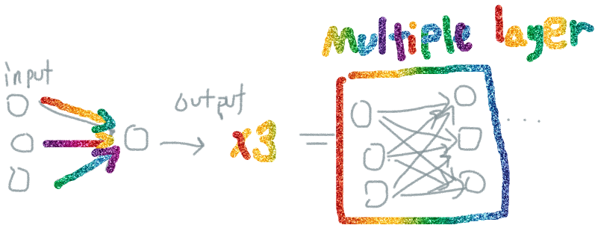

* But Deep learning isn't human neural.
* Deep learning very well disopose of data more than MI
* -deep learning: Atypical(image,sound,text,,)
* -MI: Orthpedic(excel,recordfile,database)