GROUP 3

Praveen Theerthagiri

Loren Alvarez Mejias

Bellevue University

CSD 310: Database Development and Use

Module 10

Professor Shelanskey

May 2, 2023

**Case Study:** Willson Financial

**Business Goals and Rules:**

1. To maintain compliance with SEC regulations.
2. Provide high-quality financial management and advising services to clients.
3. Review the client list, assets and billing process periodically to ensure the best service possible while keeping the business profitable.
4. Determine whether to change the billing structure by answering questions such as:

a. How many clients have been added for each of the past six months?

b. What is the average amount of assets for the entire client list in currency?

c. How many clients have a high number of transactions (*more than 10 a month*)?

Relationships:

* One client can have many assets.
* Each asset belongs to only one client.

* One client can be subject to multiple compliance regulations.
* Each compliance regulation belongs to only one client.
* Each asset can have multiple transactions.
* Each transaction belongs to only one asset.

* Each department has one employee.
* Each employee only works in one department.
* One employee can handle multiple clients.
* Each client is handled by one employee.

* Each compliance manager can have multiple clients.
* Each client has only one compliance manager.
* Each compliance manager is an employee.
* One employee can be a compliance manager

**Entity Relationship Diagram**: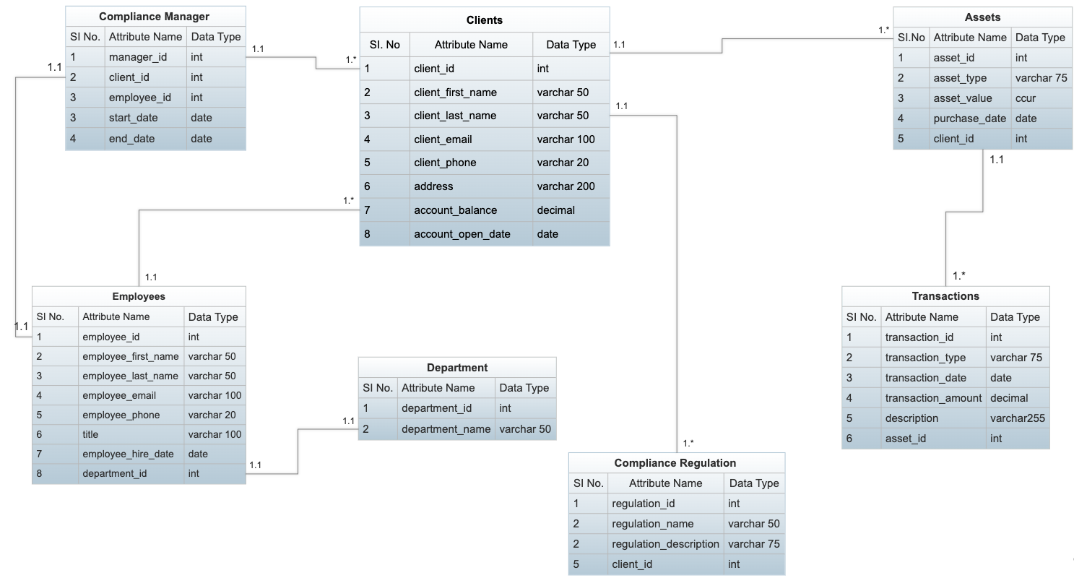

**Tables explained**:

**1.** **Client table:**

This table stores information about each client like name, contact information, account opening date, and account balance. It has a foreign key that references the primary key of the **Transaction** table.

**2**. **Transaction table**:

This table stores information about financial transactions involving client assets. Each row in this table represents a single transaction and has data for the type of transaction (e.g., buy, sell, dividend), transaction date, amount of money involved, description and a foreign key column referring **Asset** table that indicates which asset the transaction is associated with.

By having this information the firm may maintain track of each asset's and client's financial history and provide reports on investment performance and tax liabilities. It also allows compliance administrators to guarantee that all transactions are carried out in accordance with applicable legislation.

**3**. **Compliance Regulation table**:

This table stores information regarding regulatory compliance requirements that apply to clients. Each row in this table represents a single compliance regulation that the client must follow and contains information such as the regulation's description, compliance due date, compliance status (i.e., whether the client is currently compliant or not) and a foreign key reference to the **Client** table.

By having this information the firm may keep track of each client's regulatory responsibilities and check whether those duties are met on time. It also allows compliance managers to create compliance status reports for specific clients or the organization as a whole.

**4**. **Asset table**:

This table stores information about each client's assets including the type of asset, value and the date it was acquired. It has a foreign key column that references the primary key of the **Client** table.

**5**. **Employee table**:

This table holds a relationship with clients since an employee can handle many clients; a relationship with departments since one employee works at one department; and a relationship with transactions since an employee might work on multiple transactions.

**6**. **Compliance Manager table**:

This table stores information about the compliance manager assigned to each client, including the start and end dates of their assignment. The client_id column is a foreign key that references the primary key of the **Client** table. The employee_id column is also a foreign key referencing to the employee table.

**7**. **Department Table:**

This table stores information on the different departments within the company (e.g Office Administration, Managers, etc). It holds a relationship with the employees table since there is one employee per department, and as specified in the case study, there is only one department for each employee.

**Assumptions/ clarifications:**

1. We decided to remove the “Billing” table since there was not enough information or details as to what billing changes the company wanted to make, or if “billing” refers to specific assets or clients in general.
2. All the clients of Wilson Financials are SEC compliant.

**Screen shots of the sample data entered**:

1. **Client table**:

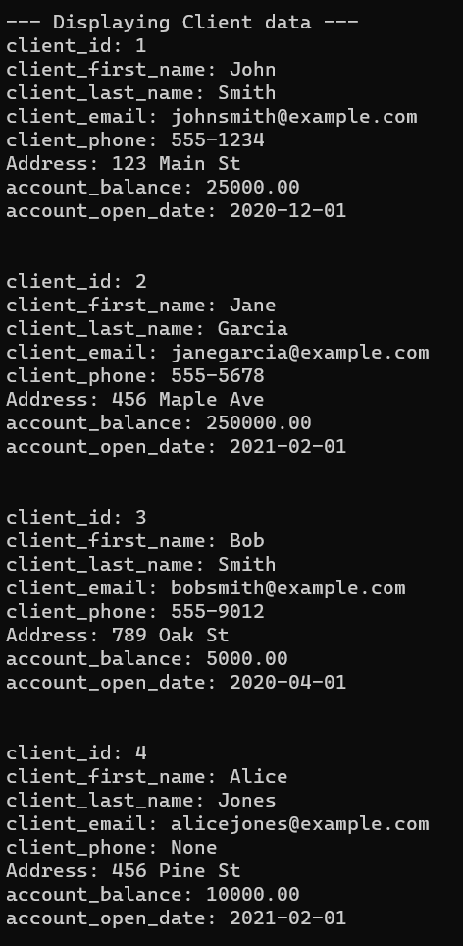

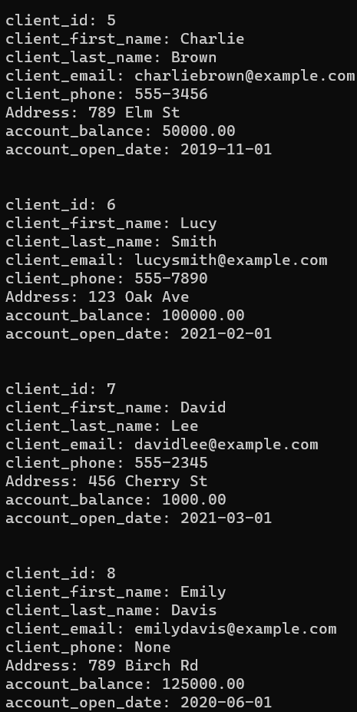

1. **Asset table:**

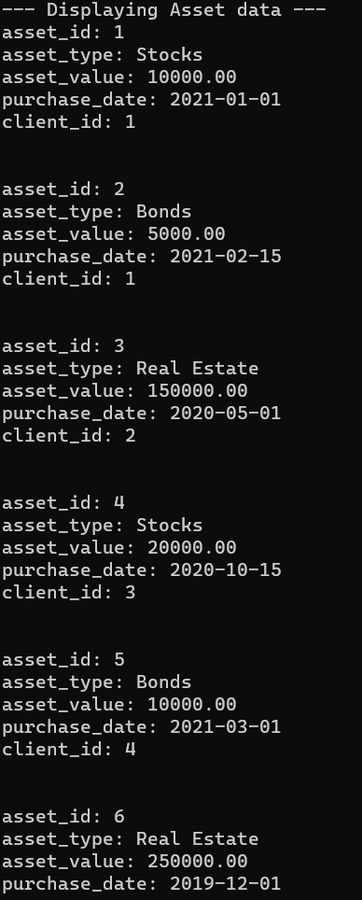

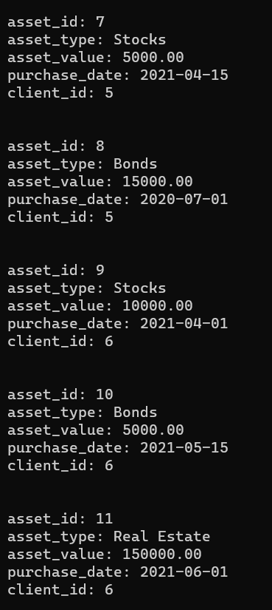

1. **Transaction table**

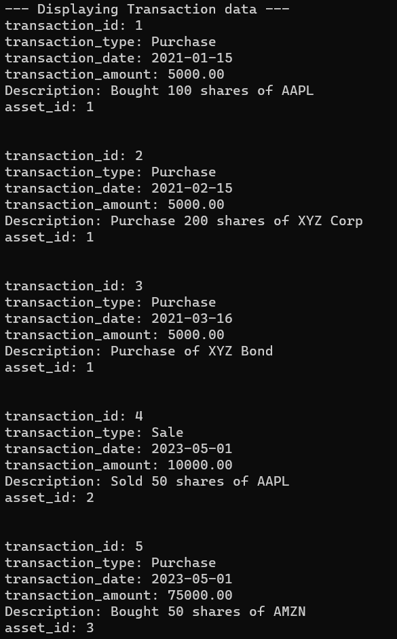

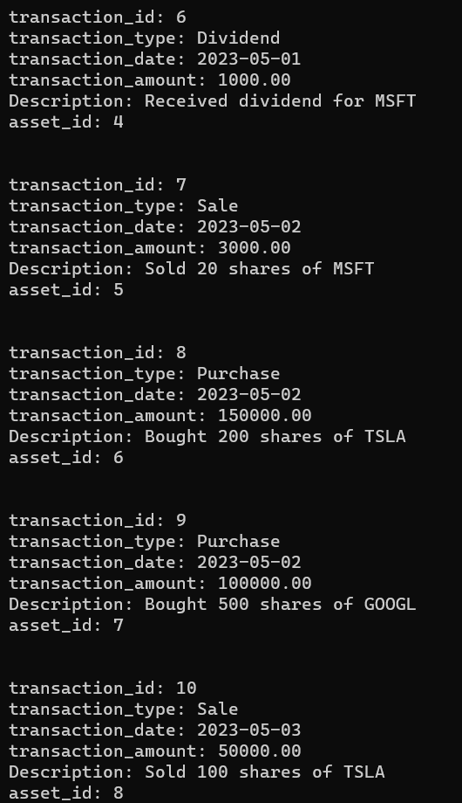

1. **Department table**

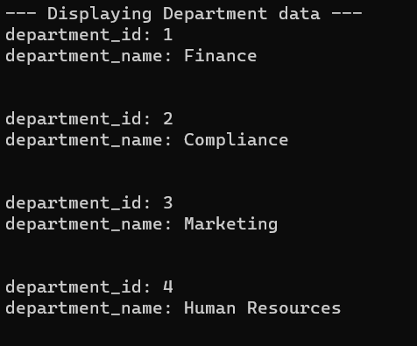

1. **Employee table**

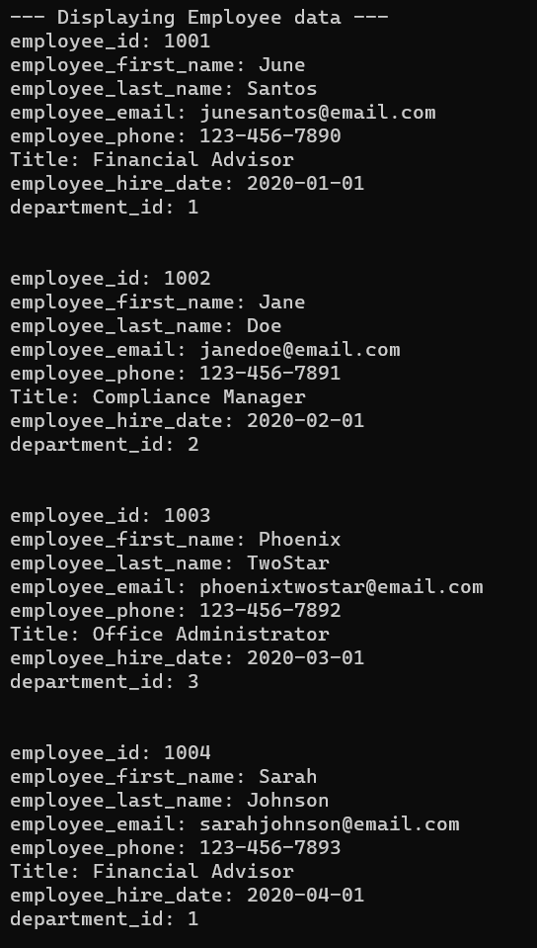

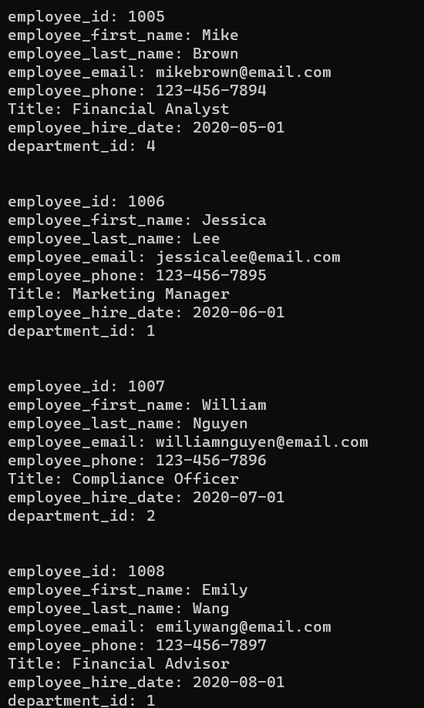

1. **Compliance Regulation table**

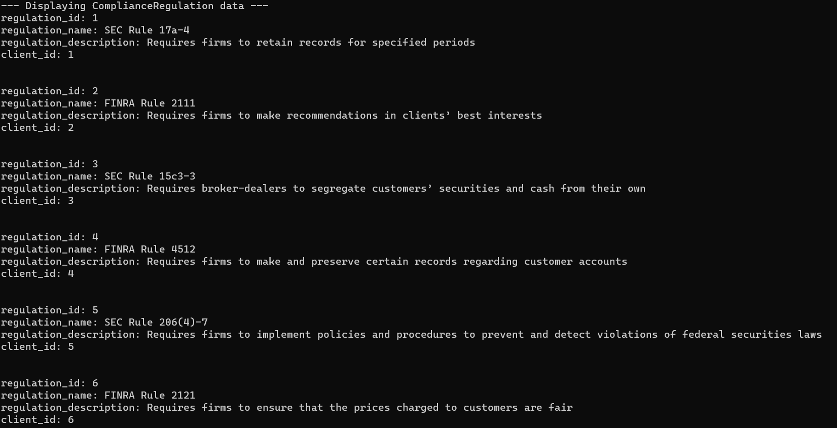

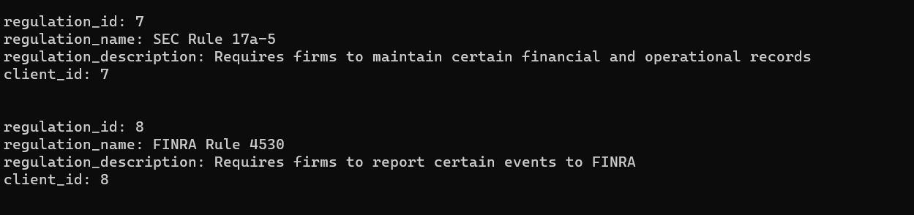

1. **Compliance Manager table**

