GROUP 3

Praveen Theerthagiri

Loren Alvarez Mejias

Bellevue University

CSD 310: Database Development and Use

Module 11.1

Professor Shelanskey

May 6, 2023

**Case Study: Wilson Financial**

From the case study provided here are some of the reports that could help in making the billing structure change decision for Wilson Financial. The questions we aim to answer with these reports are:

1. How many clients have been added for each of the past six months?
2. What is the average amount of assets (in currency) for the entire client list?
3. How many clients have a high number (more than 10 a month) of transactions?

**Reports**:

1. **Client Growth Report:**

This report will show the number of clients added for each of the past six months. This will help in analyzing the trend of client acquisition and deciding if the current billing structure is able to attract new clients or if changes need to be made.

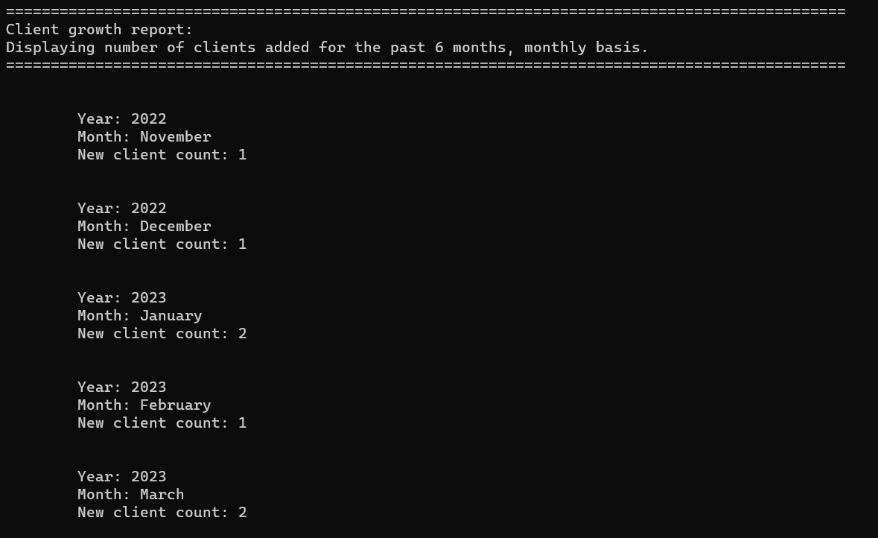

1. **Asset Value Report**:

This report will show the average amount of assets (in currency) for the entire client list. This will help in identifying the distribution of assets among clients and deciding if the current billing structure is able to generate enough revenue from clients with high assets.

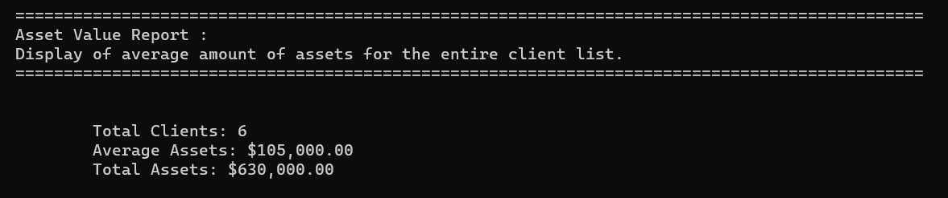

1. **Transaction Count Report:**

This report will show the number of clients with a high number (more than 10 a month) of transactions. This will help in identifying the clients that require more attention and resources and deciding if the current billing structure is able to generate enough revenue from such clients.

