**Name: Praveen Theerthagiri**

**Assignment : Module 1.2**

**Date : 03/14/2023**

**Screen shot for directory location on local machine:**

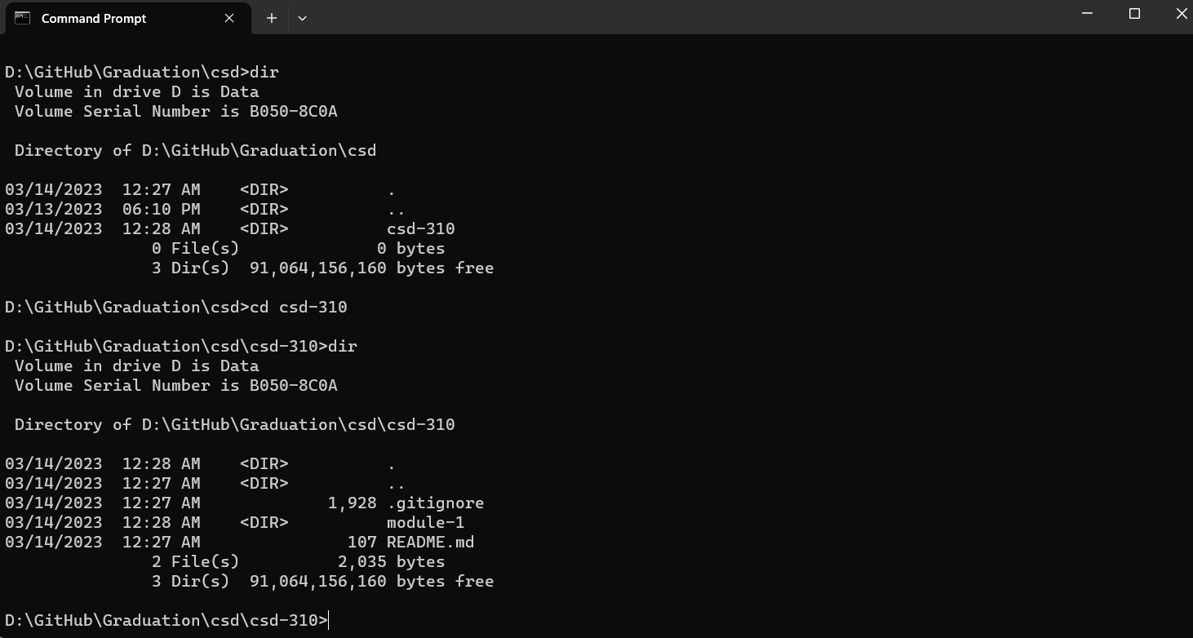

**Screen shot of the repository:**

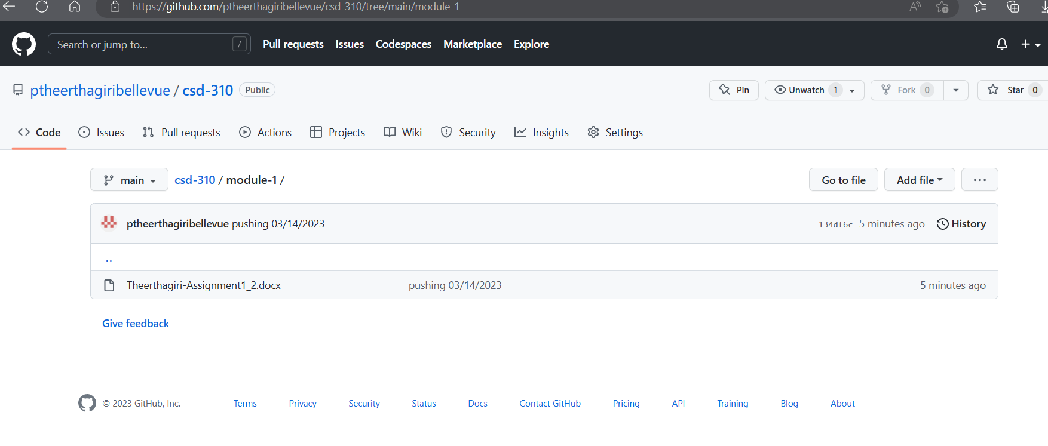

**Github repository URL** : [csd-310/module-1 at main · ptheerthagiribellevue/csd-310 (github.com)](https://github.com/ptheerthagiribellevue/csd-310/tree/main/module-1)