**Name: Praveen Theerthagiri**

**Assignment : Assignment 1.3**

**Date : 05/27/2023**

1. Screen shot of the validation result of the started code:

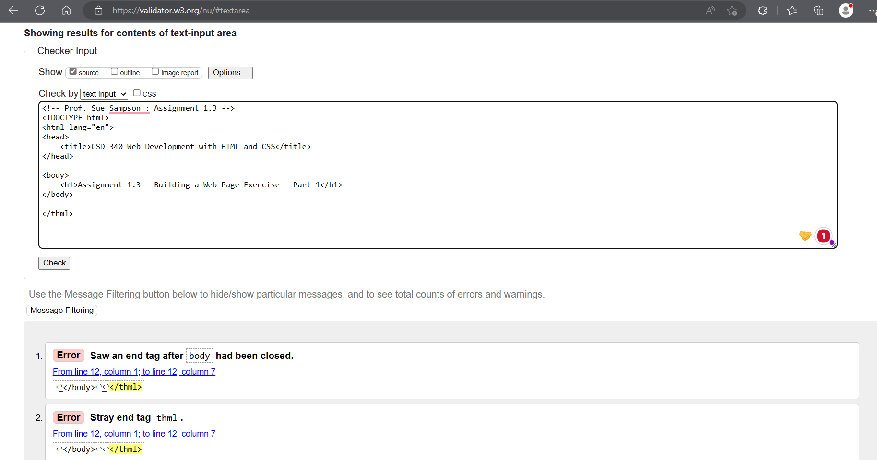

1. Screen shot of the validation result after correcting the errors:

1. Screen shot of the browser example from the local machine:

