About

* This analysis attempts to answer the question why solo matches seem so hard for a new player.

Conclusion

* A new player with less than 500 match experience player is in the bottom 16% of the experience in a lobby.
* A less capable player, with less than 0.25 K/D player, is in the bottom 14% of a lobby.
* It would require the equivalent practice and experience of 3,000 matches to approach median skill level, at the moment.

Data

* Data was collected from 11 solo matches.
* On 17 Jan 2019 and 18 Jan 2019.
* Between 7pm and 10pm.
* On Oceanic servers (from Sydney, Australia).
* Game statistics (players and eliminations) for 11 games were obtained from the replay files.
* Statistics for 913 players were obtained using the [www.fortnitetracker.com](http://www.fortnitetracker.com) public APIs.

Source code

* <https://github.com/pthiem/fortnite-solo-lobby-data-and-analysis>

Future Work

* Squad modes.
* Different times of day.
* LTM modes.

How experienced is the lobby?

* 16% of the lobby have less than 500 matches played.
* You need 2,200 matches to be in the middle.
* More than 6,000 matches puts you in the top 10%

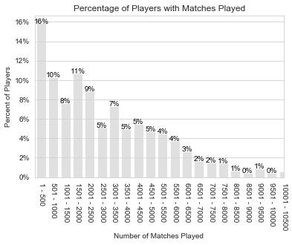 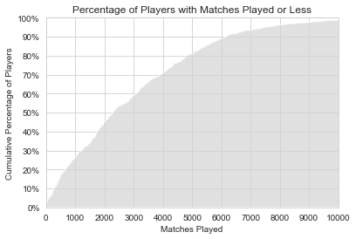

How good (by Kill Death Ratio) is the lobby?

* 14% of the lobby have a K/D ratio of less than 0.25.
* You need a K/D ratio of 0.8 to be in the middle.
* K/D ratio above 2.1 puts you in the top 10%.

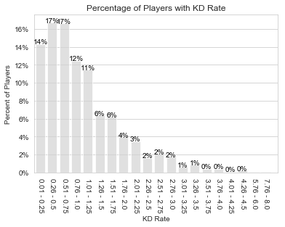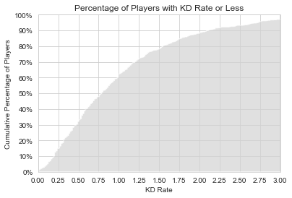

How does Kill Death Ratio improve as you play more matches?

* It does generally improve as more matches are played.
* This may be biased, that is perhaps untalented players are more likely to stop playing.
* There is a wide amount of variation.
* It takes 2,000+ games before you are likely to have a K/D ratio above 0.8.

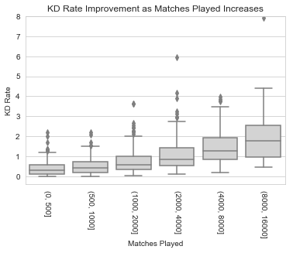

How good are the remaining players, as it progresses?

* The quality of the field gradually improves as the game proceeds.
* There is a lot of variation, even late into the game.
* The final few competitors are markedly more experienced and with high K/D ratio.
* Remaining players appear to follow an exponential decay, halving approximately every 180 seconds.

