+: public
-:private
#: protected
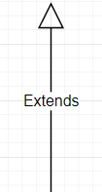 : Kế Thừa (inheritance), “A is a B”
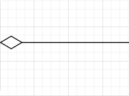 : Bao gồm (Composition), “A has B” (Person & Vehicle)

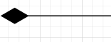 : Sở hữu ( Engine & Vehicle)
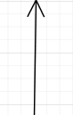 : Liên kết( có hàm gọi lẫn nhau) (Vehicle & Checker)
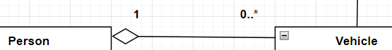
: 1 Person chỉ có 1 Vehicle

0..*: >0
1..3: [1;3]

