EEGIS

Eight-Class Imagined-Speech
Classification from EEG Signals
Multiband feature engineering and validation-weighted ensemble learning
FORMAL RESEARCH REPORT
Eight-class EEG classification study
10 November 2026

Study profile
Item | Description
Primary study | Eight imagined Spanish words; 14-channel EEG; ten-model soft ensemble
Methodological basis | Multiband signal processing, engineered descriptors, and supervised ensemble learning
Result status | Recorded experimental results; training was not repeated during report preparation

Abstract
EEGIS investigates eight-class imagined-speech recognition from electroencephalographic (EEG) recordings. One-second windows from 14 channels sampled at 128 Hz are represented using the raw signal and five frequency-band views. Statistical, spectral, nonlinear, entropy, and recurrence descriptors yield 214 feature slots per channel and 2,996 scalar values per window. Following a stratified 80/20 partition, training-fitted standardization, variance filtering, and analysis-of-variance selection reduce the representation to at most 512 coordinates. Ten heterogeneous classifiers contribute class probabilities to an ensemble weighted by cross-validation accuracy above chance.
The recorded eight-class experiment achieved 30.08% held-out accuracy and 29.98% macro F1 with the k-nearest-neighbor component fixed at k=5. An exploratory eight-class configuration with k=1 achieved 37.74% accuracy and 37.80% macro F1. The fixed k=5 configuration exceeded the 27.30% eight-class hard-voting baseline by 2.78 percentage points. Evaluation used a random window-level split; overlapping recordings, incomplete grouping information, and unresolved semantic-label provenance limit conclusions about generalization to independent participants.
The study presents the eight-class methodology, experimental configuration, aggregate metrics, and class-level recognition rates. Numerical results summarize existing experimental records and were not independently re-estimated during report preparation. Reliability constraints include preprocessing outside some inner cross-validation boundaries, limitations in short-window feature estimation, and incomplete independent-group evaluation. Verified labels, validated descriptors, and repeated grouped evaluation are required to establish stronger generalization evidence.
Keywords: imagined speech; EEG; brain–computer interface; multiband features; ensemble learning; multiclass classification; evaluation validity.

Principal findings
- The study evaluates an offline eight-class recognition workflow with a fixed vocabulary and engineered multiband features.
- The fixed k=5 and exploratory k=1 configurations are evaluated within the same eight-class label space.
- Reported performance and derived numerical comparisons are distinguished from proposed future experiments.

Contents
Abstract 2
1. Introduction 5
2. Research background 6
3. Dataset and acquisition 7
3.3 Class distribution and label provenance 8
4. System architecture 9
5. Methodology 10
5.3 Engineered feature representation 11
5.4 Descriptor estimation and reliability 12
5.5 Feature selection and validation boundaries 13
5.6 Validation-weighted soft ensemble 14
6. Experimental configuration 15
7. Evaluation protocol and performance measures 16
8. Results 17
8.2 Class-level recall 18
8.3 kNN selection analysis 19
8.4 Individual model validation and weights 20
9. Limitations and threats to validity 21
10. Recommended research and engineering plan 22
11. Conclusion 23
References 24
Appendix A. Feature representation 25

Illustrations and abbreviations

List of figures
01 Acquisition hardware and electrode layout 7
02 Eight-class sample distribution 8
03 Classification architecture 9
04 Feature representation 11
05 Validation boundaries 13
06 Weighted soft ensemble 14
07 Eight-class accuracy comparison 17
08 Class-level recall 18
09 Neighbor-selection curve 19
10 Random-window and grouped evaluation 21

List of tables
01 Methodological components and their functions 6
02 Eight-class labels, meanings, and sample counts 8
03 Band definitions in the implementation 10
04 Feature families and nominal slots per full 36-value vector 11
05 Descriptor-estimation issues requiring validation 12
06 Classifier configurations for the eight-class ensemble 15
07 Held-out performance for the two eight-class ensemble configurations 17
08 Recorded recalls and derived changes 18
09 Recorded kNN sweep mean accuracies 19
10 Exploratory k=1 ensemble validation scores and recorded weights 20
11 Major validity threats and their consequences 21
12 Suggested milestones and completion evidence 22
13 Descriptor order within a full channel/layer vector 25
14 Offsets in the 214-slot channel feature map 25

Abbreviations
ANOVA — analysis of variance; BCI — brain–computer interface; CV — cross-validation; DFA — detrended fluctuation analysis; EEG — electroencephalogram; IQR — interquartile range; kNN — k-nearest neighbors; LDA — linear discriminant analysis; MLP — multilayer perceptron; PSD — power spectral density; RQA — recurrence quantification analysis; SEF — spectral-edge frequency; SVD — singular-value decomposition; SVM — support vector machine; pp — percentage points.

1. Introduction

1.1 Background and motivation
Imagined speech is the internal rehearsal of words without an audible utterance. An EEG-based brain–computer interface seeks to associate patterns in scalp electrical recordings with a user’s intended command. In the present study, each segmented EEG window is assigned to one of eight vocabulary labels. Feature generation and machine learning provide a practical framework for representing the variability of these recordings [1].
Each window contains only 128 samples per channel. Signal variability may reflect task-related activity, recording conditions, artifacts, and participant characteristics. A large descriptor space can represent complementary properties, but it may also capture incidental correlations. The experimental design must therefore specify both the learning procedure and the independence of the observations used for evaluation.

1.2 Problem formulation
For a window X ∈ ℝ^(14×128), the objective is to learn a function f(X) predicting y ∈ {0,…,7}. The label order is Sí, No, Baño, Hambre, Sed, Ayuda, Dolor, and Gracias. The present evaluation measures recognition on a held-out random sample of windows. Generalization to a new participant or recording session requires a separate grouped evaluation.

1.3 Research objectives and scope
- Load and validate the expected multichannel CSV format and derive five frequency-band views.
- Construct an interpretable feature map and reduce its dimensionality using training data.
- Compare diverse classifiers and combine their probabilistic predictions using validation-derived weights.
- Quantify eight-class aggregate and per-class performance and identify constraints on independent evaluation.
- Define a reproducible evaluation path toward participant- or trial-independent experiments.
The scope comprises eight-class offline recognition, multiband feature engineering, dimensionality reduction, validation-weighted classification, and performance evaluation. The methodological description distinguishes measured outcomes from the requirements of subsequent independent-group and real-time studies.

2. Research background

2.1 Feature-based EEG recognition
Imagined-speech EEG recognition requires a compact representation of short, variable multichannel signals. Time-domain statistics characterize amplitude distributions, spectral descriptors summarize oscillatory structure, and entropy or fractal measures describe temporal irregularity. Combining these families can capture complementary signal properties, although interpretation depends on valid estimator definitions and sufficient observation length.
Lara-Arellano et al. developed a multiband feature-generation framework for imagined-speech EEG, with electrode and descriptor selection as central methodological components [1]. This work motivates the use of raw and band-filtered representations and a structured per-channel descriptor map. The present study uses that feature-generation concept within an eight-category ensemble formulation.

2.2 Ensemble learning and feature reduction
A heterogeneous ensemble combines estimators with different inductive assumptions. Nearest-neighbor models emphasize local similarity; linear and generative models impose compact decision structures; tree ensembles capture nonlinear interactions; and neural or kernel methods provide flexible boundaries. Probability aggregation allows these outputs to be combined in a common class space.
Table 1. Methodological components and their functions
Component | Role in the eight-class study
Multiband representation | Represent each window in raw form and five frequency intervals
Engineered descriptors | Summarize amplitude, temporal variation, spectral structure, and irregularity
Univariate feature selection | Reduce redundant or uninformative channel–descriptor coordinates
Heterogeneous soft voting | Aggregate complementary class-probability estimates
Independent evaluation | Reserve observations for measuring generalization beyond training

Feature selection and model weighting must be estimated using training observations. Preprocessing performed before an inner validation split can introduce dependence between training decisions and validation observations. Complete transformation pipelines within validation folds provide the methodological basis for controlling this effect [4].

3. Dataset and acquisition

3.1 Source and recording arrangement
The EEGIS dataset contains recordings from ten participants imagining eight Spanish words and a rest state, acquired with an Emotiv EPOC+ system using 14 channels at 128 Hz [2]. The acquisition protocol describes eight-second prompted imagination periods with participants remaining still and keeping their eyes closed [1]. The present classification task uses the eight word categories and excludes the rest condition.
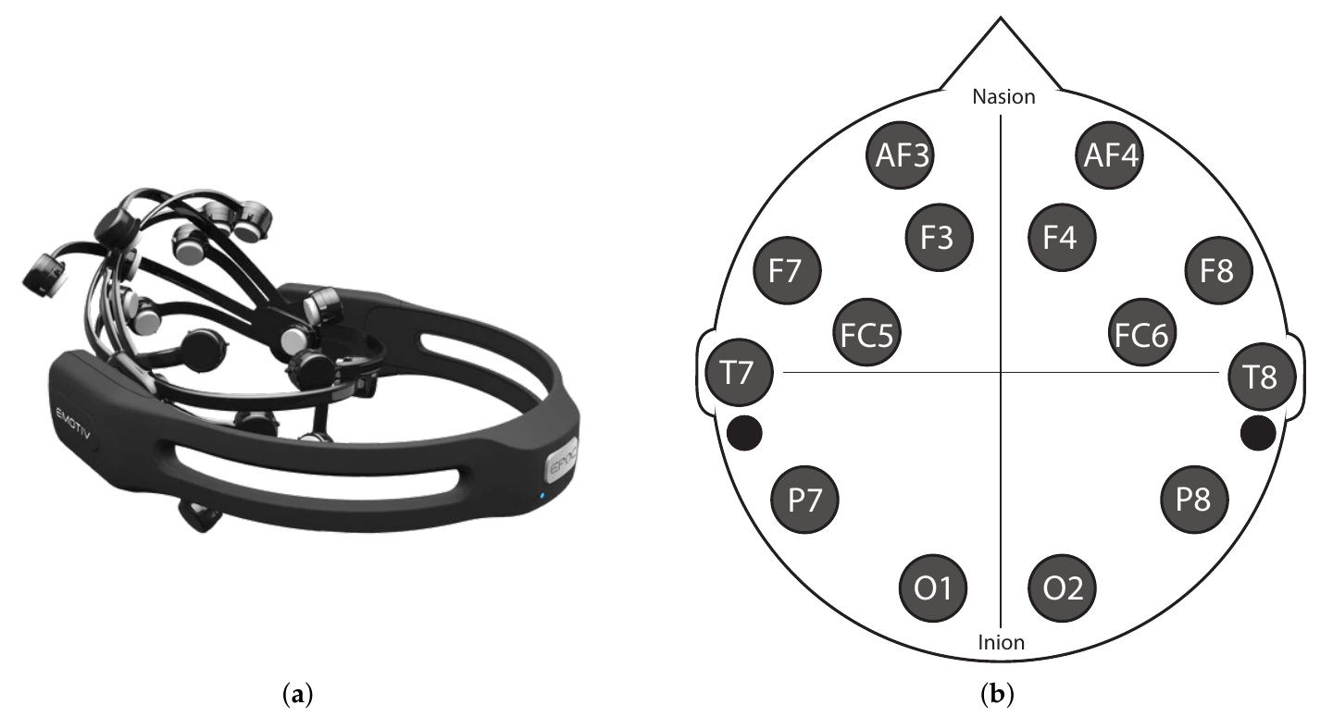
Figure 1. Acquisition hardware and electrode layout reproduced from Figure 3 of Lara-Arellano et al. [1], Eng 6 (2025), 75, under CC BY 4.0.

3.2 Signal organization
Each observation is organized as a matrix of 14 channels and 128 consecutive time samples. Numeric measurements are converted to a common floating-point representation, and the matrix orientation is standardized before filtering. Consistent electrode ordering and sampling frequency are necessary to preserve the meaning of channel-specific descriptors across observations.
Electrode order: AF3, F7, F3, FC5, T7, P7, O1, O2, P8, T8, FC6, F4, F8, AF4.
The dataset provides raw and band-filtered representations [2]. In this study, frequency decomposition is recomputed from the raw observations to maintain a consistent filtering procedure. Reliable participant-, session-, and trial-level identifiers are required to determine the independence of windows assigned to separate partitions.

3.3 Class distribution and label provenance
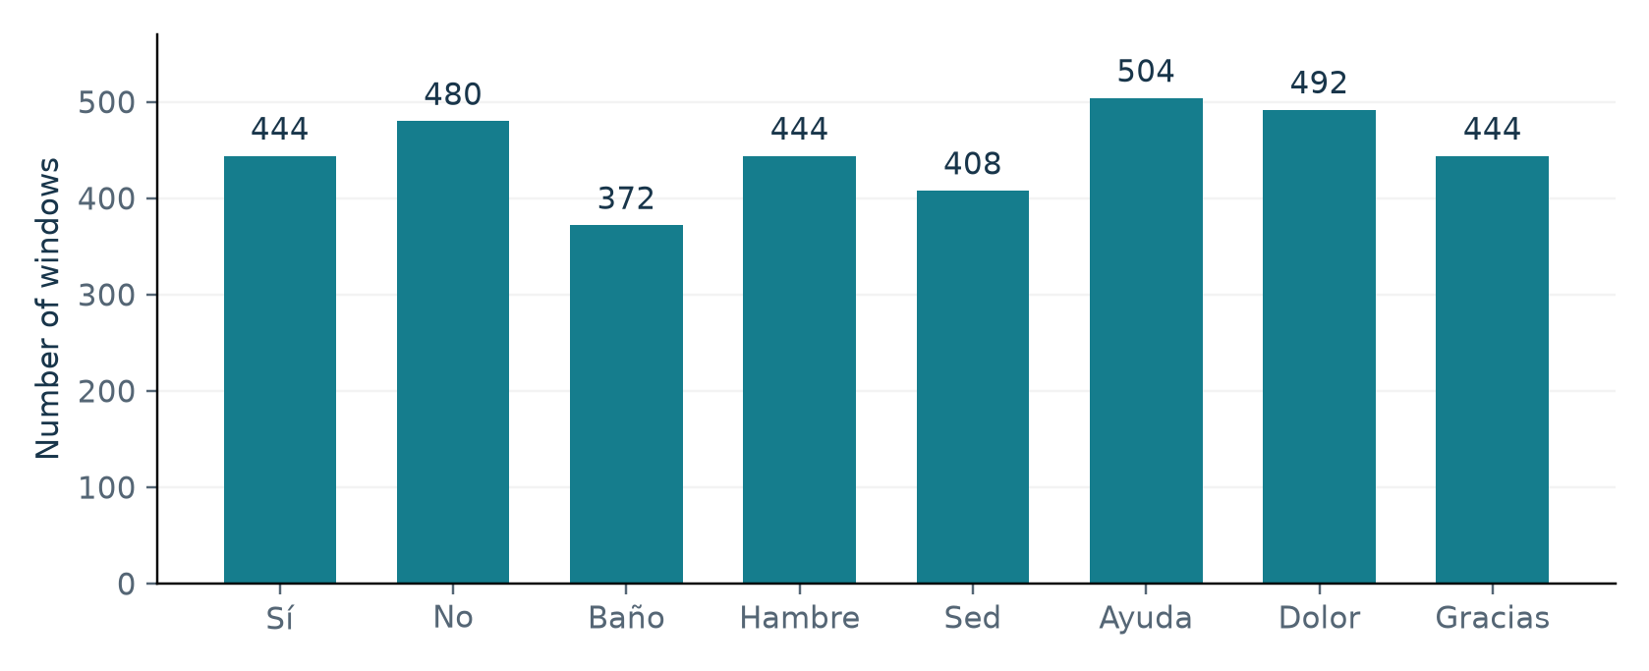
Figure 2. Class distribution for the eight imagined-word categories. The total comprises 3,588 one-second EEG windows.
Table 2. Eight-class labels, meanings, and sample counts
Label index | Class | Meaning | Windows
0 | Sí | Yes | 444
1 | No | No | 480
2 | Baño | Bathroom | 372
3 | Hambre | Hunger | 444
4 | Sed | Thirst | 408
5 | Ayuda | Help | 504
6 | Dolor | Pain | 492
7 | Gracias | Thank you | 444
— | Total | Rest excluded | 3,588

The largest class is Ayuda (504 windows), and the smallest is Baño (372), giving a maximum-to-minimum ratio of 1.35. Always predicting Ayuda would produce 504/3,588 = 14.05% accuracy on the full distribution. This is a derived reference rather than a measured held-out majority-class result. Macro metrics complement support-weighted metrics under the observed imbalance.

4. System architecture
The analysis comprises signal organization, frequency decomposition, feature extraction, train/test partitioning, standardization, feature selection, model validation, ensemble fitting, prediction, and evaluation. Figure 3 presents the sequence and the associated tensor dimensions. The workflow classifies presegmented windows and does not include continuous word-onset detection or temporal prediction smoothing.
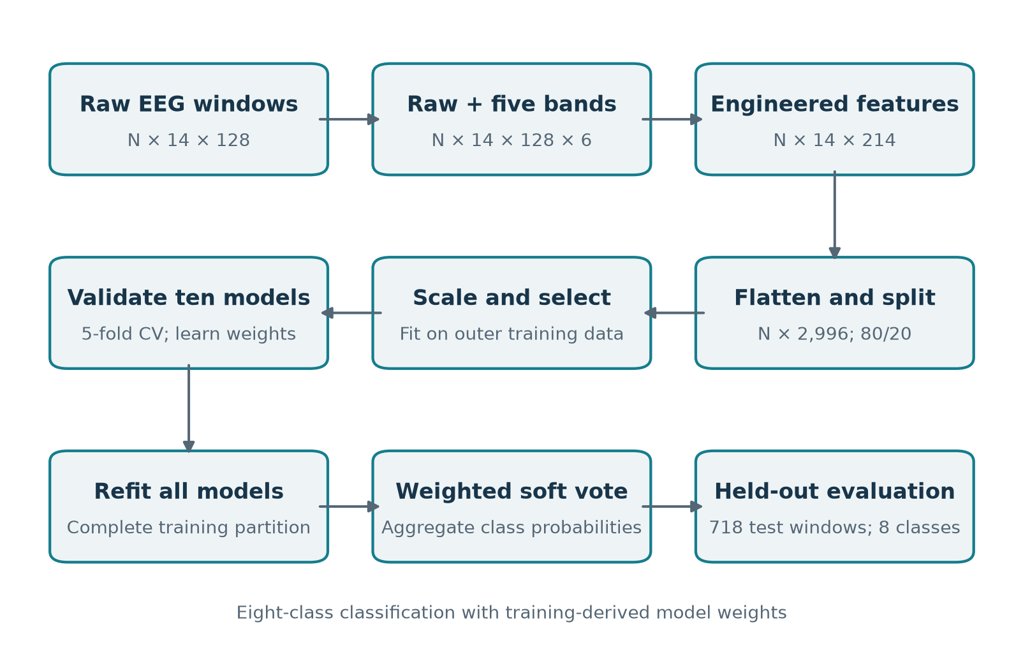
Figure 3. End-to-end architecture of the eight-class classification workflow. Held-out observations are transformed using preprocessing objects fitted on the training partition.

4.1 Tensor and control flow
A raw tensor of shape N × 14 × 128 becomes N × 14 × 128 × 6 after stacking the raw signal and five filtered views. Feature extraction reduces each time series to descriptors, yielding N × 14 × 214. The per-window map is flattened to N × 2,996 before scaling and selection. Classifier predictions are generated from at most 512 selected coordinates. The final probability tensor has ten model outputs per test window, each containing eight class probabilities.

4.2 Training and inference
All 14 electrodes contribute to the initial representation. Feature selection operates on flattened channel–descriptor coordinates. Training estimates the preprocessing parameters, selected coordinates, classifier parameters, and model weights. Inference applies those fitted transformations and combines eight-category probabilities without refitting on test observations.

5. Methodology

5.1 Frequency decomposition and numerical preparation
Five band-pass representations are produced using a fourth-order Butterworth prototype expressed as second-order sections. Each filter is applied in forward and reverse directions along the temporal axis, and its output is stacked with the unfiltered signal. A band-pass transformation increases the transfer-function order relative to the low-pass prototype, while forward–backward application modifies the magnitude response. The resulting operation is an offline, approximately zero-phase transformation.
Table 3. Band definitions in the implementation
Layer | Lower cutoff | Upper cutoff | Feature slots/channel
Raw | — | — | 34
Delta | 0.5 Hz | 4 Hz | 36
Theta | 4 Hz | 8 Hz | 36
Alpha | 8 Hz | 13 Hz | 36
Beta | 13 Hz | 30 Hz | 36
Gamma | 30 Hz | 40 Hz | 36

Forward–backward filtering reduces phase distortion for offline analysis but uses information from both time directions. It is not itself a streaming filter design. Short-window boundary effects are particularly relevant in the delta band: a one-second window contains only half a cycle at 0.5 Hz. Those values describe the configured transformation, not proof that low-frequency information is estimated reliably.

5.2 Signal-quality and numerical considerations
Artifact rejection, independent component analysis, rereferencing, baseline correction, explicit line-noise removal, and bad-channel interpolation are not established components of the evaluated workflow. Consequently, the effect of acquisition artifacts and any prior signal cleaning cannot be quantified from the reported metrics. Signal-quality screening should precede future independent validation.
During descriptor generation, undefined and infinite values are replaced by zero, and the feature representation is stored with 32-bit floating-point precision. Finite output is computationally convenient but can conceal unstable short-window estimators. A reproducible evaluation should quantify the frequency of replacements for each descriptor, band, channel, and observation.

5.3 Engineered feature representation
The extractor computes a 36-value descriptor vector for each channel and each signal layer. It retains the first 34 descriptors for the raw view and all 36 for each of the five band views. Relative band power and mean Hilbert-envelope amplitude are therefore omitted from the raw feature slice. The same feature-slot layout is used across all channels.
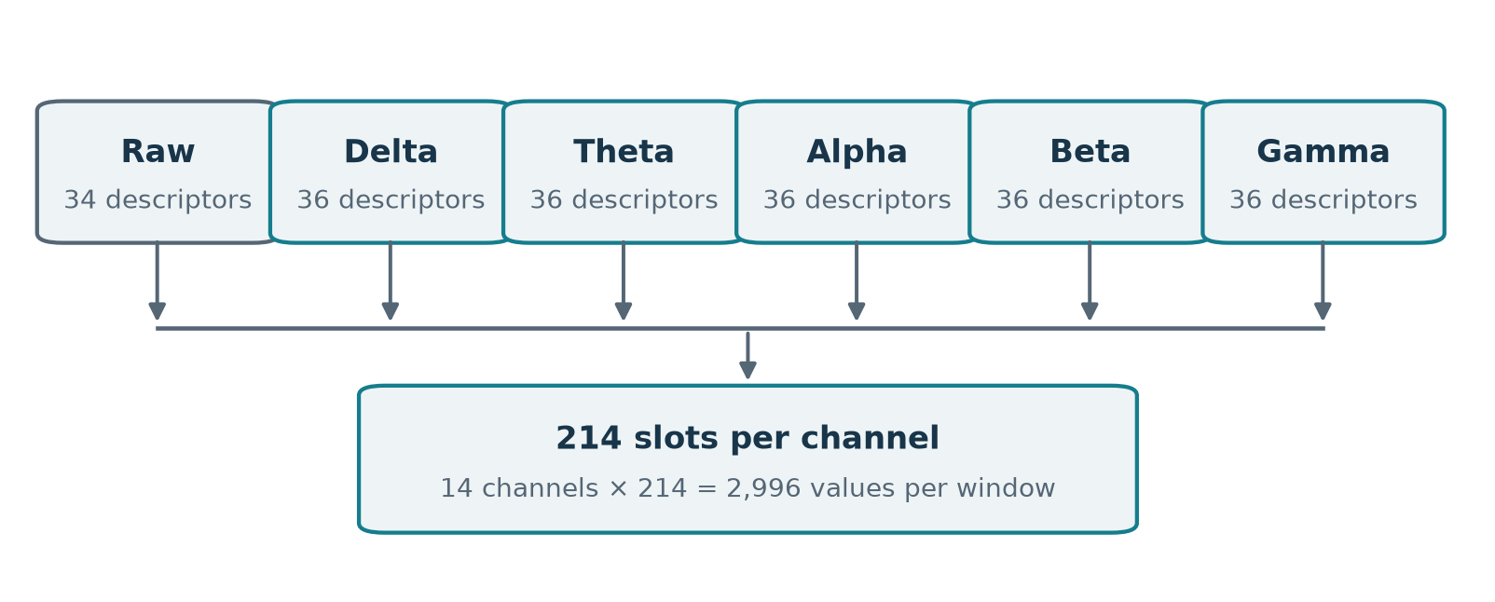
Figure 4. Feature layout: 34 raw descriptors plus 5 × 36 band descriptors = 214 slots per channel; 14 × 214 = 2,996 flattened values.
Table 4. Feature families and nominal slots per full 36-value vector
Family | Slots | Descriptors / purpose
Distribution | 12 | Mean, SD, coefficient of variation, median, mode, extrema, quartiles, IQR, excess kurtosis, skewness
DFA + Hjorth | 4 | Detrended fluctuation exponent and three intended Hjorth entries
Entropy | 4 | Permutation, approximate, spectral, and normalized SVD entropy
Fractal / scaling | 4 | Higuchi, Petrosian, Katz, and a custom Hurst estimate
Spectral | 5 | Integrated PSD, spectral centroid, and 25/50/75% spectral edges
Recurrence | 5 | Five custom recurrence statistics
Band-specific | 2 | Relative power within the current layer and mean Hilbert envelope

5.4 Descriptor estimation and reliability
For a single-channel sequence x, standardization and selected signal summaries can be written as follows. These equations explain intended quantities; where implementation differs, the discrepancy is recorded below.
zⱼ = (xⱼ − μⱼ,train) / σⱼ,train (1)
Ptotal = ∫ Sxx(f) df; fcentroid = ∫ f Sxx(f) df / Ptotal (2)
Rband = ∫[fL,fH] Slayer(f) df / ∫ Slayer(f) df (3)
Welch PSD uses fs=128 and nperseg=128. With exactly 128 samples this leaves one full-length segment under the default setup, limiting the variance-reduction advantage of Welch averaging. The frequency grid has approximately 1 Hz spacing. Relative power is calculated from each already filtered layer’s PSD, rather than from a shared raw PSD, so it is not a direct measure of the raw signal’s between-band allocation.
Table 5. Descriptor-estimation issues requiring validation
Location | Observed calculation | Implication
Hjorth entries | The two returned Hjorth statistics are assigned to activity and mobility positions, followed by a derived ratio | The estimator returns mobility and complexity. Activity should be variance; the current assignment alters the interpretation of all three entries.
RQA trapping time | Mean(lengths ≥ 2) after retaining only lengths ≥ 2 | Returns 1 when qualifying diagonal lines exist, else 0; not a vertical trapping-time statistic.
Other RQA entries | Upper-triangle diagonal lengths; full-matrix recurrence denominator | Determinism and line entropy do not implement conventional definitions consistently.
Hurst estimate | One rescaled-range ratio with log(window length) | Custom single-scale estimate; not a fitted multiscale Hurst regression.
Numerical guards | Replace all non-finite descriptors by zero | Finite output does not establish estimator validity on a 128-sample sequence.

These estimator limitations restrict feature interpretation and exact methodological reproduction. Changes to feature definitions require recalculating the representation and repeating the experiment. Existing performance values cannot be reassigned to a corrected descriptor formulation without new evaluation.

5.5 Feature selection and validation boundaries
The outer partition assigns 80% of observations to training and 20% to testing using stratification and random seed 42. Standardization parameters are estimated on training observations. Constant coordinates are removed, and the remaining coordinates are ranked using a univariate ANOVA F statistic. At most 512 coordinates are retained; a smaller count is used if fewer nonconstant coordinates are available.
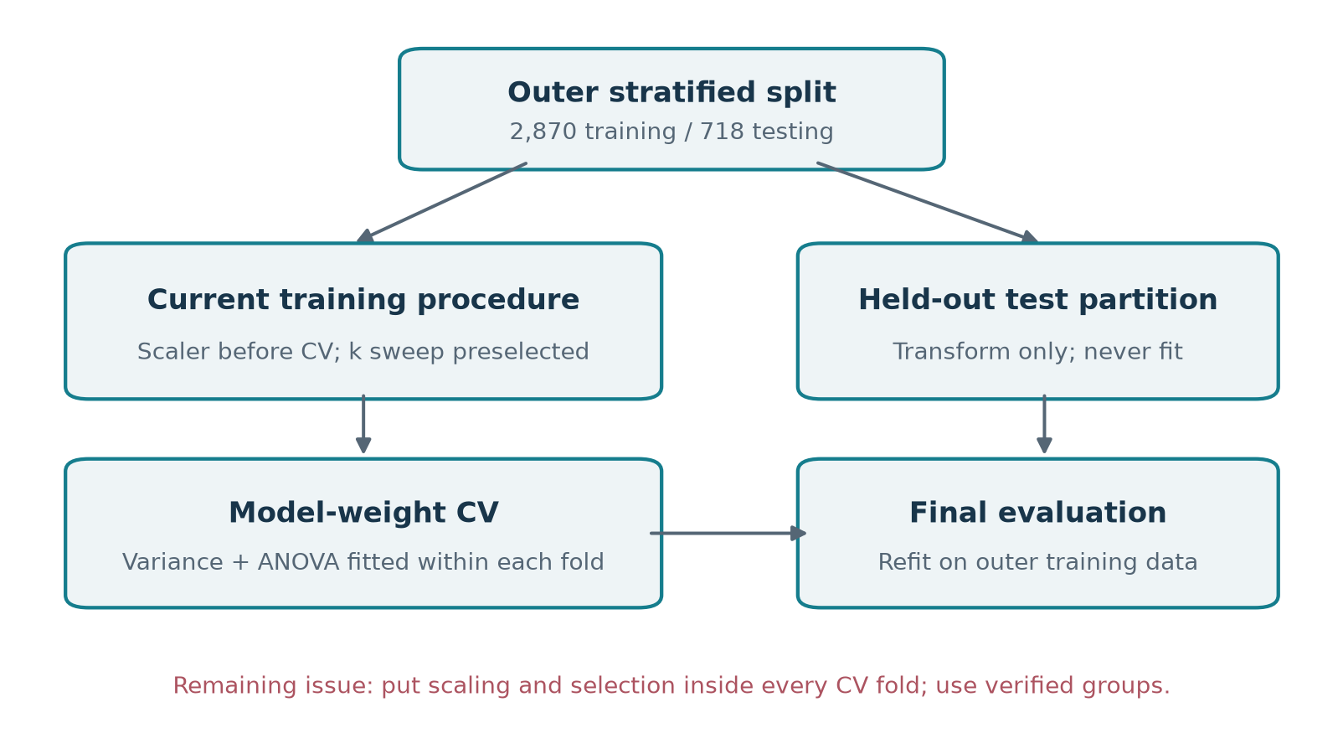
Figure 5. Validation boundaries used for model selection and ensemble weighting. Variance filtering and ANOVA selection are refitted within model-weight validation folds; scaling is fitted before inner validation.

5.5.1 Held-out evaluation boundary
Held-out test observations are excluded from standardization fitting, feature ranking, neighbor selection, and model-weight estimation. The final estimators are fitted on the outer-training partition and evaluated on the reserved test partition. Variance filtering and ANOVA selection are additionally refitted within each model-weight cross-validation fold.

5.5.2 Remaining cross-validation concerns
The k-selection sweep receives a matrix already selected using all outer-training labels, so its inner validation folds influence the selected feature set. Both the k sweep and model-weight CV also receive data standardized using the entire outer-training partition. Their validation scores therefore are not fully independent estimates of a complete training procedure. A pipeline containing scaling, variance filtering, selection, and classification within every fold addresses this issue [4].

5.6 Validation-weighted soft ensemble
The ensemble combines nearest-neighbor, linear, tree-based, generative, neural, and kernel classifiers. Each model is first scored using stratified training cross-validation, then a cloned estimator is fitted on the complete selected outer-training matrix. The weight of a model increases with the amount by which its validation accuracy exceeds the uniform eight-class chance value.
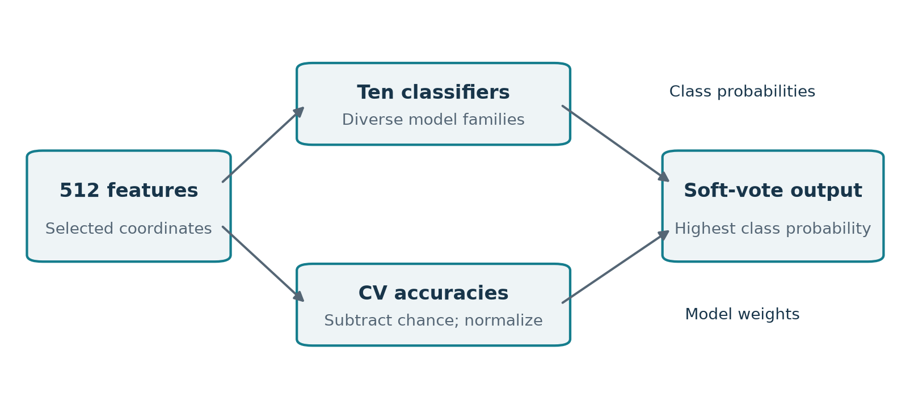
Figure 6. Probabilistic ensemble and weight calculation. All ten requested classifiers retain a nonzero contribution through a small positive offset.
aₘ = max(sₘ − 1/C, 0) + ε; wₘ = aₘ / Σᵣ aᵣ (4)
P(c | x) = Σₘ wₘ pₘ(c | x); ŷ = argmax꜀ P(c | x) (5)
Here sₘ is mean validation accuracy for model m, C=8, and ε=10⁻⁶. The sum of model weights is one. If every model is at or below chance, the epsilon term yields approximately uniform weights. The aggregation is a heuristic accuracy-weighted average rather than an optimized stacking objective. Higher validation accuracy does not guarantee better-calibrated probabilities, so probability calibration remains an open evaluation step.

Class alignment and interpretation
The prediction stage stacks the eight-category probability outputs from the ten fitted estimators and chooses the largest weighted aggregate. Probability columns must correspond to the same category order for every estimator. Explicit class alignment is necessary when applying this formulation to other label encodings or training partitions.

6. Experimental configuration
Table 6. Classifier configurations for the eight-class ensemble
Model | Explicit settings / role
kNN | Five neighbors in the fixed configuration; inverse-distance weighting
Logistic regression | C=1; balanced class weights; max_iter=500; seed=42
Random forest | 300 trees; balanced class weights; min_samples_leaf=2; n_jobs=−1; seed=42
Decision tree | max_depth=20; min_samples_leaf=2; balanced class weights; seed=42
Gradient boosting | 150 estimators; learning_rate=0.05; max_depth=2; seed=42
AdaBoost | 200 estimators; learning_rate=0.05; seed=42
Gaussian Naive Bayes | var_smoothing=10⁻⁸
Linear discriminant analysis | solver=lsqr; shrinkage=auto
Multilayer perceptron | One 128-unit hidden layer; alpha=0.001; early stopping; max_iter=300; seed=42
Support vector machine | C=2; gamma=scale; probability=True; balanced class weights; seed=42

6.1 Experimental settings
The experiment uses 3,588 windows with a stratified 80/20 partition yielding 2,870 training observations and 718 test observations. The random seed is 42, the maximum feature count is 512, and model validation uses five stratified folds. Numerical processing uses NumPy, SciPy, scikit-learn, and AntroPy. Unspecified estimator settings follow library defaults; exact package versions and a hardware/runtime profile were not retained in the experimental record.

6.2 Fixed and exploratory eight-class configurations
Two eight-class configurations are reported. The exploratory configuration uses k=1 for the nearest-neighbor constituent, while the fixed configuration uses k=5. Both share the same label space, outer split, feature cap, and ten-model soft-voting formulation. The fixed choice expresses a preference for reduced sensitivity to individual neighbors; a robustness advantage requires independent grouped evaluation.

7. Evaluation protocol and performance measures

7.1 Reported protocol
Evaluation uses one held-out random stratified partition. Aggregate metrics and class-level recalls are reported for the fixed k=5 and exploratory k=1 configurations. The 27.30% eight-class hard-voting result provides an additional baseline. A single random split and seed do not quantify the variability of these estimates.
Accuracy = number of correct predictions / number of test windows (6)
Precision꜀ = TP꜀/(TP꜀+FP꜀); Recall꜀ = TP꜀/(TP꜀+FN꜀) (7)
F1꜀ = 2 Precision꜀ Recall꜀ / (Precision꜀+Recall꜀) (8)
Macro averaging assigns equal weight to each class. Weighted averaging weights class-level scores by true support. In single-label multiclass evaluation over all categories, weighted recall equals accuracy. Undefined precision and F1 terms are assigned zero when their denominators vanish.

7.2 Confusion matrices and evidence availability
A row-normalized confusion matrix divides each true-class row by its support. Diagonal entries give class recall, while off-diagonal entries identify error destinations. The retained experimental summary provides class recalls but does not preserve the complete 8 × 8 matrix. Its off-diagonal values cannot be reconstructed from recall alone; results therefore include recall plots rather than an unsupported complete confusion matrix.

8. Results

8.1 Eight-class aggregate performance
Table 7. Held-out performance for the two eight-class ensemble configurations
Metric | Exploratory k=1 | Production k=5
Accuracy | 37.74% | 30.08%
Weighted precision | 38.02% | 30.45%
Weighted recall | 37.74% | 30.08%
Weighted F1 | 37.74% | 30.02%
Macro precision | 38.00% | 30.45%
Macro recall | 37.90% | 30.01%
Macro F1 | 37.80% | 29.98%

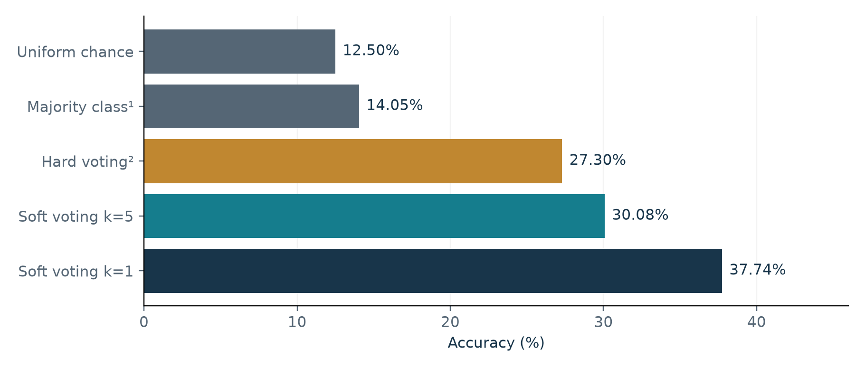
Figure 7. Accuracy references and eight-class classification results. ¹The 14.05% majority reference is derived from the full class distribution. ²The hard-voting baseline is retained from the recorded eight-class experiments.
The production configuration improves on the recorded hard-voting baseline by 30.08 − 27.30 = 2.78 percentage points. Its margin above uniform chance is 17.58 points. The exploratory k=1 value is 7.66 points higher than the production result. These arithmetic differences describe reported outcomes; they do not establish statistical significance or identify which pipeline change caused the improvement.

8.2 Class-level recall
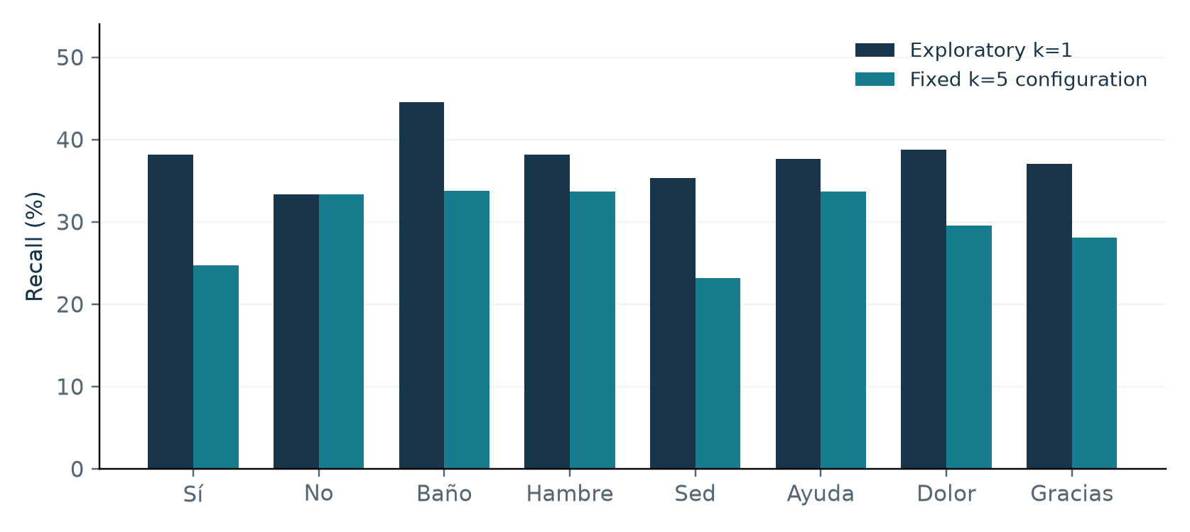
Figure 8. Recall by imagined-word class for the two recorded eight-class runs. Bars show true-class recognition rates, not precision or statistical uncertainty.
Table 8. Recorded recalls and derived changes
Class | k=1 recall | k=5 recall | k=5 minus k=1
Sí | 38.20% | 24.72% | −13.48 pp
No | 33.33% | 33.33% | 0.00 pp
Baño | 44.59% | 33.78% | −10.81 pp
Hambre | 38.20% | 33.71% | −4.49 pp
Sed | 35.37% | 23.17% | −12.20 pp
Ayuda | 37.62% | 33.66% | −3.96 pp
Dolor | 38.78% | 29.59% | −9.19 pp
Gracias | 37.08% | 28.09% | −8.99 pp

The production run’s class recall ranges from 23.17% for Sed to 33.78% for Baño. The exploratory run’s strongest recorded recall is also Baño, at 44.59%, while No is lowest at 33.33%. Increasing k is associated with lower reported recall for seven classes and an unchanged value for No in these rounded records. The available evidence does not isolate whether these changes arose exclusively from kNN or from the resulting ensemble weights.
Macro F1 is close to weighted F1 in both runs, indicating that the recorded modest class imbalance is not the sole explanation for the low overall performance. However, without off-diagonal entries and participant-level records, the report cannot identify recurrent word-pair confusions or determine whether errors are concentrated in particular people or sessions.

8.3 kNN selection analysis
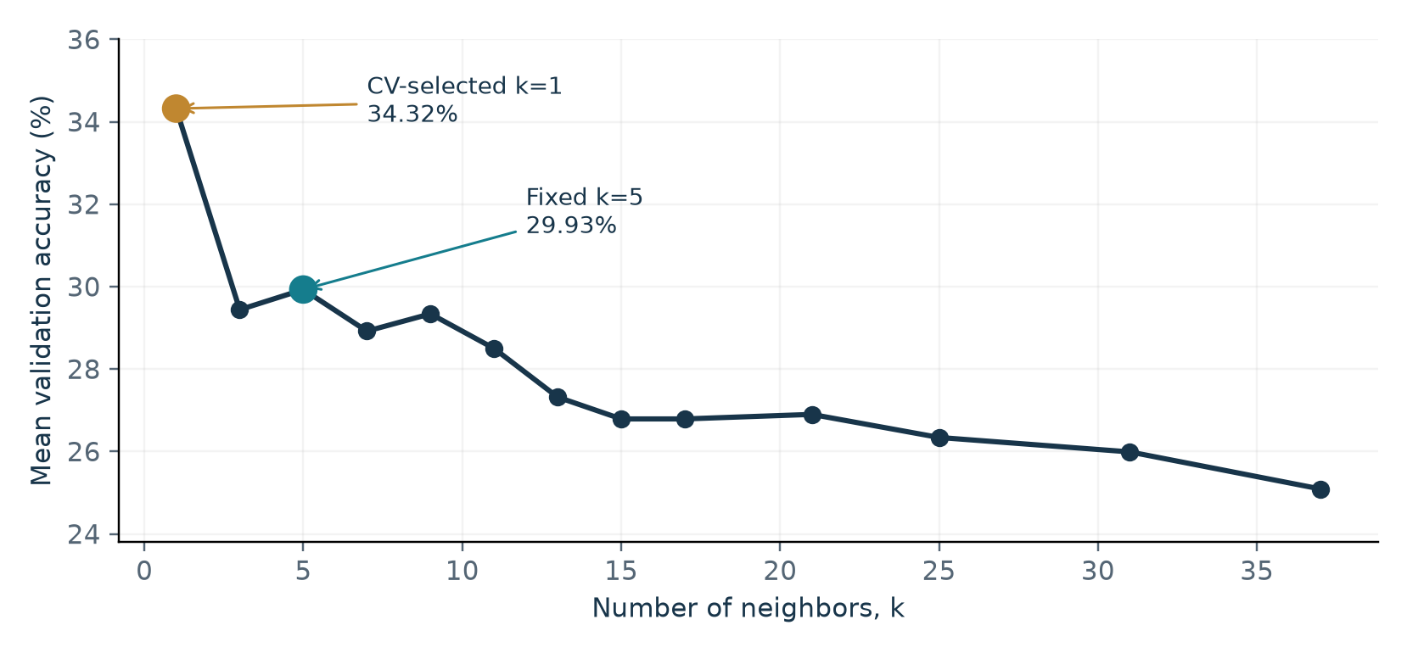
Figure 9. Recorded kNN candidate curve. Lines connect recorded means; fold-level standard deviations are unavailable and are not shown.
Table 9. Recorded kNN sweep mean accuracies
k | Mean CV accuracy | k | Mean CV accuracy | k | Mean CV accuracy
1 | 34.32% | 3 | 29.44% | 5 | 29.93%
7 | 28.92% | 9 | 29.34% | 11 | 28.50%
13 | 27.32% | 15 | 26.79% | 17 | 26.79%
21 | 26.90% | 25 | 26.34% | 31 | 25.99%
37 | 25.09% | — | — | — | —

8.3.1 Neighbor-selection criterion
The neighbor sweep uses uniform neighbor weighting and shuffled stratified cross-validation. The best mean accuracy defines a threshold equal to that mean minus its estimated standard error, calculated as the fold standard deviation divided by √folds. The smallest candidate k meeting the threshold is selected. The recorded choice is k=1; this is a threshold-based rule rather than a geometric elbow criterion.

8.3.2 Why the sweep and ensemble CV scores differ
The recorded sweep gives 34.32% for k=1 and 29.93% for k=5. The ensemble validation records instead give 31.92% and 30.87%, respectively. These are different validation paths: the sweep uses uniform neighbor weights and a representation selected before its CV, whereas the ensemble uses distance weights and refits ANOVA inside each model-weight fold. They should not be treated as duplicate estimates from an identical procedure.

8.4 Individual model validation and weights
The following table summarizes validation scores and normalized weights for the exploratory eight-class ensemble. The fixed k=5 constituent is described separately to preserve the distinction between two differently normalized ensemble configurations.
Table 10. Exploratory k=1 ensemble validation scores and recorded weights
Constituent | Mean CV accuracy | Ensemble weight
kNN, k=1 | 31.92% | 23.22%
Random forest | 27.70% | 18.18%
SVM | 24.29% | 14.10%
MLP | 20.52% | 8.60%
Gradient boosting | 20.17% | 8.18%
LDA | 19.16% | 7.97%
Logistic regression | 18.12% | 6.72%
Decision tree | 17.35% | 5.80%
AdaBoost | 15.47% | 3.55%
Gaussian Naive Bayes | 11.90% | 1.68%

The recorded k=1 weights sum to 100.00% after rounding. kNN, random forest, and SVM together account for 55.50% of the vote. Gaussian Naive Bayes lies only 1.40 percentage points above uniform chance in these CV records and receives a correspondingly small weight. The weighting rule favors classifiers that separate classes under the current validation procedure; it does not assess whether their errors are complementary.

Fixed-configuration validation records
For the fixed configuration, the kNN validation accuracy is 30.87%, and its ensemble weight is 22.25%. The complete fixed-configuration weight vector is unavailable in the retained record. The exploratory weights are therefore not combined with that entry, as doing so would mix independently normalized configurations.

Interpretation of validation scores
A constituent’s CV accuracy is neither its final held-out test accuracy nor the accuracy of the complete ensemble. The ensemble method derives weights from separate classifier accuracies, then evaluates only the aggregate model on the outer test set. Quantifying ensemble diversity, calibration, or the contribution of each member requires stored out-of-fold probabilities and controlled ablation experiments.

9. Limitations and threats to validity
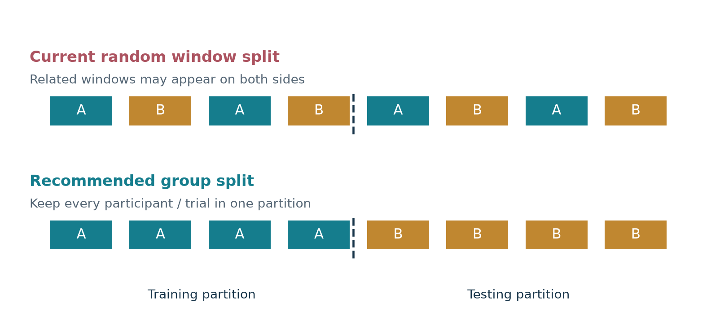
Figure 10. Conceptual comparison of random-window and grouped evaluation. A and B denote recording groups; a valid grouped protocol requires verified participant or trial identities.
Table 11. Major validity threats and their consequences
Threat | Methodological condition | Consequence
Dependent windows | Paper describes one-second windows with 48-sample overlap | Random splits may reward shared recording content.
Unknown groups | No verified participant/trial grouping is used in the outer split | No verified trial- or person-independent estimate.
Label provenance | Semantic-label assignment requires authoritative verification | Semantic class comparisons remain unresolved.
Inner CV preprocessing | Global outer-training scaler; preselected features in k sweep | CV selection and model weights may be optimistic.
Descriptor semantics | Hjorth misassignment and custom RQA definitions | Feature interpretation and paper reproduction are limited.
Incomplete run artifacts | No dataset, predictions, full production weights, or trained models | Recorded metrics cannot be independently checked.
Single evaluation / no timing | One recorded seed/split; no latency or calibration records | Uncertainty and real-time usability are unmeasured.

10. Recommended research and engineering plan

10.1 Establish trustworthy data and descriptors
Obtain the original release metadata, verify the mapping of every class folder, and identify participant, session, and trial membership for each window. Record a dataset manifest containing file hashes, labels, channel order, sampling rate, and units. Correct the Hjorth and RQA calculations against authoritative definitions, document any intentional alternatives, and log undefined feature values. Recompute features into a versioned cache after any descriptor change. These steps improve interpretability before further tuning.

10.2 Make validation match the scientific question
For an intended new-user system, use participant-disjoint outer folds; for within-user session transfer, hold out sessions; for independent-trial recognition, hold out trials. Fit the complete preprocessing and classifier pipeline inside each inner fold. Select k, feature count, hyperparameters, probability calibration, and ensemble weights using only inner-training data. Evaluate the finalized procedure once per outer fold and retain the out-of-fold probabilities and group identifiers [4].

10.3 Compare models through controlled experiments
Future comparisons should include uniform, majority-class, and simple single-model baselines. Under identical outer splits, evaluate raw-only versus multiband representations, validated feature families, alternative feature-selection strategies, single estimators versus soft voting, and equal versus learned model weights. Report macro F1, per-class recall, complete confusion matrices, and group-level uncertainty. Paired group-level comparisons are appropriate when observations within a recording are dependent.
Table 12. Suggested milestones and completion evidence
Milestone | Evidence needed before claiming completion
Data provenance | Verified labels and group IDs; manifest and release hash
Feature verification | Reference calculations on known inputs; replacement log; cache schema
Independent validation | Reproducible grouped/nested folds and saved predictions
Model comparison | Controlled ablations and repeated group-level metric summaries
Runtime study | Measured feature/inference latency, causal preprocessing, session robustness

A later real-time prototype would need signal-quality monitoring, a causal or buffered filtering design, word-onset handling, an uncertainty/rejection mechanism, and user-centered error analysis. These are proposed evaluation activities; none is presented as an implemented project capability.

11. Conclusion
The study presents an offline framework for eight-class imagined-speech EEG classification using multiband filtering, engineered descriptors, dimensionality reduction, and a heterogeneous probabilistic ensemble. Fourteen electrodes provide an initial 2,996-coordinate representation, which is reduced to at most 512 coordinates before classification.
The fixed k=5 ensemble achieved a recorded accuracy of 30.08% and macro F1 of 29.98% on a random window-level test split. The exploratory k=1 ensemble achieved 37.74% accuracy and 37.80% macro F1. The fixed configuration exceeded the eight-class hard-voting baseline by 2.78 percentage points and uniform chance by 17.58 points. These values summarize previously recorded experiments rather than new training runs.
The principal limits are incomplete semantic-label provenance, unavailable grouping information, preprocessing outside some inner-validation boundaries, and estimator limitations in short-window feature generation. The available results establish an offline baseline under the stated random-window protocol. They do not establish participant-independent performance or real-time usability.
Further work should prioritize verified labels and grouping metadata, validated descriptor definitions, and complete preprocessing within each validation fold. Repeated independent-group evaluation is required before improvements can be interpreted as stronger evidence of generalization.

References
[1] E. Lara-Arellano, A. Takacs, S. Tovar-Arriaga, and J. Rodríguez-Reséndiz, “Feature Generation with Genetic Algorithms for Imagined Speech Electroencephalogram Signal Classification,” Eng, vol. 6, no. 4, article 75, 2025. DOI: 10.3390/eng6040075. https://doi.org/10.3390/eng6040075
[2] E. Lara, A. Takacs, and J. Rodríguez, “EEGIS – Electroencephalogram Imagined Speech dataset,” Mendeley Data, version 1, 2024. DOI: 10.17632/73g4fw884c.1. https://data.mendeley.com/datasets/73g4fw884c/1
[3] AntroPy maintainers, “Hjorth parameters,” official method and API documentation. Accessed 10 November 2026. https://raphaelvallat.com/antropy/api.html
[4] scikit-learn developers, “Common pitfalls and recommended practices,” official documentation. Accessed 10 November 2026. https://scikit-learn.org/stable/common_pitfalls.html

Illustration attribution
Figure 1 reproduces the acquisition hardware and electrode-layout panels from Figure 3 of reference [1], under the Creative Commons Attribution 4.0 license: https://creativecommons.org/licenses/by/4.0/. Other illustrations present the eight-class methodology or retained experimental values.

Appendix A. Feature representation
The descriptor order below uses one-based indexing. Every filtered layer contains 36 slots; the raw layer retains slots 1–34. The five filtered layers follow the raw layer in the order delta, theta, alpha, beta, and gamma.
Table 13. Descriptor order within a full channel/layer vector
Slots | Declared feature names
1–6 | mean; std; coefficient_variation; median; mode; max
7–12 | min; q1; q3; iqr; kurtosis; skewness
13–18 | dfa; hjorth_activity; hjorth_mobility; hjorth_complexity; permutation_entropy; approximate_entropy
19–24 | spectral_entropy; higuchi_fd; total_psd; centroid_psd; determinism; trapping_time
25–30 | diagonal_line_entropy; average_diagonal_line_length; recurrence_rate; sef25; sef50; sef75
31–36 | hurst_exponent; svd_entropy; petrosian_fd; katz_fd; relative_band_power; band_amplitude

Table 14. Offsets in the 214-slot channel feature map
Layer | One-based output slots | Number retained
Raw | 1–34 | 34
Delta | 35–70 | 36
Theta | 71–106 | 36
Alpha | 107–142 | 36
Beta | 143–178 | 36
Gamma | 179–214 | 36

The feature map is flattened in channel-major order: one channel’s 214 descriptors precede those of the next channel. ANOVA selection ranks individual channel–descriptor coordinates, so selected features may differ across electrodes. The retained representation has 512 coordinates when enough nonconstant features are available.

