בֶַּקַע

beka (half a shekel)

**Contents:**

Introduction

1. Root and Comparative Material
2. Formal Characteristics
3. Syntagmatics
4. Ancient Versions
5. Lexical/Semantic Fields
6. Exegesis
   1. Literal Use
   2. Figurative Use
   3. Pictorial Material
   4. Archaeology
7. Conclusions

Notes

Bibliography/Abbreviations

# Introduction

Grammatical type: n.m.

Occurrences: 2× HB (2/0/0); 0× Sir.; 0× Qum.; 35× Inscr. (Total: 37).

Torah: 2: Gen 24:22; Exod 38:26.

Inscriptions: Ashdod; Beth-Zur; Ekron; Gezer; Jerusalem (2×); Kh. el-Kom; Kh. Uza; Lachish (3×); Nahal Elteke; Ramat Rahel; Ras Salāh; Shueifat; unknown provenance (22×).1

Text doubtful: —

**A.1** Many weights inscribed with the word בקעhave been found;2 whereas one weight was found with only the בand one with probably the letters קע(letters not clear on the photograph).3 See furthermore section 6.4. Archaeology.

# Root and Comparative Material

**A.1** The word בֶַּקַעis derived from בקע, ‘to cleave’, ‘to split’,4 which has, next to בֶַּקַע, a few derivatives: *בְּקִיַעַ, ‘breach’, ‘rubble’, and בִּקְָעָה, ‘valley’. The latter word is applied in a number of locative or topographical names: בִּקְעַת אֶָוֶן(Amos 1:5);

(Deut 34:3), etc. בִּקְעַת יְֵרֵחבֿ

**A.2** The noun בֶַּקַעis not attested in the cognate languages.5 However, the root בקע is attested in, for example, Ug. *bq*ʿ, ‘to split, open’,6 Moab. *bq*ʿ, ‘to break through (of dawn)’,7 LMHebr. בקע, ‘to split, chop’.8

בֶַּקַע**A.3** The BHebr. word, ‘weight, coin’, is used in a quotation from Exod 38:26 9in the midrashim, such as Bereshit Rabba (84:18):

אַוֶֹם מְכַרְוֶֹם בְּנָהּ שֶׁל רָחֵל בְּעֶשְִׂרִיםכֶָּסֶף, לְפִיכָךְ יִהְיֶה כָּל אֶחָד וְאֶחָד מַגִּיעבֿ בֶּקַע לַגֻּלְגֶֹּלֶת, הֲדָא הוּא דִכְִתִיב (שמות לח, כו): בֶּקַע לַגֻּלְגֶֹּלֶת .מַחֲצִית הַשֶֶּׁקֶל,

‘You sold Rachel’s son for twenty pieces of silver, therefore shall each of you bring a *beka* a head; thus it is written (Exod 38:26): *A beka a head, half a shekel*.’10

# Formal Characteristics

**A.1**  בֶַּקַעis a *qatl* formation – the most common formation of nouns (almost a quarter of all nouns)11 – of the root tertiae gutturalis √בקע.12

# Syntagmatics

**A.1** In the Hebrew Bible בֶַּקַעoccurs twice in singular absolute, whereas no other forms are attested. In epigraphical sources the word is solely applied as the designation of the weight on which it was inscribed.

**A.2**  בֶַּקַעoccurs in a nominal clause: בֶּקַע מִשְָׁקָלבֿ, ‘a *beka* is its weight’, Gen 24:22;

וְכֶסֶף צְּקוּדֵי הָעֵָדָה … בֶּקַע לַגֻּלְגֶֹּלֶת, ‘the silver of the counted ones of the congregation was

… a *beka* per head’, Exod 38:25–26.13

**A.3**  בֶַּקַעoccurs in apposition: בֶַּקַע … מַחֲצִית הַשֶֶּׁקֶל, ‘a *beka* … half a shekel’, Exod 38:26.14

# Ancient Versions

**a.** Septuagint (LXX) and other Greek versions:

δραχμὴ, ‘drachm (a weight)’:15 Gen 24:22lxx; Exod 39:3lxx (38:26mt); δίδραχμον, ‘coin of two drachmas, half shekel’:16 Exod 39:3αʹ (38:26mt).

**b.** Targumin (T):

דַּרְְכְּמבֿן, ‘drachma’:17 Gen 24:22 (TPsJ); Exod 38:26 (TPsJ).

טבי, ‘half-shekel’:18 Gen 24:22 (TSmr); Exod 38:26 (TSmr).

טֶַבַע, ‘coin’:19 Gen 24:22 (TN); Exod 38:26 (TN).

וִֹקְָלָא, ‘shekel’:20 Gen 24:22 (TO); Exod 38:26 (TO).

**c.** Peshitta (S):

¾Ćàøÿâ (*maṯqālā*), ‘weight, scale, shekel’:21 Gen 24:22; Exod 38:26.

בֶַּקַעbeka (half a shekel) 3

**d.** Vulgate (V)

*siclos duos*, ‘two shekel’:22 Gen 24:22. No equivalent: Exod 38:26.23

# Lexical/Semantic Fields

**A.1**  בֶַּקַעoccurs in the context of the description of the weight of gold (זָָהָב, Gen 24:22) and silver (כֶֶּסֶף, Exod 38:25–26). Another weight mentioned in its direct context is the shekel (→ שֶֶׁקֶל). The *beka* is even equated with a half shekel in Exod 38:26. This use seems to agree with the custom of expressing the worth of precious goods in terms of weight, whereas an amount of food was described on the basis of its size or volume.24

# Exegesis

*6.1 Literal Use*

**A.1** The word בֶַּקַעhas the basic meaning ‘split off’, ‘piece’, ‘part’,25 and in Exod 38:26 it is a ‘part’ (from two parts) of a shekel.26

**A.2** The designation בֶַּקַעis mentioned as a weight in Gen 24:22: Abraham’s servant gives rich gifts to Rebeccah. He takes (לקח) a golden ring (נֶזֶם זָָהָב), whose weight (מִשְָׁקָל) is a בֶַּקַע, as well as two bracelets, which have ten golden shekels (עֲשָׂרָה זָָהָב; cf. → שֶֶׁקֶל) as their weight. The use of*beka* weighs only a portion of a shekel. בֶַּקַעfor a ring, next to ‘ten shekels’ for bracelets, suggests that a a beka weighs only a portion of a shekel.

**A.3** In Exod 38:26 a בֶַּקַעis mentioned in the context of the mention of silver (כֶֶּסֶף, Exod 38:25) belonging to the processed materials (Exod 38:24-31) in the manufacture of the tabernacle and was gathered in a census. This is referred to as a בֶַּקַעin silver a head for every one who was numbered in the census from the age of twenty years old and upwards. A בֶַּקַעis further referred to in 38:26 as half a shekel (מַ חֲִצִיתהַשֶֶּׁקֶל, ‘half of a shekel’) ‘by the sanctuary shekel’ (שֶֶׁקֶל → ,בְּשֶׁקֶל הַרֶֹּדֶֹשׁ).

*6.2 Figurative Use* Not attested.

*6.3 Pictorial Material*

**A.1** Some pictures or drawings of *beka* weights have been published in the literature on the subject.27 Two of these are presented below (figs. 1 and 2), of which the round, stone weight is the most usual exemplar of this weight.

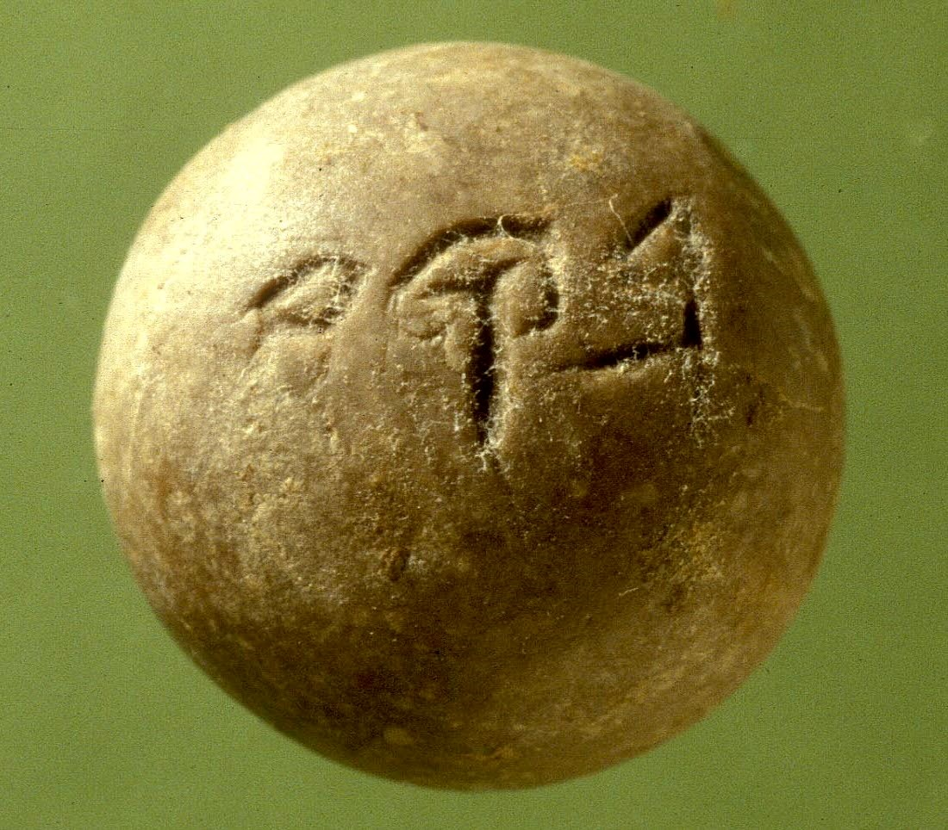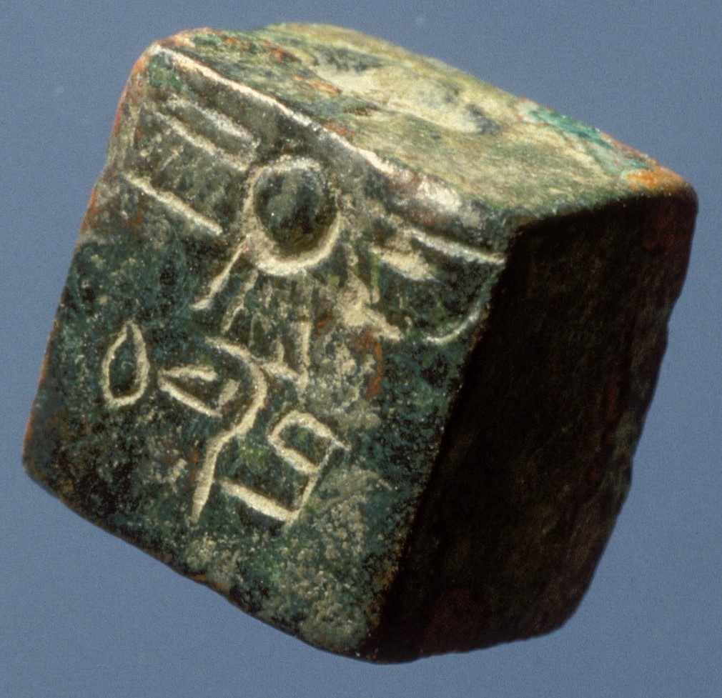

Figure 1: Stone beka-weight28 Figure 2: Metal beka-weight29

**A.2** A First Temple period *beka* weight was discovered during the sifting project of archaeological soil originating from the Western Wall foundations in the Emek Tzurim National Park under auspices of the City of David Foundation. The finding is interesting, because the weight was inscribed in mirror script (see Fig.1, below), which suggests that the craftsman was used to create seals and to write in mirror

script.30

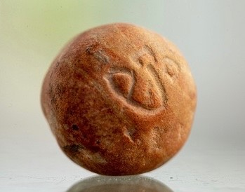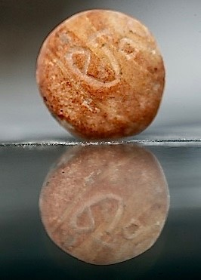

Figure 3: *Beka* weight

inscribed in mirror script.31

*6.4 Archaeology*

**A.1** Kletter mentions thirty-five weights designated with the letters ק ,ב, and ע(or two or one of these letters) as a בֶַּקַע.32 Their provenance is, as far as it is known, for the most part in Judah, they date from the late 8th century BCE, and later centuries and vary according to its calculation in weight from 5.51 to about 6.90 grams, with an average of 6,003 grams.33 These weights, all homogeneous in shape, are as a rule made of stone as all weights were,34 although a metal weight is found as well.35 It is also possible to point out a number of uninscribed *beka* weights (6.0-6.6 grams, mostly of stone), of which it is difficult to say whether they date from the same or an earlier period.36

בֶַּקַעbeka (half a shekel) 5

# Conclusion

**A.1** The בֶַּקַע, ’half shekel’, is part of a weight system that is based on the שֶֶׁקֶל. The fact that the found *beka* weights vary in weight is attributed to the existence of more than one weight standard.37 However, it can also be explained by factors such as mistakes in the manufacture of the weights, inability to accurately weigh, wear and tamper.38 Since the found *beka* weights originate from the same time and, as far as is known, come largely from the same area (Judaea) and are largely homogeneous in terms of material and shape, it is probable that these weights are of the same weight standard.39 It is therefore very likely that the same weight standard is to be applied to the בֶַּקַעof Gen 24:22 and the one of Exod 38:26. It is true that for the בֶַּקַעof Exod 38:26, unlike that of Gen 24:22, the standard of the ‘sanctuary shekel’ applies. But the question is whether this is a standard set by the sanctuary that would deviate from that which is used in the normal use of the shekel (see → שֶֶׁקֶל).

# Notes

1. ↑ See esp. Kletter 1998: 211–17 and 243, with references to the sources and earlier literature.
2. ↑ Cf. Diringer 1934: 277–80; Tav. XXIII, 14–17; Moscatti 1951: 103; Tav. XXIV, 9–10; Shany1967: 54–55; pl. XI; Kletter 1998: 211–17, 243; Heltzer 1998: 44*–46*.
3. ↑ See Kletter 1998: 213, #6; 214, #10, respectively.
4. ↑ KBL, 144: ‘Teil, Stück *part, piece*’; Zorell, 124; *HAL*, 144; *HALOT*, 150; Ges18, 169.
5. ↑ Cf. *HAL*, 144; Ges18, 169; *DNWSI*, 187.
6. ↑ *WUS*, 57, #567; *DULAT*1, 234.
7. ↑ *KAI*, 176, #181.
8. ↑ Jastrow, *DTT*, 186.
9. ↑ Jastrow, *DTT*, 186.
10. ↑ For a somewhat different rendering, cf. Freedman 1939, 783.
11. ↑ BL, 455, §61.i′.
12. ↑ BL, 456, §61.k′γ.
13. ↑ *DCH*, vol.2, 249.
14. ↑ *DCH*, vol.2, 249.
15. ↑ LEH1, vol.I, 121; LEH3, 161; *GELS*, 178.
16. ↑ LEH3, 151.
17. ↑ Levy,Jastrow,*CWTDTT*, vol.I, 188: ‘, 324: ‘(late b.h.) =*Dareicos*, eine persische Goldmünze = einem gemeinen Shekel’; דְַּרְכּבֿן(= *Daric*, *ad loc.*); Dalman, *ANHT*, 105: ‘(δραχή)

Drachme’; Sokoloff, *DJPA*, 156.

1. ↑ Tal, *DSA*, 302 s.v. טבע.
2. ↑ Levy,*DTT*, 519: ‘*CWT*, vol.I, 294: ‘1.*Teb*ʿ*a*, a coin equal to half a Sela’. Dalman,*geprägte Münze*, …bes. die Hälfte eines heiligen Sekel’. Jastrow,*ANHT*, 166: ‘1. Münze; 2. eine bestimmte Münze (ein halber Sela)’.
3. ↑ Levy,oder Sela = Dareikon, ungef. 13 Sgr. nach unserm Gelde’. Jastrow,*CWT*, vol.II, 551, ‘*Siclus*, u.zw. der gemeine Sekel = der Hälfte eines heiligen Sekels*DTT*, 1691: ‘*weight*, esp.

(*half a*) *Shekel*’. Dalman, *ANHT*, 447: ‘II. Sekel (Gewicht u. Münze)”.

1. ↑ Payne Smith, *CSD*, 321: ‘b. …*a shekel*, said to equal a drachma’.
2. ↑ *LD*, 1693: ‘a shekel’.
3. ↑ The whole phrase of MT in Exod 38:26, in which the wordin V. בֶַּקַעis applied, has no equivalent
4. ↑ De Vaux, *IAT*, vol.I, 309.
5. ↑ 144Gesenius,; *HALOTTPC*, 150; Gesvol.1, 232; BDB, 132; KBL, 144: ‘Teil, Stück18, 169. *part, piece*’; Zorell, 124; *HAL*,
6. ↑ Gesenius,*HAWAT*, 46: ‘1/2 Šeqel: ca. acht Gramm’; BDB, 132: ‘fraction, half, i.e. half-shekel, a weight’;*TPC* vol.1, 232: ‘pars dimidia, a findendo dicta (...), nonnisi spec. dimidius siclus’;

*GB*, 111: ‘halber Sekel’; Zorell, 124: ‘… sec. Ex 38 26 dimidia pars sicli sacri (= 8,18 gr. nostri ponderis…)’; *HAL*, 144: ‘e. Gewicht als Metallwert 1/2 שֶֶׁקֶל; Halbschekel’. *DCH*, vol.2, 249: ‘half a shekel’. Ges18, 169: ‘GBdtg Abgespaltenes, bzw. Teil, i. 𝔐 Beka, Halbschekel 1. Gewicht (...) = ca. 6 g. m. lok. Abweichungen’.

1. ↑ Diringer 1934: Tav. XXIII, ##14–17; Diringer 1958: 231, pl. 13; Moscatti 1951: Tav. XXIV,##9–10; Scott 1959: 36, fig. 7, ##4–6; Strobel 1964: 1166, Abb. 3, #3; Kletter 1998: 218,

Fig.36; Stern 2001: 196, Fig. I.85.

1. ↑ Photograph: Zev Radovan; courtesy of the Israel Museum, Jerusalem.
2. ↑ Photograph: Zev Radovan; private collection.
3. ↑ Cf. Borschel-Dan 2018.
4. ↑ Photograph: Eliyahu Yanai; Courtesy of the City of David Archive.
5. ↑ Kletter 1998: 17, 43, 60, 76, 78–80, 52–53, 211–17, 243.
6. ↑ Cf. Barrois 1953: 255; Diringer 1958: 228; Scott 1959: 35; De Vaux,1998: 211–17, 243; Kletter 2009: 834–35; Röllig 2003: 435–36; Bashan 2007: 706; Cf. also*IAT*, vol.I, 311; Kletter

Powell 1992: 907.

Heltzer 1998: 44*-46*, argues for 6.82gr as the weight of a Judaean half-shekel, whereas most studies assume the average weight in line with Kletter’s observations. In this respect the comment by Marvin Powell (Powell 1992: 905) should be kept inmind: ‘Most surviving weight specimens are small and deviation from a given norm increases as the size of the weight decreases.’ Similarly Weippert 1977: 93.

1. ↑ Cf. the reference to weights as ‘stones’ (Sam 14:26; Mic 6:11; cf. *HALOT*, 8; Barrois 1953: 252; De Vaux,אֶֶבֶן), comparable to Akk. and Ug.; e.g. Lev 19:36;*IAT*, vol.I, 309; Weippert2

1977: 93; Powell 1992: 905; Bashan 2007: 703.

1. ↑ Shany 1967: 54–55; Kletter 1998: 216, #20. Other (larger) weights were also cast, see Bashan2007: 703; for some illustrations of cast weights, see *ANEP*, 36, ##118–21; 341, #777.
2. ↑ Kletter 1998: 132–37, 143, 254.
3. ↑ Diringer 1958: 228.
4. ↑ Cf. Cook 1988: 1052, 1054; Kletter 1998: 71, 78, 140.

בֶַּקַעbeka (half a shekel) 7

1. ↑ Kletter 1998: 70–72.

# Bibliography

For the abbreviations applied [→List of Abbreviations](http://www.otw-site.eu/wp-content/uploads/2018/03/Abbreviations_KLY.pdf)

Barrois 1953

Augustin-Georges Barrois, *Manuel d’archéologie biblique*, 2vols., Paris: Éditions Auguste Picard, 1939–53, vol.2, 254–57.

Bashan 2007

Eliezer Bashan (Sternberg), ‘Weights and Measures: Metrological Systems in the Bible and the Ancient Near East’, *Encyclopaedia Judaica*, vol.20, Jerusalem: Keter Publishing House, 22007, 700–06.

Borschel-Dan 2018

Amanda Borschel-Dan, ‘Tiny First Temple stone weight unearthed in Jerusalem’, *Times of Israel*, 21 November 2018 ([→Borschel-Dan 2018](https://www.timesofisrael.com/straight-from-the-bible-tiny-first-temple-stone-weight-unearthed-in-jerusalem/)).

Cook 1988

Edward M. Cook, ‘Weights and Measures,’ *ISBE*, vol.4, 1046–55, spec. 1053–54. Dever 1985

William G. Dever, ‘Weights and Measures,’ *Harper’s Bible Dictionary* (ed. Paul J. Achtemeier), San Francisco: Harper & Row, 1985, 1126–31.

Dijkstra & Vriezen 2010

Meindert Dijkstra & Karel J.H. Vriezen, ‘Gewichten,’ *Bijbelse Encyclopedie* (ed. Hendrikus C. Endedijk & Sjoerd D. Heij), Utrecht: Kok, 102010, 286-87.

Diringer 1934

David Diringer, *Le iscrizioni antico-ebraiche palestinesi*, Firenze: F. Le Monnier, 1934

Diringer 1958

David Diringer, ‘Weights,’ in: *Documents from Old Testament Times* (ed. D.Winton Thomas), New York: T. Nelson, 1958, 227–232.

Freedman 1939

Harry Freedman, *Midrash Rabbah: Genesis, vol.II; Translated into English with Notes, Glossary and Indices*, London: Soncino Press, 1939.

Heltzer 1998

Michael Heltzer, ‘An Inscribed Weight in the Reuben and Edit Hecht Museum’, *Michmanim* 12 (1998), 44*–46*.

Kletter 1998

Raz Kletter, *Economic Keystones: The Weight System of the Kingdom of Judah* (JSOTSup, 276), Sheffield: Sheffield Academic Press, 1998.

Kletter 2009

Raz Kletter, ‘Weights and Measures,’ *NIDB*, vol.5, 831–41.

Moscati 1951

Sabatino Moscati, *L’Epigrafia Ebraica Antica, 1935-1950* (Biblica et Orientalia, 15), Roma: Pontificio Istituto Biblico, 1951.

Powell 1992

Marvin A. Powell, ‘Weights and Measures’, *ABD*, vol.6, 897-908.

Röllig 2003

Wolfgang Röllig, ‘Althebräische Schriftsiegel und Gewichte’, *HAE*, vol.II/2, 81– 456.

Shany 1967

Eythan Shany, ‘A New Unpublished ‘Beqʿa’ Weight in the Collection of the Pontifical Biblical Institute, Jerusalem, Israel’, *PEQ* 99 (1967), 54–55; pl. XI.

Scott 1959

Robert B.Y. Scott, ‘Weights and Measures of The Bible’, *BA* 22 (1959), 22–40.

Sellers 1962

Ovid R. Sellers, ‘Weights and Measures’, *IDB*, vol.IV, 828–39.

Stern 1976

Ephraim Stern, ‘Weights and Measures’, *Encyclopaedia Judaica*, vol.16, Jerusalem: Keter Publishing House, 1971–76, 376–92, spec. 383, 386–87.

Stern 2001

Ephraim Stern, *Archaeology of the Land of the Bible, Volume II: The Assyrian, Babylonian and Persian Periods 732–332 BCE* (ABRL), New York: Doubleday, 2001.

Strobel 1964

August Strobel, ‘Maße und Gewichte’, *BHH*, vol.II, 1159–69. Trinquet 1957

Joseph Trinquet, ‘Métrologie biblique *DB.S*, vol.V, 1212–50.

Weippert 1977

Helga Weippert, ‘Gewicht’, *BRL*2, 93–94.

Raymond de Hoop & Bertus van ’t Veld

First published: 8th February 2021

This article should be cited as:

Raymond de Hoop & Bertus van ’t Veld, ‘בֶַּקַע, beka (half a sheqel)’, pdf downloaded from: <http://www.otw-site.eu/en/kli-database/>