Requirements and Analysis
for the
Kelde, wrath of Rasgazul
Project (RAD)

Version: 1.0.1
Date: 2015-05-31
Author: Philip Tibom
Anders Bolin
Hussien Hossien
Daniel Olsson

This version overrides all previous versions.

1 Introduction

This section gives a brief overview of the project.

1

  - Purpose of application

The project aim is to create a computer based version of Zelda game that
was released for Nintendo Entertainment System. This version will have
more of an influence from the middle east then the orginal game. For
defenition, terms and rules of the game see references.

  - General characteristics of application

This will be a desktop, standalone (non networked), single player application
with a graphical interface for the Windows/Linux/Mac platforms.
The player will be able to interat with a generated world in a quest to find
what has happend to his town. In this quest he will encounter monsters and
other problems to solve during gameplay, this will be done by interaction with
figures in the world.

  - Scope of application

The application does include some simple computer AI used by enemies
inside the game world. The game is one player game and the game state
will be able to be saved by the player.

1.4 Objectives and success criteria of the project

The game should be able to generate the world and the player should be able to explore this world and interact with caracters and defeat enemies that would attack.

1.5 Definitions, acronyms and abbreviations

- GUI, Graphical User Interface

2

2 Requirements

2.1 Functional requirements

- Player should be able to start game from menu.

- Kill monsters and in doing so gain attributes to level up.

- Walk around the game map and interact with caracter.

- Open treasure chest and find loot.

- Gain objects by findong loot.

2.2 Non-functional requirements

NA (not applicable).

2.2.1 Usability

The usability of the game is of a high priority, the game should be
easy to start and play. Gameplay is placed first and quality of graphics
is placed lower on the list. Since gameplay is important we will run
tests with atleast 10 persons and the result will be presented in the
final documentation. A player will be able to play this game in English
language.

2.2.2 Reliability

NA

2.2.3 Performance

The game will be very responsive and no action should take more
then a few ms depending on the system load.

3

2.2.4 Supportability

The game will be implemented in a way that teh GUI should be modifiable
to other platforms(Android,Mobile Apps, iPad, iOS) in a few weeks time.

The implementation should prepare for the dividing of the application into
a client/server-architecture for net based games. It should be easy to partitioning
the application into a client/server architecture. A time estimation for this
should be included.

There should be automated test verifying all the use cases. Code related
to the GUI can be tested manually. GUI tests will be included in the
final documentation.

2.2.5 Implementation

To achive platform independence the appliction will use the Java enviroment
All host need JRE installed and configured. The application needs to be
installed on all host where it will run.

2.2.6 Packaging and installation

The Game will be delivered as an zip archive containing:

- A file for the application

- All needed resources

- A read me file containing how to install the game and how to play.

2.2.7 Legal

There are legal issues regarding the similarity to the game Zelda NES
but this is not covered here. Graphics and Soundfx is opensource, info
included in the project files.

2.3 Application models

2.3.1 Use case model

UML and a list of UC names (text for all in appendix)

2.3.2 Use cases priority

- Start button
- Load button
- Exit button
- Move
- Attacked by Bat
- Attacked by Eye
- Attacked by Ghost
- Open treasure
- Pickup loot
- Slash with sword
- Shoot arrow

2.3.3 Domain model

UML, possible some text.

2.3.4 User interface

GUI will be a fixed size non-themed GUI following the code conventions
The GUI will take in account different screensizes, smallest possible will
be 400 * 600. See apendix for image.

2.4 References

NA

APPENDIX

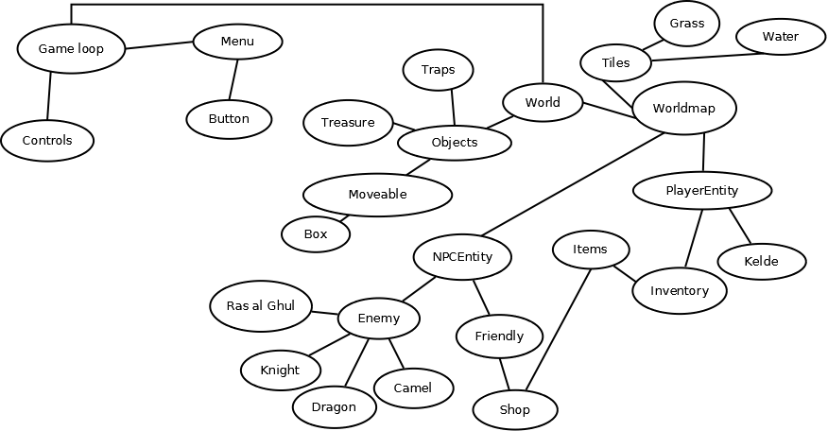

GUI

Domain model

Use case texts

