SalesAI — Outreach Platform — Project Documentation

1. Project Overview
SalesAI is an AI-powered sales outreach CRM platform built by Vedanco. It enables sales teams to manage leads, automate multi-channel outreach (Email, LinkedIn, WhatsApp), track deals, schedule meetings, and leverage Google Gemini AI for intelligent message drafting and lead intent analysis.
Attribute | Detail
Project Name | salesai---outreach-platform
Version | 0.0.0 (Early development)
Module System | ESM ('type': 'module')
Pricing Tiers | Starter ($49/mo), Pro ($149/mo), Business ($399/mo)

2. Technology Stack
Layer | Technology
Frontend | React 19, TypeScript, Vite 6
UI Icons | Lucide React
Backend | Express 5 (Node.js)
Database / Auth | Supabase (PostgreSQL + Auth)
AI Engine | Google Gemini (gemini-3-flash-preview) via @google/genai
Build Tool | Vite with @vitejs/plugin-react
Authentication | Supabase Auth (Email/Password + OTP + Google OAuth + GitHub OAuth)

3. Project File Structure
salesai/
├── frontend/ # React SPA (Vite)
│ ├── App.tsx # Root component — routing, session, state
│ ├── auth/ # Auth logic
│ ├── components/ # Reusable UI components
│ ├── layouts/ # Page wrappers
│ └── pages/ # Application views (Auth, Dashboard, Public)
├── backend/ # Express standard API
│ ├── index.ts # Main server file
│ └── middleware/ # Auth middleware
├── database/ # Supabase backend clients
├── automation/ # Google Gemini AI services
├── config/ # Environment and constants
├── utils/ # TypeScript types, helpers, loggers
├── .env # Environment variables
└── package.json # Dependencies

4. Class Diagram
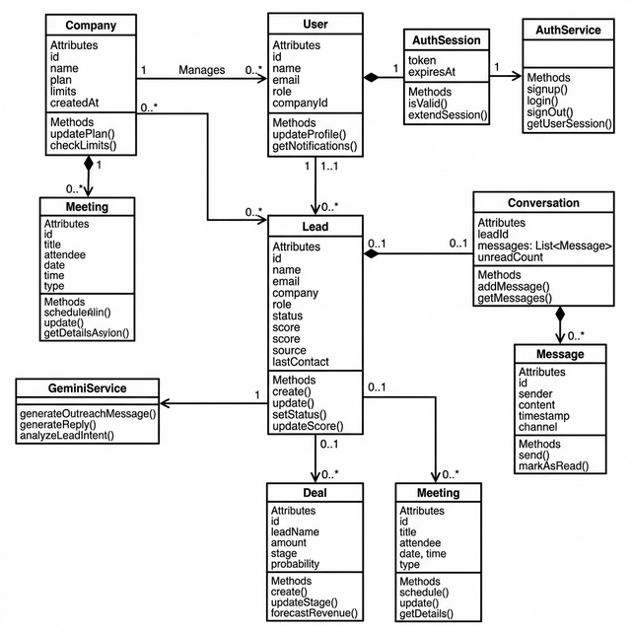

5. ER Diagram (Entity-Relationship)
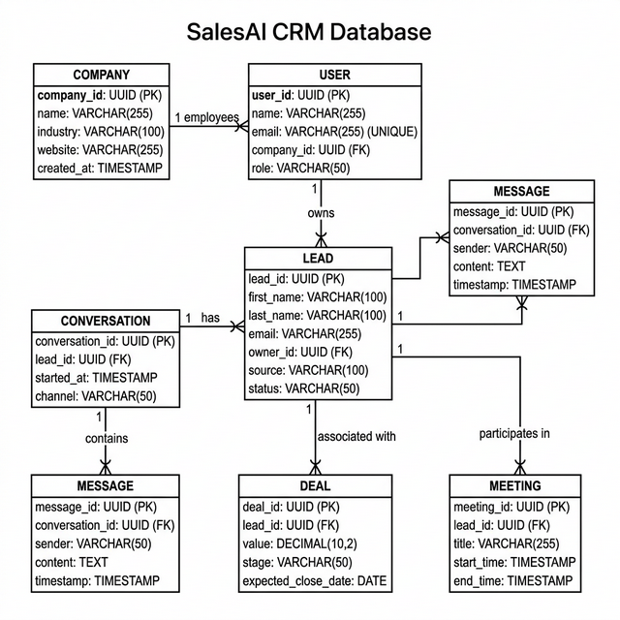

6. Activity Diagram (User Workflow)
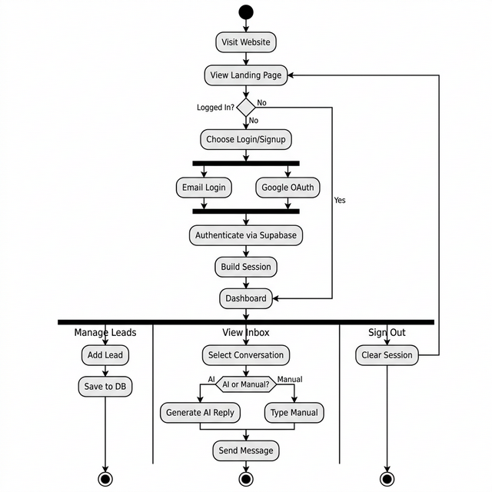

7. Architecture Summary
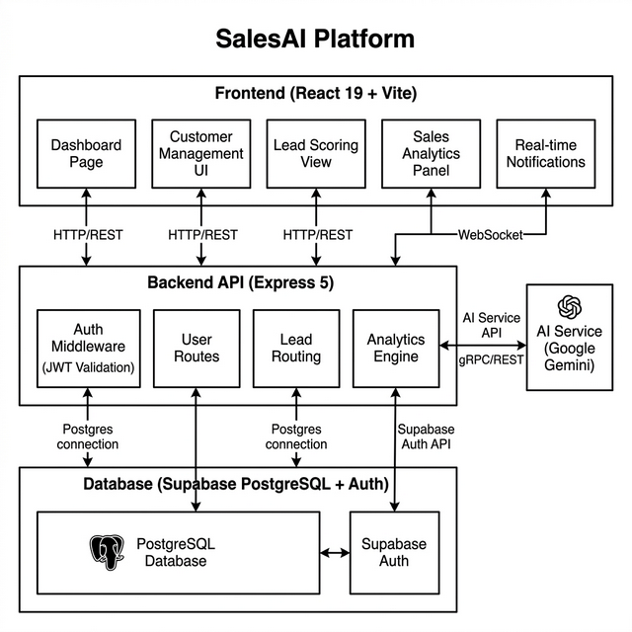

8. Key Component Descriptions
Component | File | Purpose
App | frontend/App.tsx | Root component; manages session state, view routing, mock data
AuthScreen | pages/Auth/AuthScreen.tsx | Login, Signup, OTP entry; calls authService
DashboardView | pages/Dashboard/DashboardView.tsx | Stat cards, recent leads, upcoming meetings
InboxView | pages/Dashboard/InboxView.tsx | Chat UI with AI-powered reply generation
GeminiService | automation/geminiService.ts | AI functions: outreach, reply drafting, intent classify

