Create a Community in Salesforce

**Use Case:-**

For the use case I have created a community using a classic template (Salesforce Tabs + Visualforce). In which I have cloned the[Customer Community Plus User](https://zakuda001-dev-ed.my.salesforce.com/00e0o000002nKKo) Profile and assigned the users directly from Login Page to it. I have selected 3 Tabs (Home, Account, Contact) from Administration in the community and allow the external users to self-register applied the sharing rule required to the community user.

**How to enable community in Salesforce?**

To enable community in Salesforce go to**setup -> Build -> Customize -> Communities**and click on**settings**and check **enable communities** check box and enter your **domain name**and**save**it.

**Note:** You cannot change your domain name once you save it. This domain name will be used in all of your communities.

See the below screen for reference.

[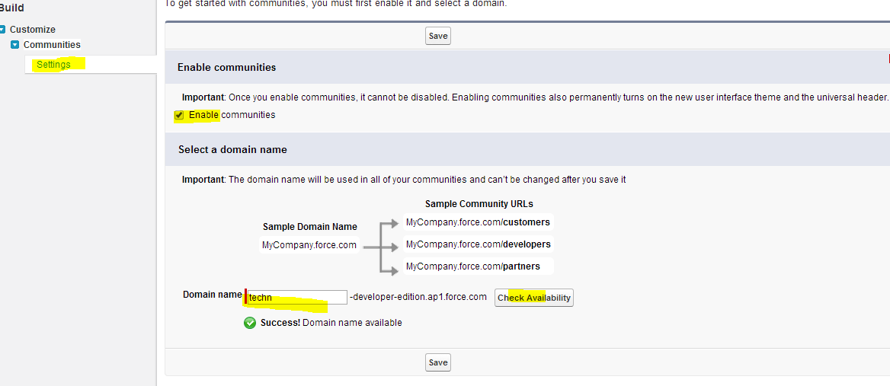](https://www.salesforcetutorial.com/wp-content/uploads/2014/06/Communities-1.png)

in the above screen Check availability button is used to check whether the domain entered by you is available or not.

Once communities is enabled new header will be enabled in your salesforce org, there you can swipe between multiple communities. See the below screen for reference.

[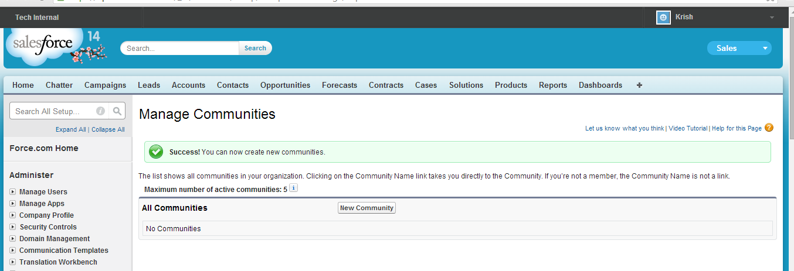](https://www.salesforcetutorial.com/wp-content/uploads/2014/06/Community-2.png)

Now communities are enabled. Further we will see how to create communities.

**How to create communities in salesforce?**

To create communities go to **setup -> Build -> Customize -> Communities -> Manage Communities** -> and click on **New communities** button. And enter **name, description** and **url** and click on **create** button.

> Select the Template for Community either lightning template or classic template.

> After creating the community click on the workspaces link on your communities Page to see your workspace of your community.

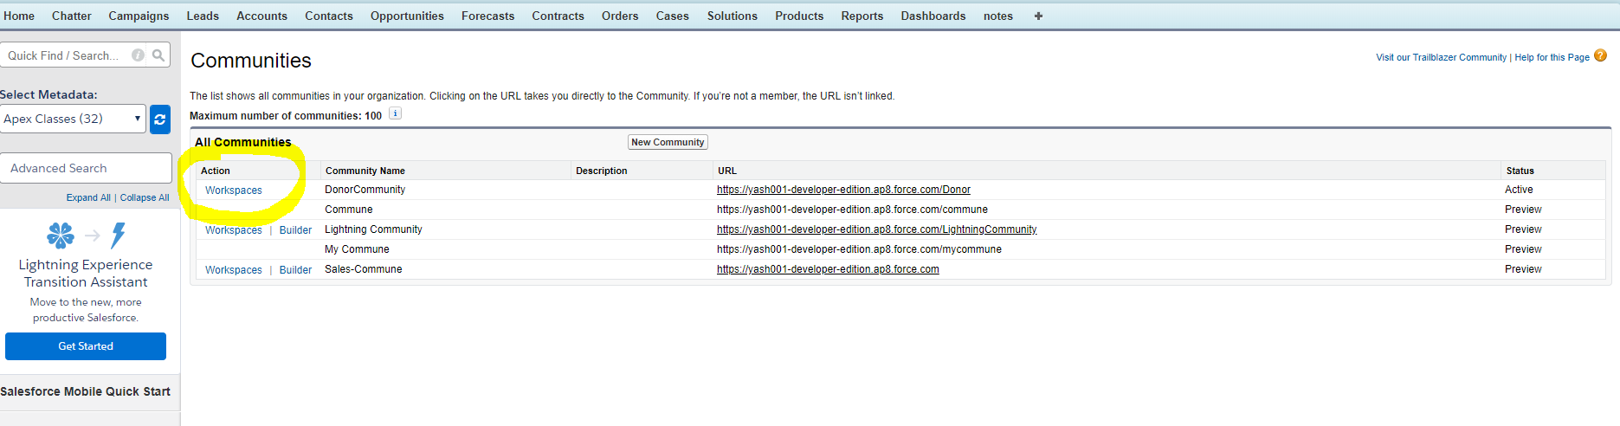

> Choose the part of the community you want to manage:

* Preview the community or access your community’s settings in the Community Builder, Lightning Platform, or Site.com Studio from Community Management or Community Workspaces.
* In **Engagement**, you can view Insights reports and take action on activity in your community.
* In **Dashboards**, you can view community dashboards and reports.
* In **Moderation**, you can set up moderation rules and monitor flagged feed items.
* In **Topics**, you can manage navigational and featured topics.
* In **Recommendations**, you can set up custom recommendations to appear in your community.
* In **Reputation**, you can set up reputation levels and points.
* In **Administration**, you can customize your community properties, such as name, description, URL, status, and template. You can also update your community settings, such as members, tabs, branding, login and registration, and emails.

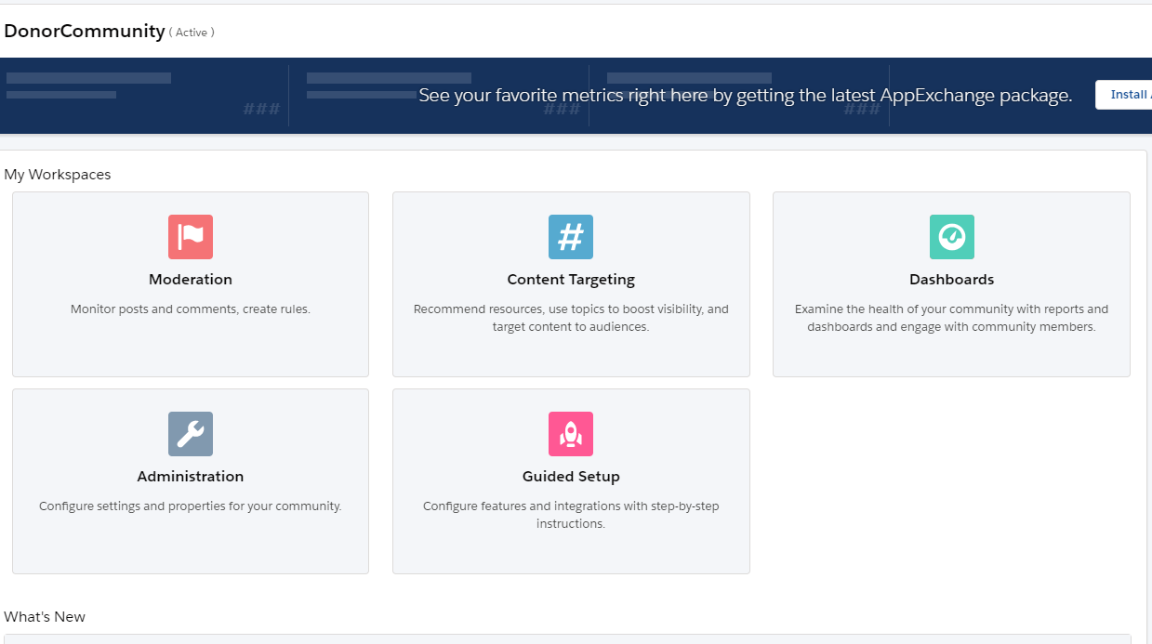

> Administration:

* Use the Administration page to update the community’s basic setup.
* [**Members**](https://help.salesforce.com/articleView?id=networks_customize_members.htm&type=5#networks_customize_members)—Add or remove members based on profiles or permission sets.
* [**Tabs**](https://help.salesforce.com/articleView?id=networks_customize_tabs.htm&type=5#networks_customize_tabs)— select the tabs you want community members to see. Tabs are also used to determine community navigation in the Salesforce app. If your community was created with one of the self-service templates, tab settings aren’t used.
* [**Branding**](https://help.salesforce.com/articleView?id=networks_customize_branding.htm&type=5#networks_customize_branding)— select a provided branding colour theme. This branding controls header and footer text for pages in your community. The branding settings apply if you’re using the default or the Salesforce tabs + Visualforce template.
* [**Login & Registration**](https://help.salesforce.com/articleView?id=networks_customize_login.htm&type=5#networks_customize_login)—Select the login page for this community, and set up self-registration.
* [**Emails**](https://help.salesforce.com/articleView?id=networks_customize_email.htm&type=5#networks_customize_email)—Customize email sender information, Chatter email branding, and templates in your community emails.
* [**Pages**](https://help.salesforce.com/articleView?id=networks_page_overrides.htm&type=5)—Configure page assignments for your community, and access the Lightning Platform and Site.com settings for this community.
* [**Preferences**](https://help.salesforce.com/articleView?id=networks_customize_miscellaneous.htm&type=5#networks_customize_miscellaneous)— Update important settings, such as content flags, nicknames, public access to Chatter, and file limits.
* [**Settings**](https://help.salesforce.com/articleView?id=networks_customize_settings.htm&type=5)— Edit your community name, description, and community URL. You can also manage the status of your community and update your community template.

In Order to self-register to the community you need to Allow external users to self-register and assign the profile you have created before

and also Assign the account to it.

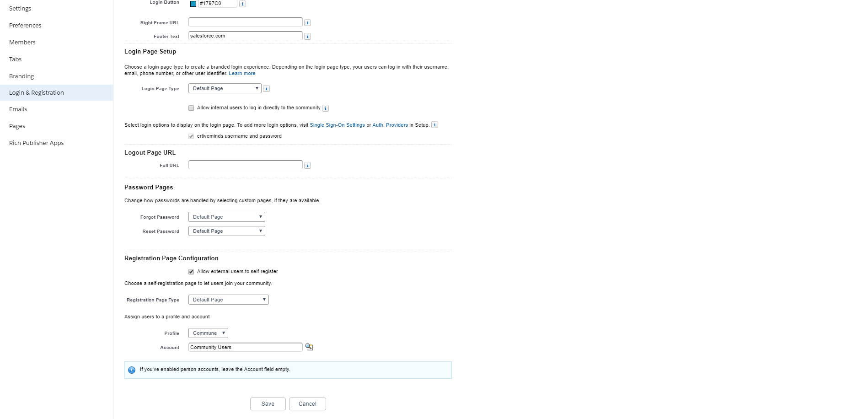

References:-

1. <https://www.youtube.com/watch?v=Jzhpjl1Rhag>
2. <https://trailhead.salesforce.com/en/content/learn/projects/set-up-a-community>
3. <https://trailhead.salesforce.com/en/content/learn/modules/community_rollout_impl>
4. <https://trailhead.salesforce.com/en/content/learn/modules/identity_external>
5. <https://www.youtube.com/watch?v=yqn5TTuirdg>
6. <https://www.youtube.com/watch?v=nWEwV8yJbEk>