Database Systems Assignment 2

Patrick Tjahjadi (890003)

Q1. List the first name, last name, department name and current job title of all staff.

SELECT first_name, last_name, department_name, job_title

FROM staff NATURAL JOIN jobs LEFT JOIN departments

ON staff.department_id = departments.department_id;

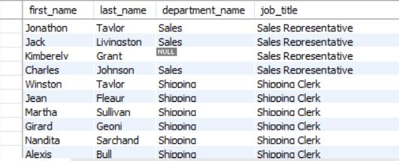

107 rows returned.

(Note: The screenshot is intentionally captured from the middle to showcase an employee that has department name NULL)

Q2. List every country name and the number of staff in each country. Order the result by country name.

SELECT country_name, count(staff_id)

FROM countries LEFT JOIN locations

ON countries.country_id = locations.country_id

LEFT JOIN (departments NATURAL JOIN staff)

On locations.location_id = departments.location_id

GROUP BY country_name

ORDER BY country_name;

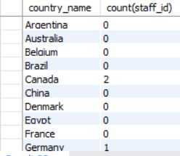

25 rows returned.

Q3. Who has spent the shortest amount of time in a job? Print their name (first and last name), how long the job lasted in days and the job title.

SELECT first_name, last_name, DATEDIFF(job_history.end_date, job_history.start_date) AS duration, job_title

FROM staff INNER JOIN job_history NATURAL JOIN jobs

ON staff.job_id = job_history.job_id

ORDER BY duration;

LIMIT 1;



1 row returned.

Q4. For all supervisors who supervise five or more staff, list their first name, last name, job title, and the number of staff members they supervise.

SELECT supervisor.first_name, supervisor.last_name, job_title, COUNT(supervised.supervisor_ID) as num_supervised

FROM staff supervised INNER JOIN staff supervisor NATURAL JOIN jobs

ON supervised.supervisor_ID = supervisor.staff_ID

GROUP BY supervisor.first_name, supervisor.last_name, jobs.job_title, supervisor.staff_id

HAVING COUNT(supervised.supervisor_ID) >= 5;

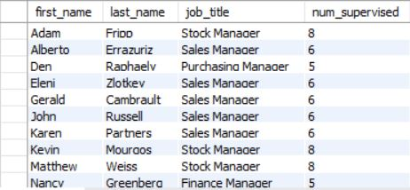

14 rows returned.

Q5. Print department names of departments that currently have neither a manager nor any staff.

SELECT department_name

FROM departments

WHERE (manager_id IS NULL

AND department_name NOT IN (SELECT department_name FROM departments NATURAL JOIN staff));



16 rows returned.

Q6. Which region has the most locations? Print the region name, as well as the total number of locations in that region.

SELECT region_name, count(region_name) as num_locations

FROM regions INNER JOIN countries

ON regions.region_id = countries.region_id

INNER JOIN locations

ON countries.country_id = locations.country_id

GROUP BY region_name

ORDER BY count(region_name) DESC

LIMIT 1;



1 row returned.

Q7. Some staff members are eligible for a commission. Find the names of staff who will exceed the maximum salary for their job title if they achieve their commission. The calculation of a staff member’s total income if the commission is achieved is their salary multiplied by the commission percent and added onto their original salary. List the staff member’s first name, last name and the amount by which they will exceed the maximum salary for their current job role. Order the results from the highest amount to lowest.

SELECT first_name, last_name, (salary * commission_pct + salary - max_salary) AS exceed

FROM staff INNER JOIN jobs

ON staff.job_id = jobs.job_id

WHERE (salary * commission_pct + salary - max_salary) > 0

ORDER BY (salary * commission_pct + salary - max_salary) DESC;

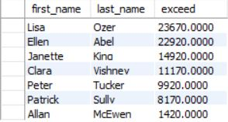

7 rows returned.

Q8. List the cities, country names and region names for cities outside the United States of America and Europe where no staff work.

SELECT city, country_name, region_name

FROM regions INNER JOIN countries

ON regions.region_id = countries.region_id

INNER JOIN locations

ON countries.country_id = locations.country_id

WHERE NOT((country_name = 'United States of America'

OR region_name = 'Europe')

OR locations.location_id IN (SELECT location_id FROM (locations NATURAL JOIN departments NATURAL JOIN staff)));

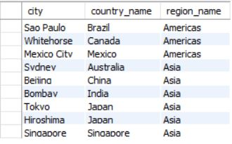

9 rows returned.

Q9. Print job titles, the date the jobs ended, and the current manager’s first and last name for all jobs that ended in 2006 which are currently not managed by Steven King.

SELECT job_title, end_date, first_name, last_name

FROM job_history INNER JOIN departments

ON departments.department_id = job_history.department_id

INNER JOIN staff

ON departments.manager_id = staff.staff_id

INNER JOIN jobs

ON jobs.job_id = job_history.job_id

WHERE EXTRACT(YEAR FROM end_date) = 2006

AND manager_id NOT IN (SELECT staff_id FROM staff where staff.first_name = 'Steven' AND staff.last_name = 'King');

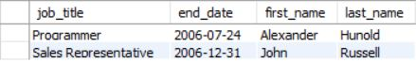

2 rows returned.

Q10. Print the first name, last name and current salary for all staff who held more than one job position prior to their current position, and whose current salary is below the average value of maximum salaries for all positions they held in the past prior to their current position.

SELECT first_name, last_name, salary

FROM staff INNER JOIN job_history

ON staff.staff_id = job_history.staff_id

INNER JOIN jobs

ON job_history.job_id = jobs.job_id

GROUP BY first_name, last_name, salary

HAVING (COUNT(hire_date) > 1 AND (salary < AVG(max_salary)));

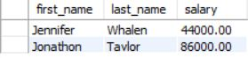

2 rows returned.