**Assessing Melbourne’s Employment and Housing Correlations**

The domain of the study covers employment and real estate.

The aim of this report is to assess the correlation between the number of people employed and the price of housing within a particular time period. This report aims to answer the following question: “**Do the increase in employment rates contribute to the rise of house prices in Melbourne?**” With the steady increase of house pricing in Melbourne over the past decade, this report studies the trend from 2002 to 2016 and assesses employment rate as a factor in changing house prices. This report could then be beneficial for the Victorian government and the general working public.

This information can be useful and innovative in order for people to understand the trends of increasing house prices over the past decade. If there is a positive correlation between employment rate and house pricing, The Victorian Government could then impose appropriate income and real estate taxes to assess overall affordability and people’s purchasing power. Furthermore, people can use this report for further reference in real estate purchase, lease, investment, etc. Although this report only considers the City of Melbourne area, this information can be used as a reference for other suburbs all across Victoria and Australia.

This report uses the following 2 datasets:

1. ‘Median House Prices – By Type and Sale Year’: Contains data about the median house and residential apartment prices from 2000 to 2016 for the City of Melbourne. This dataset provides not only the median price but also the number of transactions for each type of residential housing each year. This dataset is extracted from the City of Melbourne website. Link: <https://data.melbourne.vic.gov.au/Property-Planning/Median-House-Prices-By-Type-and-Sale-Year/i8px-csib>
2. ‘Employment by Block by Industry’: Contains data about the number of people employed within a particular block, classified by industry (ANZSIC1) and yea**r**. The 20 sectors provided are considered for this report to extract its total for each block and year. It covers the year 2002 to 2016 for the City of Melbourne area. This data is also extracted from the City of Melbourne website. Link: <https://data.melbourne.vic.gov.au/Economy/Employment-by-block-by-industry/b36j-kiy4>

These datasets were chosen because they are both provided by the City of Melbourne website, which is a reliable, credible and accurate source. Both datasets are in CSV format.

The raw data provided by both datasets are untidy and contain several outliers and missing values. Therefore, it would be hard to justify any correlation between the two datasets without processing them. By processing and visualising the data, people can easily see the correlation between the two factors by giving them human-readable visual access towards the big, messy data. Hence, processing the raw data adds value towards inferences.

Moreover, processing and visualising the data gives the Victorian government and the general public more context so they can make better inferences about the correlation between the number of employment and house pricing without the necessary costs required for a manual census or survey. With this report, the Victorian government can easily detect which employment industry affects real estate pricing the most as well.

Prior to processing the data, several pre-processing methods were done to successfully integrate the datasets:

1. Unnecessary data was removed. This included the data that were recorded prior to 2002. Since the number of employment dataset only recorded the year starting from 2002, the median house prices for 2000 and 2001 were not included in this report.
2. For missing data, it is assumed that no people work for that particular industry within that time period and suburb. Hence, blank entries are given the number zero to successfully bypass Python’s loop control structure.
3. Outliers in the datasets were not removed because they may provide interesting information within a particular time period and suburb. Moreover, these outliers are assumed to be accurately recorded due to the City of Melbourne being a reputable source. Several interesting inferences could then be made due to those outliers and is hence better left unchanged.
4. For prices in dollars, the dollar signs and thousand separators are removed in Python to allow arithmetical operations using the libraries **re** and **decimal**.

To reduce the number of columns required for visualisation, the 20 employment industries were classified into different categories, namely: Business Sector for ‘Business Services’, ‘Finance and Insurance’, ‘Manufacturing’, ‘Retail and Trade’ and ‘Wholesale Trade’; Public Services Sector for ‘Education and Training’, ‘Electricity, Gas, Water and Waste’, ‘Health Care’ and ‘Public Administration and Safety’; IT Sector for ‘Admin and Support’ and ‘Information Media and Telecommunications’; Housing Sector for ‘Accommodation’ and ‘Real Estate Services’; Operations Sector for ‘Construction’, ‘Manufacturing’, ‘Rental and Hiring’ and ‘Transport, Postal and Storage’; And the Others Sector for ‘Arts’, ‘Agriculture’, ‘Food and Beverage’ and ‘Other’. This will allow simpler visualisation and analysis compared to having 20 comparisons. All of the data processing involved in this study was done by Python with the following libraries: **pandas, matplotlib, numpy, re and decimal.**

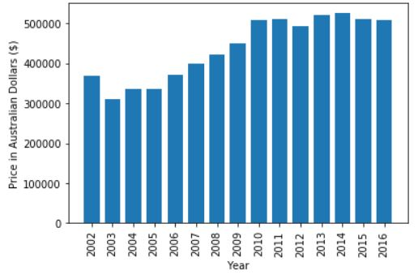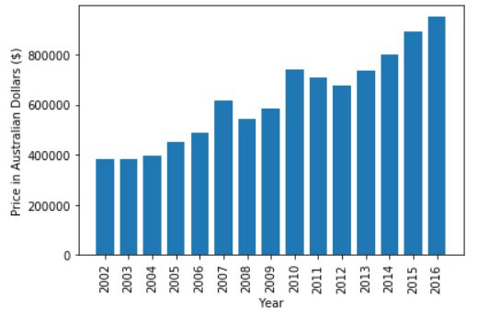Firstly, this report must assess the change in house pricing from 2002 to 2016 in Melbourne by means of a bar graph. The price of housing has significantly increased since 2002.

**Figure 2:** Median House Price in Melbourne

**Figure 1:** Median Apartment Price in Melbourne

Needless to say, housing prices have increased steadily over the past decade (**Figure 1, Figure 2**). Interestingly, however, there are some years in-between that have higher or lower median house prices. Through speculation, the increase in the country’s economic growth, along with the increase in people’s purchasing power has led to more demand than supply and enabled people to purchase housing. Hence, this has led house prices to increase to reduce the shortage of housing supply. This is further backed by the fact that 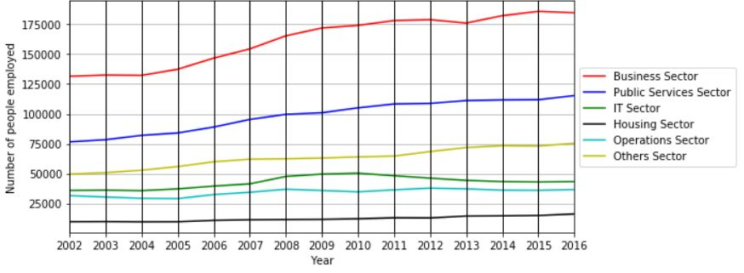there is indeed a rise in the number of employment in Melbourne since 2002 (**Figure 3**).

**Figure 3:** Number of employment per year for each sector (City of Melbourne)

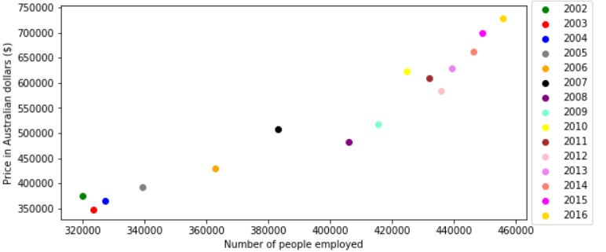Interestingly, the number of people employed in the business sector has experienced the most growth. From what the analysis has shown, it would seem that there is indeed a positive correlation between the number of people employed and the average median price for a residential apartment and a house/townhouse. (**Figure 4**).

**Figure 4:** Median house and apartment price averaged vs number of people employed (City of Melbourne)

Through Python, it is found that there is a percentage increase of housing price from 2002 to 2016 by 194.14% while the number of people employed increased by 142.54%. This concludes that the number of people employed is a factor towards changing house prices in Melbourne (**Figure 4**).

With this initial investigation, it can be further concluded that this report is feasible in determining the correlation between employment and real estate. Resources are readily available, and the Victorian government could use this initial investigation for further studies. However, further processing and analysis such as studying the trends for each employment sector would be crucial for this study.

Therefore, the positive correlation between the number of employment and housing prices makes this initial investigation a success, and by further studying each employment sector and suburb, the reason behind what drives the increase in housing prices can be achieved.