Media Cell #CongratulationsCESociety
Department of Biochemistry
Students have secured Ranks at the university level in the External Examination held during 2021
7 students in university top 10 ranking
CONGRATULATION!


Uni. Second Shail Khambolja 8.80 GPA


Uni. Fifth Bhoomi Mori 7.80 GPA


Uni. SIxth Mayur Mahida 7.64 GPA
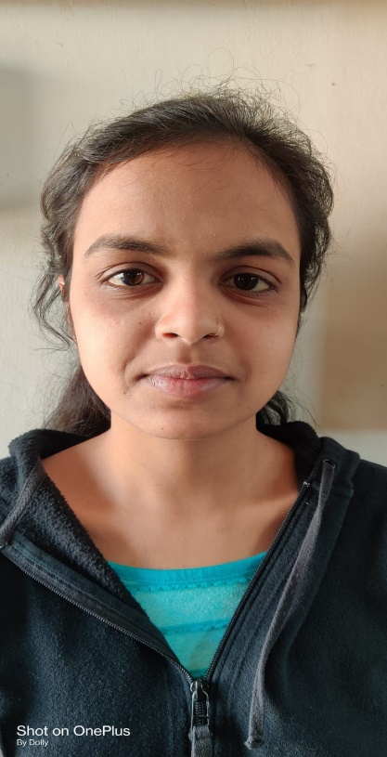
Uni. Ninth Krupa Parmar 7.32 GPA
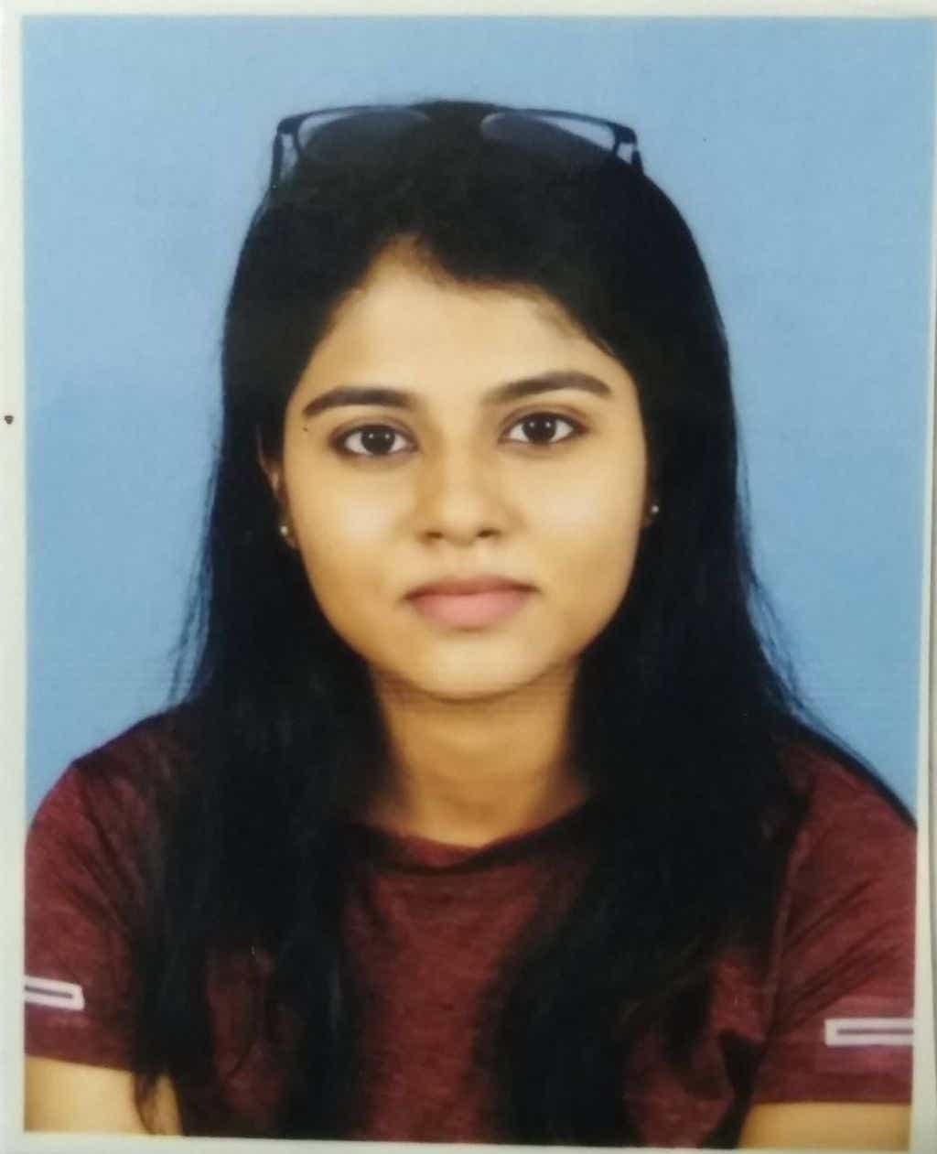
Uni. Ninth Anjali Maithani 7.32 GPA
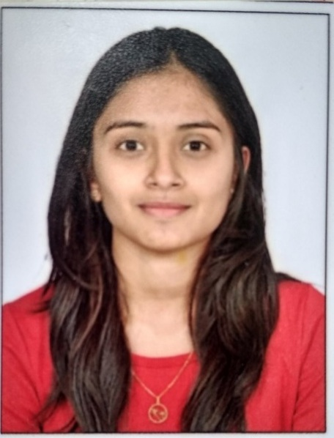
Uni. Tenth Prakruti Amipara 7.28 GPA
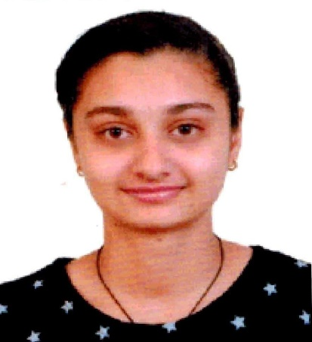
Uni. Tenth Janki Khamboliya 7.28 GPA

Media Cell #CongratulationsCESsociety
Shri A.N. Patel PG Institute of Science & Research
Department of Biochemistry

Students have secured Ranks at the university level in the Fourth Semester External Examination held in April 2022
7 students in the university’s top 10 rankings as well as 100% result
CONGRATULATIONS!

Semester-I (Batch: 2021-23)
Rank | CGPA | Name | Rank | CGPA | Name
First  (Uni. First) | 8.71 |   Shail Khambolja | Second  (Uni. 4th) | 7.75 |   Bhoomi Mori
Third  (Uni. 6th) | 7.61 | 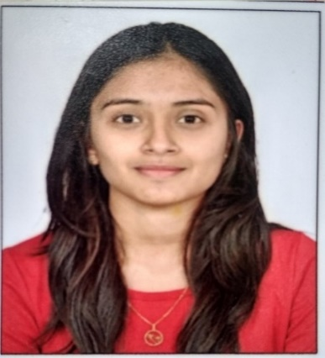  Prakruti Amipara | Fourth  (Uni. 7th ) | 7.50 |   Mayur Mahida
Fifth  (Uni. 8th) | 7.34 |   Janki khamboliya | Sixth  (Uni. 9th ) | 7.21 | 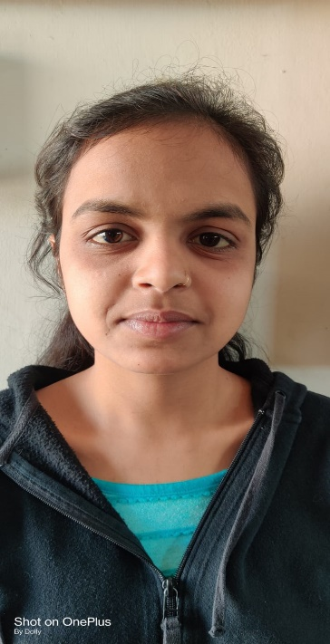  Krupa parmar
Seventh  (Uni. 10th) | 7.20 |   Anjali maithani

Media Cell #CongratulationsCESsociety
Shri A.N. Patel PG Institute of Science & Research
Department of Biochemistry
Students have secured Ranks at the university level in the First Semester External Examination held during January 2022
10 students in university rankings
CONGRATULATIONS!

Semester-I (Batch: 2021-23)
Rank | GPA | Name | Rank | GPA | Name
First  (Uni. Second) | 7.72 | 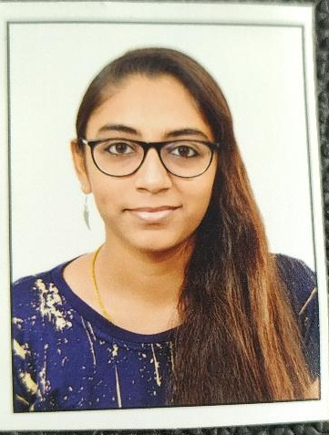  Nehalba Dabhi | Fourth  (Uni. 5th) | 7.24 | 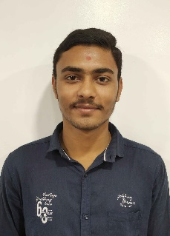  Sagar Tankariya
First  (Uni. Second) | 7.72 | 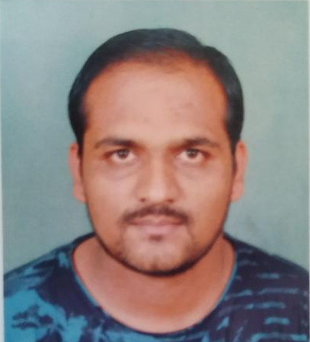  Akkrammiya Chavda | Fifth  (Uni. 7th ) | 7.08 |   Kunjesh Bhadani
Second  (Uni. Third) | 7.48 | 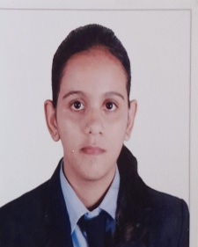  Heena Prajapati | Sixth  (Uni. 8th ) | 7.04 |   Fiza Vohra
Third  (Uni. 4th ) | 7.40 |   Kevin Vekariya | Sixth  (Uni. 8th ) | 7.04 | 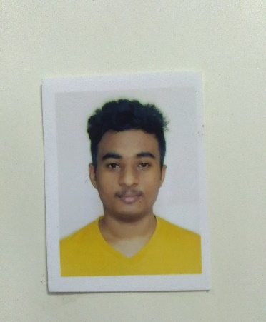  Pranav Bhoi
Fourth  (Uni. 5th ) | 7.24 |   Heta Patel | Sixth  (Uni. 8th ) | 7.04 |   Shivani duhlani

Media Cell #CongratulationsCESsociety
Shri A.N. Patel PG Institute of Science & Research
Department of Biochemistry
Students have secured Ranks at the university level in the Second Semester External Examination held in April 2022
10 students in university rankings
CONGRATULATIONS!

Semester-II (Batch: 2021-23)
Rank | GPA | Name | Rank | GPA | Name
First  (Uni. First) | 7.68 |   Kevin Vekariya | Fourth  (Uni. 5th) | 7.08 |   Nehalba Dabhi
Second  (Uni. Second) | 7.52 |   Heena Prajapati | Fifth  (Uni. 6th ) | 7.04 |   Sagar Tankariya
Second  (Uni. Second) | 7.52 |   Shivani duhlani | Sixth  (Uni. 8th ) | 6.92 | 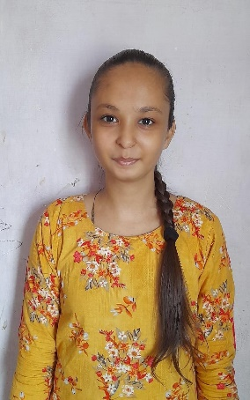  Neha Rathod
Third  (Uni. 3rd ) | 7.20 |   Akkrammiya Chavda | Seventh  (Uni. 9th ) | 6.88 |   Heta Patel
Third  (Uni. 3rd ) | 7.20 |   Pranav Bhoi

