**Media Cell #CongratulationsCESociety**

**Department of Biochemistry**

**Students have secured Ranks at the university level in the External Examination held during 2021**

**7 students in university top 10 ranking**

**CONGRATULATION!**

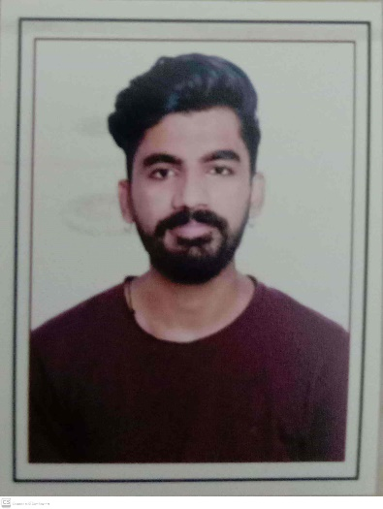

**Uni. Second Shail Khambolja 8.80 GPA**

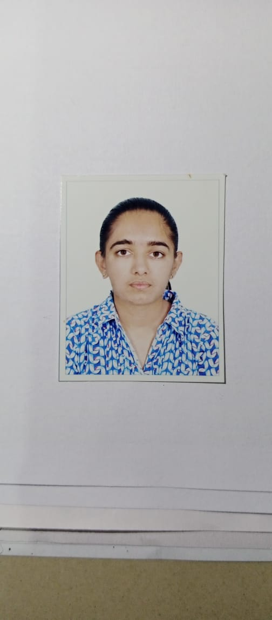

**Uni. Fifth Bhoomi Mori 7.80 GPA**

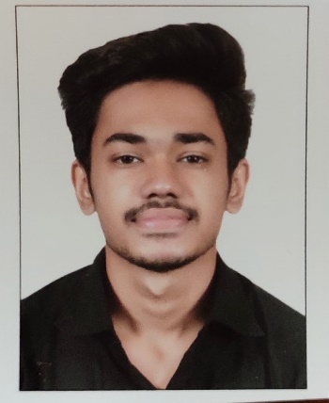

**Uni. SIxth Mayur Mahida 7.64 GPA**

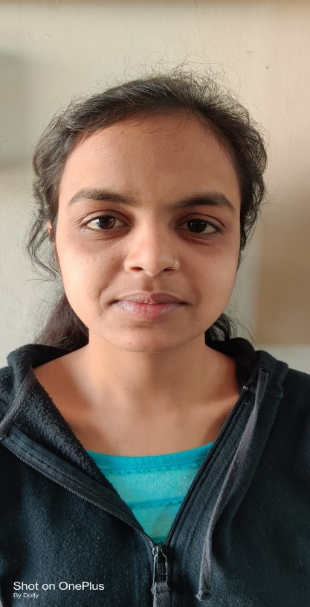

**Uni. Ninth Krupa Parmar 7.32 GPA**

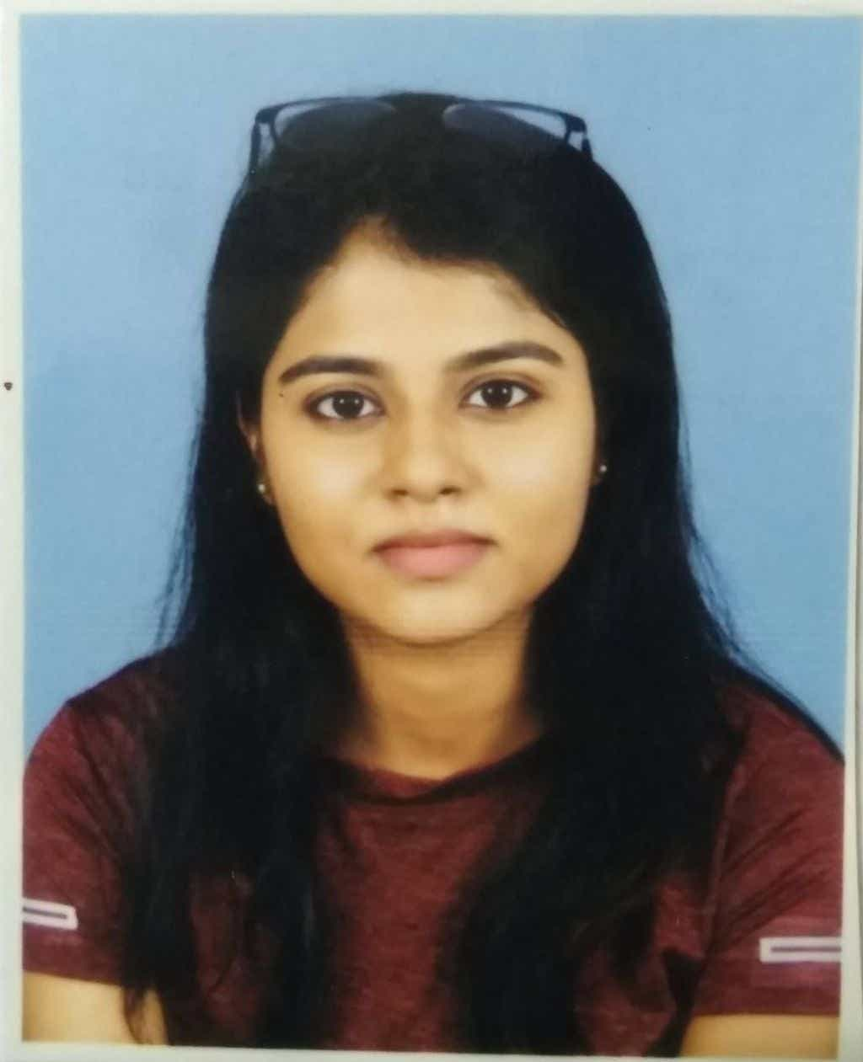

**Uni. Ninth Anjali Maithani 7.32 GPA**

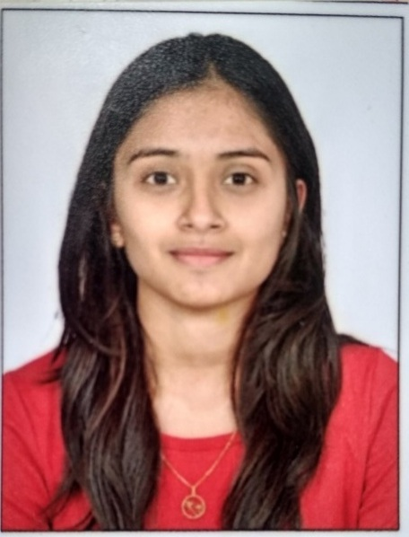

**Uni. Tenth Prakruti Amipara 7.28 GPA**

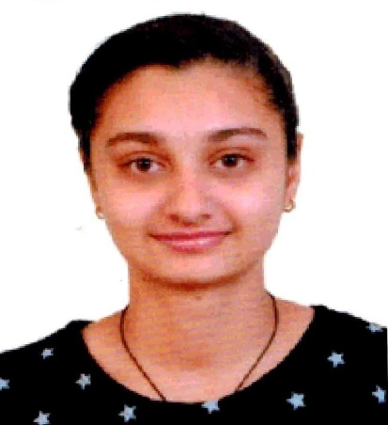

**Uni. Tenth Janki Khamboliya 7.28 GPA**

**Media Cell #CongratulationsCESsociety**

**Shri A.N. Patel PG Institute of Science & Research**

**Department of Biochemistry**

**Students have secured Ranks at the university level in the Fourth Semester External Examination held in April 2022**

**7 students in the university’s top 10 rankings as well as 100% result**

**CONGRATULATIONS!**

|  |  |  |  |  |  |
| --- | --- | --- | --- | --- | --- |
| **Semester-I (Batch: 2021-23)** | | |  | | |
| **Rank** | **CGPA** | **Name** | **Rank** | **CGPA** | **Name** |
| **First**  **(Uni. First)** | 8.71 | Shail Khambolja | **Second**  **(Uni. 4th)** | 7.75 | Bhoomi Mori |
| **Third**  **(Uni. 6th)** | 7.61 | Prakruti Amipara | **Fourth**  **(Uni. 7th )** | 7.50 | Mayur Mahida |
| **Fifth**  **(Uni. 8th)** | 7.34 | Janki khamboliya | **Sixth**  **(Uni. 9th )** | 7.21 | Krupa parmar |
| **Seventh**  **(Uni. 10th)** | 7.20 | Anjali maithani |  |  |  |

**Media Cell #CongratulationsCESsociety**

**Shri A.N. Patel PG Institute of Science & Research**

**Department of Biochemistry**

**Students have secured Ranks at the university level in the First Semester External Examination held during January 2022**

**10 students in university rankings**

**CONGRATULATIONS!**

|  |  |  |  |  |  |
| --- | --- | --- | --- | --- | --- |
| **Semester-I (Batch: 2021-23)** | | |  | | |
| **Rank** | **GPA** | **Name** | **Rank** | **GPA** | **Name** |
| **First**  **(Uni. Second)** | 7.72 | C:\Users\ANSDP.CES\Desktop\NEHAL.jpg  Nehalba Dabhi | **Fourth**  **(Uni. 5th)** | 7.24 | Sagar Tankariya |
| **First**  **(Uni. Second)** | 7.72 | Akkrammiya Chavda | **Fifth**  **(Uni. 7th )** | 7.08 | Kunjesh Bhadani |
| **Second**  **(Uni. Third)** | 7.48 | C:\Users\ANSDP.CES\Desktop\HEENA.jpg  Heena Prajapati | **Sixth**  **(Uni. 8th )** | 7.04 | Fiza Vohra |
| **Third**  **(Uni. 4th )** | 7.40 | Kevin Vekariya | **Sixth**  **(Uni. 8th )** | 7.04 | Pranav Bhoi |
| **Fourth**  **(Uni. 5th )** | 7.24 | Heta Patel | **Sixth**  **(Uni. 8th )** | 7.04 | Shivani duhlani |

**Media Cell #CongratulationsCESsociety**

**Shri A.N. Patel PG Institute of Science & Research**

**Department of Biochemistry**

**Students have secured Ranks at the university level in the Second Semester External Examination held in April 2022**

**10 students in university rankings**

**CONGRATULATIONS!**

|  |  |  |  |  |  |
| --- | --- | --- | --- | --- | --- |
| **Semester-II (Batch: 2021-23)** | | |  | | |
| **Rank** | **GPA** | **Name** | **Rank** | **GPA** | **Name** |
| **First**  **(Uni. First)** | 7.68 | Kevin Vekariya | **Fourth**  **(Uni. 5th)** | 7.08 | C:\Users\ANSDP.CES\Desktop\NEHAL.jpg  Nehalba Dabhi |
| **Second**  **(Uni. Second)** | 7.52 | C:\Users\ANSDP.CES\Desktop\HEENA.jpg  Heena Prajapati | **Fifth**  **(Uni. 6th )** | 7.04 | Sagar Tankariya |
| **Second**  **(Uni. Second)** | 7.52 | Shivani duhlani | **Sixth**  **(Uni. 8th )** | 6.92 | Neha Rathod |
| **Third**  **(Uni. 3rd )** | 7.20 | Akkrammiya Chavda | **Seventh**  **(Uni. 9th )** | 6.88 | Heta Patel |
| **Third**  **(Uni. 3rd )** | 7.20 | Pranav Bhoi |  |  |  |