**Keryar**

1. Technology > Website development

Last comment has not been changed.



1. Growth > digital marketing

Format of textual line is not perfect.

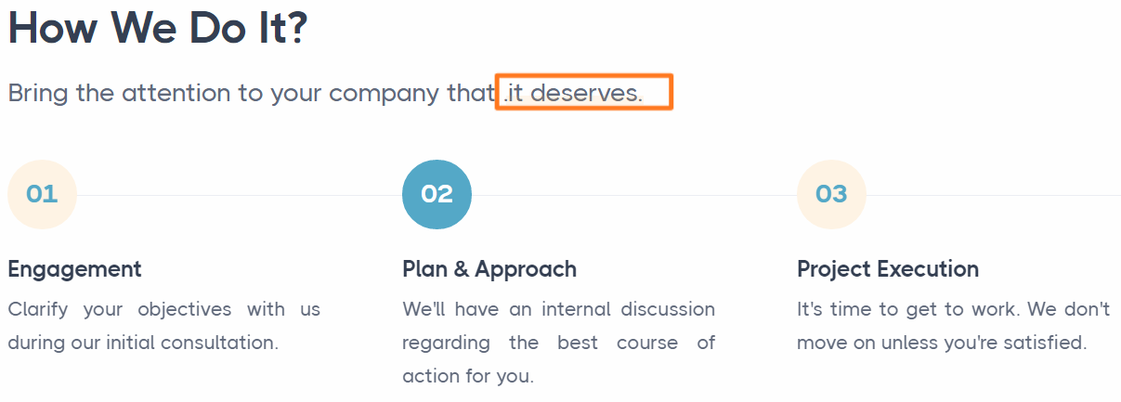

1. Growth > Social media marketing

Text is different. Make it same.

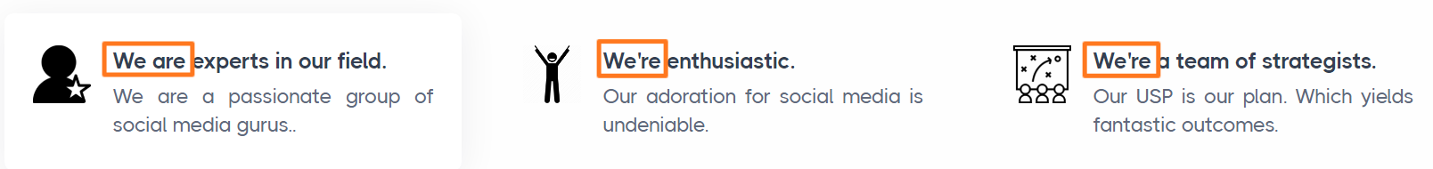

1. Management > Ecommerce service

Missing full stop.

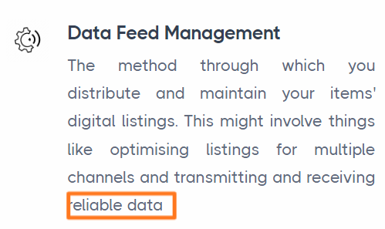

1. Keryar > about

No need to add and before along with

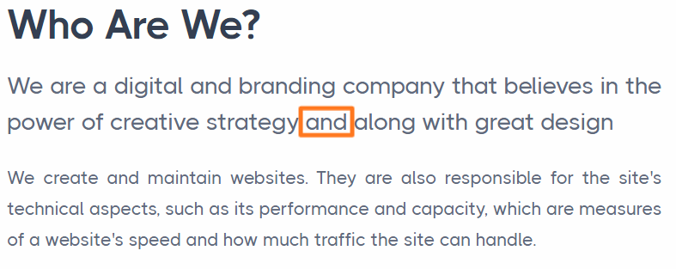

1. Keryar > about

Need space after full stop.

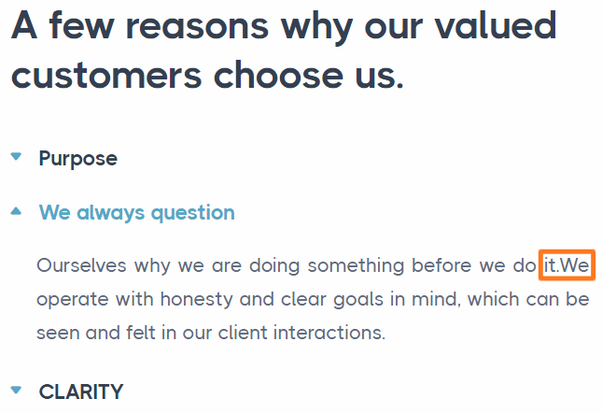

1. Technology > ecommerce

No space after numbers in 2nd and 3rd.

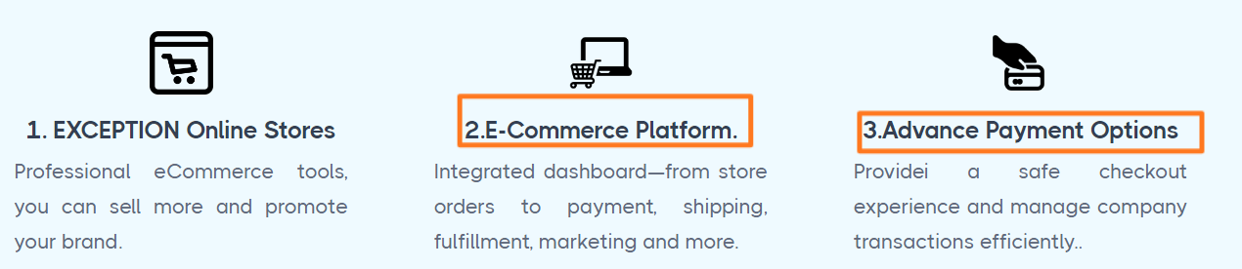

1. Growth > Social media marketing

Space after together.

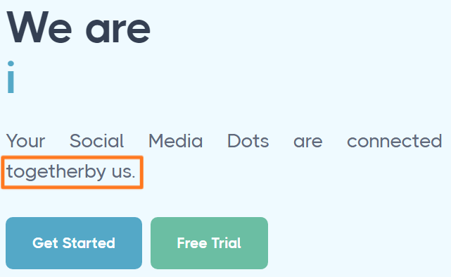

1. Growth > SEO > four blocks of comments are on textual content. **DONE**
2. Growth > Lead generation > in black block section > numbers of completed project, happy client and award won are not in same align with text.

**Link related pages:**

1. Technology > Web application > Learn more link under easy usage is not working.
2. Technology > website development > web design and mobile design links are interchange.
3. Technology > Ecommerce > No link for free trial link in upper part of website and also at bottom part of website.
4. Technology > Mobile application > No links for app store and google play.
5. Technology Cyber security > Explore now link at the upper side is not working.
6. Technology > Cyber security > Contact us link at the upper side is not working.

#### Technology > Cyber security > Evaluate, minimize, and manage > Learn more link is not there

#### Technology > Cyber security > Govern and safeguard > Learn more link is not there

#### Technology > Cyber security > Recognize and respond > Learn more link is not there

1. Technology > Cyber security > Govern and safeguard > Learn more link is not there
2. Technology > Cyber security > recognize and response > Learn more link is not there
3. Technology > Cyber security > implication for security > Learn more link is not there
4. Technology > uiux > No links for app store and google play in upper and at bottom side of website.
5. Growth > Social media marketing > free trail is not there.
6. Growth > Google ad management > explore now link is not there.
7. Growth > Lead generation > Read more link
8. Management > Cloud service > See project and learn project link
9. Management > Hosting service – when click on hosting service the blue colour is still getting on Ecommerce service.
10. Management > Hosting service > Free trail link.
11. Management > Hosting service > basic and corporate plan > choose plan link
12. Product > free trail link at the upper and bottom side of the website.
13. Keryar > blog > read more link on all images of that page
14. Keryar > team work, coding, workspace, meeting, business tips link
15. Keryar > portfolio > snow flak theme, budget app, mission theme, storage app > see project link
16. Last “i” icon > our story, terms of use, privacy policy, contact us links are not there.

**Language related pages:**

1. Language in comment block - Technology > web application, website development, Mobile application, ecommerce, cyber security, uiux
2. Language in comment block – growth > digital marketing, social media marketing, SEO, Lead generation
3. Language in “we bring solutions to make business grow” – Management > ecommerce service
4. Management > Hosting service – Language in “Hosting service block”, “ we make spending stress free”
5. Product – Language in “we have considered our solution”, “ we make spending stress free”, “we bring solutions to manage your finance” and in comment section

## Keryar > blog – Language in “[Fringilla Ligula Pharetra Amet](https://rumit.co.in/keryar/blog-post.html)”, “[Ligula tristique quis risus](https://rumit.co.in/keryar/blog-post.html)”, “[Nullam id dolor elit id nibh](https://rumit.co.in/keryar/blog-post.html)”, “[Ultricies fusce porta elit](https://rumit.co.in/keryar/blog-post.html)”, “Morbi leo risus porta eget”

1. Keryar > client – language in 1st paragraph.
2. Keryar > FAQ – language in all the questions
3. Keryar > testimonial – language in comment sections
4. Keryar > portfolio – language in whole page
5. No font justification in website in many places. **DONE**



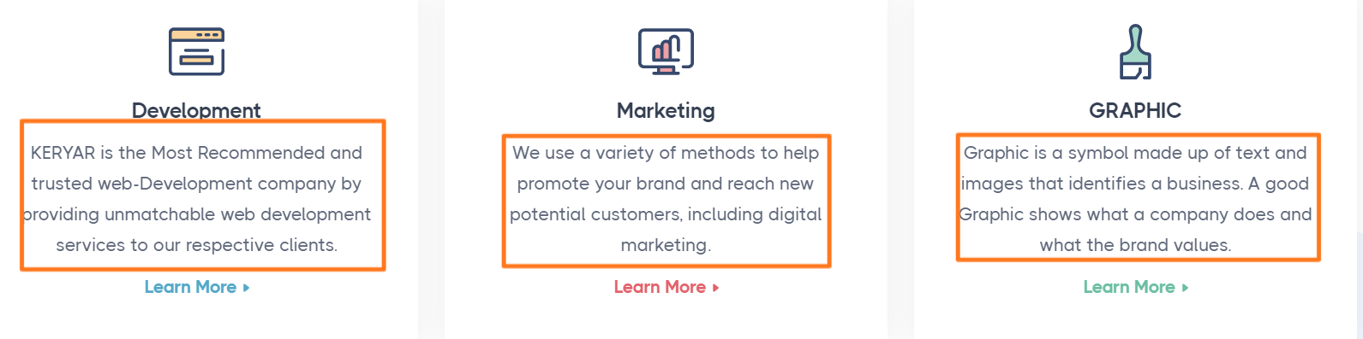



1. Responsive : iphone eXpensive portrait width : 375px

Iphone 6-8 portrait width: 375px

From URL : <https://www.responsinator.com/?url=https%3A%2F%2Frumit.co.in%2Fkeryar%2F>

|  |  |
| --- | --- |
| Technology > cyber security  Numbers should be in small font. | Marketing > Digital marketing |
| Keryar > about |  |

1. Connect > Join us

Send button is appearing on the text

Screen:

Iphone 6-8 plump portrait width: 414px

Android(pixel2) portrait width : 412px

iphone eXpensive landscape width : 734px

Android (pixel2) landscape width: 684px

Iphone 6-8 portrait width: 375px

Iphone 6-8 landscape width: 667px

Iphone 6-8 plump landscape width: 736px

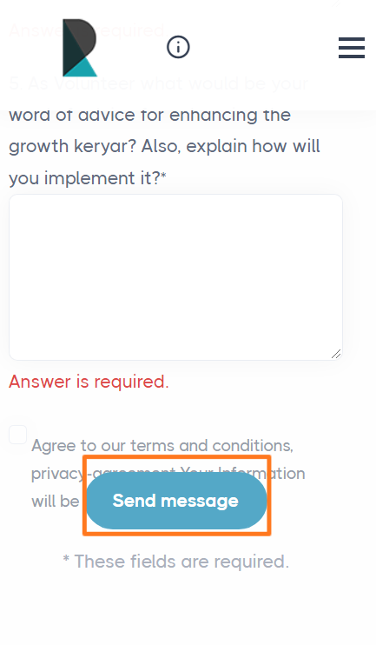

1. Connect > General queries

Connect > Get quick quote

Phone number text and number are not in proper place.

In screen: Android(pixel2) portrait width: 412px

Iphone eXpensive portrait width: 375px

Iphone 6-8 portrait width: 375px

Iphone 6-8 plump portrait width: 414px

Iphone portrait width: 768px

Iphone landscape width: 1024px

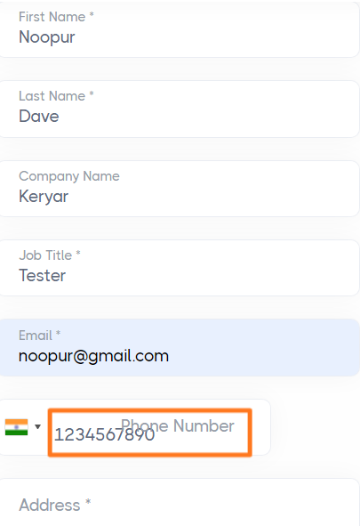

1. Top icon button is not appearing in following screen.

Android(pixel2) portrait width : 412px

Iphone eXpensive portrait width : 375px



1. Menu icon in mobile screen is not showing sometimes.

Android (pixel2) portrait width: 412px

iphone eXpensive landscape width : 734px

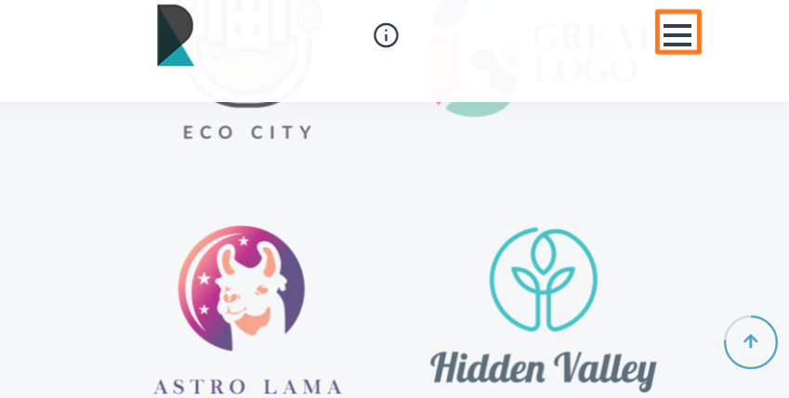

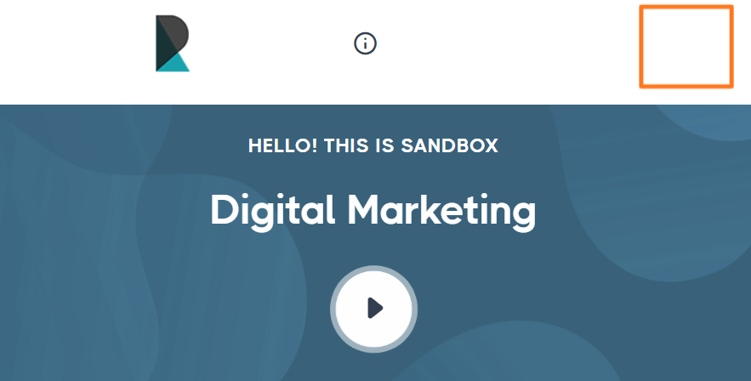

1. Responsive : Iphone eXpensive landscape width : 734px

Android (pixel2) landscape width: 684px

Iphone 6-8 landscape width: 667px

Iphone 6-8 plump landscape width: 736px

1680*1050, 320*568

1920*1200, 320*480

1920*1080, 800*1280

1600*900, 1024*768

1440*900, 600*960

1366*768, 768*1024

1024*800, 1366*1024

1024*600, 768*1024

375*667, 414*736,

360*640, 411*731

384*640

From URL : <https://www.responsinator.com/?url=https%3A%2F%2Frumit.co.in%2Fkeryar%2F>

Connect > get quick quote

Connect > General queries

Phone number text and its textbox are overlapping. Also in mobile screens textbox of phone number is not in equal size of other textboxes.

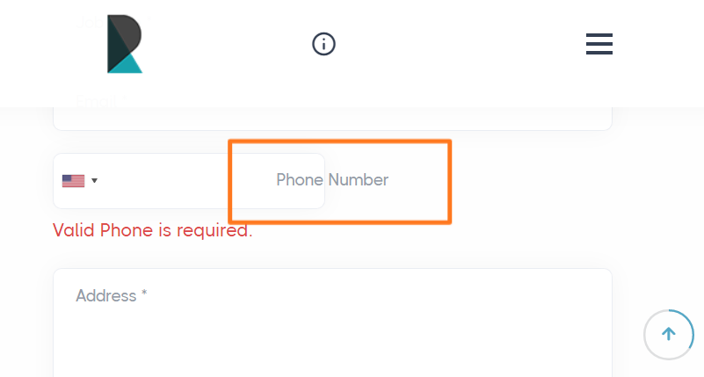

1. In footer email is getting cut in the screen 1024*800, 1024*600, 1024*768.

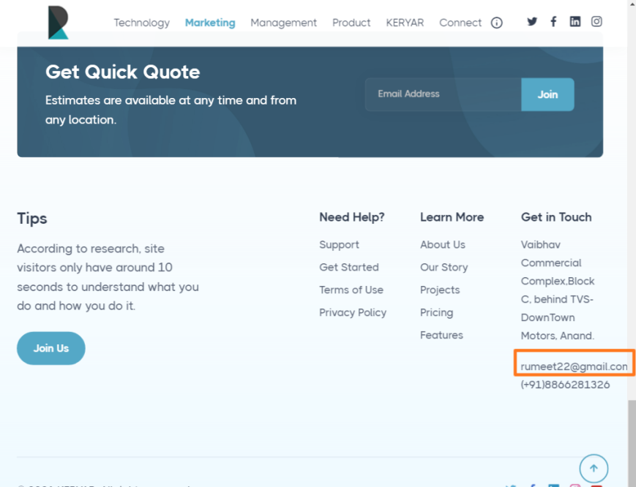

1. Marketing > SEO

All four boxes are not of same size. Make same amount of content in boxes.

