DBS311 D - Lab 2 – In-Lab submission only, unless you have a permission from me to submit by e-mail. Your Word or TXT Document must have both SELECT statements and the OUTPUTS. You may also submit your Lab Printout to our Reception Office, Room A3058 by the due date, Thursday, February 01st by 4pm
Use DEMO tables here → LOCATION, DEPARTMENT, EMPLOYEE

- Display the department number and Highest, Lowest and Average pay per each department. Name these results High, Low and Avg.
Sort the output so that department with highest average salary are shown first.
Answer;
SELECT department_id, MAX(salary) AS High,
MIN(salary) AS Low,
round(AVG(salary),0) AS Avg
FROM employee
GROUP BY department_id
ORDER BY Avg DESC;

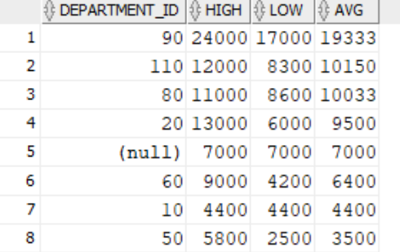

- Display how many people work the same job in the same department. Name these results Dept#, Job and HowMany. Include only jobs that involve more than one person.
Sort the output so that jobs with the most people involved are shown first.
Answer;
SELECT department_id AS "Dept#",
job_id AS "Job",
COUNT(*) AS "HowMany"
FROM employee
GROUP BY department_id,job_id
HAVING COUNT(*)>1
ORDER BY COUNT(*) DESC;
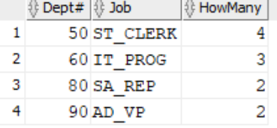

- For each job title display the job title and total amount paid each month for this type of the job. Exclude titles AD_PRES and AD_VP and also include only jobs that require more than $15,000.
Sort the output so that top paid jobs are shown first.
Answer;
SELECT job_id AS "Job Title",
SUM(salary) AS "Total Amount Paid"
FROM employee
GROUP BY job_id
HAVING job_id NOT IN ('AD_PRES', 'AD_VP') AND
SUM(salary) > 15000
ORDER BY "Total Amount Paid" DESC
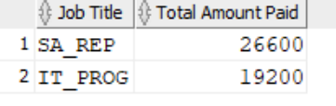

- For each manager number display how many persons he / she supervises. Exclude managers with numbers 100, 101 and 102 and also include only those managers that supervise more than 2 persons.
Sort the output so that manager ids with the most supervised persons are shown first.
Answer;
SELECT manager_id, COUNT(*) AS "Persons he Supervises"
FROM employee
WHERE manager_id NOT IN (100, 101, 102)
GROUP BY manager_id
HAVING COUNT(*) > 2
ORDER BY COUNT(*) DESC;
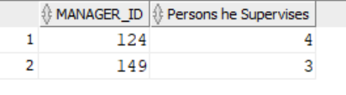
- For each department show the latest and earliest hire date, but exclude departments 10
and 20 and also exclude those departments where the last person was hired in this century (Century started on Jan 01st 2000). Sort the output so that most recent latest hire dates are shown first.
Answer;
SELECT department_id,
MAX(hire_date) AS "Latest Hire Date",
MIN(hire_date) AS "Earliest Hire Date"
FROM employee
WHERE department_id NOT IN (10, 20)
GROUP BY department_id
HAVING MAX(hire_date) < TO_DATE('2000-01-01', 'YYYY-MM-DD')
ORDER BY MAX(hire_date) DESC;
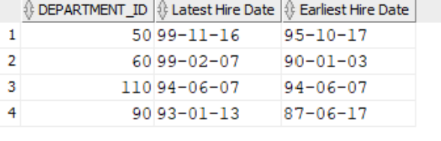
- For each department show its name, city and how many people work there, excluding departments which name starts on S (do not use LIKE here) and showing only those ones that employ at least 3 persons. Sort the output by department name ascending.
One possible row will look like shown here:
Executive Seattle 3

SELECT d.department_name,l.city,
COUNT(e.employee_id) AS "Number of Employees"
FROM department d
JOIN location l ON d.location_id = l.location_id
JOIN employee e ON d.department_id = e.department_id
WHERE SUBSTR(d.department_name, 1, 1) <> 'S'
GROUP BY d.department_name, l.city
HAVING COUNT(e.employee_id) >= 3
ORDER BY d.department_name ASC;
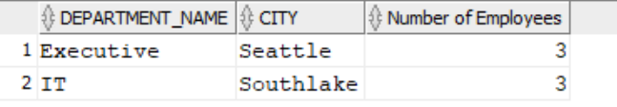
- BONUS Variation of Q6 where you will show only departments that do not begin on A and with less than 3 employees, including also Empty departments. One possible row will look like shown here:
Contracting Seattle 0
SELECT d.department_name,l.city,
COUNT(e.employee_id) AS "Number of Employees"
FROM department d
JOIN location l ON d.location_id = l.location_id
LEFT JOIN employee e ON d.department_id = e.department_id
WHERE SUBSTR(d.department_name, 1, 1) <> 'A' OR e.employee_id IS NULL
GROUP BY d.department_name, l.city
HAVING COUNT(e.employee_id) < 3 OR COUNT(e.employee_id) IS NULL
ORDER BY d.department_name ASC;

