DBS311 D- Lab 5 – In-Lab submission only, unless you have a permission from me to submit by e-mail. Your Word or TXT Document must have both SELECT statements and the OUTPUTS. You may also submit your Lab Printout to our Reception Office, Room A3058 by due date.

Due by Thursday, March 7th by 4pm
- Write a stored procedure called Even_Odd that gets an integer number as its Input parameter and prints
The number is even.
If a number is divisible by 2.
Otherwise, it prints
The number is odd.

Show testing with one even and one odd integer.
CREATE OR REPLACE PROCEDURE Even_Odd(
num IN NUMBER)
AS BEGIN
IF MOD(num,2)=0 THEN
DBMS_OUTPUT.PUT_LINE('The number is even.');
ELSE
DBMS_OUTPUT.PUT_LINE('The number is odd.');
END IF;
END;
/
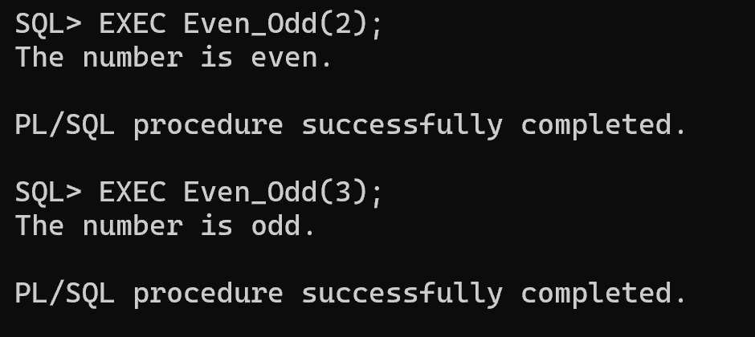
For next 3 questions, you need to use PRODUCT SCHEMA tables -- Employees, Products, Warehouses etc

- Create a stored procedure named Find_Employee. This procedure gets an employee number and prints the following employee information:
First name
Last name
Email
Phone
Hire date
Job title

The procedure gets a formal value as the p_empid of type NUMBER.
See the following example for employee# of 107 (actual parameter). Use table EMPLOYEES.
First name: Summer
Last name: Payn
Email: summer.payne@example.com
Phone: 515.123.8181
Hire date: 07-JUN-16
Job title: Public Accountant

The procedure displays a proper error message if any error occurs.
Show testing with one invalid employee Id and one valid Id.
CREATE OR REPLACE PROCEDURE Find_Employee (
p_empid IN NUMBER)
AS firstName VARCHAR2(255 BYTE);
lastName VARCHAR2(255 BYTE);
email VARCHAR2(255 BYTE);
phone VARCHAR2(50 BYTE);
hireDate DATE;
jobtitle VARCHAR2(255 BYTE);
BEGIN
SELECT first_name, last_name, email, phone, hire_date, job_title
INTO firstName, lastName, email, phone, hireDate, jobtitle
FROM employees
WHERE employee_id = p_empid;

DBMS_OUTPUT.PUT_LINE('First name: ' || firstName);
DBMS_OUTPUT.PUT_LINE('Last name: ' || lastName);
DBMS_OUTPUT.PUT_LINE('Email: ' || email);
DBMS_OUTPUT.PUT_LINE('Phone: ' || phone);
DBMS_OUTPUT.PUT_LINE('Hire date: ' || hireDate);
DBMS_OUTPUT.PUT_LINE('Job title: ' || jobtitle);
EXCEPTION
WHEN OTHERS THEN
DBMS_OUTPUT.PUT_LINE('Employee with ID ' || p_empid || ' does not exist.');
END;
/
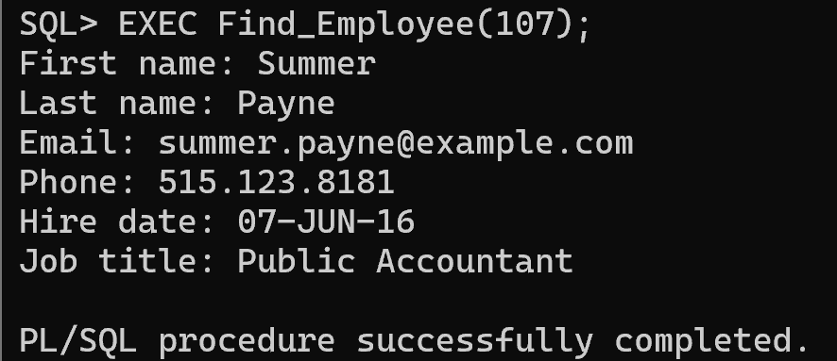

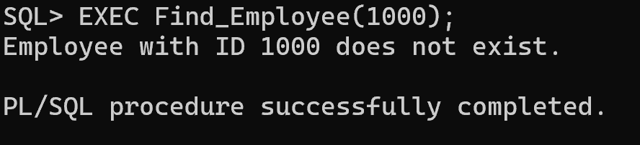
- Every year, the company increases the price of all products in one category. For example, the company wants to increase the price (list_price) of products in category 1 by $5. Write a procedure named Update_Price_by_Cat to update the price of all products in a given category and the given amount to be added to the current price if the price is greater than 0. The procedure shows the number of updated rows if the update is successful or shows 0 rows updated, if the input was an invalid category Id.
The procedure gets two parameters:
- p_catid IN products.category_id%TYPE
- p_amount IN NUMBER
To define the type of variables that store values of a table’ column, you can also write:
variable_name table_name.column_name%TYPE;
The above statement defines a variable of the same type as the type of the table’ column.
v_category_id products.category_id%TYPE;
Or you need to see the table definition to find the type of the category_id column. Make sure the type of your variable is compatible with the value that is stored in your variable.
To show the number of affected rows the update query, declare a variable named v_rows_updated of type NUMBER and use the SQL Attribute sql%rowcount to set your variable. Then, print its value in your stored procedure.
v_rows_updated := sql%rowcount;
SQL%ROWCOUNT stores the number of rows affected by an INSERT, UPDATE, or DELETE.
Show testing with one invalid category Id and one valid Id.
Undo your Update > Rollback
CREATE OR REPLACE PROCEDURE Update_Price_by_Cat (
p_catid IN products.category_id%TYPE,
p_amount IN NUMBER
)
AS
v_rows_updated NUMBER;
BEGIN
UPDATE products
SET list_price = list_price + p_amount
WHERE category_id = p_catid
AND list_price > 0;

v_rows_updated := sql%rowcount;
DBMS_OUTPUT.PUT_LINE(v_rows_updated || ' rows updated.');

EXCEPTION
WHEN NO_DATA_FOUND THEN
DBMS_OUTPUT.PUT_LINE('0 rows updated’);
WHEN OTHERS THEN
DBMS_OUTPUT.PUT_LINE('Error!');
END;
/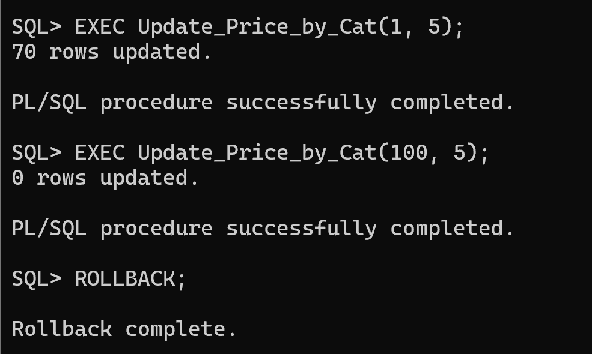
- Every year, the company increases the price of products whose price is less than the average price of all products by 1%. (list_price * 1.01). Write a stored procedure named Update_Price_Under_Avg. This procedure does not have any parameters. You need to find the average price of all products and store it into a variable of the same type. If the average price is less than or equal to $1000, update products’ price by 2% if the price of the product is less than the calculated average. If the average price is greater than $1000, update products’ price by 1% if the price of the product is less than the calculated average. The query displays an error message if any error occurs. Otherwise, it displays the number of updated rows.

Show your testing.
Undo your Update > Rollback
CREATE OR REPLACE PROCEDURE Update_Price_Under_Avg
AS v_avg_price NUMBER;
v_rows_updated NUMBER;
BEGIN SELECT AVG(list_price) INTO v_avg_price FROM products;
IF v_avg_price <= 1000 THEN
UPDATE products
SET list_price = list_price * 1.02
WHERE list_price < v_avg_price;
ELSE
UPDATE products
SET list_price = list_price * 1.01
WHERE list_price < v_avg_price;
END IF;

v_rows_updated := SQL%ROWCOUNT;
DBMS_OUTPUT.PUT_LINE(v_rows_updated || ' rows updated.');

EXCEPTION
WHEN OTHERS THEN
DBMS_OUTPUT.PUT_LINE('Error!');
END;
