DBS311 D - Lab 3 – In-Lab submission only, unless you have a permission from me to submit by e-mail. Your Word or TXT Document must have both SELECT statements and the OUTPUTS. You may also submit your Lab Printout to our Reception Office, Room A3058 by the due date, Thursday, February 08th by 4pm
Use DEMO tables here → LOCATION, DEPARTMENT, EMPLOYEE

- Display last name and job title for all employees who perform the same job as Davies. Exclude Davies from this query.
SELECT last_name, job_id
FROM employee
WHERE job_id=(SELECT employee.job_id
FROM employee WHERE employee.last_name = 'Davies')
AND employee.last_name <>'Davies';
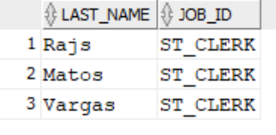

- Display last name, job title and hire date for all employees hired after Grant.
Sort the output by the most recent hire date.
SELECT last_name, job_id, hire_date
FROM employee
WHERE hire_date > (SELECT employee.hire_date FROM employee
WHERE employee.last_name='Grant')
ORDER BY hire_date DESC;

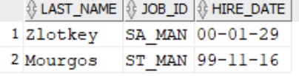

- Display city, province name, postal code and country code for all cities located in countries with NAMES (not Country Codes) starting on letter I (meaning Italy, Israel and India).
If the province is blank, show message Unknown.
Heading sample should be like:
City, Province, Prov_Code, Cnt_Code
Sort the output by city ascending. Do NOT use Join method.
SELECT city AS City,NVL(state_province,'Unknown') AS Province,
postal_code AS Prov_Code, country_id AS Cnt_Code
FROM location
WHERE country_id IN (SELECT country_id FROM country
WHERE country_name LIKE 'I%')
ORDER BY city ASC;

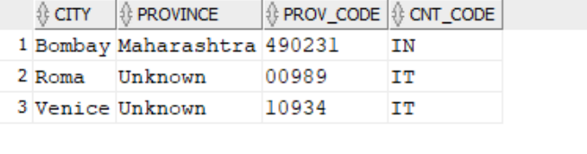
- Display last name, job title and salary for all employees who earn less than the Average salary in the Sales department. Do NOT use Join method.
Sort the output by top salaries first and then by job title.
SELECT last_name,job_id,salary
FROM employee
WHERE salary <( SELECT AVG(salary)FROM employee
WHERE department_id=( SELECT department_id FROM department
WHERE department_name='Sales'))
ORDER BY salary DESC, job_id;
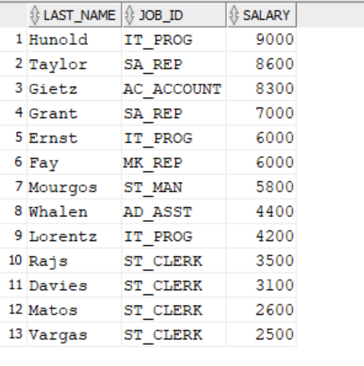

- Display last name, job title and salary for all employees whose salary matches any of
the salaries from the IT Department. Do NOT use Join method.
Sort the output by salary ascending first and then by last_name.
SELECT last_name,job_id , salary
FROM employee
WHERE salary IN (SELECT salary FROM employee WHERE department_id = (SELECT department_id FROM department WHERE department_name = 'IT'))
ORDER BY salary ASC, last_name;
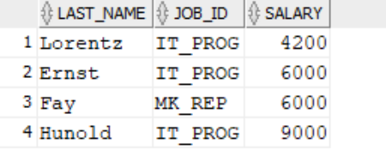

- Display last name and salary for all employees who earn less than the Lowest salary in ANY department.
Sort the output by top salaries first and then by last name.
SELECT last_name, salary
FROM employee
WHERE salary < ANY (SELECT MIN(salary) FROM employee GROUP BY department_id)
ORDER BY salary DESC, last_name;
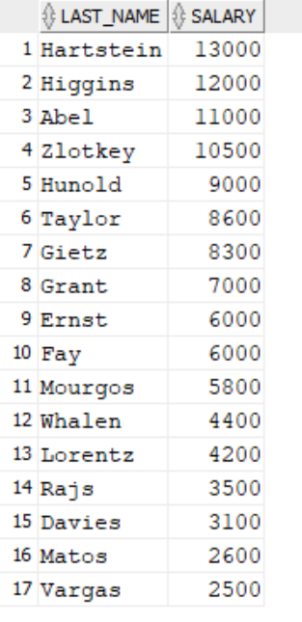
7 BONUS: Show job title, last name and salary for each person earning the highest amount for that job. Exclude all managers from this query. Sort the output by jobs ascending. (it is a Multiple Column SubQuery).

SELECT job_id,last_name,salary
FROM employee
WHERE (job_id, salary) IN (SELECT job_id,MAX(salary)
FROM employee
WHERE employee_id NOT IN (SELECT manager_id
FROM employee
WHERE manager_id IS NOT NULL)
GROUP BY job_id)
ORDER BY job_id ASC;
